Appendix 1: Core Creative Team Consultation

  - Introduction

The Creative Core Team (from heron in CCT) were responsible for delivering the ‘Made in Hull’ project at all levels, including developing the narrative, commissioning and supporting the artists, and overseeing production.
    - The Core Creative Team
In order to gain feedback from members of the CCT, consultation was undertaken both before and after delivery of the live ‘Made in Hull’ event.
The data collection methodology employed was online surveys, supplemented by in-depth telephone interviews. The templates for the surveys and discussion guides are provided in Appendices 2 – 4:
- CCT (Pre-Event) Survey: carried out as a combined online survey and telephone interview
- CCT (Post-Event) Survey: carried out as an online survey
- CCT (Post-Event) Depth Interview Discussion Guide: carried out a one-to-one telephone interview.
The focus of this research was to undertake two types of evaluation:
- Process Evaluation: motivations, creative development, artist commissions, live event locations, and project and production management.
- Outcomes Evaluation: artistic quality of the event; the extent to which diversity was explored and / or represented within the team and the event; the presentation, interpretation and learning linked Hull’s history and heritage; audience profile, reaction and feedback; skills and knowledge development among stakeholders; collaboration and partnership development among stakeholders; and perception changes towards Hull among stakeholders.

  - CCT Profile
    - Demographic Profile
As a key funder of Hull 2017, Arts Council England (ACE) are not only interested in the demographic profile of the audiences for ‘Made in Hull’. They also wish to know the demographic profile of the creative team involved in delivering the event, to inform the Creative Case for Diversity.
As such, all six members of the CCT were asked to complete an Equal Opportunities Monitoring Form.
Two members of the CCT were Hull residents, with the remainder residing in the Southern England - Bristol, Hemel Hempstead and London.
The responses show that there was a good mix of age groups, with team members spread across 5 age ranges (ages ranged between 35 and 64 years). Equally, there was even representation on the team of both males and females.
Diversity was lacking in terms of disability and ethnicity. No one self-identified as disabled (as per the definition provided by the Equal Opportunities Act 2010), and all stated they were ‘White: Welsh / English / Scottish / Northern Irish / British’.
Figure X: Age of Creative Core Team
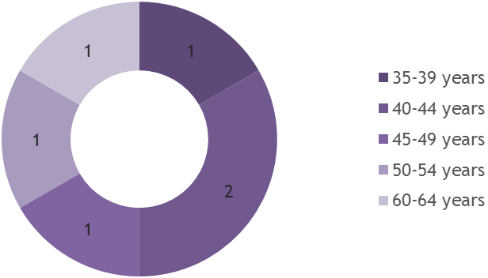
Figure X: Gender of Creative Core Team
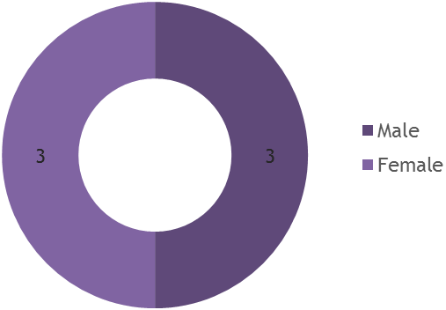
    - Profile Working on Similar Events
All members of the CCT were approached and selected to be a part of the team because of their track record and experience of working on large-scale events, including outdoor events.
However, experience was a bit more mixed when looking at their previous work on projects where heritage or commemoration, and Hull (the city and / or its people) were a source of inspiration:
- 2 of 5 stated that they had previously worked on projects where heritage or commemoration were a source of inspiration;
- 2 of 5 stated that they had previously worked on projects where Hull (the city and / or its people) were a source of inspiration; and
- 1 stated they had both worked on projects where heritage or commemoration were a source of inspiration and on projects where Hull (the city and / or its people) were a source of inspiration.
Figure X: Experience Working on Similar Projects
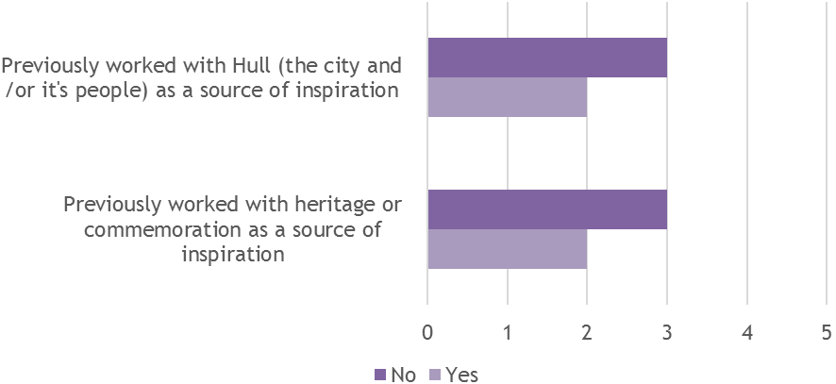
    - Personal Connections to Hull
4 out of the 5 CCT members who responded during the Pre-Event consultation stated they had one or more personal connections to the city:
- 1 stated ‘My family come from Hull’, ‘I was born in Hull’, ‘I grew up in Hull’, and ‘I currently live in Hull’;
- 1 stated ‘My family come from Hull’ and ‘I currently live in Hull’;
- 1 stated ‘I currently live in Hull’ and ‘I studied at the University of Hull’;
- 1 stated ‘I currently live in Hull’.
Figure X: CCT Personal Connections to Hull
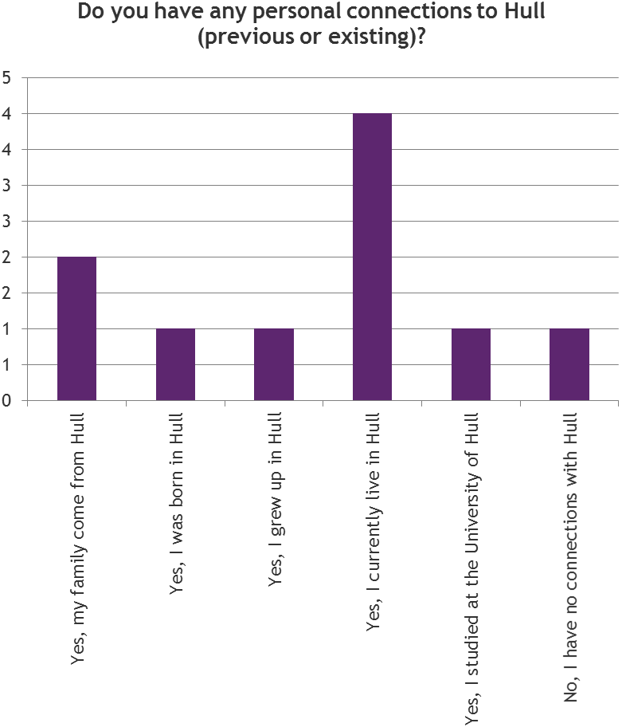
  - Process Evaluation
In order to inform the planning, development and delivery of future projects, a series of questions were asked linked to the process of ‘Made in Hull’. These concentrated primarily on:
- Motivations: What attracts the calibre of creative professionals required to deliver a project such as ‘Made in Hull’?
- Creative Development: How was the concept of the project conceived and how did this change or not over time?
- Artist Commissions: How were artists selected and how did they deliver against their individual Creative Brief?
- Live Event Locations: How were locations selected and how did they perform as stages for the installations?
- Project and Production Management: What were the strengths and weaknesses in relation to the project and production management of ‘Made in Hull’, and what would be done differently as a result?
    - What Was It About ‘Made in Hull?
4 out of 5 CCT members, who responded to the Pre-Event Survey, reported that they had heard about Hull becoming UK City of Culture 2017 before being involved in the project. When asked how much the city’s “status” influenced their decision to work on the project, 3 of the 4 who provided a response said it completely influenced their decision.
The other CCT member responding to this question said they would have wanted to work on something like this anyway, given the calibre of the team.
The CCT were asked to share their other key motivations for working on the project, with the opportunity to provide up to three key motivations:
- Motivations cited by more then one individual were being invited to join the team; a personal connection to Hull; and the chance to challenge perceptions held towards the city by residents and others.
- Motivations cited as a single occurrence were the community engagement opportunity; the idea being interesting; the opportunity to promote Hull’s culture; and the link of the project to their previous work.
    - Creative Development of ‘Made in Hull’
Creative Concept
The creative concept for ‘Made in Hull’ was developed principally through a series of meetings - in its initial stages, between the Curator, Writer and Hull 2017’s CEO, Martin Green. There was a sense within this group that an opening ceremony would be ‘too lavish’ and that the opening event should be as inclusive as possible. This led to discussions around a non-ticketed event in central Hull, which could be accessed by a wide range of people.
The aim was, to in some way reflect the last 75 years of Hull’s history, i.e. living memory, through encouraging people to draw on their own personal stories and memories. This led to the original plan of delivering a city light show with embedded historical archive footage.
Subject Matter
As a result of the creative concept, Hull’s history and heritage became the main inspiration for ‘Made in Hull’. The CCT approached the subject matter in a number of ways, in the beginning, principally:
- To mark or explore a moment in time for Hull;
- To explore unknown stories or histories of Hull in a new way;
- To showcase the contribution that Hull has made to the world;
- To celebrate Hull's sons and daughters; and
- To showcase Hull's historic buildings and public spaces.
Further exploration of this found that the CCT were keen to avoid the project simply ‘re-telling’ Hull’s history; the idea was to provide the audience with a new perspective on these stories that would evoke an emotional response.
Some of the issues that CCT members said they wanted to provide a new perspective on were:
- The role of immigration in building Hull and the contribution it has made to its heritage;
- Modern-day slavery in a city that has historically played a vital role in its abolition;
- Hull’s famous and influential sons and daughters – “game changers”.
‘We didn't want to tell the dry history but the lived history. We want to express how that history has brought us to 2017.’
Members of the CCT with strong connections to Hull tended to take the lead on which areas of Hull’s history and heritage to focus on.
The team used Hull History Centre and other local historical archives to find out more about the specifics of Hull’s history and heritage. They also spoke to local historians, who they found to be very useful in uncovering hidden stories.
One CCT member felt that the secrecy surrounding the project had prevented them from talking to members of the local community, who may have provided another important perspective on the city’s past.
Figure X: Approach to Subject Matter by CCT
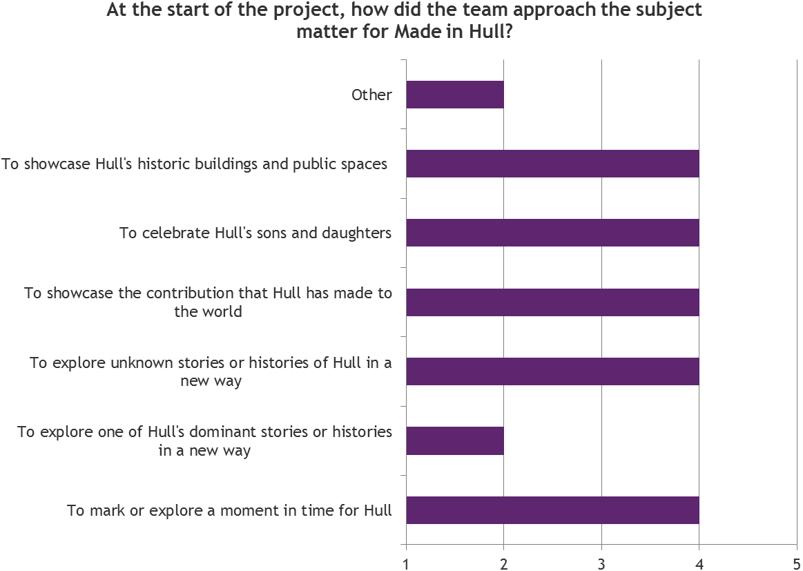
To explore one of Hull's dominant stories or histories in a new way was also part of the focus of the CCT, but to a lesser extent than the elements listed above.
With all these elements in mind, the team developed a series of ‘loose’ creative briefs, which were given to the commissioned artists. These artists went on to develop the artworks in collaboration with the CCT.
It was at the point when the artists came on board that the approach to the subject matter changed somewhat, primarily for two key reasons:
- The way that the commissioned artists interpreted their creative brief forced the CCT to look at the project in new ways;
- As information was uncovered (be it through conversations or via research within the different archives utilised in the project), different ways of exploring and communicating these stories came to light – in essence the history challenged a number of preconceived ideas.
‘There's a wealth of information that people have found in the archives and as that has come out there's been different ways of exploring and communicating it.’
‘The artistic interpretations of the briefs we sent out was the point at which the creative process really developed.’
Team Approach
The creative development of ‘Made in Hull’ seems to have been a very collaborative process.
Whilst a couple of people led on the direction of the overarching narrative, the rest of the team played an important role in contributing their own artistic ideas and making practical suggestions on how to deliver the event based on their own areas of expertise.
The team was made up of people who had significant experience in their field; some of who were local and others who had never visited the city before. This diversity was considered important because it provided a variety of perspectives on the creative process.
There appears to have been a divide within the CCT between those responsible for the narrative and those responsible for production, which became apparent closer to the time of the event. Some of those responsible for the narrative felt a little detached during the production phase, which caused tension when it came to making key decisions.
‘How the project was managed at the later stages made it difficult for us to have conversations with the artists about their work and how we could make it more relevant.’
One comment was that there was no process of reflection for the CCT, despite the fact that many of them had never worked on this kind of project before. Evaluating their performance during the creative development phase perhaps would have given them confidence that the project was moving in the right direction.
There was disappointment that there was no opportunity to thank the artists or the production team during or after the event, e.g. the absence of a wrap party was a disappointment for some, particularly as this was originally proposed. They felt this would have shown appreciation for the CCT, whilst also allowing them to ‘wind down creatively’.
    - Artist Commissions
Most CCT members said they had been satisfied with the commissioning process, which involved the following stages:
- A shortlist was drawn up by the CCT, based on the knowledge held within the Hull 2017 team – a focus was given to up and coming artists and local artists who had recently applied for grants via the Creative Communities Programme (where their proposed project fit within the overall concept).
- Shortlisted artists were invited to meet the full CCT to discuss past and current work, their suitability for the proposed brief, and to present their creative ideas.
- Selected artists were given some resource for R&D to explore their creative ideas further and come up with their proposal.
- Artists and the CCT met so artists could report on R&D work and further develop their creative ideas with the CCT.
- CCT confirmed the final list of commissioned artists.
The CCT reported that some artists required more support than others, but in all cases they worked closely with artists to ensure each piece answered the creative brief and could be delivered within the timescales and budget.
Some artists developed a closer working relationship with individual members of the CCT, particularly where they required further support on a particular aspect of production such as sound or lighting.
‘Every single person answered the creative brief. But the ones who succeeded the most were the ones who thought outside the box.’
‘The collaborations were predicated on the idea of the artists bringing additional creative value to the core team's briefs for each trail location whilst maintaining a strong 'Hull-centric' focus. This worked well on the whole.’
    - Live Event Locations
The location was considered to be another strong aspect of the event.
‘Made in Hull’ was initially planned for Ferensway but the CCT later changed it to Queen Victoria Square and the Old Town for the following reasons:
- Queen Victoria Square was a more natural place for crowds to congregate, and therefore easier to manage;
- The architecture in Queen Victoria Square and the Old Town lent itself to the artworks and projections, which had been initially proposed by the artists; and
- There was a more natural ‘trail’ from Queen Victoria Square down Whitefriargate to The Deep.
‘First of all we were going to use Ferensway because we could see it was crying out for love. But people will naturally congregate on Queen Victoria Square, so we moved it there and the rest of the trail just seemed to fit together perfectly.’
The decision to move away from Ferensway was seen as a bold decision so late in the day, but all the CCT members agreed it was the correct decision to make, despite the extra pressure it added.
Indeed, post-event, all 6 CCT members strongly agreed that the locations selected were appropriate for the artwork (given the parameters and strategy to bring people into the city centre).
    - Project and Production Management
Overall, feedback on the project and production management of ‘Made in Hull’ was positive.
Project Management
Prior to the event being delivered, the CCT were asked to rate the project management of ‘Made in Hull’ to date. An average rating of 3.5 out of 5 stars (n=4) was awarded.
Figure X: Project Management of ‘Made in Hull’
Illustration of 3.5 stars
Top-level aspects of the project management of ‘Made in Hull’ were assessed at pre-event delivery stage, as were some of the more detailed aspects.

At the top-level:
- Contracting and development meetings were seen to be good; whilst
- Communications were average to good.
Figure X: Project Management – Top Level Feedback
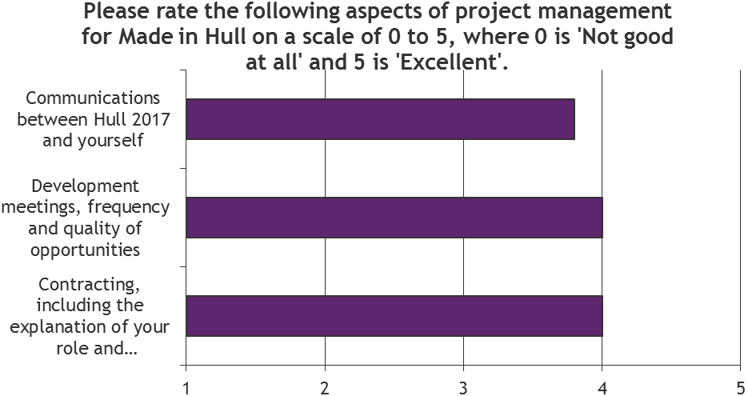
The more detailed exploration of the Project Management showed that, on average, all elements were handled well with a rating of good to excellent. The only one scoring below good was individuals’ sense that they had been able to deliver their work to a high standard because of the support provided by Hull 2017. This is illustrated in the figure overleaf.
Feedback on how the Project Management of ‘Made in Hull’ could have been improved was through having:
- A clear “Lead” or decision maker on the project;
- A smaller more focused CCT;
- Greater access to other individual members of the CCT;
- Longer lead-in time for all CCT members;
- Starting sooner in the creative development process to enable artists more time to prepare and pilot their work;
- Focusing on the emotional impact of art; and
- Increased frequency and more effective communications within the CCT.
Figure X: Project Management – The Detail
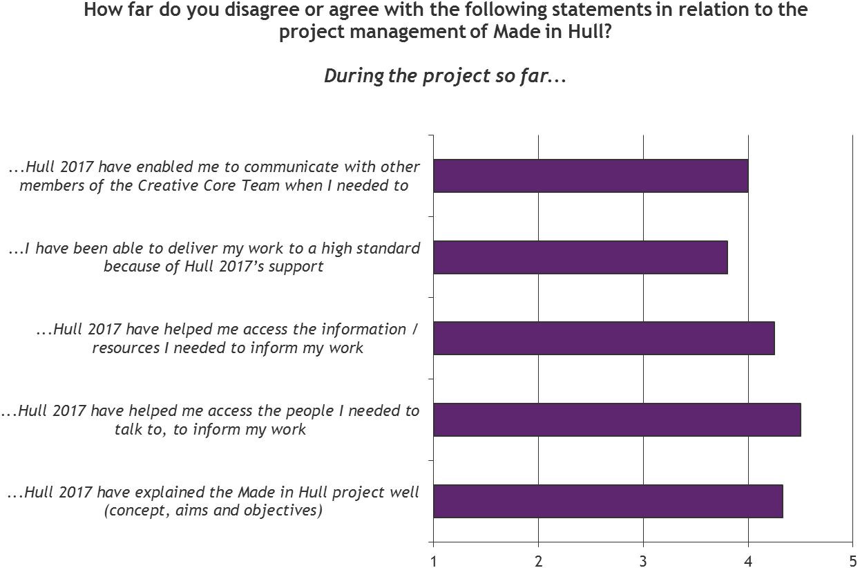
Production Management
After the event was delivered, the CCT were asked to rate the Production of ‘Made in Hull’, where ‘Production’ referred to the live delivery of the event from 1-7 January. An average rating of 4 out of 5 stars (n=6) was awarded.
Figure X: Production of ‘Made in Hull’
Illustration of 4 stars
All aspects of the production of the event were given at least 4 out of 5. The lighting was given the highest rating of 4.8 out of 5, with lighting, sound, the installation of the artworks and interpretation of the event being particularly singled out for their quality. This is illustrated in the figure overleaf.
Feedback on how the Production Management of ‘Made in Hull’ could have been improved was through:
- Employing a more experienced Events Management Company;
- Employing a more experienced Technical and Operations crew;
- Identifying ways that the technical equipment could have been better hidden or less invasive within the viewing area, particularly in terms of Queen Victoria Square;
- Ensuring that all artists had adhered to the “Hull-centric” focus of the project, with the installation at the underpass being generally considered to be the least successful because it alienated audiences and did not draw on any aspects of Hull’s culture or heritage;
- Greater detail and levels of interpretation at each of the installations, though there was a realization that time and budget had impacted on this area; and
- Having more time and a greater budget for the project as a whole, which in turn would have allowed for greater investment in the Events Management Company and Technical and Operations crew.
‘[It] felt more like a festival site than a cultural exhibition.’
Despite these areas for improvement, the CTT did not feel their shortcomings had detracted from the audience experience, and they praised the team’s efforts in pulling the event together on a tight budget.

Figure X: Production of ‘Made in Hull’ – The Detail
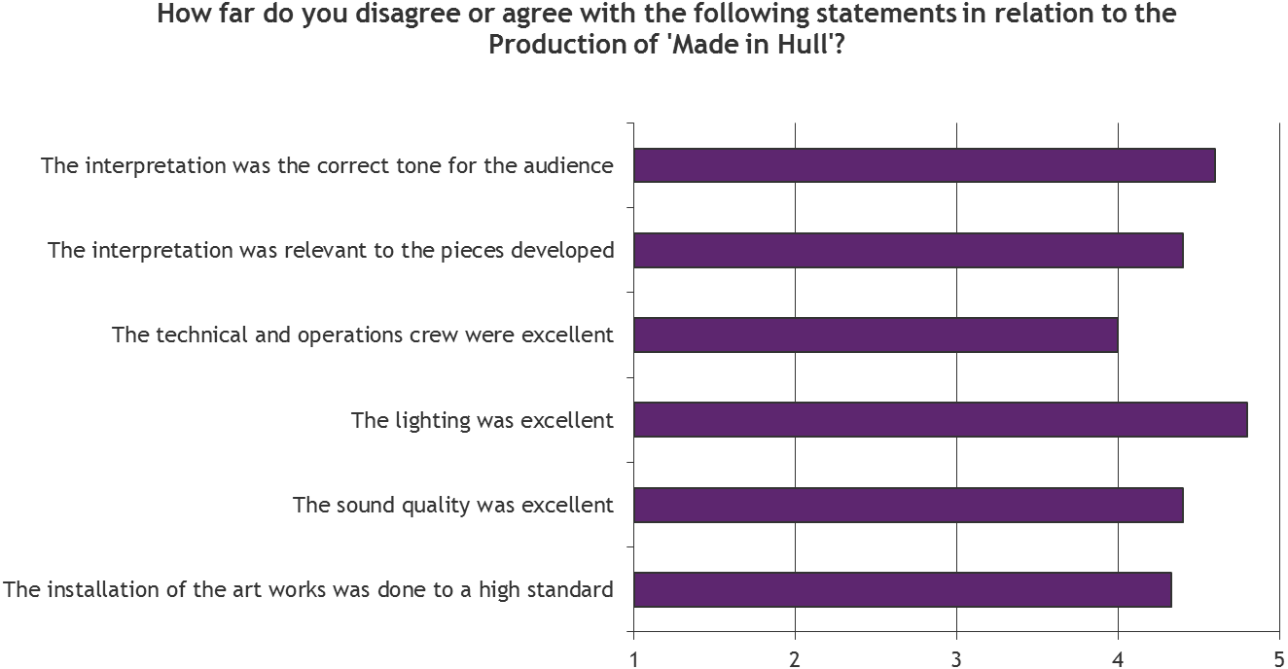
  - Expectations & Outcomes
During the pre-event consultation process, the CCT were asked about their expectations for the event in regard to a range of outcomes and impacts, whilst post-event they were asked about what they believed had been delivered in terms of outcomes and impacts.
The key areas of focus were:
- Artistic Quality: of the commissions and the event as a whole.
- Creative Case for Diversity: perceptions of how diversity was represented or explored within the commissions and event as a whole.
- Hull’s Heritage and History: the success of the project in presenting and interpreting the heritage and history of Hull to audiences.
- Audiences: observations and perceptions of the audience profile, audience reaction and outcomes for audiences.
- Skills and knowledge development: new and existing skills, knowledge and learning, in regard to professional skills and the heritage and history of Hull, as a result of working on ‘Made in Hull’.
- Collaboration and partnerships: new and existing collaborations and partnerships built or developed as a result of working on ‘Made in Hull’.
- Perceptions of Hull: shifts in the perceptions of Hull amongst CCT member, as a result of working on ‘Made in Hull’.
    - Artistic Quality
Arts Council England (ACE) has developed a number of metrics to measure the artistic quality of an event, which in line with ACE guidance, were asked of the CCT pre- and post-event. When comparing the results at these two points in time, the data shows that:
- Pre-event, the average score across all of the quality metrics was 8 out 10 or above – the lowest scoring metric being ‘Originality: it is groundbreaking’ (8 out of 10) and the highest scoring metric being ‘Presentation: it will be well produced and presented’ (10 out of 10).
- Post-event, the average score across all of the quality metrics was between 7.7 to 8.8 out 10 – the lowest scoring metrics being ‘Originality: it was groundbreaking’ and ‘Risk: The artists really challenged themselves with this work’ (7.7 out of 10) and the highest scoring metrics being ‘Enthusiasm: I would come to something like this again’ and ‘Relevance: It had something to say about the world in which we live’ (8.8 out of 10).
- Overall, all but one of the quality metrics scored a lower average score post-event than it did pre-event – the most dramatic shift between expectations and reactions were in relation to ‘Presentation: It will be / was well produced and presented’ and ‘Risk: The artists are really challenging themselves with this work’, both reducing by 1.5
- The only quality metric that received a higher average score post-event than it did pre-event was ‘Concept: It is an interesting idea / programme’, which increased by 0.3.
A full breakdown of answers by each Quality Metric is presented in Table X and Figure X.
Rationale was provided by members of the CCT in relation to the answers given, predominantly post-event. These included:
Presentation
The schedule that the CCT were working to created limitations on what was possible in regard to presentation. As a result, some felt there was room for improvement.
‘We could always do better, that's just a mantra for moving forwards, but our schedule was challenging.’
Distinctiveness
Although members if the CCT had worked on similar projects before, the mix of archive materials with light and sound was new for some. Many felt that it was definitely something audiences in Hull were experiencing for the first time, both in terms of scale and content.
‘The archive [elements] with the son et lumiere idea was unique for artists and audience.’
Challenge
It was generally felt that some installations were more thought provoking than others, which was also intentional. Some, for example, were utilising historical evidence to challenge preconceptions held in and about the city, whilst others were meant to be more easily accessible.
‘Whilst presenting content familiar to Hull residents, it did it in surprising ways. It also (i.e. the Deep) presented content based on historical evidence that challenged some Hull residents’ preconceptions about immigration.’
Captivation
Generally, it was felt that the project was absorbing for audiences and CCT members alike.
‘Even having been a part of the team I was keen to go around each evening while I was in attendance and see and hear things again.’
Enthusiasm
As with captivation, this was considered from both audience and CCT member viewpoints, and all felt that it was something they would take part in again.
‘Because it was about my city, its history and people.’
Local Impact
There was an overriding sense that the project had to happen in Hull, as it was about giving residents ownership of their own and their ancestors’ stories, whilst at the same time presenting these to the rest of the world.
‘In order for Hull people to feel City of Culture year was relevant to them. And to showcase the culture, history and heritage of the city to the outside world.’
Concept
As with the local impact, the CCT members talked about the strength of the concept in putting something together that gave people ownership of it, in a way that spoke to both Hull’s residents and visitors. It was felt this was done successfully.
‘Handing artistic directorship to a Hull filmmaker was a great idea - it's a beautifully coherent concept about showing to itself and bringing people together in way which gives them genuine ownership of their collective story.’
Relevance
It was felt that a number of the installations asked questions of the audience, which had a poignancy with the world today, as well as presenting aspects of Hull’s present and future.
‘Elements of the event portrayed the city and its people in their contemporary lives. Elements whilst speaking of the past also referenced current political issues (e.g. immigration and unemployment) plus spoke about the city's future direction of travel (wind-power).’
Originality
In general, it was felt that the techniques adopted in the creation of ‘Made in Hull’ were not new to the creative professionals working on the project, or the artists commissioned. However, for the many of the audiences attending the event it was new and groundbreaking.
‘I think we were using techniques that have been pretty well established. But for me this is not a key factor in the success of the event as a whole. Authenticity and sincerity are however, and I think that's what gave the piece it's life and held its audience captive.’
Risk
Although CCT members generally felt artists were capable of delivering their artworks, some felt that certain artists had been overly ambitious with some of their ideas, whilst others needed the confidence to be more ambitious with their vision. Therefore, opinions differed by installation.
A couple of CCT members felt the timescales and budget had restricted them from choosing from a wider pool of artists, but all agreed that in general the artists delivered their pieces to a high standard.
‘Their task was to honestly and authentically portray the culture and history of the city and its people, whilst simultaneously appealing to an outside audience.’
Excellence
Overall, the positive response from the city and audiences was seen as testament to the excellence of the event.
‘Having queried it being ground breaking…I realise that I've never been to anything quite like it. For me the most exciting end result is to feel the energy of the crowd moving through the event and to see their delight and ownership, their pride in their city.’
Rigour
There was a general feeling that the project was the result of a concentrated team effort, with dedication and skill brought to bear, ensuring that it was the best it could be given the time and budgetary constraints.
‘I'm sure there are things that every member of the team would want to revisit, but I think the consideration of what needed to be covered by Sean and Rupert was key and once in place liberated everyone to push forwards with clear briefs, that explored the various aspects of Hull's history and cultural life.’
In addition to the ACE Quality Metrics, the post-event survey showed that the CCT felt, on average, the artists selected were the right ones and that the locations selected were appropriate. Both aspects were rated an average of between 4 and 5 out of 5 on a scale of Strongly Disagree to Strongly Agee.
The installations at Queen Victoria Square and The Deep were singled out for being particularly successful in terms of the production quality, emotional response and audience reaction, and the installations on the trail in between these two points were also seen as largely successful.

Figure X: Quality of Artists and Locations
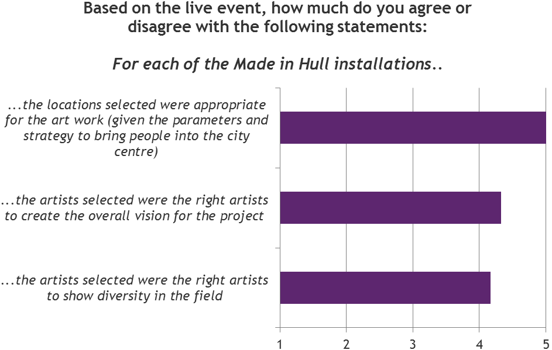
Overall, it was felt that the installations really showed off Hull’s impressive architecture and encouraged people to look up.
One comment was that the production looked more expensive than what it actually cost, which suggests the team managed to get value for money.
Table X: Arts Council Quality Metrics – CCT Pre- and Post-Event
ACE Quality Metrics | Pre-Event  (n=5) | Post-Event  (n=6) | Change in score from Pre- to Post- Event
Presentation: It will be / is well produced and presented | 10.0 | 8.5 | -1.5
Distinctiveness: It will be / is different from things I’ve experienced before | 8.8 | 8.2 | -0.6
Challenge: It will be / is thought-provoking | 9.0 | 8.2 | -0.8
Captivation: It will be / is absorbing and will hold my attention | 9.2 | 8.5 | -0.7
Enthusiasm: I will / would come to something like this again | 9.3 | 8.8 | -0.4
Local impact: It is / is important that it's happening here (in Hull) | 9.8 | 8.7 | -1.1
Concept: It will be / is an interesting idea | 9.2 | 9.5 | 0.3
Relevance: It will have/has something to say about the world in which we live | 9.2 | 8.8 | -0.4
Originality: It will be / is ground-breaking | 8.0 | 7.7 | -0.3
Risk: The artists are really challenging/challenged themselves with this work | 9.2 | 7.7 | -1.5
Excellence: It will be / is one of the best examples of its type | 9.8 | 8.5 | -1.3
Rigour: It will be / is well thought through and put together | 9.4 | 8.2 | -1.2

Figure X: Arts Council Quality Metrics – CCT Pre- and Post-Event
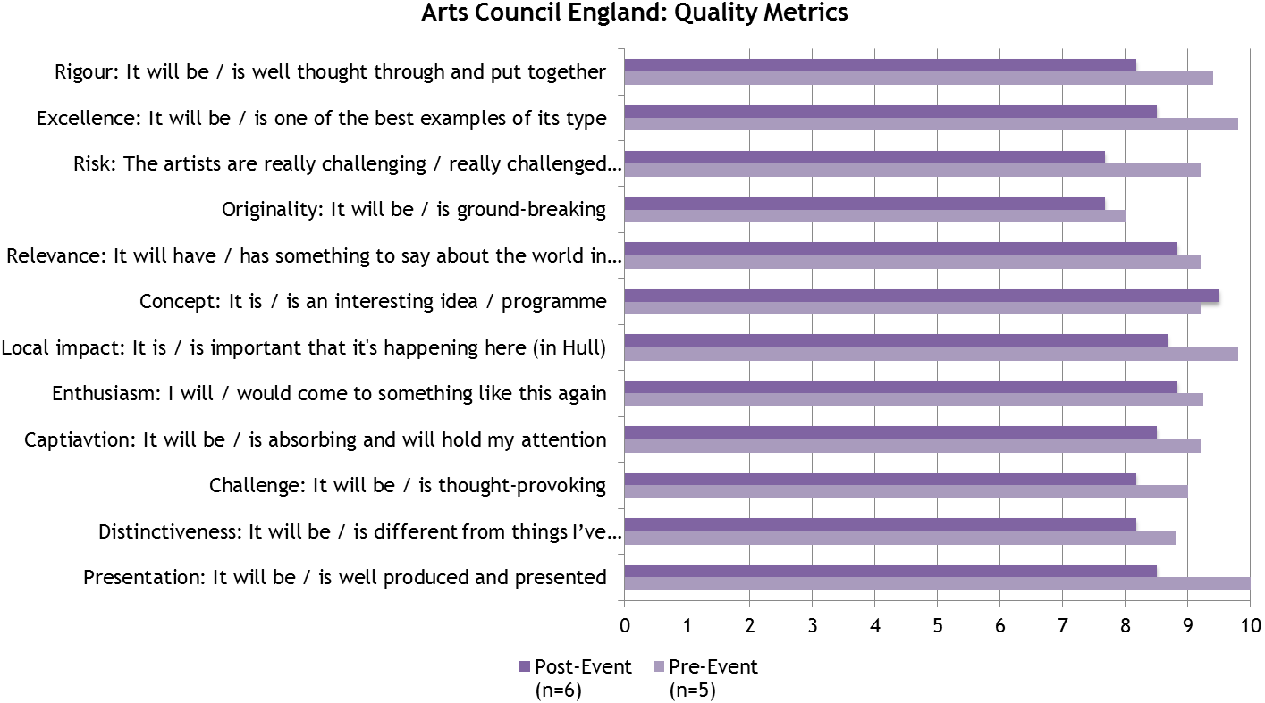
    - Creative Case for Diversity
Pre-event, all members of the CCT felt that diversity would be explored and / or represented in ‘Made in Hull’. This was true, both of the artists creating the artworks and the content / narrative of the artworks themselves. Some members of the team stated that a conscious effort had been made by the CCT to ensure that this was the case.
‘Every artist has, in some way, gone into that topic [of diversity]. I'm not sure if it's something we asked for but it's certainly been reflected in their work.’
‘[Diversity is] represented in one of the locations where we explore the movement of people from different cultures. We know that Hull's history is predominantly White, but we are also showcasing that the city is built on migrants - particularly over the last two centuries.’
Some members stated their desire to challenge the perception of Hull being dominated by ‘White culture’ through the project, and to demonstrate that it has been built on migrants.
‘I think there was a pretty good reflection of diversity balanced with more mainstream aspects of historical thought. A good balance, whilst this is not binary, for the sake of argument it's vital that there is cross fertilisation between the traditional and the iconoclastic, for people of different tastes and cultural backgrounds to be taken away from their norms and comfort zones, to be challenged and have their horizons shifted.’
Despite this, there was mention that the event lacked a ‘youth voice’, with only one of the final installations being youth-oriented.
    - Presentation and Interpretation of History and Heritage
Before the event it was hoped that ‘Made in Hull ‘would help people learn more about the city’s past. Some hoped it would instill a sense of pride in local people, whilst others simply wanted the artworks to be “thought-provoking”.
Equally, there were high hopes that the project would have an impact on proving the value of heritage inspired arts projects, both from the viewpoint of the cultural sector and audiences.
4 members of CCT responded to statements linked to this. An average score of 9.5 out of 10 for level of agreement (where 10 was Strongly Agree) was awarded to all three statements:

- Made in Hull will demonstrate new ways of interpreting the history and heritage of a city through the arts’
- Made in Hull will present audiences with new ways of engaging with the history and heritage of a city through the arts’
- Made in Hull will contribute to the development of artistic practice in celebrating a city's history and heritage’
Post-event, the team universally agreed that ‘Made in Hull’ had successfully enhanced the audience’s understanding of – and ability to engage with – the city’s past. They also felt it had contributed to the development of artistic practice in celebrating the city’s past. An average score of 8.8 - 9.2 out of 10 for level of agreement (where 10 was Strongly Agree) was awarded to all three statements:
- Made in Hull enhanced audiences' understanding of the city's past.’
- Made in Hull improved audiences' experience of engaging with the city's past.’
- Made in Hull contributed to the development of artistic practice in celebrating the city's past.’
These results are presented in Figures X and X overleaf.
‘In a way we wanted to make it an outdoor, interactive museum…but museums have a responsibility to present information without slant. Artists have their own interpretation on historical events.’
There was a suggestion that the event had sparked people’s interest in the history of Hull, and in that sense it had offered a springboard for people to find out more about the past.
There was a discussion around the impact of a heritage or historically inspired arts event on the audience and how it’s different to that of a conference, traditional museum exhibition, or publication. In summary they felt the key differences were:
- Made in Hull wasn’t ‘demanding’ on the audience – it was an immersive experience that swept people up with the emotion of each piece; and
- It was able to reach a much wider audience because its appeal was much broader and the scale much larger.
‘Made in Hull shows that art doesn’t have to be demanding – it was like turning a TV on but it actually takes you on a fishing boat, or back to the WW2. It’s an art form that doesn’t feel like an art form.’

Figure X: Made in Hull – Interpretation and Presentation of History and Heritage (Pre-Event)
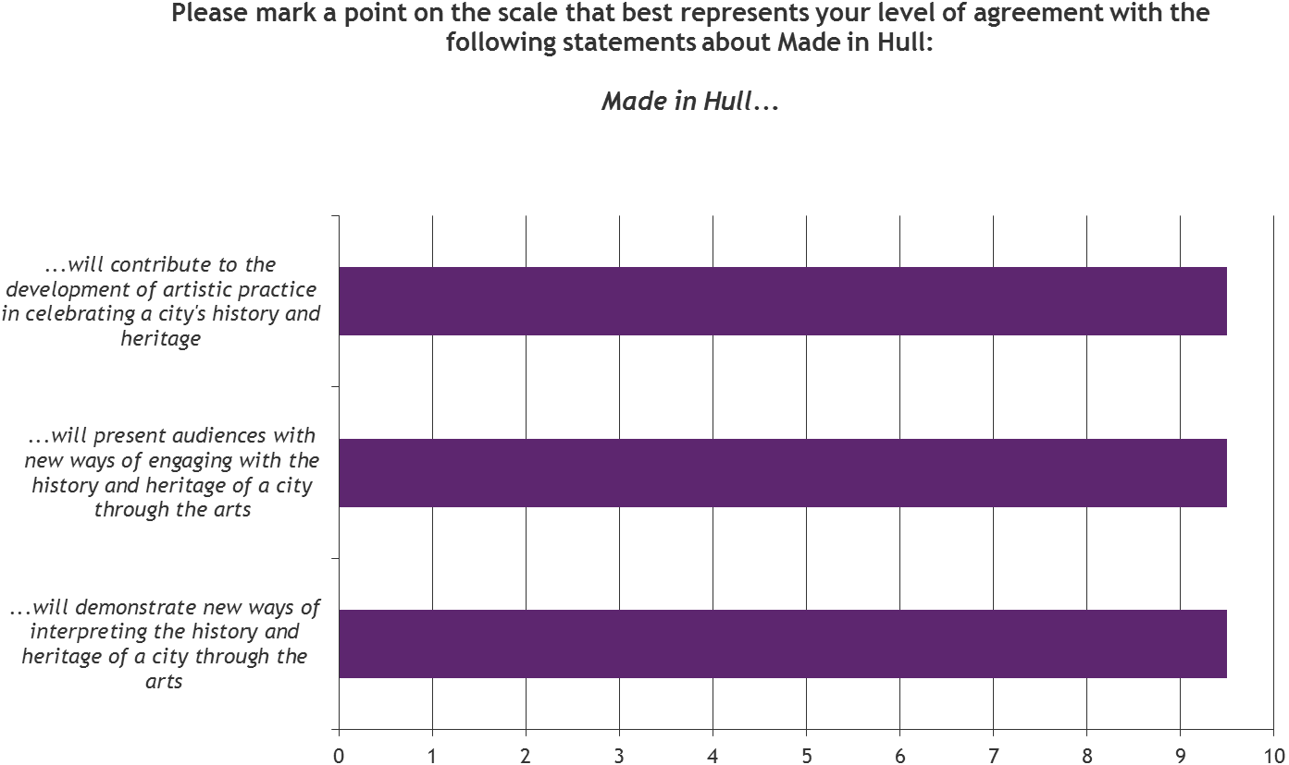
Figure X: Made in Hull – Interpretation and Presentation of History and Heritage (Post-Event)
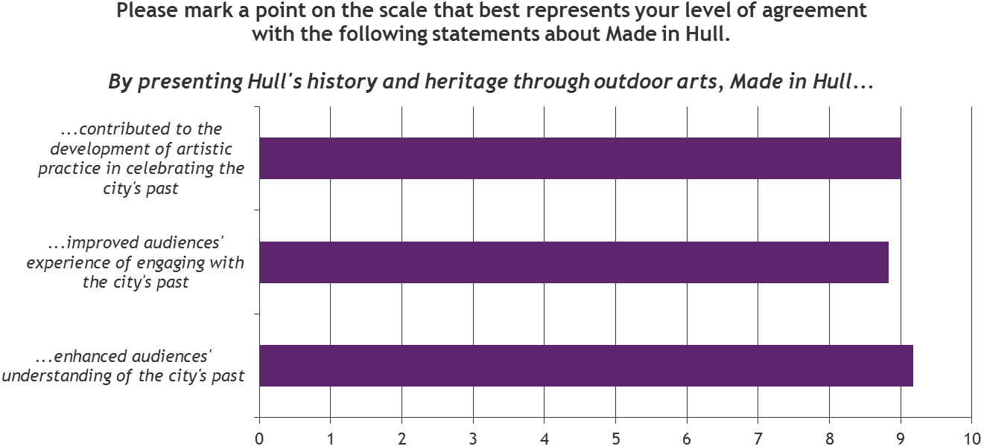

    - Audience Outcomes
Most agreed that attendance and audience reaction were the two most important measures of success for the project. In this respect there was agreement that ‘Made in Hull’ had been an overwhelming success.
The CCT members also highlighted the following in their feedback on the event, as indicators of its success:
- Audience profile – particularly people from across the generations, people visiting from the Hull estates, and those who might otherwise have thought ‘culture isn’t for me’;
- The largely positive social media response; and
- The small number of public complaints.
Based on their observations and interactions with the audience, the CCT felt the event had made an impact in the following ways:
- An improved sense of civic pride and a stronger sense of identity;
- Stirring memories and encouraging conversations about the past;
- Creating an interest in Hull’s history and heritage;
- Changing people’s perceptions of a city with a previously poor reputation;
- Introducing the language of art and culture to the people of Hull; and
- Creating a long-lasting memory.
‘For the people of Hull, the event strengthened and validated their sense of identity.’
    - Skills and Knowledge
Professional Skills and Knowledge
Half the CCT members said they had learnt new skills and two-thirds said they’d developed existing skills through working on ‘Made in Hull’.
CCT members were most likely to have gained or developed artistic or creative skills (e.g. art forms, artistic techniques) from working on the project, most closely followed by skills and knowledge in Project Development; Museums, Libraries and Archive skills (e.g. researching archives, cataloguing, conservation, interpretation); Project Management; Audience Development; Production & Technical Skills; and Team Working.

Figure X: Skills and Knowledge Gained and / or Developed
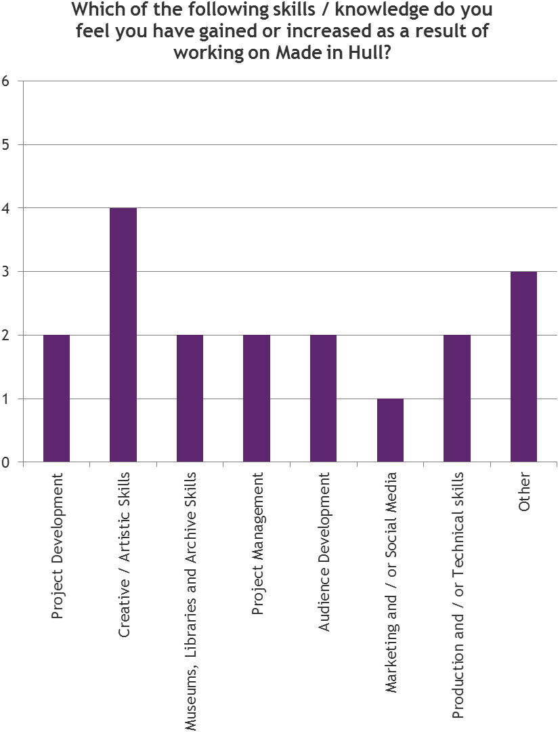

In explaining their answers to the above question, individual CCT members cited the following rationale:
- Managing other artists work;
- Leadership of the team;
- Developing themes and narratives for a new genre;
- Delegation of tasks;
- Being introduced to the commissioning process.
Some members of the team were given more responsibility for certain aspects of the project, which perhaps explains why fewer people learned or developed skills such as historical information-gathering and production skills.
Some CCT members had not managed or advised other artists before, which helped them to develop skills in this area.
However, there was still a sense that certain skills and knowledge were shared and learned across the CCT, particularly in relation to creative concepts and project management.
A couple of people felt that more should have been done to include local artists, writers and producers in the development of ‘Made in Hull’, to teach them the skills to be able to deliver a similar kind of event in the future.
Knowledge of Hull’s History and Heritage
Since working on ‘Made in Hull’ almost all the CCT members said they had learnt a lot about the history and heritage of the city:
- On average, CCT members gave an average score of 8.8 out of 10 in relation to how much they had learnt about Hull’s heritage working on the project; and
- On average, CCT members gave an average score of 8.7 out of 10 in relation to how much they had learnt about Hull’s history working on the project.
For the purposes of the survey:
- Heritage was defined as valued objects and qualities such as historic buildings and cultural traditions that have been passed down or preserved from previous generations.
- History was defined as past events connected with a person, thing or place.
Figure X: Learning Linked to Hull’s Heritage & History
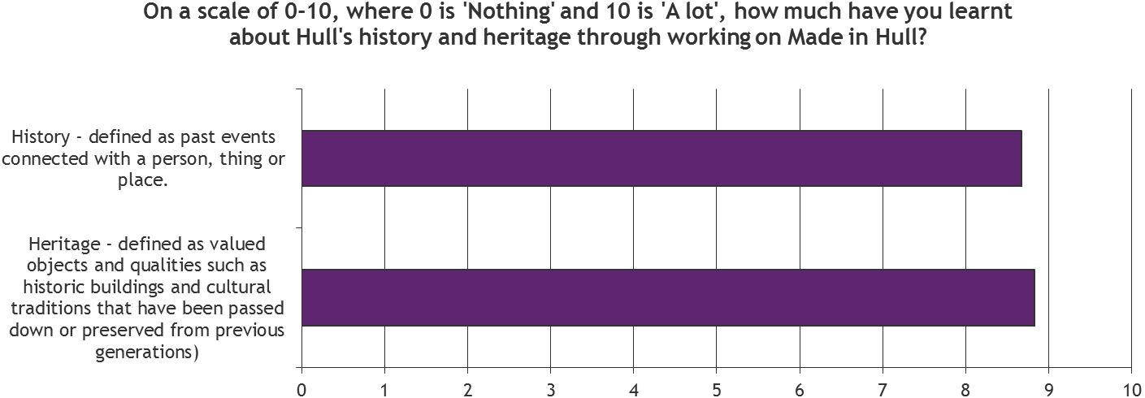
    - Collaboration & Partnerships
All the CCT members spoke enthusiastically about the opportunities the project had presented them with in terms of working with new people and organisations.
Almost all stated that they had been able to collaborate with other individuals and/or organisations; all had built new relationships with individuals and/or organisations they had not come across before; and most had been able to develop existing relationships with other individuals and/or organisations that pre-dated ‘Made in Hull.’
Figure X: Collaborative Opportunities
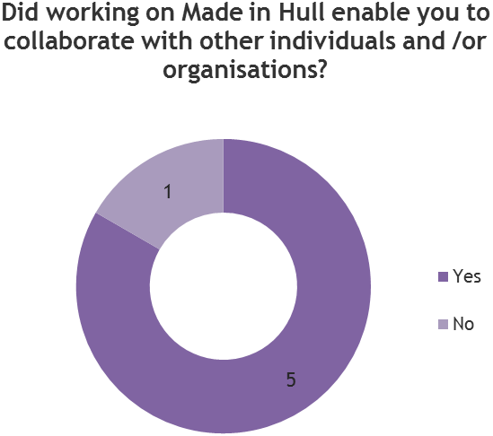
Figure X: New Relationship Building Opportunities
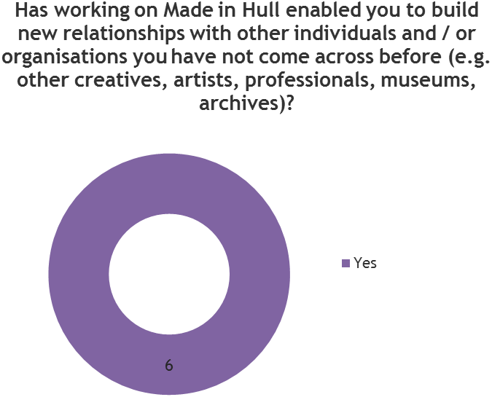
Figure X: Existing Relationship Building Opportunities
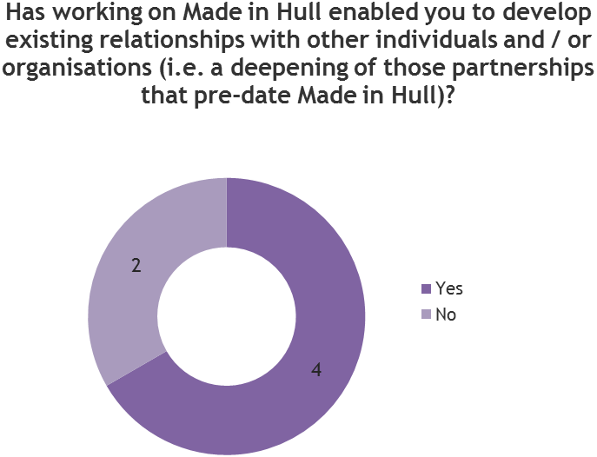
Many said they would be keen to work with these individuals or organisations in the future, be it at least one other member of the CCT, one or two of the artists, or the delivery partners involved. Indeed, some were already working on a new project at the time of interview.
All of them agreed that the project had enabled them to increase and diversify their network, which would help enhance their future work.
‘I’m spoilt for choice now in terms of who I’m able to work with in the future.’
    - Perceptions of Hull
Prior to working on the project members of the CCT said they would have only been able to describe Hull as a northern port city; would have probably gone along with the joke of it being a ‘crap town’; described it as misunderstood; talked positively about the surrounding area; or said it was a city in the making.
Pre-event, as a result of their work to date on ‘Made in Hull’, the majority of the CCT said they would speak more positively about Hull to others, but this increased to all members of the CCT post-event.
Reasons linked mainly to the fact they had an increased knowledge of, and therefore more to talk about in relation to the city; and that they had been surprised about how much the city offers in terms of alternative culture.
Members from outside the city said they had learnt a lot about the people of Hull since working on the project. One commented that the people of Hull had been really impressed by the project despite there being a sense of skepticism in the run up to 2017.
Figure X: Perceptions of Hull Amongst CCT Pre- and Post-Event

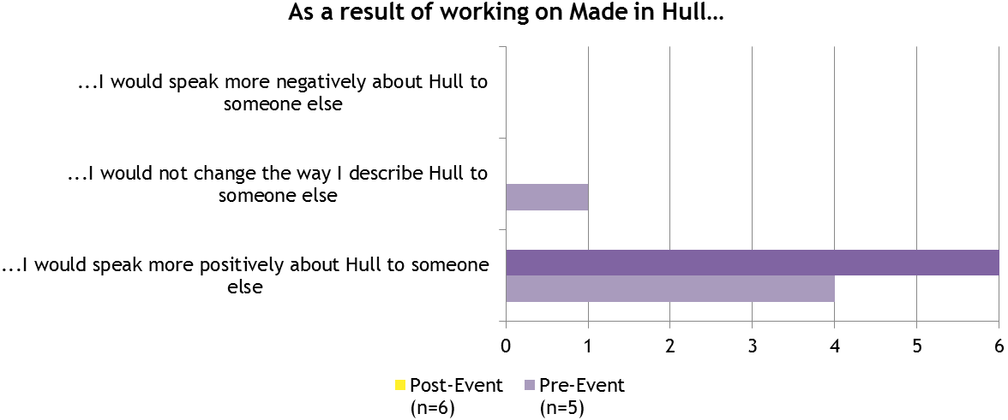
Some said the event has made people take Hull more seriously, whilst others said it had showed the ambition and value of Hull as a UK City of Culture.
‘From a contemporary perspective I've learnt that Hull is not a backward city like I remember it. It's an interesting, artistic hub.’
‘I think Hull is a wonderful and misunderstood city. It's an interesting paradox that it has traded on its isolation to some extent - it is part of the Hull brand to use clumsy shorthand. I will encourage people to visit Hull because it has its own centre of gravity. What is key for me is that Hull… feels empowered to take steps to have a profile on the world stage and not just within the UK.’
‘Definitely seen Hull mentioned more on BBC down south, and by people in general. Think we achieved something special because the audience was happy and engaged and people are starting to see Hull in a new light.’
‘It was a great event and taught a lot of the heritage and history of the city in a very imaginative way.’
‘The event showed the power and value of what the city has and can achieve, and communicated that both to its residents and the outside world.’
‘Now people see the press they take Hull seriously when they talk to me about the place instead of joking about it as 'funny place to have city of culture' so it allows me to get serious and talk about the range of creative events unfolding in the city.’
3 agreed and 3 strongly agreed that the event had placed Hull nationally on the arts radar for the coming year.
Figure X: Hull’s Place on the National Arts Radar
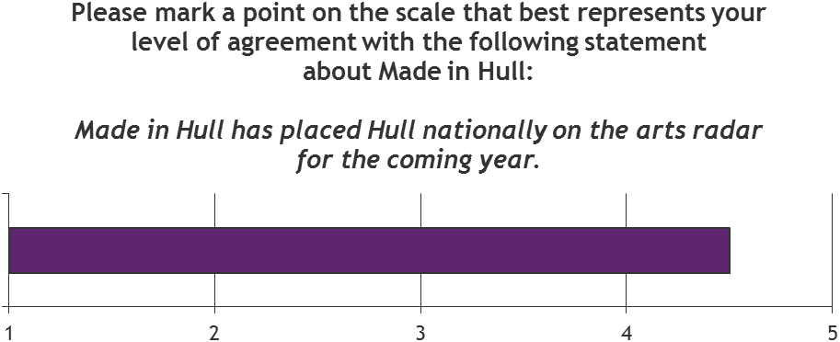
There was also mention made of the positive coverage within the local and national press, as well as positive feedback from peers within the arts sector.

