V1.

1.

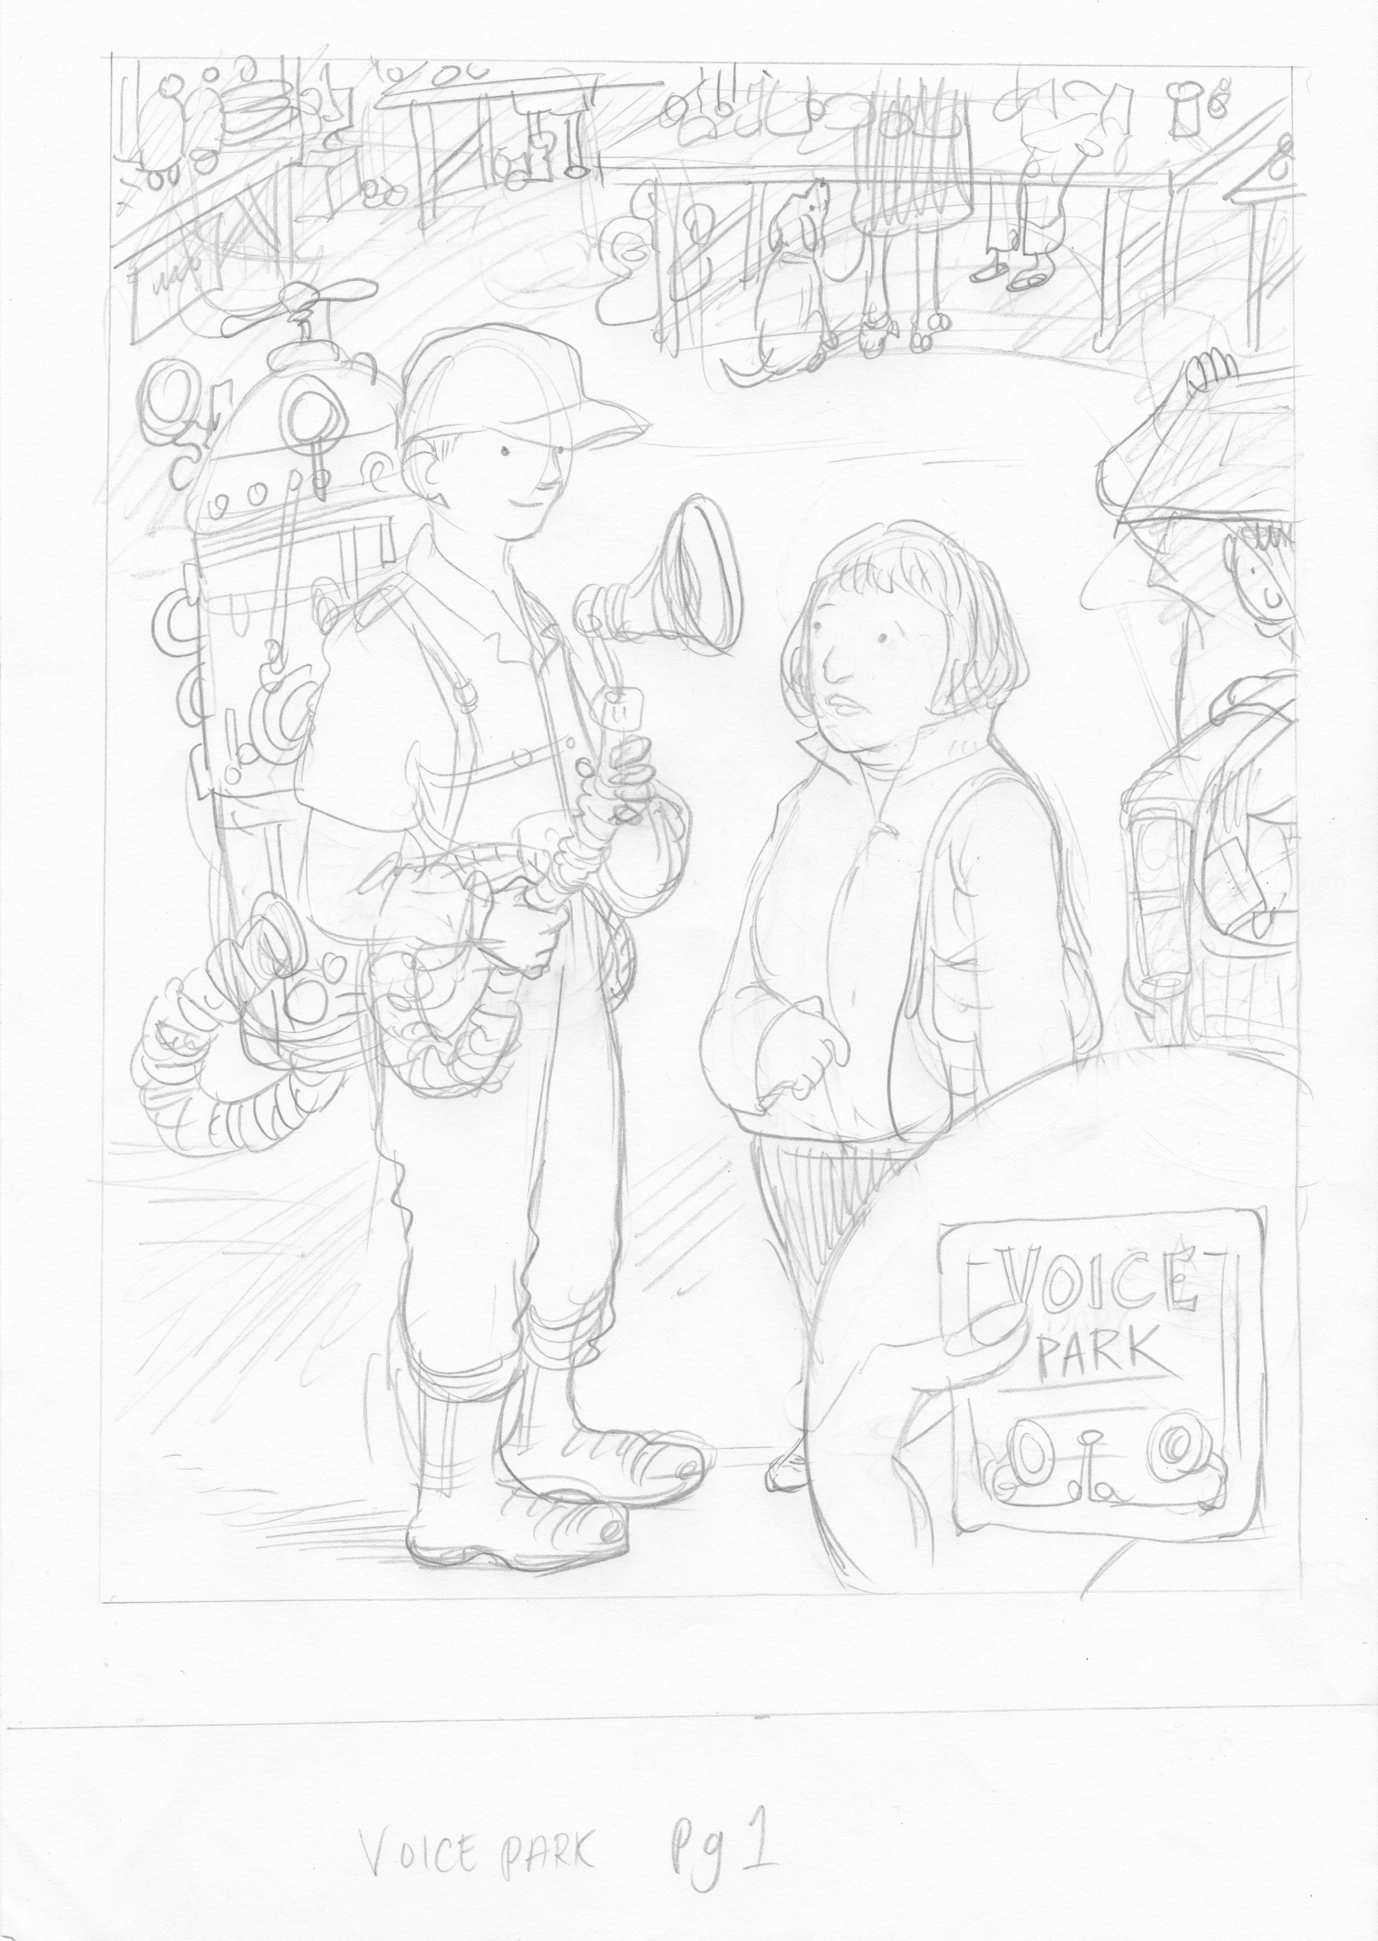

It was a Sunday morning on Walton Street Market, the kind on that goes on forever with the smell of bacon and the murmur of chat and laughter. Agnes was happily browsing the books when a man in beige overalls and a strange contraption on his back appeared in front of her.

He explained that he was collecting voices, but she instantly recoiled; what good would her voice be? What would she say? Her cheeks burned as she stared at her feet, hoping he’d go away. Instead, he held one end of the contraption gently up in front of her.

‘Make a noise,’ he said. ‘Any noise at all!’

Agnes closed her eyes and willed something to build inside her. Up, up, up, until out and into the machine it came – the tiniest ‘ahhh!’, like she was sitting in the dentist’s chair. And as it passed, she was sure she felt the smallest flicker of excitement in her stomach, disappearing as soon as it took breath.
The man pressed a card into her hand and told her to look out for a Voice Park, where her sound would live. In a daze, she found herself back on the bus with a book on her lap, the card pressed carefully between its pages.

2.

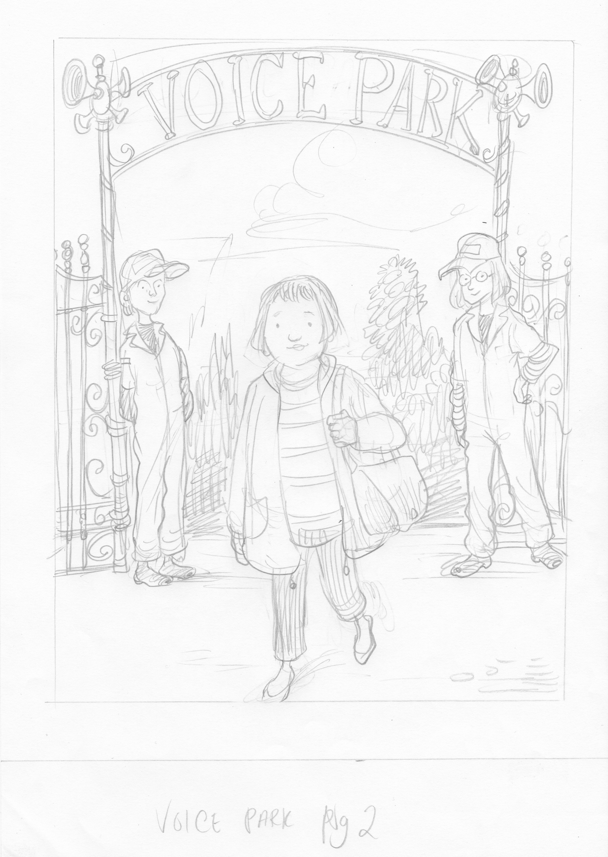

Three months later it was September, the end of a beautiful balmy day, and Agnes was enjoying a walk through Pickering Park. People passed by with dogs and children, some greeting each other as they passed, others with newspapers tucked under their arms looking for quiet places to read. In the distance, near the old paddling pool, Agnes caught the gentle glow of lights and heard the bubbling of voices and excitement.
She didn’t realise that this was the Park the man was telling her about at Walton Street Market, but she couldn’t help but be intrigued; it felt so warm and comforting, and the strange shapes seemed to call to her.
As she approached the bridge to see what was happening, two smiling people in those same beige overalls greeted her. She wanted to turn back, but before she knew it, she was walking past them and through the ornate gates of the Voice Park...

3.
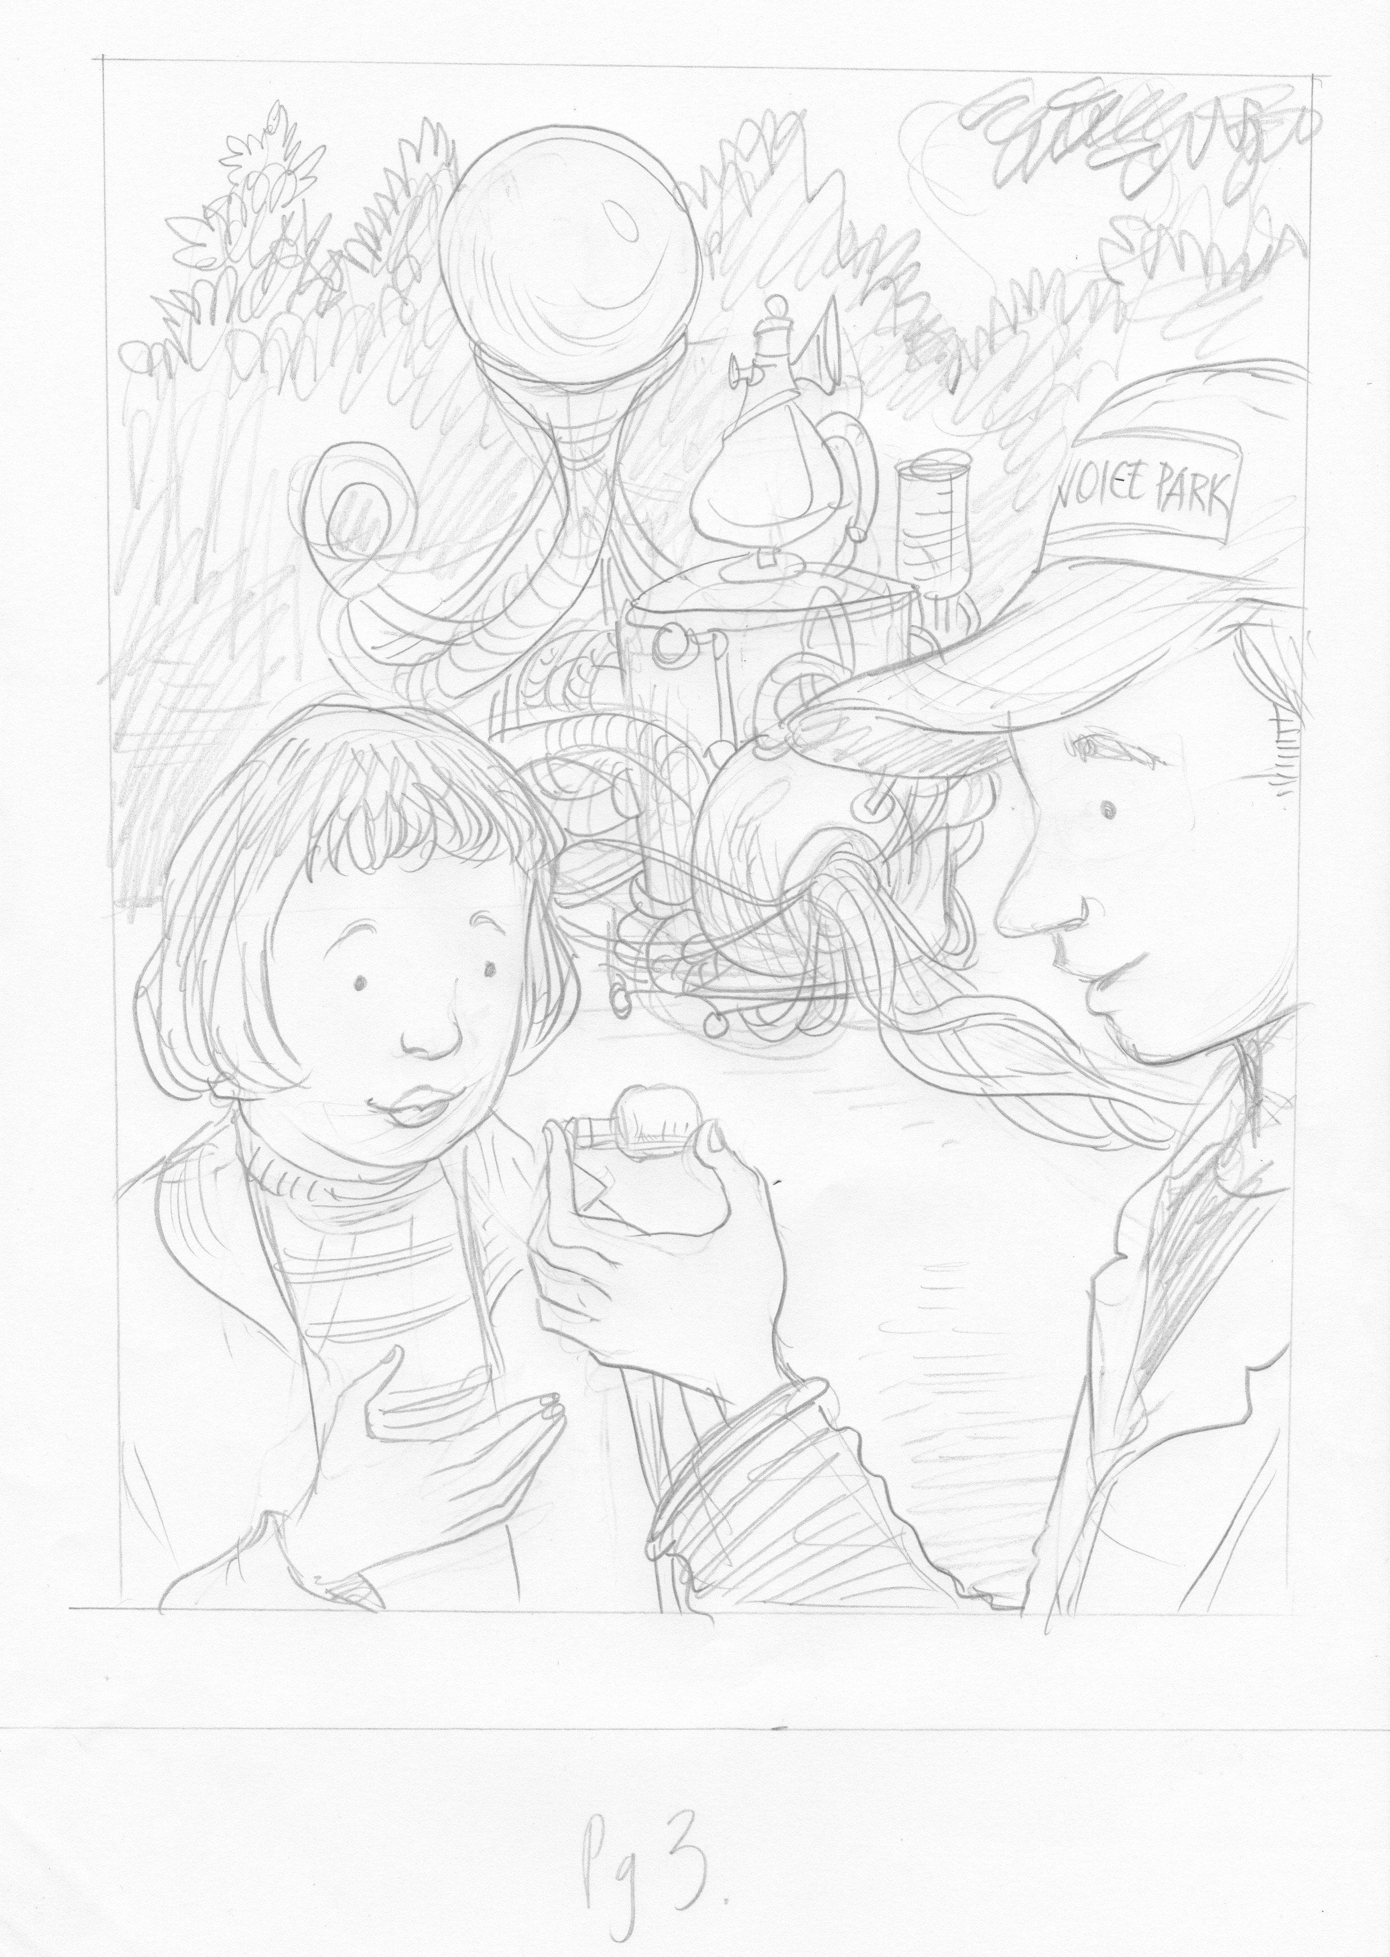
As day gave way to dusk, Agnes didn’t notice. She was enchanted with the sounds coming out of the strange shapes, listening and playing alongside people of all ages, from wide-eyed babies to curious older folk. Before she knew it she’d reached the end of the Park, and found herself in front of a strange-looking barbeque obscured by curls of steam. The man from Walton Street Market gently handed her a small glass tube.
‘This,’ he whispered reverently, ‘is the elixir. It’s made of the collective power of the voices of Hull, all distilled down to their most potent form.’
‘When you need the power of Hull’s voice behind you – a job interview perhaps, or when you’re bursting to say something that just won’t come out – rub it on your throat for the most powerful voice.’
Bemused, Agnes nodded and tucked the vial carefully into her handbag. When will I ever need such a thing? she wondered to herself. But deep inside her stomach that sensation had started up again, and this time it didn’t subside.

4.
For days afterwards, Agnes couldn’t shake the Voice Park off. Was her voice really part of it, so strong and sure? She never dreamed that she could be part of something like that.
She began to realise that, while she loved the dreams and adventures of her books, she also had a few of her own she wanted to live. She kept the vial on her dining table for a few weeks until one day, remembering the man’s words, she rubbed some on her throat and – well, that’s when things really started to happen.
Agnes now volunteers for all kinds of incredible, exciting things. From art exhibitions to huge concerts, she enjoys answering people’s questions, showing them where things are, and just talking. She hasn’t looked at her feet once, and her cheeks don’t flush whenever someone looks at her; in fact, she actually likes the sound of her voice. It’s loud, clear and confident.
Agnes carried on using the elixir for a little while, but she soon realised that she didn’t really need it. Her voice had been there all along - she just needed to find it.

V2.

How would you feel if someone wanted to take a piece of your voice? Bemused? Puzzled? Scared? If so, you wouldn’t be alone. That’s exactly how Agnes felt – and more – when she was asked this very question one Sunday morning in Walton Street Market.
She was happily browsing the books when a man in beige overalls and an unfathomable contraption on his back accosted her for a ‘voice donation’. He didn’t want to take no for an answer, and she felt her cheeks burn as he cracked jokes, trying to make her join in.
Eventually, just to get rid of him, she agreed. Pushing her face against the end of the strange machine, she managed a strangled ‘ahhh!’ which she was sure would be no use to anyone. She felt ridiculous, but the man seemed delighted.
Pressing a card into her hand, he told her about a Voice Park – a place where her sound would be heard. Agnes didn’t say anything, but placed it in her purse and watched him walk away, his machine clanking and puffing. A small flicker of excitement lit her stomach, then died.

Agnes had forgotten all about the man at the market and his Voice Park, until fate took her for a stroll through Pickering Park. It was the kind of September evening that made you itchy to be outside, so she’d brought a book with the hope of finding somewhere quiet to read, away from the distraction of others.
At first she couldn’t make out where the sounds were coming from. A group of young girls passed, craning their necks and talking loudly about the pretty lights in the old paddling pool. To Agnes it sounded like a delicious drone of music and noise, pulling her in further and further.
Before she knew it, she was standing on the bridge with two beaming beige-overalled people in front of her. She felt suddenly foolish, but they smiled so widely and welcomed her so generously, that she realised this was exactly where she was meant to be.
Remembering the card in her purse, she walked into the bustling Voice Park.

As Agnes’ eyes adjusted to the settling dark, she could see people of all ages standing, crouching, leaning into different types of machines. Sounds seemed to come from everywhere, different ‘ahhh’s’ and ‘oooh’s’ and vowel noises in so many pitches, from so many mouths.
For once, she didn’t feel silly or small. She experimented and inspected and listened and played. Moving across the Park she found herself in front of a smoking machine that looked like a barbeque, with the man from Walton Street Market sitting behind it.
‘This,’ he whispered, handing her a small glass bottle, ‘is the distilled power of Hull’s collective voice. Use it wisely, when you need the power of a big voice behind you. Just the smallest drop on your throat will do the trick.’
Bemused, Agnes tucked the vial into her back and smiled her thanks, stepping back into the night and leaving the sounds and lights of the Voice Park behind her.

The vial stayed in Agnes’ bag, but unlike the card, she didn’t forget it was there; quite the opposite, in fact.
The elixir seemed to call out to her. When she was paying for her shopping, or walking through the park in the hopes of finding the Voice Park again, she almost fancied she could feel it crackling with energy, willing her to open and use it.
And then one day, she did. Just the tiniest bit.
Now Agnes is a very different person from that Sunday in Walton Street Market. Her adventure involved becoming a volunteer, working on all kinds of exciting events and projects (usually ones that involve talking and organising and being clear and heard).
She still carries the vial in her bag as a reminder, and it’s still full. But now Agnes understands that it was never something she needed – she just had to ignite that spark in her stomach and never let it go out.

