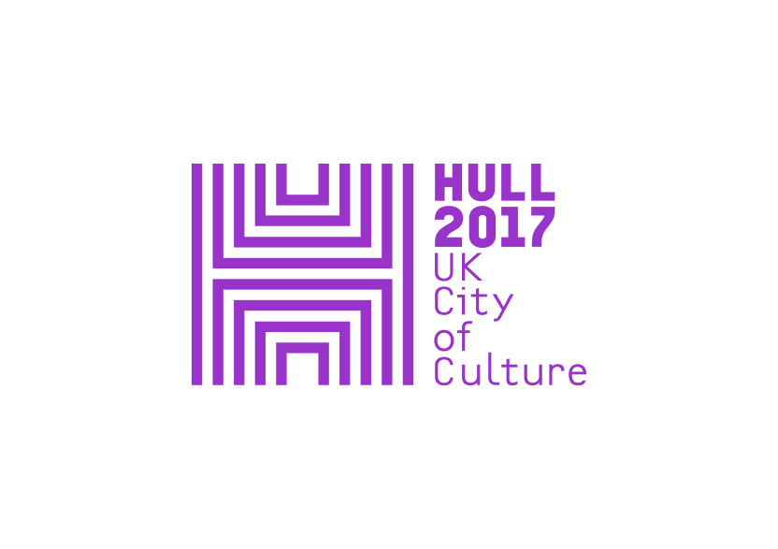

**PRESS RELEASE**

**Friday 7 April 2017**

**HULL UK CITY OF CULTURE 2017 presents**

**LOOK UP: *THE TRAIN TRACK AND THE BASKET***

**BY CLAIRE BARBER**

**7 April to 29 June, FREE, Hull Paragon Interchange/Railway Station**

**hull2017.co.uk/traintrack**

Between 1848 and 1914, more than two million people arrived into Hull by ship from mainland Europe, and left by train to the transatlantic ports of Liverpool and Southampton, seeking new lives in the New World. This mass movement of people, many of whom were in Hull for just a few hours, ended abruptly with the outbreak of the First World War.

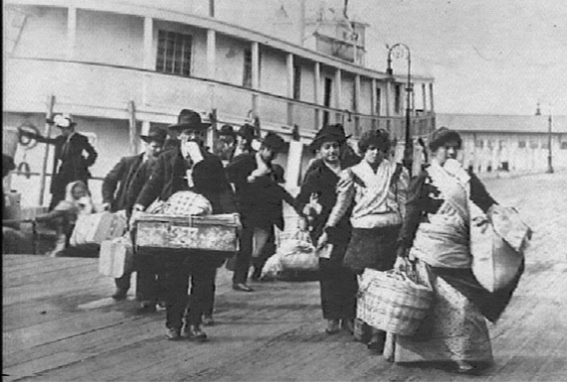

Claire Barber’s installation at Hull’s Paragon Interchange Station, *The Train Track and the Basket*, explores this example of transmigration and the notion that craft skills and belongings traverse routes of passage, alongside people. It is the latest work in the series of public art commissioned by Hull 2017 to make people look at and experience the city in new ways.

Claire said, “*My work is partly inspired by social narrative painting made at the time of transmigration, which captures loss, lament and excitement at a new beginning. Particularly the idea of looking at what people take with them on a journey, both as luggage and in terms of their culture and craft skill*.”

Many people passing through Hull used large woven baskets to carry their belongings on their journey and brought skills such as double cloth weaving, while absorbing the skills of others. They adapted their techniques to the materials available to them in a new country. There are a number of basket weaving patterns and skills in North America today that can be traced back to northern Europe

Hull's railway station today, with its constant movement of people, mirrors the weaving process: the action of double weaving, layers crossing over layers, countless patterns created every time people enter and exit. As individuals weave in and out, carrying luggage that reflects who they are, they too add and take new influences in an ever-changing space.

*The Train Track and the Basket* is made from digitally printed vinyl panels installed on each of the fourteen large arched windows within the entrance at Hull Paragon railway station.

“*I am very interested in communicating textile processes diagrammatically and their fusion with the sequential documentation of train tracks. I have taken multiple photographs while walking systematically along train platforms. These images are then joined together to be used like a fibre through the work. The ensuing woven abstraction allows people to linger in the space of transmigration rather than through the personal and private space of a displaced person*.”

The images on the windows also make reference to the materials that make the baskets, the plants and seeds that migrate along train tracks, and the final destination of the people who passed through the station during that time.

The work explores the creative conjunction of two seemingly disparate objects, the basket and the train track, to articulate a tangle of poetic metaphors relating to the period of transmigration through Hull 1836-1914.

Martin Green, Director of Hull 2017, comments: "*Claire Barber's work highlights the way that Hull has always been an international city, with connections around the world. And a place of passage it is also strongly linked to cities across the UK. As the conversations about the Northern Powerhouse develop and we embrace the idea of a cultural corridor across the north, The Train Track and the Basket also reminds us of the historic links between Hull and Liverpool."*

***Look Up*** is an ambitious year-long programme of temporary artworks commissioned by Hull UK City of Culture 2017, which responds to and reveals, in new and surprising ways, Hull’s remarkable architecture, streets and public spaces. It is curated by Andrew Knight and Hazel Colquhoun it .

To date ***Look Up*** has brought Nayan Kulkarni’s ***Blade***, which was temporarily installed in Queen Victoria Square, and Michael Pinsky’s ***The City Speaks*** which will remain in place on Hull’s Tidal Surge Barrier until the end of the year. Chris Dobrowlski’s ***Washed Up Car-go*** was recently installed at The Deep’s car park and will remain there until 4 June.

Further *Look Up* commissions will be popping up throughout 2017, in shopping centres, streets and other public spaces around Hull, by artists including Bob & Roberta Smith, Tania Kovats and Claire Morgan.

*Look Up* has been developed in partnership with a number of organisations and companies including The Deep, GF Smith, Hull School of Art & Design and Royal Institute of British Architects (RIBA). Details about future works in the programme will be announced in due course.

**-Ends-**

For press information, please contact:

Susie Gray or Clair Chamberlain at The Corner Shop PR

[susie@thecornershoppr.com](mailto:susie@thecornershoppr.com) /07834 073 795

[clair@thecornershoppr.com](mailto:clair@thecornershoppr.com) / 020 7831 7657

For general information about Hull UK City of Culture 2017, please contact;

Ben McKnight – [ben.mcknight@hull2017.co.uk](mailto:ben.mcknight@hull2017.co.uk) / 07718 100 793.

**Notes to Editors**

**Clare Barber**

Claire Barber joined the University of Huddersfield in 2009 and is currently Senior Lecturer in Textile Practice to support students specializing in a range of textile art and craft subjects.

Since graduating from Fine Art (Tapestry) at the Royal College of Art in 1994, Claire has pursued a peripatetic career exhibiting widely and completing over twenty artist-in residencies and commissioning models in the UK and across Eastern Europe, Australia and Japan. The practice, which has been broad ranging, has included temporary installations, interactive and socially engaged works as well as sculptural and architectural interventions.

Between 2010 and 2012, Claire worked with colleague Steve Swindells, at the former Snibston Discovery Museum, which led to the publication Mining Couture, published by Black Dog, 2012. This commission provided Claire with the opportunity to deepen her investigation into the relationship between fashion and mining that she had previously explored at gold mining ghost towns in western Australia while Visual Arts Fellow at Edith Cowan University, Australia (1998-99). Claire’s most recent textile-related artworks have been presented at ‘Repetition Variation’ exhibition curated by Joanna Bryant and Julian Page and presented at Frameless Gallery, London (2015);  ‘Da Vinci Engineered: From Renaissance mechanics to contemporary art’ exhibition curated by Lara Goodband and presented at  Zebedees Yard, Hull (2016) and ‘Contextile2016 Contemporary Textile Art Biennial’, Guimarães, Portugal. A further installation You Are the Journey (an embroidered intervention) forms part of the ‘Migrations’ exhibition curated by Jessica Hemmings and presented at Huddersfield Art Gallery (2016).

Claire and the writer and academic Penny Macbeth(Manchester Metropolitan University), are currently engaged in research towards a co-curated exhibition, with support of The Textile Society, Collaborative Ventures Funding (University of Huddersfield) and their curatorial mentor June Hill.

In 2016 Claire Barber received the degree of Doctor of Philosophy by Publication in recognition of a programme of work entitled Cloth in Action: The Transformative Power of Cloth in Communities.

**Hull UK City of Culture**

**Hull UK City of Culture 2017** is a 365 day programme of cultural events and creativity inspired by the city and told to the world. Hull secured the title of UK City of Culture 2017 in November 2013. It is only the second city to hold the title and the first in England.

**Divided into four seasons**, this nationally significant event draws on the distinctive spirit of the city and the artists, writers, directors, musicians, revolutionaries and thinkers that have made such a significant contribution to the development of art and ideas.

The Culture Company was set up to deliver the Hull 2017 programme and is an independent organisation with charitable status. It has raised £32 million, with over 60 partners supporting the project, including public bodies, lottery distributors, trusts and foundations and local and national businesses. Key contributions are coming from: **Host City** – Hull City Council; **Principal Partners** - Arts Council England, BBC, Big Lottery Fund, East Riding of Yorkshire Council, Heritage Lottery Fund, KCOM, KWL, Spirit of 2012, Yorkshire Water and the University of Hull; **Major Partners** –Associated British Ports, Arco, BP, the British Council, British Film Institute, Green Port Hull, Hull Clinical Commissioning Group, MKM Building Supplies, P&O Ferries, Paul Hamlyn Foundation, Sewell Group, Siemens, Smith & Nephew and Wykeland Group.

68 per cent of the funding is dedicated to public facing activities, including the widest range of cultural events in every corner of the city, with a further 11 per cent for legacy and contingency. More than £5 million is being invested in volunteering, learning and community engagement. £1.6 million is being invested to ensure a legacy after 2017. This includes capacity building, such as supporting existing events so they can grow, staging curtain-raiser events, developing future programming for after 2017 and building a new platform to support a unified ticketing system for the city.

Hull 2017’s International Partners are: Aarhus, Denmark, which is European Capital of Culture 2017; Reykjavik, Iceland; Rotterdam, The Netherlands; and Freetown, Sierra Leone (twinned with Hull). These relationships are reflected in a number of events throughout the year.

For information go to [www.hull2017.co.uk](http://www.hull2017.co.uk)

Follow us on **Twitter** @2017Hull **Instagram** @2017hull **Facebook** HullCityofCulture