**Store:Store Documents:Curated Place:New CP Logos:CP Logos:Curated Place Logo Sets:EPS/AI:Curated Place EVENT MANUAL.ai**

**John Grant’s North Atlantic Flux: Sounds from Smoky Bay**

Hull 2017 UK City of Culture

28th April – 1st May 2017

V. 20-04-2017.1

Submitted as DRAFT to SAM HUNT

Section 1 – Change History 3

Section 2 - Contents 3

Section 3 – Distribution List 4

Section 4 – Joint Statement of Intent 5

Section 5 – Health and Safety Policy 6

Section 6 - Background / Outline of Events 8

Section 7 - Roles and Responsibilities 9

Section 8 – Command and Control 11

Section 9 – Event Security 15

Section 10 – Communication 15

Section 11 – Traffic Management Plan 15

Section 12 – Medical and Welfare 15

Section 13 – Waste Management 15

Section 14 – Wayfinding 15

Section 15 – Staff Welfare 16

Section 16 – Programme 17

Section 17 – Schedule / Timeline 23

SECTION 18 - MOVEMENT ORDERS 35

# **Section 1 –** Change History

Complied by: Stephen C Nuttall & Andy Brydon (Curated Place)

|  |  |  |  |  |
| --- | --- | --- | --- | --- |
| **Version** | **Date** | **Author** | **Pages affected** | **Comments** |
| 1 | 12/4/17 | SCN | ALL |  |

# Section 2 - Contents

|  |  |
| --- | --- |
|  | Change History 1 |
|  | Contents 2 |
|  | Distribution List 3 |
|  | Joint Statement of Intent and Plan Sign Off 4 |
|  | Health and Safety Policy (Organisers / Contractors) 5 |
|  | Background / Outline of Events 7 |
|  | Roles and Responsibilities 8 |
|  | Command and Control 15 |
|  | Event Security and Stewarding 17 |
|  | Communications 19 |
|  | Traffic Management Plan 20 |
|  | Medical and Welfare 20 |
|  | Waste Management 20 |
|  | Signage 21 |
|  | Event Activities 21 |
|  | Staff Welfare Plan 21 |
|  | Contingency Planning 21 |
|  | Timeline 23 |
|  | Fire Arrangements 23 |
|  | Appendices 24 |

# **Section 3 –** Distribution List

|  |  |
| --- | --- |
| **CURATED PLACE** | |
| Andy Brydon (AB) | Director |
| Chris Carney (CC) | Lead Production Manager |
| Susan Wareham (SA) | Production Manager |
| Hannah Ayre (HA) | Production Manager |
| Stephen C. Nuttall (SCN) | Production Manager |
| Lianray Pieenar (LP) | Production Team |
| Emilia Eriksson (EE) | Production Team |
| Agusta Thorarinsdottir (AT) | Accommodation & Transport Manager |
| **HULL CITY OF CULTURE** | |
| Aidan Lesser (AL) | Production Manager |
| Liam Rich (LR) | Producer |
| Sam Hunt (SH) | Executive Producer |
| **HPSS** | |
| Iain Firth (IF) | Technical Manager |
| Graham Roberts (GR) | Technical Manager |
| **VENUES** | |
| Tony Evans | Technical Manager (Hull City Hall) |
| Andrew Stephens | Manager (Jubilee Church) |
| Rob Fletcher | Manager (Gate No.5) |
| Joe Hubbard | Manager (Fruit) |

# **Section 4 –** Joint Statement of Intent

The aim of this **Joint Statement of Intent** is to ensure that a co-ordinated approach has been undertaken for the planning and delivery of this event. All organisations and agencies involved in the delivery of this event agree that all measures to be taken are considered reasonable in respect of ensuring the safety of those attending the event.

The Event Organiser will put in place the necessary arrangements and set up appropriate systems and procedures to manage and deliver the event. This will involve the fullest discussions and input from all his/her partner agencies and organisations.

Every care has been taken to reduce risk, increase safety and set up rigorous and robust procedures to ensure a safe environment for all participants and spectators alike.

The following representatives of the organisations and agencies involved in the planning of the event agree with the above noted measures and acknowledge that all reasonable steps have been taken to ensure a safe environment for all participants and spectators alike.

|  |  |  |  |
| --- | --- | --- | --- |
| **Agency** | **Name** | **Date** | **Signature** |
| Hull UK City of Culture 2017 Event Commissioner | Liam Rich |  |  |
| Contractor / CP | Andy Brydon |  |  |
| Lead Production Manager / CP | Chris Carney |  |  |
| Police | TBC |  |  |
| Fire & Rescue Service | TBC |  |  |
| Hull City Hall | Tony Evans |  |  |
| Jubilee Church | Andrew Stephens |  |  |
| Gate No.5 | Rob Fletcher |  |  |
| Fruit | Joe Hubbard |  |  |

# **Section 5 –** Health and Safety Policy

It is the policy of the Event Organiser to provide and maintain safe systems of work, including safe premises and equipment, and ensure that all reasonable steps are taken to remove hazards at the event, and to safeguard the health and safety of employees and the public in so far as they may be affected by the Event Organiser’s authorised activities.

The Event Organiser recognises his/her responsibility to ensure, as far as is reasonably practicable, the health and safety of all their employees and any third parties involved, whether contractors or members of the public.

The Event Organiser will provide such information, instruction, training and supervision as is necessary to ensure, so far as is reasonably practicable, the health and safety at work of their employees and others affected by their undertakings and will publish detailed rules and regulations for particular activities where necessary.

* John Grant’s North Atlantic Flux – Sounds from Smoky Bay is commissioned by Hull 2017 UK City of Culture and delivered by Curated Place. Risk Assessments have been carried out by the responsible personnel for all events are within the appendices.
* Curated Place have complied with all health and safety requirements of the venues that are being used for the festival.
* Public Liability Insurance of the production of the festival is held by Curated Place.

Health & Safety Responsibilities

Event Organiser

The Event Organiser is responsible for ensuring, so far is as reasonably practicable, the health and safety of all their employees, contractors and members of the public and for the creation and maintenance of a positive health and safety culture at the event. He will ensure that risks are assessed and that an event safety plan is created. In particular the Event Organiser will satisfy himself that any contractors engaged to provide services or contribute to the event will have a written health and safety policy, have carried out risk assessments relative to the event and have completed a method statement.

Site Owners

Hull City Hall, Jubilee Church, Gate No.5 and Fruit owns and occupies the site of the event. They are in control of the sites and need to ensure that the venue is safe and without risk to anyone who uses the site.

Duty of care is also owed under HASAWA 1974 Sections 3 & 4 to anybody affected by the employer’s undertaking including persons that are not invited or in this case cannot be classed as attendees. Therefore they must be safe even if they have no knowledge or intention to comply with rules & regulations in place for safety. Design, Information and Management should take this into account.

Employees

All employees are required to comply with and abide by Part 1 Sections 7 and 8 of the Health and Safety at Work Act.

Contractors

Persons supplying services, infrastructure or equipment for an event are responsible for the health, safety and welfare of their staff and members of the public within the confines of their allocated area or those effected by their work activity. They will provide to the Event Organiser:

A. A copy of their health and safety policy.

B. Copies of risk assessments relating to the provision of the service, infrastructure or equipment.

C. Method statements relating to their work.

D. A copy of their appropriate liability insurance(s).

Management of Health and Safety

Health and safety systems and procedures for this event will ensure the assessment of risk and the effective planning, organisation, control, monitoring and review of preventative measures to eliminate or control the risks. Details of these will be contained in an event/safety manual created for this event. Generic risk assessments will be attached as appendices to this policy and will provide a basis for these matters in the event/safety manual.

Safety Advice

The Event Organiser and Site Managers will be advised on health and safety matters by a representative of each venue who will provide competent advice in respect of employees within the meaning of the Management of Health and Safety at Work Regulations 1999.

Accidents and Incidents

A system for the reporting of accidents / incidents is in operation within the venues arrangements and it is the duty of every employee to report all accidents and incidents. Accidents and incidents within the confines of contractors allocated areas will be reported under their own arrangements with copies of details given to the organiser.

This policy will be brought to the attention of all employees and will be reviewed / amended as necessary.

# **Section 6 -** Background / Outline of Events

Name - John Grant’s North Atlantic Flux – Sounds from Smoky Bay

Date - Friday 28th April to Monday 1st May 2017

Venues - Hull City Hall, Jubilee Church, Gate No.5, Fruit, Mortimer Suite, Queens Hall

Project Narrative

To celebrate Hull’s Nordic links, singer-songwriter John Grant has invited a glorious line-up of artists to the city to create a small, boutique festival with an exciting music programme offering an intimate experience for a limited audience of only 1,500 people. The four-day festival will explore audio adventures, surprise collaborations, and remarkable sound experiments unlike anything else the city has seen before.

The most exciting and innovative musicians from Scandinavia and Iceland are heading to the UK for a four-day live music festival like no other.

Critically acclaimed singer-songwriter John Grant gathers some of today’s most exciting musicians, including GusGus, Susanne Sundfør, Lindstrøm, Sóley, Sykur, Prins Póló, Nordic Affect, Ragga Gisla, Fufanu, Ghostigital and more for one of the most thrilling events of the year.

Produced by innovative arts organisation Curated Place this unmissable showcase of Nordic talent features surprise collaborations and remarkable sound experiments alongside an exclusive live set by John Grant himself.

Website - <https://www.hull2017.co.uk/whatson/events/john-grants-north-atlantic-flux-sounds-from-smoky-bay/>

# **Section 7 -** Roles and Responsibilities

**During the event the main contacts to the event organisers will be**

**Andy Brydon +44 7774 115 647 and Chris Carney +44 7743 432 129**

The Client

The client is Hull 2017 UK City of Culture. The team will work directly with the contractor to deliver the display within the aims, content, budget and resources for the event, delivering the following remit: -

* Oversee and co-ordinate the planning and delivery of John Grant’s North Atlantic Flux – Sounds from Smoky Bay.
* Co-ordinate communication between partners.
* Promote the Event through Hull 2017 UK City of Culture Marketing communicating content and timings through a number of channels.

The Contracted Event Organiser

The contracted event organiser is Curated Place who have been commissioned by Hull 2017 UK City of Culture to deliver John Grant’s North Atlantic Flux – Sounds from Smoky Bay, ensure there is an adequate communication system in place to manage the event, ensure adequate first aid cover for the event including build and derig, manage the event sites during the three phases of the event (build, live & derig), maintain overall responsibility for the strategic and operational management of the event. CP’s remit includes: -

* Co-ordinate the installation and derig of all presentations.
* Manage the enforcement for all health & safety issues.
* Maintain Event Manual and correlate risk assessment materials.
* Assess and manage crowd management at event location, ensuring suitable first aid and medical provision.
* Providing a risk assessment for all activity.
* Provide Public Liability insurance certificate.
* Apply for and implement all necessary traffic management regulations and temporary signage relevant to the programme.
* Negotiate with venue owners for use of sites.

Security Stewarding

Due to the nature of the activity specialist crowd control stewarding will be required. Specialized Security have been appointed based on their previous experience of delivering crowd management and security to similar events. Event Security to provide security and stewarding on the following basis -

* Ensure an adequate communication network is in place for the staff deployed
* Ensure staff are adequately trained and provided with the appropriate PPE
* Co-ordinate stewards to manage the event as detailed herein
* Record all incidents, accidents and communications in a log for the Site Manager.
* Protect public safety
* Provide information to the public
* Provide intelligence to the Site Manager
* Monitor crowd capacities
* Manage crowd flow and react to pinch points, as required

Police

The normal role and responsibilities of the Police encompass the protection of life and property. Police will assess the event and provide the officer cover it deems necessary for the event.

Site Managers

Venue management has overall responsibility for the festival venues. CP’s Site Managers have responsibility for the creative management and staffing of Hull City Hall, Jubilee Church, Fruit & Gate No.5. The event organiser will communicate with the venues management to ensure:

* Site Managers will inform staff of the full timetable of events and schedules.
* Site Managers will assess and agree any restrictions relating to the presentation.
* Site Managers will work alongside venue staff to ensure RAMS are followed by all on site contractors, artists, production staff, venue staff, Hull 2017 staff and volunteers.
* Site Managers will work alongside Security Stewarding and venue management to agree public access times and open and lock up event sites.
* Site Managers will monitor and feedback on any issues during the installation period.
* Site Managers will manage the event sites for the duration of the install, live event and derig.

Volunteers

Volunteers have been recruited through Hull 2017 UK Capital of Culture. They will assist Curated Place in delivering the event and will have varying duties over the festival.

First Aid

* Risk assess the event and determine adequate first aid cover
* Provide supervisor / manager, who will maintain radio contact with the Event Manager, roaming first aiders and a first aid post to treat casualties
* Ensure an adequate communication plan is in place for their operation
* Provide first aid treatment, as required
* Operate within own policy, procedure and training
* Provide the Event Manager with a summary of incidents after the event

Contractors / Performers / Suppliers

* Ensure works are risk assessed and carried out as per procedures, risk assessment and health and safety policy
* Adhere, at a minimum, to health and safety regulations or guidance, as relevant
* Ensure staff are adequately trained, briefed and equipped to carry out the works
* Provide evidence of Public Liability, Risk Assessments for works and Health and Safety Policy to the Event Manager

|  |
| --- |
| Section 8 – Command and Control |

Production Office:

Curated Place Production office will be situated in Jubilee Church. CP crew will command and control the event from this site from Thursday 27th of April to 2nd of May 2017.

A radio control centre will log all incidents and notable events including security and first aid. All Curated Place crew will be on walkie talkies along with SIA security, First Aiders and Hull 2017 production as per the radio comms diagram.

Hull City Hall

Curated Place Crew along with HPSS will be setting up in this Venue from 6AM Friday 28th of April

* Event start time/end times: 18.30-23.00 Friday, 16.00-23.00 Saturday, 13.30-22.30 Sunday
* Access to building is over 3 days
* Artist Sound Checks will be conducted from 12.00 each day
* De-rig will be on the Monday 8.00 – 17.00 by Curated Place Crew and HPSS
* Radio Protocol should be followed (see attached method statement)
* Suspension / re-start or cancellation of the Event will be managed by repeated announcements and word of mouth by the event organisers staff and volunteers and assisting the media team in getting the message out to the public (See the RAMS evacuation plan).
* The cancellation of the activity will be managed by on the ground by Curated Place contacting their helpers with PR and messaging controlled by the Hull City 2017 media team.
* Emergency Vehicle access will be as per venue RAMS.
* The Information and Rendezvous Point will be at the Production Office in Jubilee Church. This will be where the first aiders, Event Organiser and Lost and found point will be based.
* The Casuality Clearing Station will be as per venue RAMS
* Ambulance Loading Point will be as per venue RAMS
* Evacuation Cluster Point will be at the Maritime Museum opposite the front entrance of the City Hall

Jubilee Church/Queens Hall

Curated Place Crew along with HPSS will be setting up in this Venue from TBC Thursday 27th of April

* Event start time/end times: 19.00 – 21.00 Friday, 11.00 – 22.30 Saturday, 15.00 – 19.00 Sunday, 13.30 – 18.00 Monday
* Access to building over 5 days
* Artist Sound Checks will be conducted from 12.00 each day but with BBC Late Junction on site from 8.00 on the Saturday and John Grant’s rehearsal from 9.00 Sunday
* De-rig Tuesday 2nd of May 8.00 – 17.00
* Suspension / re-start or cancellation of the Event will be managed by repeated announcements and word of mouth by the event organisers staff and volunteers and assisting the media team in getting the message out to the public (See the RAMS evacuation plan).
* The cancellation of the activity will be managed by on the ground by Curated Place contacting their helpers with PR and messaging controlled by the Hull City 2017 media team.
* Emergency Vehicle access will be as per venue RAMS.
* The Information and Rendezvous Point will be at the Production Office in Jubilee Church. This will be where the first aiders, Event Organiser and Lost and found point will be based.
* The Casuality Clearing Station will be as per venue RAMS
* Ambulance Loading Point will be as per venue RAMS
* Evacuation Cluster Point will be at the Maritime Museum opposite the front entrance of the City Hall

Mortimer Suite

Curated Place Crew will be setting up in this Venue Friday 28th of April from 9.00 – 17.00

* Event start time/end times: 11.00 – 23.00 Saturday, 11.00 – 23.00 Sunday
* Access to building over 3 days
* Durational exhibition
* De-rig will be on the Monday 8.00 – 17.00 by Curated Place Crew and artist
* Suspension / re-start or cancellation of the Event will be managed by repeated announcements and word of mouth by the event organisers staff and volunteers and assisting the media team in getting the message out to the public (See the RAMS evacuation plan).
* The cancellation of the activity will be managed by on the ground by Curated Place contacting their helpers with PR and messaging controlled by the Hull City 2017 media team.
* Emergency Vehicle access will be as per venue RAMS.
* The Information and Rendezvous Point will be at the Production Office in Jubilee Church. This will be where the first aiders, Event Organiser and Lost and found point will be based.
* The Casuality Clearing Station will be as per venue RAMS
* Ambulance Loading Point will be as per venue RAMS
* Evacuation Cluster Point will be at the Maritime Museum opposite the front entrance of the City Hall

Gate No. 5

Curated Place crew along with HPSS will be setting up at this Venue on Thursday 27th of April from 9.00 – 17.00

* Event start time/end time: 21.00 – 03.00 Friday, 22.00 – 03.00 Saturday, 22.00 – 03.00 Sunday
* Access to building over 4 days
* De-rig Monday 1st of May 9.00 – 17.00
* Suspension / re-start or cancellation of the Event will be managed by repeated announcements and word of mouth by the event organisers staff and volunteers and assisting the media team in getting the message out to the public (See the RAMS evacuation plan).
* The cancellation of the activity will be managed by on the ground by Curated Place contacting their helpers with PR and messaging controlled by the Hull City 2017 media team.
* Emergency Vehicle access will be as per venue RAMS.
* The Information and Rendezvous Point will be at the Production Office in Jubilee Church. This will be where the first aiders, Event Organiser and Lost and found point will be based.
* The Casuality Clearing Station will be as per venue RAMS
* Ambulance Loading Point will be as per venue RAMS
* Evacuation Cluster Point will be in the venue car park behind Gate 5

Fruit

Curated Place Crew along with HPSS will be setting up at this Venue Monday 1st of May from 11.00

* Event start time/end time: 13.00 – 19.00 Monday only
* Access to the building on the Monday only
* De-rig Monday night from 19.00
* Suspension / re-start or cancellation of the Event will be managed by repeated announcements and word of mouth by the event organisers staff and volunteers and assisting the media team in getting the message out to the public (See the RAMS evacuation plan).
* The cancellation of the activity will be managed by on the ground by Curated Place contacting their helpers with PR and messaging controlled by the Hull City 2017 media team.
* Emergency Vehicle access will be as per venue RAMS.
* The Information and Rendezvous Point will be at the Production Office in Jubilee Church. This will be where the first aiders, Event Organiser and Lost and found point will be based.
* The Casuality Clearing Station will be as per venue RAMS
* Ambulance Loading Point will be as per venue RAMS
* Evacuation Cluster Point will be on Humber Street outside the Humber Street Gallery

**Suspicious packages/vehicles**

* Stewards must remain vigilant as regards the possibility of the discovery of suspect packages or vehicles and should make a cursory check of their area of responsibility when they patrol the site.
* Upon the discovery of any suspicious package, it must not be touched or moved. Members of the public should be kept back a minimum distance of 25 metres. Event Control should be contacted immediately who will alert the Police in order to advice on the appropriate next step and if evacuation must proceed.

**Suspension**

* Suspension / re-start or cancellation of the Event will be managed by repeated announcements by PA and word of mouth by the event organisers staff and volunteers.
* In the event of a major incident, other incident or crime which has or is likely to have a significant impact on the event, The Police will advice on the required response and take such action as is considered necessary.
* Emergency Evacuation plans are as per venue RAMS, the Stewards and Volunteers would be advised by Hull City Council and CP on which exit/s to guide the public out of. The event organiser would co-ordinate the response and to deal with consequences of this evacuation (Police, medical, security and fire). On the launch evening a PA will be on site. At other times megaphones will be on site to make further announcements.
* Any decision to suspend or cancel the event is the responsibility of Liam Rich, who will also consult with relevant parties before making the decision. In order to communicate and disseminate information about a potential cancellation, the latest time to make the decision is **Noon on 28th of April**
* The cancellation of the activity will be managed by using the Hull 2017 press team and Corporate communication and by CP contacting their helpers and assisting the media team in getting the message out to the public. Event stewards, staff and volunteers will speak with the public to pass on all appropriate information. Information would be circulated to through the participating venues who will all have a PA system installed.

|  |
| --- |
| Section 9 – Event Security |

Event Security is provided by each venue except Jubilee Church Hall.

*Jubilee Church Hall security is Hull2017’s preferred supplier of SIA staffing.*

|  |
| --- |
| Section 10 – Communication |

* Curated Place will hire walkies for crew communication (30)
* Venue security crew chiefs will be allocated radios to communicate with venue managers and control.
* Additional communications between staff will be either through mobile phone or verbal.
* A list of mobile phone contact numbers is contained in the call sheet.
* Pre Event publicity for the event includes website, social and online media, poster distribution, phone App, press, Multi Agency publicity approach and ‘word of mouth’.

|  |
| --- |
| Section 11 – Traffic Management Plan |

* There is no TTRO in place for this event outside of venue deliveries

|  |
| --- |
| Section 12 – Medical and Welfare |

* 2 First aiders are provided by City Hall for the daytime events.
* These will be on radio to ensure coverage of the entire programme.
* If additional assistance is required CP/Hull2017 will contact the Emergency services
* Welfare facilities are provided by the venues
* Lost persons will be dealt with by verbal communication and said person escorted to the information and rendezvous point. In any incident that can not be managed by the assistants on site, or the appropriate time has passed then the police will be contacted.
  + A log book of incidents will be present on site during the launch day to ensure proper procedures are followed.

|  |
| --- |
| Section 13 – Waste Management |

* The event will use the existing bin provision within venues

|  |
| --- |
| Section 14 – Wayfinding |

* + Signage will be provided by Hull2017
  + Hull2017 volunteers will provide wayfinding between venues
  + The programme (as correct at 20-04-2017) is attached as appendices

|  |
| --- |
| Section 15 – Staff Welfare |

* Jubilee Church will be accessible for staff from 8am daily until close of main venues.
* The production office can provide secure storage of personal goods.
* Toilets will be provided by the venues.
* Welfare breaks will be for as and when required.

|  |
| --- |
| Section 16 – Programme |

|  |  |  |  |  |  |  |
| --- | --- | --- | --- | --- | --- | --- |
|  |  |  |  |  |  |  |
|  |  |  |  |  |  |  |
| **Friday 28/04** | **City Hall** | **Mortimer Suite** | **Jubilee Chuch** | **Queens Hall** | **Gate No.5** | **Fruit** |
| **18.30-19.00** | **Doors** | **Doors** | **Doors** | **Doors** |  | **Doors** |
| **19.00-19.30** |  | **Jez Riley-French** | **Tonik Ensemble** | **AIA** |  |  |
| **19.30-20.00** | **Mt. Wolf** |  |  |  |  |
| **20.00-20.30** | **Susanne Sundfør** | **Sleepy Folk** |  |  |
| **20.30-21.00** |  |  |  |  |
| **21.00-21.30** | **GusGus** | **Curfew** |  |  |  |
| **21.30-22.00** |  |  | **Doors** |  |
| **22.00-22.30** |  |  |  | **Sweaty Records Presents: Kosmodod, Volruptus, ThizOne** |  |
| **22.30-23.00** | **Curfew** | **Curfew** |  |  |  |  |
| **23.00-23.30** |  |  |  |  |  |  |
| **23.30-00.00** |  |  |  |  |  |  |
| **00.00-00.30** |  |  |  |  |  |  |
| **00.30-01.00** |  |  |  |  |  | **Curfew** |
| **01.00-01.30** |  |  |  |  |  |  |
| **01.30-02.00** |  |  |  |  |  |  |
| **02.00-02.30** |  |  |  |  |  |  |
| **02.30-03.00** |  |  |  |  | **Curfew** |  |
|  |  |  |  |  |  |  |
|  |  |  |  |  |  |  |
|  |  |  |  |  |  |  |
| **Saturday 29/04** | **City Hall** | **Mortimer Suite** | **Jubilee Chuch** | **Queens Hall** | **Gate No.5** | **Fruit** |
| **10.00-10.30** |  |  |  |  |  |  |
| **10.30-11.00** |  |  |  | **Rehearsal** |  |  |
| **11.00-11.30** |  | **Doors** |  | **Space** |  |  |
| **11.30-12.00** |  | **Jez Riley-French** | **Doors** | **for Halldor** |  |  |
| **12.00-12.30** |  | **BBC3 Late Junction SET UP 08:00 - 14:00** | **& Symphonia UK Collective** |  |  |
| **12.30-13.00** |  |  | **AND** |  |  |
| **13.00-13.30** |  |  | **Eyvind &** |  |  |
| **13.30-14.00** |  |  | **RNCM.** |  |  |
| **14.00-14.30** |  | **BBC3 Late Junction 14:00 - 18:00** |  | **Mt** |  |
| **14.30-15.00** |  | **& Blatnova** |  |  |
| **15.00-15.30** |  |  |  |  |
| **15.30-16.00** |  |  |  |  |
| **16.00-16.30** | **TBC** |  |  |  |
| **16.30-17.00** |  |  |  |  |
| **17.00-17.30** | **Nányë** |  |  |  |
| **17.30-18.00** |  |  |  |
| **18.00-18.30** |  |  |  |  |  |
| **18.30-19.00** |  |  | **Halldór Smárason with Adelle Stripe & Sinfonia UK** |  |  |
| **19.00-19.30** | **Prins Póló** | **Ragga Gisla** |  |  |  |
| **19.30-20.00** |  |  |  |
| **20.00-20.30** | **Wrangler DJ Set** |  | Eyvind Gulbrandsen & The Royal Northern College of Music |  |  |
| **20.30-21.00** | **Nordic Affect** |  |  |  |
| **21.00-21.30** | **Blatnova** |  |  |
| **21.30-22.00** | **Steve Cobby & Russ Litten** |  |  |
| **22.00-22.30** | **Lindstrøm 21.45-23.00** | **Curfew** | **Doors** |  |
| **22.30-23.00** | **Curfew** |  | **NAFter Party with Luke Eargoggle & Actress DJ** |  |
| **23.00-23.30** | **Curfew** | **Curfew** |  |  |  |
| **23.30-00.00** |  |  |  |  |  |
| **00.00-00.30** |  |  |  |  |  |
| **00.30-01.00** |  |  |  |  |  |
| **01.00-01.30** |  |  |  |  |  |
| **01.30-02.00** |  |  |  |  |  |
| **02.00-02.30** |  |  |  |  |  |
| **02.30-03.00** |  |  |  |  | **Curfew** |  |
|  |  |  |  |  |  |  |
|  |  |  |  |  |  |  |
|  |  |  |  |  |  |  |
| **Sunday 30/04** | **City Hall** | **Mortimer Suite** | **Jubilee Chuch** | **Queens Hall** | **Gate No.5** | **Fruit** |
| **10.00-10.30** |  |  |  | **John Grant Rehearsal (8am-12noon)** |  |  |
| **10.30-11.00** |  |  |  |
| **11.00-11.30** |  | **Doors** |  |
| **11.30-12.00** |  | **Jez Riley-French** |  |
| **12.00-12.30** |  |  |  |
| **12.30-13.00** |  |  |  |
| **13.00-13.30** |  |  |  |
| **13.30-14.00** | **Doors** |  |  |
| **14.00-14.30** | **Jobina Tinnemans & Jakob Tekeila with Hull Choir** |  |  |  |
| **14.30-15.00** |  |  | **Doors** |  |
| **15.00-15.30** |  | **Tom Kay** |  |  |
| **15.30-16.00** |  | **Eva-lina** |  |
| **16.00-16.30** |  |  |  |
| **16.30-17.00** |  | **Nils Bech** |  |  |
| **17.00-17.30** |  | **Equis** |  |
| **17.30-18.00** |  |  |  |
| **18.00-18.30** |  | **Satellites** |  |  |
| **18.30-19.00** | **Ghostigital** |  |  |
| **19.00-19.30** | **Curfew** | **Pinquins** |  |
| **19.30-20.00** |  |  |  |
| **20.00-20.30** | **Sóley** |  | **Curfew** |  |
| **20.30-21.00** |  |  |  |
| **21.00-21.30** |  |  |  |  |
| **21.30-22.00** | **John Grant** |  |  |  |
| **22.00-22.30** |  |  | **Doors** |
| **22.30-23.00** | **Curfew** | **Curfew** |  |  | **John Grant After-Party with Wrangler Live & James Orvis** |
| **23.00-23.30** |  |  |  |  |
| **23.30-00.00** |  |  |  |  |
| **00.00-00.30** |  |  |  |  |
| **00.30-01.00** |  |  |  |  |
| **01.00-01.30** |  |  |  |  |
| **01.30-02.00** |  |  |  |  |
| **02.00-02.30** |  |  |  |  |
| **02.30-03.00** |  |  |  |  | **Curfew** |
|  |  |  |  |  |  |  |
|  |  |  |  |  |  |  |
|  |  |  |  |  |  |  |
| **Monday 01/05** | **City Hall** | **Mortimer Suite** | **Jubilee Chuch** | **Queens Hall** | **Gate No.5** | **Fruit** |
| **10.00-10.30** |  | |  |  |  |  |
| **10.30-11.00** |  |  |  |
| **11.00-11.30** |  |  |  |
| **11.30-12.00** |  |  |  |
| **12.00-12.30** |  |  |  |
| **12.30-13.00** |  |  | **Doors** |
| **13.00-13.30** |  |  | **X-Ray Katt (Mixnots)** |
| **13.30-14.00** | **Doors** | **Doors** |
| **14.00-14.30** | **Science of the Lamps** | **Sebastian Edin** |  |
| **14.30-15.00** |
| **15.00-15.30** |  |  |  |
| **15.30-16.00** | **Fufanu** | **Tronhjem** |  |
| **16.00-16.30** | **Rosyan** |
| **16.30-17.00** |  |  |
| **17.00-17.30** | **Mugison** | **Alex Mørch** |  |
| **17.30-18.00** | **Sykur** |
| **18.00-18.30** | **Curfew** | **Curfew** |
| **18.30-19.00** |  |  | **Curfew** |
| **19.00-19.30** |  |  |  |
| **19.30-20.00** |  |  |  |
| **20.00-20.30** |  |  |  |
| **20.30-21.00** |  |  |  |

# Section 17 – Schedule / Timeline

 

John Grant’s North Atlantic Flux: Sounds from Smoky Bay

- CALL SHEET -

|  |  |  |  |  |  |  |
| --- | --- | --- | --- | --- | --- | --- |
| Production Company:  Client: | |  | | | Curated Place.  Hull 2017- UK City of Culture |  |
| Project:  Dates: | |  | | | John Grant’s North Atlantic Flux  Live Event: 28/04/17 – 01/05/17. |  |
| Curated Place –  Director:  Andy Brydon (AB)  [andy@curatedplace.com](mailto:andy@curatedplace.com)  +44 7774 115647  Lead Production Manager:  Chris Carney (CC)  [chris@curatedplace.com](mailto:hannah@curatedplace.com)  +44 7743 432129  Accommodation & Transport Manager:  Agusta Thorarinsdottir (AT)  [agusta@curatedplace.com](mailto:agusta@curatedplace.com)  +44 7737 790271  Production Manager:  Stephen C. Nuttall (SCN)  [stephen@curatedplace.com](mailto:stephen.nuttall.illustration@gmail.com)  +44 7966 662978  Production Manager:  Susan Wareham (SW)  [susan@curatedplace.com](mailto:susan@curatedplace.com)  +44 7814 883524  Production Team:  Lianray Pienaar (LP)  [lianray.pienaar@gmail.com](mailto:lianray.pienaar@gmail.com)  +44 7576 400001  Production Team:  Hannah Arye (HA)  [hannah@curatedplace.com](mailto:hannah@curatedplace.com)  +44 7981 687280  Production Team:  Emilia Eriksson (EE)  [emskthreshold@gmail.com](mailto:emskthreshold@gmail.com)  +44 7807 107411  Hull 2017: UK City of Culture –  Production Manager  Aidan Lesser (AL)  [aidan.lesser@hull2017.co.uk](mailto:aidan.lesser@hull2017.co.uk)  +44 7828 926751  Producer  Liam Rich (LR)  [liam.rich@hull2017.co.uk](mailto:liam.rich@hull2017.co.uk)  +44 7957 193195  Executive Producer  Sam Hunt (SH)  [sam.hunt@hull2017.co.uk](mailto:sam.hunt@hull2017.co.uk)  +44 7713 094461  Accommodation Agent  Liz Neal (LN)  [liz.neal@vhey.co.uk](mailto:liz.neal@vhey.co.uk)  01482 391535    HPSS Ltd  Unit 3 Quayside Business Park  West 1  West Dock Street  Hull, HU3 4HH  Main Contact  Iain Firth (IF)  [iain@hpss.co.uk](mailto:iain@hpss.co.uk)  +44 7976 872741  Contact  Graham Roberts (GB)  [graham@hpss.co.uk](mailto:graham@hpss.co.uk)  Contact  Dave Mitchell (DM)  [dave@hpss.co.uk](mailto:dave@hpss.co.uk)  ALL OTHER HPSS STAFF WORKING ON THE FESTIVAL WILL BE SHOWN AS ‘HPSS’. | |  | | | Venue One (V1)  Hull City Hall  Queen Victoria Square  Carr Lane  HU1 3RQ  Main Contact: Tony Evans (Technical Manager)  Email: [tony.evans@hcandl.co.uk](mailto:tony.evans@hcandl.co.uk)  Phone: 01482 612858  Contact: Richard Mobbs (Stage Manager)  Email: [richard.mobbs@hcandl.co.uk](mailto:richard.mobbs@hcandl.co.uk)  Phone: 01482 612969  Contact: Claire Balfour (Head of Programming)  Email: [claire.balfour@hcandl.co.uk](mailto:claire.balfour@hcandl.co.uk)  Phone: 01482 614311  Venue Two (V2)  Mortimer Suite  Hull City Hall  Queen Victoria Square  Carr Lane  HU1 3RQ  SEE HULL CITY HALL CONTACTS.  Venue Three (V3)  Jubilee Church  62 King Edward Street  HU1 3SQ  Main Contact: Andrew Stephens  Email: [andrew@notdull.org](mailto:andrew@notdull.org)  Mobile: +44 7910 944609  Venue Four (V4)  Queens Hall  Jubilee Church  62 King Edward Street  HU1 3SQ  Main Contact: Andrew Stephens  Email: [andrew@notdull.org](mailto:andrew@notdull.org)  Mobile: +44 7910 944609  Venue Five (V5)  Gate No.5  Wincolmlee  Hull  HU2 0PZ  Main Contact: Rob Fletcher  Email: [robertfletcherplumbing@yahoo.co.uk](mailto:robertfletcherplumbing@yahoo.co.uk)  Mobile: +44 7743 897378  Venue Six (V6)  Fruit  62-63 Humber Street  HU1 1TU  Main Contact: Joe Hubbard  Email: [joe@fruitspace.co.uk](mailto:joe@fruitspace.co.uk)  Mobile:  Jobina Tinnemans Technician  Ashley S. Cantwell (ASC)  [ashely.s.cantwell@hotmail.co.uk](mailto:ashely.s.cantwell@hotmail.co.uk)  +44 7818 472114 |  |
| ACCOMMODATION |  | | |  | |  |
| Please contact Production & Accommodation Agent for individual accommodation. | | |  | | | |
|  |  | | |  | |  |

DAILY SCHEDULES

|  |  |  |  |  |
| --- | --- | --- | --- | --- |
| Wednesday 26th April 2017. | | | | **Site Vehicles** |
| Time | Location | Activity | Crew Responsible |  |
| **TBC** | HULL | **Curated Place Arrive** | Curated Place | 2 |
| 5.30-7.30pm | Hull Central Library | **Lead Volunteer Training** | HA, AT, SN | X |

|  |  |  |  |  |
| --- | --- | --- | --- | --- |
| Thursday 27th April 2017. | | | | **Site Vehicles** |
| Time | Location | Activity | Crew Responsible |  |
| **08:00-18:00** | V3, V4, V5 | **Festival Set Up** | HPSS, Curated Place | 3 |
| **08:00** | V3, V4 | **Set up of Curated Place Production Office** | Curated Place | 1 |
| **18:30-21:00** | Penthouse East, 94 Alfred Gelder Street, Hull Hu1 2AN | **Jobina Tinnemans & Hull Choir Rehearsal.** | SW (absent), ASC | X |
|  |  |  |  |  |

|  |  |  |  |  |
| --- | --- | --- | --- | --- |
| Friday 28th April 2017. | | | | **Site Vehicles** |
| Time | | Location | Activity | Crew Responsible |  |
| **06:00-15:00** | | V1 | **Festival Set Up** | HPSS, Curated Place | 2 |
| **09:00-17:00** | | V2 | **Jez Riley French Set Up** | Curated Place | 1 |
| **12:00** | | V3 | **Delivery of 6ft 3inch Piano by Forsyth’s.** | Forsyth’s, V3 Staff, Curated Place | 1 |
| **15:00-15:30** | | V1 | **Mt. Wolf Line Check** | Artist, HPSS, Curated Place | X |
| **15:00-16:30** | | V3 | **Susanne Sundfør Line Check** | Artist, HPSS, Curated Place | X |
| **16:00-18:00** | | V1 | **GusGus Line Check** | Artist, HPSS, Curated Place | X |
| **17:00-17:50** | | V3 | **Tonik Ensemble Line Check** | Artist, HPSS, Curated Place | X |
| **18:30** | | V1, V2, V3 | **Doors Open** | ALL | X |
| **18:30-21:00** | | V4 | **Jobina Tinnemans & Hull Choir Rehearsal.** | SW, ASC | X |
| **18:45** | | V3, V4 | **Delivery of Percussion Instruments (Pinquins)** | SW | 1 |
| **19:00-22:00** | | V2 | **Jez Riley-French** | Artist/Volunteers | X |
| **19:00-19:30** | | V3 | **Tonik Ensemble LIVE** | Artist | X |
| **19:30-20:30** | | V1 | **Mt. Wolf LIVE** | Artist | X |
| **20:00-21:00** | | V3 | **Susanne Sundfør LIVE** | Artist | X |
| **21:00-22:00** | | V1 | **GusGus LIVE** | Artist | X |
| **21:15** | | V3, V4 | **Venue Closed** | ALL | X |
| **21:30** | | V5 | **Sweaty Records arrive** | Artist, Curated Place | X |
| **22:00** | | V5 | **Doors Open** | ALL | X |
| **22:00-02:30** | | V5 | **Sweaty Records LIVE** | Artist | X |
| **22:15** | | V1, V2 | **Venue Closed** | ALL | X |
| **03:00** | | ALL | **Festival Day Closes** | ALL | X |
|  | |  |  |  |  |
| Saturday 29th April 2017. | | | | | **Site Vehicles** |
| Time | | Location | Activity | Crew Responsible |  |
| **08:00** | | V3 | **BBC Late Junction on site** | SW, HPSS | 1 |
| **09:00-12:00** | | V4 | **Halldór Smàrason & Sinfonia UK Collective Rehearsal** | HPSS, Curated Place | X |
| **10:00-10:40** | | V3 | **Ragga Gisla Line Check** | BBC, HPSS, Curated Place | X |
| **10:45-11:20** | | V3 | **Nordic Affect Line Check** | HPSS, Curated Place | X |
| **11:00** | | V2 | **Doors Open** | SCN, HA | X |
| **11:00-23:00** | | V2 | **Jez Riley-French** | Artist, Volunteers | X |
| **11:30-12:00** | | V3 | **Steve Cobby & Russ Litten Line Check** | BBC, HPSS, Curated Place | X |
| **12:00-13:00** | | V4 | **Blatnova Rehearsal** | HPSS, Curated Place | X |
| **12:00-12:40** | | V3 | **Roller Bassoon Line Check** | BBC | X |
| **12:00-12:40** | | V1 | **Prins Póló Line Check** | HPSS, Curated Place | X |
| **12:45-13:30** | | V3 | **Pinquins Line Check** | BBC | X |
| **13:00-13:40** | | V1 | **Nänyé Line Check** | HPSS, Curated Place | X |
| **13:30-14:00** | | V3 | **BBC Late Junction Lunch** | BBC | X |
| **13:30** | | V3 | **Doors Open** | ALL | X |
| **14:00-14:40** | | V1 | **Lindstrøm Line Check** | HPSS, Curated Place | X |
| **14:00-18:00** | | V3 | **Late Junction LIVE –**  **14:00-Pinquins**  **14:30-Improvisation**  **15:00-Cobby & Litten**  **15:30-Improvisation**  **16:00-Roller Bassoon**  **16:30-Improvisation**  **17:00-Ragga Gisla**  **17:30-Improvisation**  **17:50-J.Grant & R.Gisla** | ALL | X |
| **15:00-16:00** | | V1 | **Wrangler Line Check** | HPSS, Curated Place | X |
| **16:00-17:30** | | V4 | **Eyvind Gulbrandsen & the RNCM Rehearsal** | HPSS, Curated Place | X |
| **16:30** | | V1 | **Doors Open** | ALL | X |
| **17:30-18:30** | | V1 | **Nányë LIVE** | Artist | X |
| **18:00** | | V4 | **Doors Open** | ALL | X |
| **18:30-19:00** | | V4 | **Halldór Smàrason & Sinfonia UK Collective LIVE** | Artist | X |
| **19:00-20:00** | | V3 | **Ragga Gisla LIVE** | Artist | X |
| **19:30-20:30** | | V1 | **Prins Póló LIVE** | Artist | X |
| **20:00-20:30** | | V4 | **Eyvind Gulbrandsen & the RNCM LIVE** | Artist | X |
| **20:30-21:30** | | V3 | **Nordic Affect LIVE** | Artist | X |
| **20:30-22:00** | | V1 | **Wrangler DJ SET** | Artist | X |
| **21:00-22:00** | | V4 | **Blatnova LIVE** | Artist | X |
| **21:30-22:30** | | V3 | **Steve Cobby & Russ Litten LIVE** | Artist | X |
| **22:00-23:00** | | V1 | **Lindstrøm LIVE** | Artist | X |
| **22:00** | | V5 | **Luke Eargoggle arrives** | Artist, Curated Place | 1 |
| **22:30-00:30** | | V5 | **Luke Eargoggle LIVE** | Artist | X |
| **22:45** | | V3, V4 | **Venue Closed** | ALL | X |
| **23:15** | | V1, V2 | **Venue Closed** | ALL | X |
| **00:00** | | V5 | **Actress DJ arrives** | Artist, Curated Place | 1 |
| **00:30-02:30** | | V5 | **Actress DJ LIVE** | Artist | X |
| **03:00** | | ALL | **Festival Day Closes** | ALL | X |

|  |  |  |  |  |
| --- | --- | --- | --- | --- |
| Sunday 30th April 2017 – Note: Cannot access V3 until 14:00. | | | | **Site Vehicles** |
| Time | Location | Activity | Crew Responsible |  |
| **08:00-12:00** | V4 | **John Grant Rehearsal** | HPSS, Curated Place | X |
| **10:30-13:00** | V1 | **Jobina Tinnemans & the Hull Choir Rehearsal** | HPSS, Curated Place, ASC | X |
| **11:00-22:30** | V2 | **Jez Riley-French** | Artist, Volunteers | X |
| **12:00-14:00** | V4 | **Pinquins Rehearsal** | HPSS, Curated Place | X |
| **13:30** | V1 | **Doors Open** | ALL | X |
| **13:30-14:00** | V3 | **Tom Kay Line Check** | HPSS, Curated Place | X |
| **14:00-14:30** | V1 | **Jobina Tinnemans & the Hull Choir LIVE** | Artist | X |
| **14:00-14:20** | V3 | **Satellites Line Check** | HPSS, Curated Place | X |
| **14:00-14:20** | V4 | **Equis Line Check** | HPSS, Curated Place | X |
| **14:20-14:40** | V4 | **Eva-lina Line Check** | HPSS, Curated Place | X |
| **14:20-14:55** | V3 | **Nils Bech Line Check** | HPSS, Curated Place | X |
| **14:30** | V3/V4 | **Doors Open** | ALL | X |
| **14:30-17:30** | V1 | **John Grant Rehearsal** | HPSS, Curated Place | X |
| **15:00-16:00** | V3 | **Tom Kay LIVE** | Artist | X |
| **15:00-16:00** | V4 | **Eva-lina LIVE** | Artist | X |
| **16:30-17:30** | V3 | **Nils Bech LIVE** | Artist | X |
| **17:00-18:00** | V4 | **Equis LIVE** | Artist | X |
| **17:30-17:50** | V1 | **Sóley Line Check** | HPSS, Curated Place | X |
| **17:50-18:10** | V1 | **Ghostigital Line Check** | HPSS, Curated Place | X |
| **18:00** | V1 | **Doors Open** | ALL | X |
| **18:00-19:00** | V3 | **Satellites LIVE** | Artist | X |
| **18:30-19:30** | V1 | **Ghostigital LIVE** | Artist | X |
| **19:00-20:00** | V4 | **Pinquins LIVE** | Artist | X |
| **20:15** | V3, V4 | **Venue Closed** | ALL | X |
| **20:00-21:00** | V1 | **Sóley LIVE** | Artist | X |
| **21:30-22:30** | V1 | **John Grant LIVE** | Artist | X |
| **22:00** | V5 | **X-Ray Katt & Wrangler arrive** | Artist, Curated Place | 1,2 |
| **22:15** | V5 | **Doors Open** | ALL | X |
| **22:30-23:30** | V5 | **X-Ray Katt LIVE** | Artist | X |
| **22:45** | V1, V2 | **Venue Closed** | ALL | X |
| **23:30-00:30** | V5 | **Wrangler LIVE** | Artist | X |
| **23:30** | V5 | **James Orvis arrives** | Artist, Curated Place | 1 |
| **00:30-02:30** | V5 | **James Orvis LIVE** | Artist | X |
| **03:00** | ALL | **Festival Day Closes** | ALL | X |

|  |  |  |  |  |
| --- | --- | --- | --- | --- |
| Monday 1st May 2017. | | | | **Site Vehicles** |
| Time | Location | Activity | Crew Responsible |  |
| **08:00-17:00** | V1, V2 | **Festival De Rig** | HPSS, Curated Place | 2 |
| **11:00-11:40** | V3 | **Mugison Line Check** | HPSS, Curated Place | X |
| **11:00-11:40** | V4 | **Alex Mørch Set Up/LC** | HPSS, Curated Place | X |
| **11:00-11:40** | V6 | **Sykur Set Up/LC** | HPSS, Curated Place | X |
| **11:40-12:20** | V6 | **Rosyan Set Up/LC** | HPSS, Curated Place | X |
| **12:00-12:40** | V3 | **Fufanu Line Check** | HPSS, Curated Place | X |
| **12:00-12:40** | V4 | **Tronhjem Set Up/LC** | HPSS, Curated Place | X |
| **13:00** | V6 | **Doors Open** | ALL | X |
| **13:00-13:40** | V3 | **Science of the Lamps Line Check** | HPSS, Curated Place | X |
| **13:00-13:40** | V4 | **Sebastian Edin Set Up/LC** | HPSS, Curated Place | X |
| **13:00-15:30** | V6 | **X-Ray Katt LIVE** | Artist | X |
| **13:30** | V3, V4 | **Doors Open** | ALL | X |
| **14:00-15:00** | V3 | **Science of the Lamps LIVE** | Artist | X |
| **14:00-15:00** | V4 | **Sebastian Edin LIVE** | Artist | X |
| **15:30-16:30** | V3 | **Fufanu LIVE** | Artist | X |
| **15:30-16:30** | V4 | **Tronhjem LIVE** | Artist | X |
| **16:00-17:00** | V6 | **Rosyan LIVE** | Artist | X |
| **17:00-18:00** | V3 | **Mugison LIVE** | Artist | X |
| **17:00-18:00** | V4 | **Alex Mørch LIVE** | Artist | X |
| **17:30-18:30** | V6 | **Sykur LIVE** | Artist | X |
| **18:30** | V3, V4 | **Festival De Rig** | ALL | 2 |
| **19:00-20:00** | V6 | **Festival De Rig** | HPSS, Curated Place | 1 |

|  |  |  |  |  |
| --- | --- | --- | --- | --- |
| Tuesday 2nd May 2017. | | | | **Site Vehicles** |
| Time | Location | Activity | Crew Responsible |  |
| **08:00-16:00** | V3, V4 | **Festival De Rig** | HPSS, Curated Place | 2 |
| **12:00** | V4 | **Collection of 6ft 3inch Piano by Forsyth’s.** | Forsyth’s, V3 Staff, | 1 |

|  |  |  |  |  |
| --- | --- | --- | --- | --- |
| Wednesday 3rd May 2017. | | | | **Site Vehicles** |
| Time | Location | Activity | Crew Responsible |  |
| **x** | x | **x** | x | X |

MAPS

Venue One & Venue Two (V1 & V2)

Hull City Hall & Mortimer Suite

Queen Victoria Square

Carr Lane

HU1 3RQ

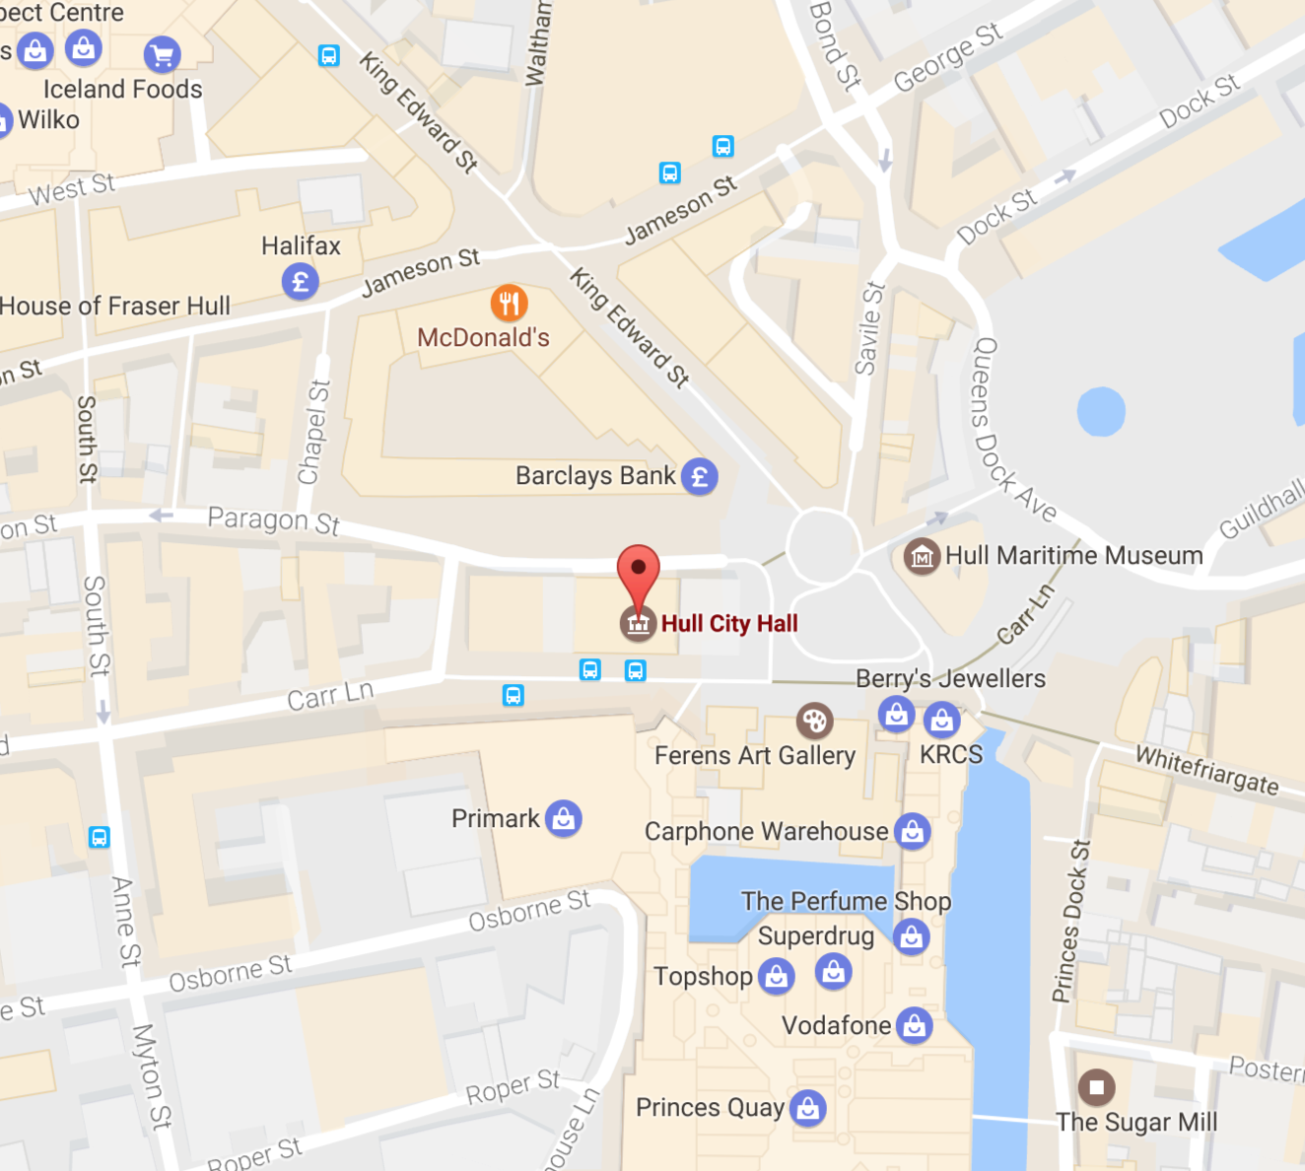

Venue Three & Venue Four (V3 & V4)

Jubilee Church & Queens Hall

62 King Edward Street

HU1 3SQ

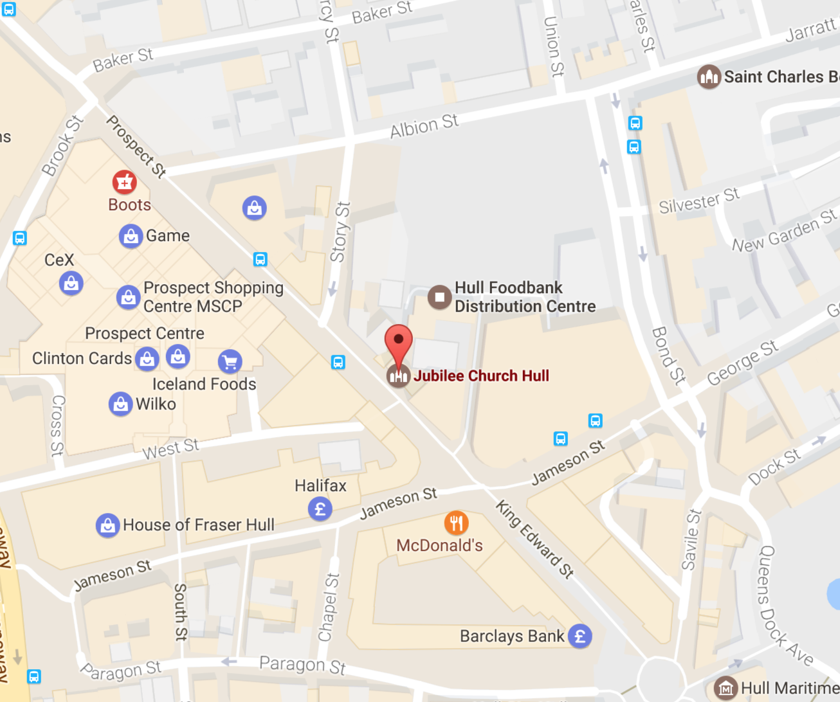

Venue Five (V5)

Gate No.5

Wincolmlee

Hull

HU2 0PZ

Directions:

Gate No.5 is located on the roundabout of Bankside, Air Street and Wincolmlee, approximately 4 minutes from Hull City Centre, 3 minutes from Cottingham Road and 4 minutes from Princes Avenue.

Hull Train Station is a 5-minute taxi ride away from the venue.

The venue is approximately a 10-minute walk from Beverley Road and a 15-minute walk from Myton Bridge and Freetown Way.

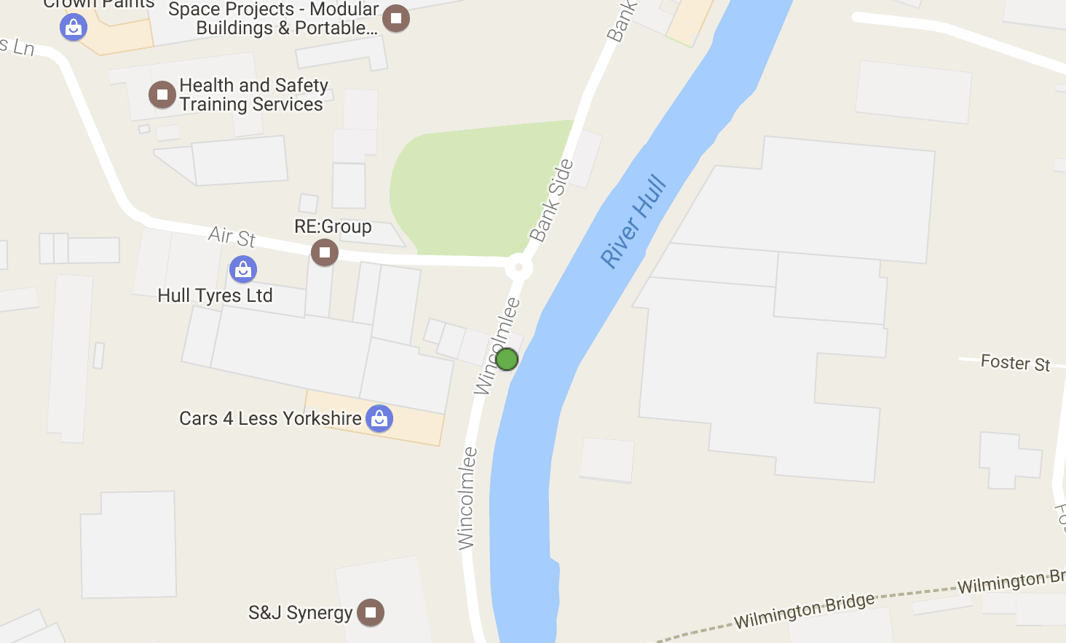

Venue Six (V6)

Fruit

62-63 Humber Street

HU1 1TU

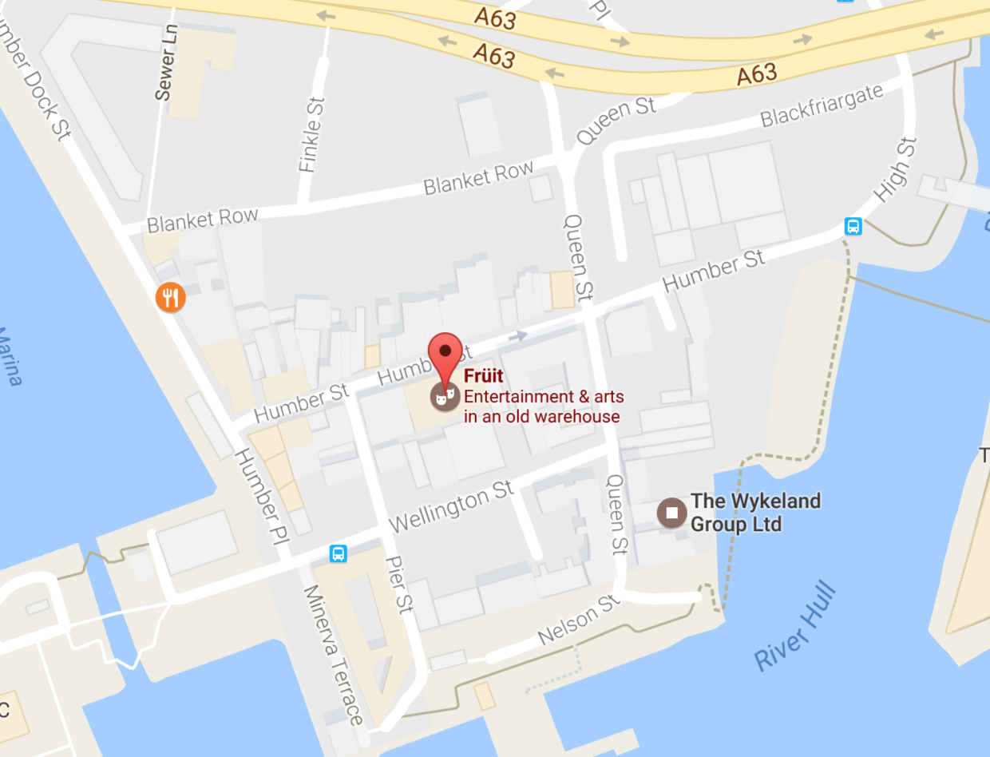

|  |  |  |
| --- | --- | --- |
| CURATED PLACE | | |
| Andy Brydon (AB) | [andy@curatedplace.com](mailto:andy@curatedplace.com)  +44 7774 115647 | Director |
| Chris Carney (CC) | [chris@curatedplace.com](mailto:chris@curatedplace.com)  +44 7743 432129 | Lead Production Manager |
| Stephen C. Nuttall (SCN) | [stephen@curatedplace.com](mailto:stephen@curatedplace.com)  +44 7966 662978 | Production Manager |
| Susan Wareham (SW) | [susan@curatedplace.com](mailto:susan@curatedplace.com)  +44 7814 883524 | Production Manager |
| Lianray Pienaar (LP) | [lianray.pienaar@gmail.com](mailto:lianray.pienaar@gmail.com)  +44 7576 400001 | Production Team |
| Hannah Ayre (HA) | [hannah@curatedplace.com](mailto:hannah@curatedplace.com)  +44 7929 365245 | Production Team |
| Fridthjofur Thorsteinsson | [fridthjofur@fif.fi](mailto:fridthjofur@fif.fi)  +44 7799812 510 | Production Team |
| HULL 2017: UK CITY OF CULTURE | | |
| Sam Hunt (SH) | [sam.hunt@hull2017.co.uk](mailto:sam.hunt@hull2017.co.uk)  +44 7713 094461 | Executive Producer |
| Liam Rich (LR) | [liam.rich@hull2017.co.uk](mailto:liam.rich@hull2017.co.uk)  +44 7957 193195 | Producer |
| Aidan Lesser (AL) | [aidan.lesser@hull2017.co.uk](mailto:aidan.lesser@hull2017.co.uk)  +44 7828 926751 | Production Manager |
| Liz Neal (LN) | [liz.neal@vhey.co.uk](mailto:liz.neal@vhey.co.uk)  01482 391535 | Accommodation Agent |
| ARTISTS | | |
| Name | Contact (email & mobile) | Time, Date, Venue |
| John Grant | Matt Pengelly – 07931 126 961 – [mjpengelly@gmail.com](mailto:mjpengelly@gmail.com) |  |
| John Grant Band | Rob – [Rob@codaagency.com](mailto:Rob@codaagency.com) - |  |
| Gus Gus | Nadine – [nadine@mct-agentur.com](mailto:nadine@mct-agentur.com) – 49 305 363 8200 |  |
| Mt. Wolf | Julie Thorp - 07890 708 626 - [julie@crcmusic.co.uk](mailto:julie@crcmusic.co.uk) |  |
| Jez Riley French | Jez – [tempjez@hotmail.com](mailto:tempjez@hotmail.com) – 0747 465 9301 |  |
| Tonik Ensemble | Anton – [anton.kaldal@gmail.com](mailto:anton.kaldal@gmail.com) - |  |
| Susanne Sundfor | James – [james.Masters@unitedtalent.com](mailto:james.Masters@unitedtalent.com) – 020 7278 3331 |  |
| Prins Polo | Svavar – [svavar@havari.is](mailto:svavar@havari.is) - |  |
| Wrangler | Steve – [steve@randommusicmgmt.com](mailto:steve@randommusicmgmt.com) – 07949134974 |  |
| Wrangler TECH | Ben - 07913 730859  Dan - 07800593220 |  |
| Lindstrom | Andre – [andre@backroom-entertainment.de](mailto:andre@backroom-entertainment.de) – 493043015 -45 |  |
| Sweaty Records | Dodi – [thordur.kari@gmail.com](mailto:thordur.kari@gmail.com) - |  |
| BBC Late Junction | Becca Gaskell – 07932 761717  Joby Waldmen – 07855 710729  Paul Nickson – 07941 158468 |  |
| Pinquins | Ane Marthe Sørlien Holen - +47 970 26762 – [www.anemarthe.no](http://www.anemarthe.no) |  |
| Ghostigital | Einar – [manager@fufanu.rocks](mailto:manager@fufanu.rocks) - |  |
| Steve Cobby & Russ Litten | Steve – [stevecobby@mac.com](mailto:stevecobby@mac.com) –(0)7963552573 |  |
| Simon Desbrulias | +44 (0) 1482 466366 / [S.Debruslais@hull.ac.uk](mailto:S.Debruslais@hull.ac.uk) |  |
| Nordic Affect | Halla Steinunn Stefánsdóttir - +46730753535 [hallasteinunn@gmail.com](mailto:hallasteinunn@gmail.com) - [www.nordicaffect.com](http://www.nordicaffect.com/) |  |
| Luke Eargoggle | Lukas – [lukas.pettersson3@gmail.com](mailto:lukas.pettersson3@gmail.com) - |  |
| Actress DJ | Debbie – [debbie@lb-agency.ne](mailto:debbie@lb-agency.ne) - |  |
| Soley | [persilleyo@gmail.com](mailto:persilleyo@gmail.com) - |  |
| Mugison | Mukki – [mugison@gmail.com](mailto:mugison@gmail.com) - |  |
| Nils Bech | Ida Bille / +45 70127722 / [ida@birdseyeagency.dk](mailto:ida@birdseyeagency.dk) |  |
| Satellites | James – [james@houseofopportunity.co.uk](mailto:james@houseofopportunity.co.uk) – 07770 756 304 |  |
| Adelle Stripe | [adellestripe@btinternet.com](mailto:adellestripe@btinternet.com?bcc=dropbox@46009577.curatedplace.highrisehq.com)  07951 880 587 |  |
| Halldor Smarason | [halldorsmarason@gmail.com](mailto:halldorsmarason@gmail.com) |  |
| Lee Tsang  Symphonia UK Collective | [L.Tsang@hull.ac.uk](mailto:L.Tsang@hull.ac.uk) |  |
| James Orvis | James – [jamesorvis87@gmail.com](mailto:jamesorvis87@gmail.com) - |  |
| Eyvind Gulbrandsen and the Royal Northern College of Music | [eyvgul@gmail.com](mailto:eyvgul@gmail.com) |  |
| Science of the Lamps | Kaya – [kaya@scienceofthelamps.com](mailto:kaya@scienceofthelamps.com) – 07876286283 |  |
| Ragga Gisla | [raggagisla@gmail.com](mailto:raggagisla@gmail.com) |  |
| Sykur | Halldor – [sykur@sykur.com](mailto:sykur@sykur.com) - |  |
| Tom Kay | Tom – [tomkaymusic@hotmail.com](mailto:tomkaymusic@hotmail.com) - |  |
| Fufanu | Einar – [manager@fufanu.rocks](mailto:manager@fufanu.rocks) - |  |
| Hermigervill | Sveinbjörn - +354 694 4207 - |  |
| ON-SITE CONTRACTORS / SERVICES | | |
| Iain Firth (IF)  HPSS | [iain@hpss.co.uk](mailto:iain@hpss.co.uk)  +44 7976 872741 | AV, Tech Production |
| Ev Parry | +44 7500 804412 | Percussion Delivery Person. |
| Trevor Ostler | 01482 875188 | Piano Tuner |

# SECTION 18 - MOVEMENT ORDERS

**Premier Executive Chauffeur Services**

**Contact: Neil Ryan – 07866 852400**

**Car Service - schedule**

Saturday 29th of April

Holiday Inn Marina

Contact: Jorgen Brennhovd Tel. +47 913 174 69

7AM pick up for a flight 10.45 at Manchester Airport Terminal 1

Saturday 29th of April

SAS flight from Oslo 10AM at Manchester Airport

Contact: Lindstrom Tel: [+47 412 06 577](tel:+47%20412%2006%20577)

__________________________________________________

Sunday 30th of April

Leeds/Bradford Airport

Contact: Ber Quinn

9.50 KLM KL1541

And take to Holiday Inn Marina

___________________________________________________

Sunday 30th of April

11.30 Pick up at Holiday Inn Marina

Contact: Lindstrom

Take to Manchester Airport Terminal 1 for a 16.35 flight

On Standby car Service over the weekend in Hull – 35 per hour (2 hr minimum)

**Transit Info**

1. **Friday 28th of April**

Pick up at Manchester Airport Terminal 1

**11.15** flight from Berlin (EasyJet1898)

X2 (Sweaty Records – contact no. tbc)

**11.35** flight from Iceland KEF (Icelandair FI440)

X6 (GusGus/Jon Thor/ Ragga – contact Aggi 00354 8942282))

Take to Hull – Holiday Inn Express

1. **Friday 28th of April**

Pick up at London Luton Airport

**13.10** flight from Iceland KEF (EasyJet U2 2296)

X 12 (Sweaty Records (x1) / Prins Polo (x2) / Ragga(x6) / Nordic Affect(x3)

Contact: Doddi 00354 6590703 or Svavar 00354 8491995

Take to Hull – Holiday Inn Marina (Sweaty Records) – Holiday Inn Express (rest)

**Extra job : Saturday 29th of April**

**Pick up at Stansted Airport**

**13.15 EasyJet from Iceland KEF (EasyJet U23034)**

**X 7 (Ghostigital, contact Einar** +354 896 8933)

1. **Sunday 30th of April**

Pick up at Manchester Airport – Terminal 1

**11.35** flight from Iceland KEF (Icelandair FI440)

X 5 (Soley (x1) / Sykur (x4)

**12.35** flight from Iceland KEF (EasyJet EZY1806)

x 1 (Mugison)

Contact: Halldor 00354 8651591 or Muggi 00354 820 3800

Take to Hull – Holiday Inn Express

_______________________________________________________________________

1. **Saturday 29th of April**

Pick up in Hull – Holiday Inn Marina (Jon Thor) – Holiday Inn Express (GusGus)

Time: 2PM

X 5 people – take to London Heathrow for a flight to Iceland at 21.10 (Terminal 2)

Contact: Jon Thor (tbc) or Aggi 003548942282

1. **Sunday 30th of April**

Pick up in Hull – Holiday Inn Express (Ragga)

Time: 2.30AM

X 7 people – take to Manchester Airport for a flight to Iceland at 6.30 AM (Terminal 1)

Conact: Ragga 00354 8690149

1. **Sunday 30th of April**

Pick up in Hull – Holiday Inn Marina (Sweaty Records x1) / Holiday Inn Express (Halldor/Prins Polo/Nordic Affect x 6)

Time: 9 AM

X 7 people – take to Manchester Airport for a flight to Iceland at 13.35 (Terminal 1)

Contact: Doddi 00354 6590703 or Halla 00354 8213930

1. **Tuesday 2nd of May**

Pick up in Hull – Holiday Inn Express

Time: 2PM

X12 people – take to London Heathrow for a flight to Iceland at 21.10 (Terminal 1)

Contact: Einar 00354 8968933

**AIRPORT ARRIVALS**

|  |  |  |  |  |  |  |
| --- | --- | --- | --- | --- | --- | --- |
| **Thursday** |  |  | Friday |  |  |  |
| **27th of April** | **17.45** |  | 28th of April | **11.15** | **11.35** | **13.15** |
| **Manchester Airport** | SAS flight form CPH Jorgen Brennhovd |  | Manchester Airport | EasyJet from Berlin Sweaty Records - Sigtryggur and Bjargmundur | Icelandair from KEF 1)GusGus 2)Jon Thor (Tonik) |  |
|  |  |  | London Luton |  |  | EasyJet from KEF 1)Sweaty Records Thordur Kari 2)Prins Polo x 2. 3)Ragga x 7. 4)Nordic Affect x 3 |

|  |  |  |  |  |  |  |  |
| --- | --- | --- | --- | --- | --- | --- | --- |
| **Saturday** |  |  |  |  | **Sunday** |  |  |
| **29th of April** | **10.00** | **13.05** | **16.50** |  | **30th of April** | **11.35** | **12.35** |
| **Manchester Airport** | SAS from OSL - Lindstrom |  |  |  | **Manchester Airport** | Icelandair fro KEF 1)Soley 2)Sykur x 4 | EasyJet from KEF Mugison |
| **Leeds/Bradford** |  |  | KLM from AMS - Luke |  |  |  |  |
| **London Stanstead** |  | EasyJet from KEF - Ghostigital x 2 |  |  |  |  |  |