HMAP Dataset 16

Peru, South-east Pacific

Supporting Documentation



Summary

Dataset Title: Peru, South-east Pacific

Large Marine Ecosystem: 13: Humboldt Current

Subject: catch, effort and biological data relating to four demersal species fished off Peru (hake, seabass, croaker and searobin) since 1950

Data Provider: Claudia Wosnitza-Mendo
Instituto del Mar del Peru (IMARPE)
Callao
Peru
email: claudiawosnitza@yahoo.de

Data Editor: David J Starkey, MHSC, University of Hull
d.j.starkey@hull.ac.uk

Extent: 6449 records

Keywords: historical statistics; HMAP; Peruvian demersal fisheries; Humboldt Current

Citation:
(a) The dataset: please cite as follows: M. Ballón, C. Wosnitza-Mendo, R. Guevara-Carrasco and C. Benites, ‘Peru, South-east Pacific’,, in D.J. Starkey & J.H. Nicholls (comp.) HMAP Data Pages (www.hull.ac.uk/hmap)
(b) Supporting documentation: please cite as follows: M. Ballón, C. Wosnitza-Mendo, R. Guevara-Carrasco and C. Benites, ‘HMAP Dataset 16: Peru, South-east Pacific, Supporting Documentation’, in D.J. Starkey & J.H. Nicholls (comp.) HMAP Data Pages (www.hull.ac.uk/hmap)

2. Research Context & Objectives

Although Peru is located in tropical latitudes (between 3˚ 23’S and 18˚ 21’S), the sea off its shores is characterised by the coldness of the waters of the prevailing Humboldt Current. This constitutes one of the main upwelling regions of the world, and is marked by the highest level of primary production and the greatest fishery based on a single pelagic species (anchovy). This marine ecosystem varies greatly on seasonal, inter-annual (ENSO cycle) and multi-decadal scales. The physical factors which condition the particular climate of this region are the cold surface current flowing towards the equator, the subsurface moving towards the South Pole with its oxygenated undercurrent, the Andes mountains with peaks over 6000 metres above sea level, and the south-eastern trade winds, which form part of the South Pacific Anti-cyclonic gyre. Upwelling determines most of the biological processes in this ecosystem.

The pelagic element of this LME has been studied extensively, largely because of the volatility of the anchovy stock, the scale of the fishery and the alternation in the relative abundances of anchovy and sardine that has been evident over the last 40 years. As a consequence, comparatively little scholarly attention has been afforded to the demersal system off Peru, even though demand for these bottom-dwelling fish increased to such an extent that landings grew from about 50,000 tonnes in the late 1960s to over 330,000 tonnes in 1978 (see chart below). This impacted upon the health and distribution of the hake population in particular, and with younger individuals taken as they migrated into the fishing grounds, the stock suffered from overfishing and the fishery was closed in 2002.

The aim of this research is to assess the impact that fishing activity has had upon four demersal species off the Peruvian coast since c.1950. Focusing on hake, seabass, croaker and searobin, the investigation is designed to establish the extent to which the catching effort has altered the distribution, diversity and abundance of these species. Among the results of the analysis will be a series of targets for the recovery of these species.

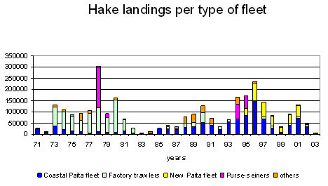

3. Primary Source Materials

The principal sources of information for this strand of WP2 research are the statistical returns regarding catches and fishing effort collected by the state’s fishery agencies since the 1950s, and data returned by scientific cruises undertaken since the early 1980s. This evidence facilitates analysis of the spatial and temporal distribution patterns of the demersal fish assemblages, and the structure of populations, notably in terms of length-frequencies, mean length, range and maximum sizes. With regard to the changing distribution of hake stocks, some provisional findings are presented on the Visualisations page of the HMAP Data Pages website (http://www.hull.ac.uk/hmap/visualisation). Moreover, the declining trend in the size of individual fish taken in the sample cruise data can be discerned in the table below.

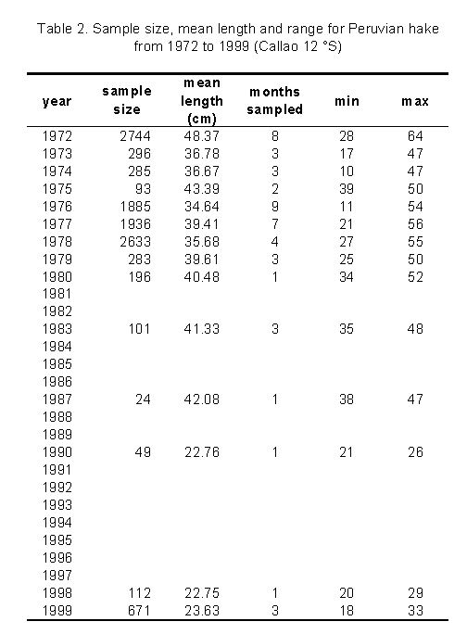

4. Metadata: Explanation of Data Fields

The entries below are outlined as per the field headings of HMAP Dataset 16. An explanation is offered for each field in general terms, and also in dataset specific terms.

ID
ID is the unique, consecutive serial numbers for the complete HMAP database.

InstitutionCode
InstitutionCode is the name given to the overall project of which this Dataset forms a part (HMAP).

CollectionCode
CollectionCode is the specific HMAP project Dataset reference code (used for OBIS referencing purposes).

DateLastModified
This is the date when the data were last modified.

CASE_STUDY
CASE_STUDY is the location identifying description of the Dataset. In this instance: Southeast Pacific demersal fishery off the Peruvian coast.

DATASET
DATASET is the HMAP project unique Dataset reference.

REFERENCE
REFERENCE refers to the source of records employed in the research.

Citation
Citation is the field where the formal attribution is shown for users of the HMAP Datasets to cite; it credits the researchers and editors of a Dataset together with its database compilers. This citation must be quoted whenever records are referenced or employed for any purpose.

Please quote the relevant citation when using extracts or details from this Dataset:

- M. Ballón, C. Wosnitza-Mendo, R. Guevara-Carrasco and C. Benites, ‘Peru, South-east Pacific’, in D.J. Starkey & J.H. Nicholls (comp.) HMAP Data Pages (www.hull.ac.uk/hmap)

BasisOfRecord
BasisOfRecord is the abbreviation applied that indicates whether the record is based on observations (O), living organisms (L), specimens (S), germplasm/seeds (G), photos (P), or from literature with original basis unknown (D); the HMAP value is generally 'O'.

OCEAN_REGION
This field indicates the specific Ocean Region where the Dataset research has been carried out. If this field shows 'None', then the research reflects activities carried out in non-seaward locations (e.g. in rivers, weir fishing, etc.). In this Dataset, the South Pacific Ocean region was researched.

LME
This field indicates the name of the Ecosystem where the record event occurred. To find out more about LMEs (which are confined to continental shelf regions) browse the Large Marine Ecosystem site (http://www.edc.uri.edu/lme/) where LME GIS data may be downloaded. In this Dataset, the Humboldt Current region was researched.

LME_NUMBER
This field indicates the number of the LME that is shown in the previous field. In this Dataset, the LME number is 13.

LATITUDE
The LATITUDE refers to a mean value of the species distribution from surveys and should be cross referenced with the LONGITUDE field for specific location determination. For this Dataset, this field was calculated from the median position of all positive hauls during investigative surveys between 1975 and 2000 in order to determine the position for length-frequency distributions, catch statistics and efforts. The Catch Per Unit Effort (see CPUE field) of surveys refers to median latitude and longitude during each survey.

LAT_PRECISION
This gives the actual precision of the calculated LATITUDE field. The available options are:
- Approx Approximate position
- Estimated Estimated position
- Exact Exact position
- Ground Centre Notional centre of the relevant fishing ground
- Unknown Position not known

LONGITUDE
The LONGITUDE refers to a mean value of the species distribution from surveys and should be cross referenced with the LATITUDE field for specific location determination. For this Dataset, this field was calculated from the median position of all positive hauls during investigative surveys between 1975 and 2000 in order to determine the position for length-frequency distributions, catch statistics and efforts. The Catch Per Unit Effort (see CPUE field) of surveys refers to median latitude and longitude during each survey.

LON_PRECISION
This gives the actual precision of the calculated LONGITUDE field. The available options are:
- Approx Approximate position
- Estimated Estimated position
- Exact Exact position
- Ground Centre Notional centre of the relevant fishing ground
- Unknown Position not known

ST_YEAR
This field refers to the start year of the beginning of the sampling.

EN_YEAR
This field refers to the end year of the end of the sampling. Unless the sampling spanned an extensive period, this value is usually the same as the ST_YEAR field entry.

ScientificName
This field indicates the scientific name of the species under investigation which is linked to the HMAP related FISH BASE database containing detailed information about the species that were sampled.

ObservedWeight
This field indicates the observed mass of the sample in Kilograms. Where this data is not available, a value of "unknown" is entered.

Catch_N
CATCH_N indicates the actual number of specimens sampled for a particular record. Where this data is not available, a value of "unknown" is entered.

GENDER
This field indicates the Gender of the species in the sample. The values available are shown as follows:
- 'M' male
- 'F' female
- 'U' unknown
- 'B' both male and female
- 'H' hermaphrodite

NOTES
The NOTES field gives detailed information specific to a particular record. The details are provided to clarify specific entries and where further explanation is required than is generally provided in this METADATA file. For complete and academically verifiable explanations, refer to the published research materials that are indicated in the REFERENCE field.

Abbreviations used in the NOTES field:
- TR Trawlers
- PS Purse-Seiners
- [1] Anuario estadístico pesquero Perú Ministerio de Pesquería
- [2] IMARPE internal report
- [3] Report of the second session of the international panel of experts for assessment of Peruvian hake population. March 2004. Bol.Ins. Mar PerúVol 21/N° ½
- [4] Anuario estadístico pesquero Perú Ministerio de Pesquería (years 1970-2003)

Vessel_Type
This field gives a description of the vessel type that was employed in the sampling process. The available values (in metric tonnes) range from:
- Small Trawler < 50 tonnes; main engine < 500 hp
- Medium Trawler 50 to 150 tonnes; main engine < 1000 hp
- Big Trawler (factory) > 50 tonnes; main engine > 1000 hp
- Purse-Seine vessels target species is anchovy with incidental hake catches

HOME_PORT
This is the home port of the fleet employed in the sampling.

Method
The METHOD is an indicator of the primary gear used in the fishery; it indicates the means by which samples were extracted. This is typically the actual method of fishing, such as "Bottom Trawl".

Length
The LENGTH field shows the actual species sample length indicated in centimetres (cm). For this Dataset, LENGTH (this field) and FREQUENCY (next field) data of the Merluccius gayi peruanus SPECIES relates specifically to samples from Tumbes 3°30' S, Paita 5° S, Salaverry 8° S, and Chimbote 9° S.

Frequency
The Frequency field (regular occurrence) indicates the frequency at which the species for the given period occurs and is weighted according to the total annual CATCH_W (next field).

NOTE
- FREQUENCY data of the Paralabrax humeralis SPECIES are poor for the years 1969 and 1983
- FREQUENCY data of the Paralonchurus peruanus SPECIES are poor for the years 1963, 1966, 1991 and 1992
- FREQUENCY data of the Prionotus stephanophrys SPECIES are poor for the year 1983
- For this Dataset, LENGTH and FREQUENCY data of the Merluccius gayi peruanus SPECIES relate to samples from Tumbes 3°30' S, Paita 5° S, Salaverry 8° S, and Chimbote 9° S

Catch_W
This field indicates the mass of the catch in metric tonnes (t).

NOTE
- Records (inclusive) from 556389 to 556444 are based on investigative surveys from specific vessels (RV Humboldt, RV Olaya, RV SNP-1). The CATCH_W and EFFORT values are not available for these records; the CPUE values are mean values derived from data that is weighted to sub-areas. Original data are available in IMARPE records. These specific records have CPUE values that are shown in tonnes per square nautical mile (t/nm²). See the CPUE and EFFORT field descriptions as well.

Effort
This field shows the EFORT taken by the fishery and is measured according to the number of trips undertaken.

NOTE
- Records (inclusive) from 556389 to 556444 are based on investigative surveys from specific vessels (RV Humboldt, RV Olaya, RV SNP-1). The CATCH_W and EFFORT values are not available for these records; the CPUE values are mean values derived from data that is weighted to sub-areas. Original data are available in IMARPE records. These specific records have CPUE values that are shown in tonnes per square nautical mile (t/nm²). See the CPUE and CATCH_W field descriptions as well.

CPUE
The CPUE field (Catch Per Unit Effort) is expressed in metric tonnes per trip. See notes on LATITUDE and LONGITUDE fields for more information.

NOTE
Records (inclusive) from 556389 to 556444 are based on investigative surveys from specific vessels (RV Humboldt, RV Olaya, RV SNP-1). The CATCH_W and EFFORT values are not available for these records; the CPUE values are mean values derived from data that is weighted to sub-areas. Original data are available in IMARPE records. These specific records have CPUE values that are shown in tonnes per square nautical mile (t/nm²). See the CATCH_W and EFFORT field descriptions as well.

5. Outputs

C. Wosnita-Mando, M. Ballón, C. Benitez & R. Guevera-Carresco, ‘Changes in the distribution area of Peruvian hake: effect of fisheries’, (in prep.)

Enquiries regarding the information contained in this document and the accompanying dataset should be directed to David J Starkey (d.j.starkey@hull.ac.uk) or John H Nicholls (j.nicholls@hull.ac.uk).

