**PRSF NEW MUSIC BIENNIAL**

**HULL**

**29th JUNE to 2nd JULY 2017**

**ARTIST PACK**

**ARTIST**: Eliza Carthy and The Moulettes

**ARTIST CONTACT (Mobile number):** TBC – PROMOTER TO CONFIRM

**VENUE**: Stage@theDock

[Address](https://www.google.com/search?biw=2400&bih=1217&q=www+fruitspace+co+uk+address&stick=H4sIAAAAAAAAAOPgE-LWT9c3LDOyTMpKK9GSzU620s_JT04syczPgzOsElNSilKLiwFSWNTXLgAAAA&sa=X&ved=0ahUKEwiT5cTKt7jUAhUlKMAKHZ4BA-AQ6BMIowEwEA): Stage@TheDock, 47 Queen Street, Hull, HU1 1UU.

[Phone](https://www.google.com/search?biw=2400&bih=1217&q=www+fruitspace+co+uk+phone&sa=X&ved=0ahUKEwiT5cTKt7jUAhUlKMAKHZ4BA-AQ6BMIpgEwEQ): 01482 304080

**LOADING IN FROM:** Queen Street (yellow dot)

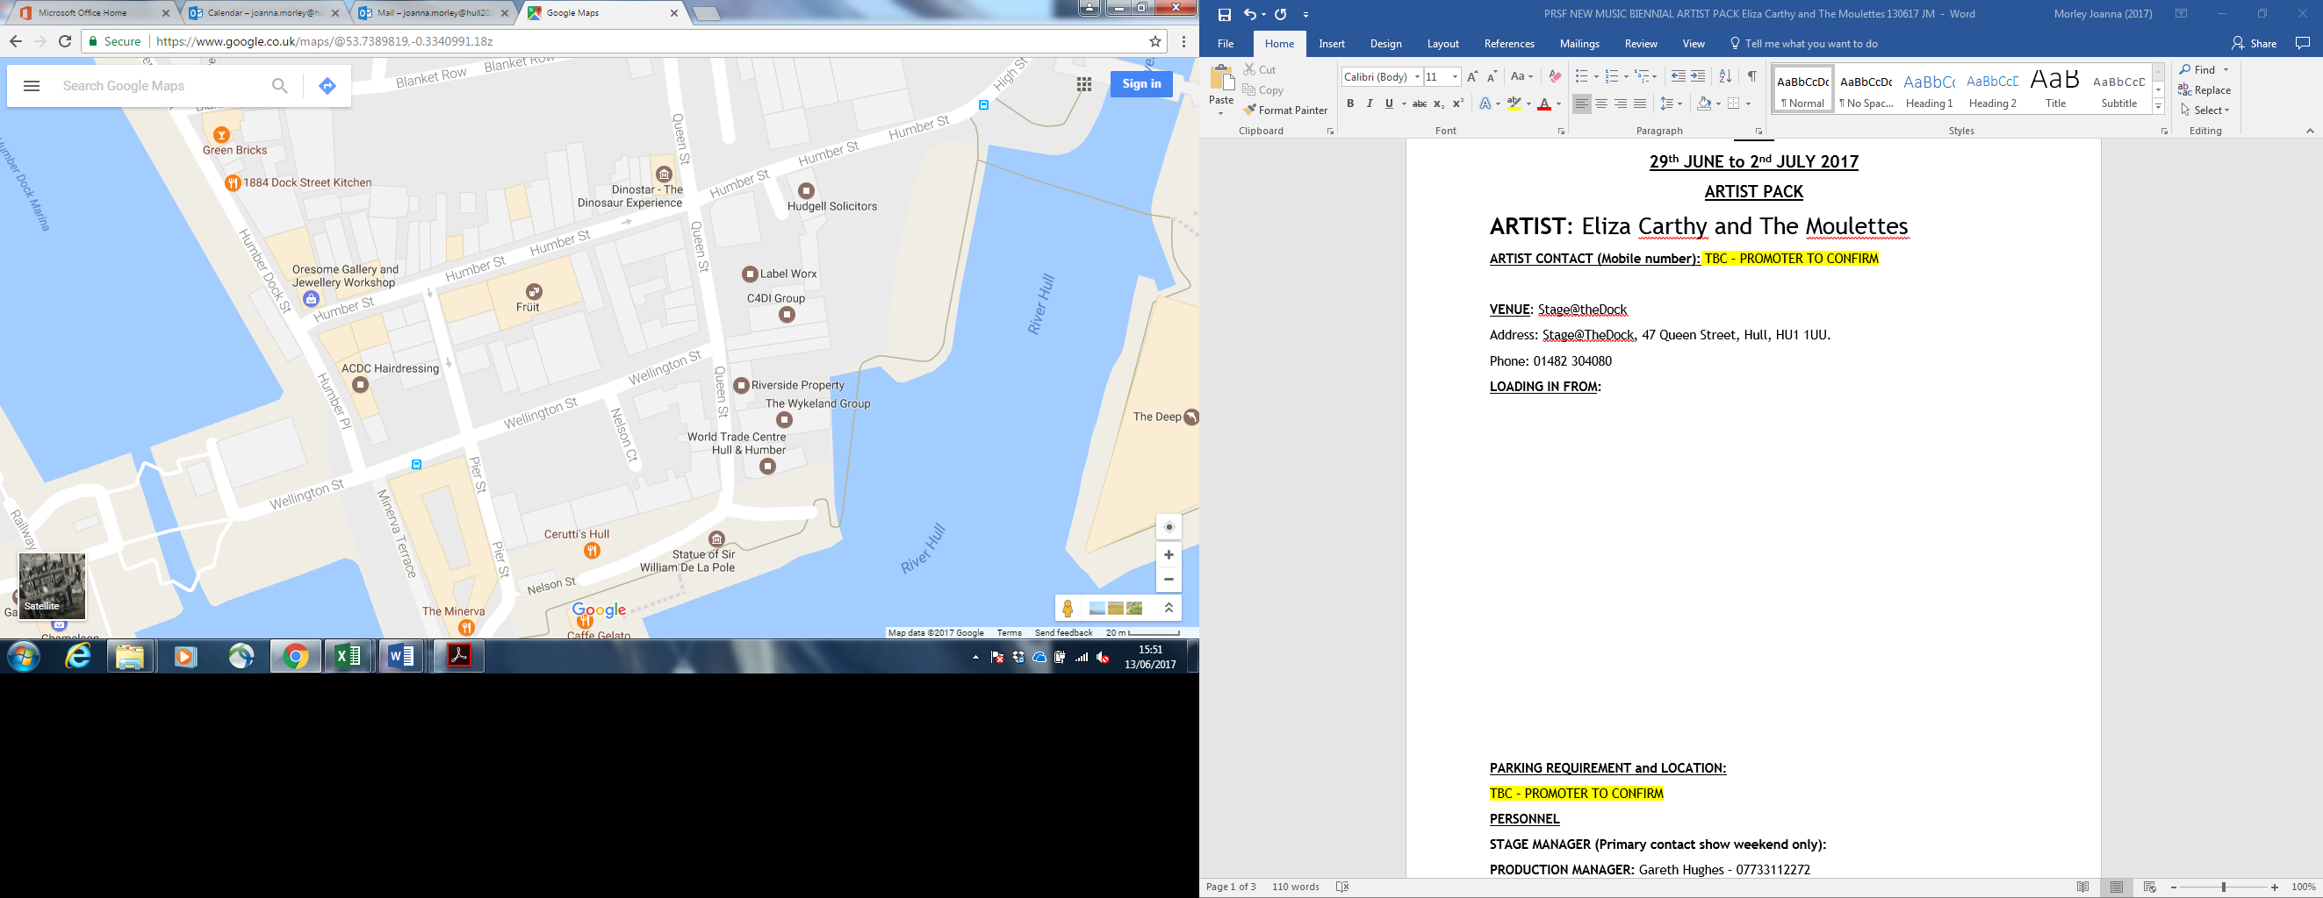

**PARKING REQUIREMENT and LOCATION:**

TBC – PROMOTER TO CONFIRM

**PERSONNEL**

**STAGE MANAGER (Primary contact show weekend only):** Hannah Lutkin - 07709 351209

**PRODUCTION MANAGER:** Gareth Hughes – 07733112272

**PRODUCTION ASSISTANT**: Joanna Morley – 07725 942808

**VENUE CONTACT**:

**DATE AND TIME OF PERFORMANCE: Saturday 1st July 20:30 (45mins)**

**PRODUCTION SCHEDULE:**

|  |  |  |  |
| --- | --- | --- | --- |
| **SATURDAY 1 JULY** |  | |  |
|  |  | |  |
|  |  | |  |
|  |  | |  |
| 20:30 | PERFORMANCE - Eliza Carthy - Rivers and Railways | |  |
|  |  | |  |
|  | |
|  | |

**TECHNICAL**

**RIDER:**

TB Food Rider:

Snacks/ crudités/ sandwiches/ fruit on arrival

Hot Meal for Band & Crew (6 People)

(3 vegetarians & 3 meat eaters- but happy to eat Vegetarian food if thats easier)

Drinks:

2 x Large bottles of Sparkling Water

Cucumber

Herbal Tea/ Tea/ Coffee & Kettle

Selection of quality beers / ales

1 bottle of Red Wine

1 small bottle of quality Gin

Tonic Water

2 Lemons

2 Limes

Honey

**BACKLINE**:

|  |  |  |
| --- | --- | --- |
| **BACKLINE** | Kick Drum | ALBEMARLE KIT 2 |
|  | Snare Drum x2 | ALBEMARLE KIT 2 |
|  | Rack drum x2 | ALBEMARLE KIT 2 |
|  | Rack Tom | ALBEMARLE KIT 2 |
|  | Floor Tom | ALBEMARLE KIT 2 |
|  | All hardware and cymblas | ALBEMARLE KIT 2 |
|  | 2 kick brum pedals | ALBEMARLE KIT 2 |
|  | Drum mat | ALBEMARLE KIT 2 |
|  | 2 single keyboard stands | STS |
|  | 2 guitar stands | STS |
|  | Bass amp (2 channel) | STS |
|  | Fender Guitar amp | STS |
|  | Keyboard Amp | STS |

**ACCREDITATION**

David & Alice Porter (Directors)

Steve & Sam Shaw (Directors)

Peter & Lorraine Boardman (Directors)

Wes Zepherin (Director)

Kirsty & Gary Halliday (Marketing)

Ben Pugh (Production)