The Hull 2017 UK City of Culture survey collected postcodes from 350 Place des Anges attendees. The table below illustrates the Mosaic profile of those attendees (these have not been included in the overall Yorkshire Festival 2016 profile so as not to skew the overall Festival profile towards one event).

The following table shows the Mosaic profile for all survey respondents who provided postcodes. Mosaic classifies consumers in the UK into 15 groups and 66 types. Indices under 80 are shown in grey and indicate significant under-representation of the segment amongst the audience compared to the population of the base area. Indices over 120 are shown in gold and illustrate significant over-representation of a segment

The table compares audience profile for Place des Anges with (1) that of households in the UK; and (2) households in the Yorkshire & Humber region.

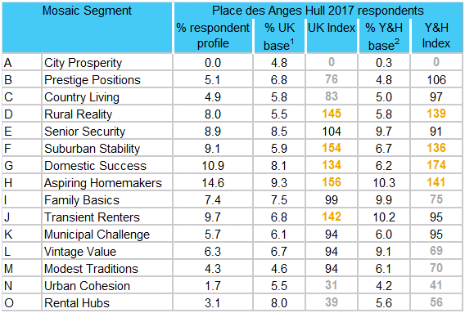

N = 350

The top segments vary from the overall 2016 Yorkshire Festival profile in that the group O Rental Hubs is much less prominent, the group H Aspiring Homemakers is much more prominent; and group F Suburban Stability is slightly more prominent and in the top 6 segments. Group D Rural Reality is also more prominent in the Place des Anges respondent profile.