**New Voices at Hull**

**Thursday 25th May 2017**

**Brynmor Jones Library, University of Hull, 7pm**

**Free!**

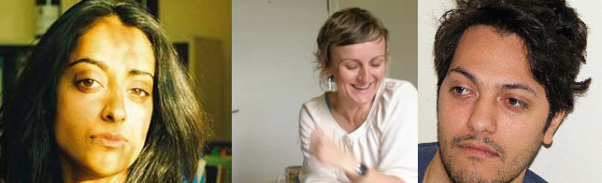

As part of the University’s celebration of literature for 2017 *The Word is Hull*, we are hosting a series of three poetry readings celebrating new poetry.

Over the course of the three events, we will be bringing some of the most exciting poets from around the world to Hull as part of the Larkin Reflections project. Our poetry readings complement the Philip Larkin Exhibition “New Eyes Each Year” showing in the Brynmor Jones Library exhibition space July – October 2017.

**Poets reading on Thursday 25th May, 7pm**

**Sandeep Parmar** was born in Nottingham in 1979 and was raised in Southern California. She received her PhD in English Literature from University College London in 2008 on the unpublished autobiographies of the modernist poet Mina Loy. She holds an MA in Creative Writing from the University of East Anglia. She is the Reviews Editor of *The Wolf*magazine and edited*The Collected Poems of Hope Mirrlees* for Carcanet Press (2011). Her critical book on Loy, *Reading Mina Loy's Autobiographies*, appeared from Bloomsbury in 2013. She teaches twentieth-century literature and creative writing at the University of Liverpool.

**Edward Doegar**’s poems, reviews and translations have appeared in various magazines including *Poetry Review, Granta* (online), *Prac Crit* and *Poetry London*. He is a fellow of the Complete Works and a consulting editor at *The Rialto*. His pamphlet, *For Now*, will be published by clinic in March.

**Julie Corbett** describes herself as ' local poet and storyteller'. Her work has appeared in Magma, The Fib Review and several anthologies including *Versions of the North: Contemporary* *Yorkshire Poetry* (2013), published by Five Leaves. Julie is also a creative writing PhD student at the University of Hull.

**Catherine Sadler** is completing her PhD at the University of Hull. She completed an MA in creative writing at Manchester Metropolitan and is working on her first collection.