**PRS New Music Biennial 2017 – Composer Residency**

The PRS New Music Biennial Composer Residency project is an embedded community participation project in Hull, running from January 2017-March 2018, part of the UK City of Culture programme.

Multiple award winning local musician ELIZA CARTHY, is one of five composers undertaking residencies, working in Hull, so that local communities can spend time and create music with some of the New Music Biennial’s brilliant music creators.

Each residency will lead to the creation of music involving community participants, which will be showcased in a sharing event at Hull City Hall on 24 June, and extracts from the resulting work will be presented as part of the PRS New Music Biennial Festival weekend (2 July) woven together into a large-scale culmination piece, bringing together community participants and musicians from all five residencies for a ‘supergroup’ moment.

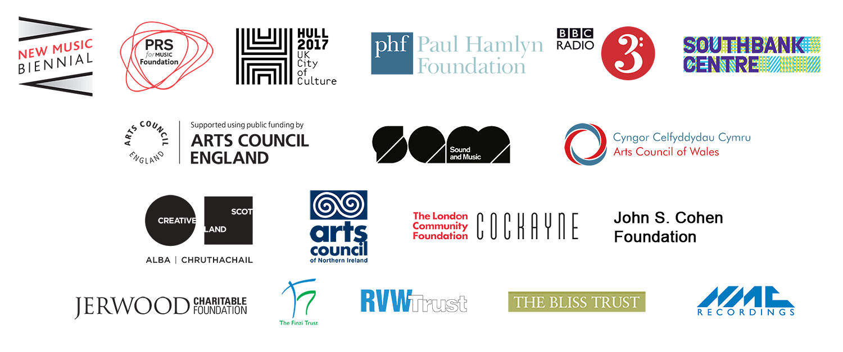

Eliza Carthy would like to meet and talk with, and workshop ideas with, as many local people, with different backgrounds, ages, jobs, lifestyles, ethnicities, and outlooks as possible.

This 1 - 2 hour group interview/ interactive workshop is to find out and gather peoples views, ideas and thoughts on Hull, and what it is like, in their opinion, living there. ‘What is Hull?’ – to you?

Participants will be asked some questions, to get them started, and then encouraged to broaden their answers and ideas in a creative way.

This may be in the form of word games, (e.g.: 60 seconds to describe best and worst things in Hull, word association games, different perspective scenarios etc.) question and answer exercises, imaginary situations (e.g.: If I were the Mayor of Hull for a day I’d ...) or brainstorming discussions, or simple sentence writing exercises and word banks – depending on the group and their feedback.

The sessions will flexible enough to develop organically, to get the most suitable participation from each group.

Eliza will make time to discuss feedback with the group and try to really get some insight into how the city has influenced people’s lives, and how they feel about their town and its landscape, its people, its values, its culture, its history and its future.

Eliza will then collate everything that she has been given and this material will form the basis, and maybe even some actual lines, of the lyrics of the composition, and will also direct the overall feel and style of the commissioned piece of music, that she will compose with local musicians.

All participants will be offered to join up with the other contributors for a ‘sharing/performance’ of the final work – in Hull, on Saturday 24th June.

**ELIZA CARTHY (MBE) – BIOG:**

If there is one musician who embodies the dynamism and vitality of the current English folk revival, it’s Eliza Carthy. Beloved of staunch traditionalists and iconoclasts alike, Eliza’s music effortlessly crosses boundaries of genre and style. Whether performing a centuries-old ballad or a self-written song, her powerful, nuanced voice, fiercely beautiful fiddle playing and mesmerizing live performances have influenced a whole generation of young musicians.

Describing herself simply as a “modern English musician”, Eliza Carthy is one of the most recognisable faces in British folk. Launching head-on into the scene in the early 90s, she quickly became one of its great innovators. She has spearheaded the re-emergence of English traditional music as a vibrant, exciting genre that could stand proud next to other world music. At 39, with a wealth of experience under her belt, Eliza’s talent has matured and is flourishing. She continues to bring new audiences to English folk through well-judged collaborations, recordings and performances.

Born into a formidable musical dynasty, Eliza grew up steeped in the folk traditions of England. Her mother Norma was one of The Watersons, whose tight harmony arrangements of traditional songs became one of the defining sounds of the 1960s folk revival. Her father, Martin Carthy, is a hugely significant singer and guitarist, who influenced the likes of Bob Dylan and Paul Simon.

As a youngster Eliza was profoundly inspired by the incredible range of traditional and contemporary musicians who were part of the Waterson/Carthy world. But far from being a copyist, Eliza began from an early age to develop her own, unique approach to traditional music. This was at least partly because of her own vastly eclectic tastes: she is knowledgeable about and interested in musical traditions from all over the world, which continue to fuel her creativity to this day.

Championed from an early age by the likes of John Peel, Andy Kershaw, Billy Bragg and Glastonbury founder Michael Eavis, Eliza has rarely stood still artistically. From the purest unaccompanied traditional songs to original music incorporating myriad influences, she has moved through English folk music like a force of nature, both stirring it up and putting it back on the map through television, radio and live performance.

Eliza’s musical knowledge and ability is also well respected outside of the folk world: she has been a judge at both the Q Awards and the Ivor Novello Awards, and in 2005 co-presented the BBC Radio 3 World Music Awards with Benjamin Zephaniah. Her achievements have been acknowledged with numerous BBC Radio 2 Folk Awards, two Mercury Prize nominations, and in 2003 she was the first English traditional musician to be nominated for a BBC Radio 3 Award for World Music.

After more than a decade based in Edinburgh, Eliza is delighted to be back home in Yorkshire. Mum to two young daughters, Eliza just completed two years in her role as Folkworks Artistic Associate at The Sage Gateshead, following Northumbrian piper Kathryn Tickell into this prestigious post. Her role involved a number of curated performances, research, education, international collaboration, and large-scale legacy projects.

Never one to sit still for long, she has released two new collaborative albums: *The Moral of the Elephant* (2014) with her father, Martin Carthy, and *Bottle* (2015) with American traditional musician and singer Tim Eriksen (Cordelia’s Dad), and her brand new CD – BIG MACHINE with 12 piece big band – ELIZA CARTHY AND THE WAYWARD BAND is released on Feb 3rd 2017.

**A SELECTION OF CAREER HIGHLIGHTS**

**Media**

* BBC Radio 2: *Eliza Carthy’s Anglicana* (four-part series on the history of English folk music)
* ITV: *Heaven and Earth* (hour long documentary)
* Channel 5: *My Music* (hour-long documentary)
* BBC Radio 2: The Sony Award-winning Mark Radcliffe Show (regular co-presenter)
* BBC 2: Later…With Jools Holland (multiple appearances)
* BBC Television: *In Search of English Folk Song* (directed by Ken Russell)
* NBC’s Late Night with Conan O’Brien (music guest)
* BBC 4’s *Folk Britannia* Season (featured artist)

**Patronage**

* English Folk Dance and Song Society – Vice President
* Whitby Folk Week – Patron
* Cheltenham Folk Festival – Patron
* The Vagina Monologues – Ambassador
* Resonance FM – Ambassador

**Awards and Nominations**

* BBC Radio 2 Folk Awards (8, including Best Album, Best Traditional Track and Folk Singer of the Year)
* Mercury Prize nominations (2, for *Red Rice* and *Anglicana*)
* Paul Hamlyn Award for Artists
* June 2105 – Eliza was awarded an MBE in the Queens Honours List, for services to Folk Music.

**Producing Credits**

* 9 acclaimed solo albums, plus *Gift*, her collaboration with Norma Waterson, for which she also provided arrangements and most of the instrumentation, and *The Moral of The Elephant,* recent critically acclaimed duo album with her dad, Martin Carthy.

**Notable Collaborations and Guest Appearances**

* Billy Bragg & Wilco, *Mermaid Avenue vols I and II* (winners of 2 Grammy Awards)
* *Welcome Songs*, a collaboration with Robert Hollingworth and community choirs for the London 2012 Cultural Olympiad
* Hal Wilner’s *Rogues Gallery* project, alongside Brian Ferry, Sting, Johnny Depp, the McGarrigle family, Richard & Teddy Thompson and Tim Robbins
* Patrick Wolf’s critically-acclaimed album *The Bachelor*
* The Imagined Village (a World music and English trad adventure, featuring members of The Bays, Transglobal Underground and AfroCelt Sound System)
* 4 Meltdown Festivals at the Southbank (curated by Nick Cave, Patti Smith, Hal Willner and Richard Thompson)
* Work with Paul Weller, Jools Holland, jazz legend Bill Frisell, seminal Scots Latin/trad fusion band Salsa Celtica, Finnish *Lord of the Rings* composers Vartinna, Joan Baez, Cerys Matthews, 90s dance pioneers Red Snapper and many more.
* BBC Radio 6 Music Festival 2015 – Commissioned to write new music and live appearance with KATE TEMPEST (rapper).