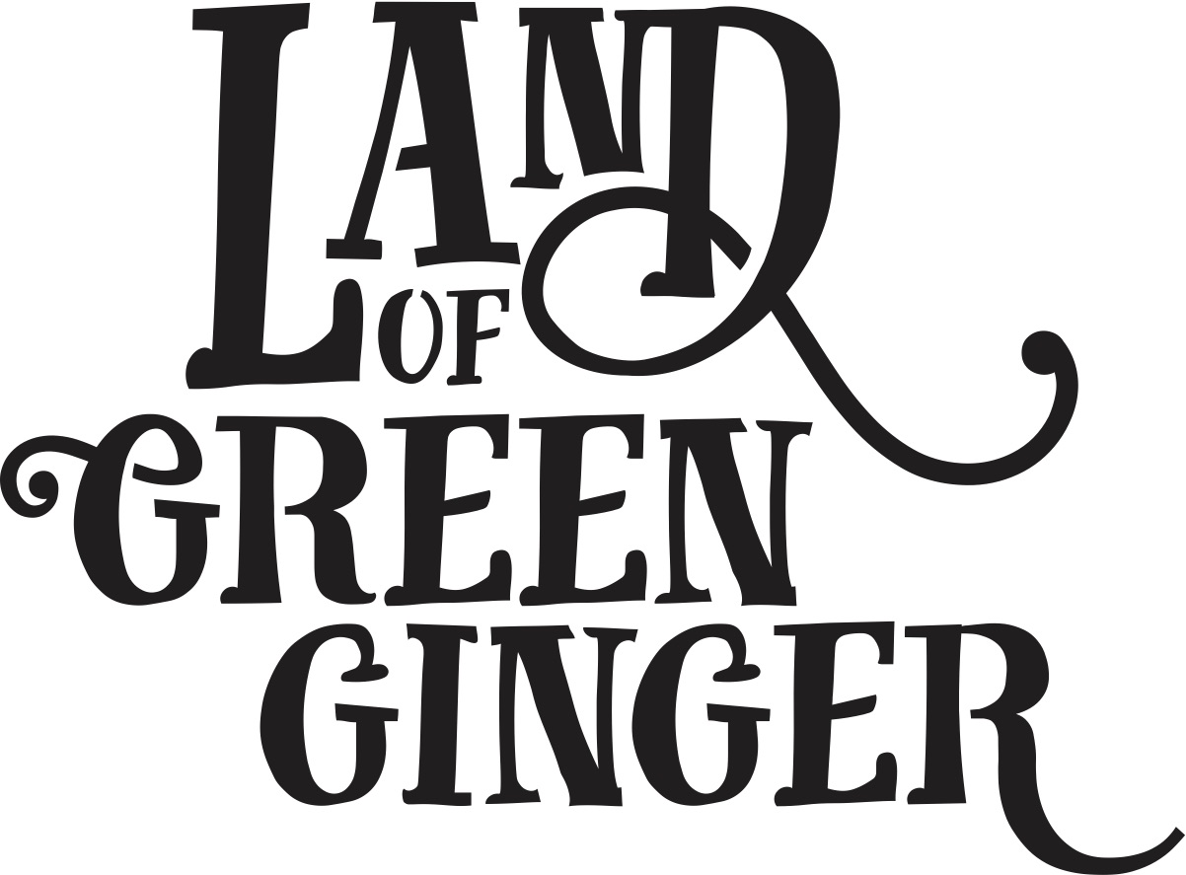

**Book**

**Project Plan**

**Summary**

Throughout the year Hull 2017’s ground-breaking community engagement project, Land of Green Ginger, invited Hull’s residents to immerse themselves in a magical citywide story, inspired by and celebrating the spirit of Hull.

In 2018, the Land of Green Ginger story will culminate in a seventh Act of Wanton Wonder – a beautiful book that will be delivered to every household in Hull.

The Land of Green Ginger book will tell the stories of the project, the narrative as it took place and the stories of the local people it touched. It will be the record of City of Culture as lived by the residents of the city and as informed by their imagination and creativity.

This project plan outlines the formats, timescales and budget for delivery of the Land of Green Ginger book.

**Quantities**

x118,500 for postage to reach every home in Hull.

x1,500 extra books printed for potential workshops.

**Style**

260x210mm *(the same size as “hello hull” magazine)*

60 pages

300gsm outer cover

120gsm inners

Full colour throughout.

Special finish on cover.

Special insert – TBC.

PUR bound.

**Timescales**

The book will be delivered in the week of 2 April, which is exactly a year since the Land of Green Ginger crates discovery news broke in 2017. This is also over the Easter Holidays.

To ensure delivery in the week of 2 April, the following deadlines will be in place:

|  |  |  |
| --- | --- | --- |
| **Date** | **Action** | **Lead** |
| W/C 18 December | Illustrator brief finalised and circulated | Maddie |
| Monday 8 January | Illustrator deadline for applications | All |
| W/C 8 January | Illustrator shortlisting | Maddie & Katy |
| Friday 12 January | Initial manuscript complete | Katy |
| W/C 15 January | Illustrator appointed. Manuscript and full brief delivered for illustrator to start work. | Maddie, Katy, Illustrator |
| W/C 22 January | First draft manuscript complete. | Katy |
| W/C 29 January | First draft sketches complete, feedback given. | Illustrator |
| Monday 5 February | Royal Mail delivery booked | Laura |
| W/C 5 February | Final manuscript complete and submitted to illustrator | Katy |
| W/C 12 February | Final illustrations complete.  Illustrations, manuscript and design brief submitted to designer. | Illustrator  Laura |
| Monday 19 February | Printing booked. | Laura |
| Friday 23 February | Design work complete | Designer |
| Monday 26 February | Book sent to print. | Laura |
| Monday 19 March | Printed book with Royal Mail for distribution | Printer |
| W/C 2 April | Book delivered. | Royal Mail |

**Budget**

To be fully scoped – quotes with us in early January 2018.

|  |  |
| --- | --- |
| Writer/Illustrator | £15,000 |
| Design | £10,000 |
| Print | £60,000 |
| Postage | £50,000 |
| **Total** | **£135,000** |