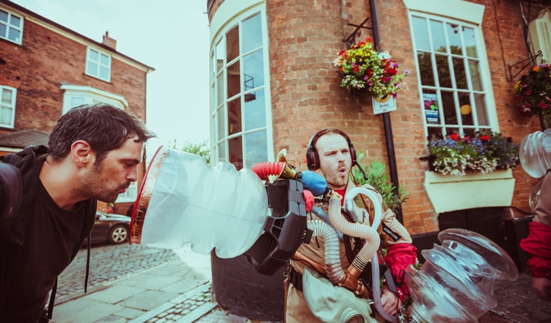

They’ve become a recognisable sight on the streets of Hull, popping up across the city to collect vocal vapour from people of all ages. And now the newly-formed Re-Rediffusion have finally unveiled their plans for all the ooo’s and aaa’s they’ve been gathering up over the past months, appealing for help with a very particular quest...

The journey started back in July, when KCOM found a crate with a Rediffusion logo printed on the outside. Contacting the Green Ginger Fellowship for advice, they passed it over for investigation as part of the larger cache of crates found under the city earlier this year.

The Fellowship found a number of strange apparatus within the crate, prompting a number of members of the public to come forward with stories of how their relatives had once worked for a secret research arm of Rediffusion. Inspired by the finds, they decided to re-form as Re- Rediffusion to continue the work that had been started almost 90 years ago.

James Crumpton of Re-Rediffusion commented:

‘My grandfather worked for Rediffusion, and was also part of their top secret research group.

He left me a notebook full of sketches and formulae, but it never made much sense until now. When the Fellowship started investigating I started talking to other people whose relatives had been involved with Rediffusion. We decided to reform to see if we could assemble the pieces of machinery, like the picture in my granddad’s notebook.

I’m really pleased we decided to do it. It’s a nice feeling to finish something I know my granddad was working on.’

Re-Rediffusion assembled the apparatus - the Voice Extraction and Rediffusion Apparatus, or VEARA for short - and have been using it to extract ‘vocal vapour’ from people across the city over the past three months. But what are they going to do with it?

Vanessa O’Riordan of Re-Rediffusion said:

‘Rediffusion distributed voices out across the city. We’ve been experimenting to see if we can reverse this network and bring all the voices back to one place – a Voice Park.

‘It’s been a long process extracting and distilling all the different voices, but we now believe we’ve found a way to harness this energy.

‘We don’t want to give too much away, but Voice Park will give visitors an opportunity to play with the collective power of Hull's voice as a tangible thing. We want to make it possible for people to be able to walk through it, see it and hold it. We’re also hoping to find the *Essence de Voix,* the most potent distillation of the city’s voices.’

Considered the fourth Act of Wanton Wonder discovered by The Green Ginger Fellowship, Voice Park follows on from 7 Alleys in East Park, The Longhill Burn and the much-celebrated return of The Gold Nose of Green Ginger to North Point Shopping Centre over the summer.

Voice Park will be open for the public to explore from Tuesday 26 September to Sunday 1 October at Pickering Park Pool, between the following times:

Tues - Friday: 3.30 - 9.30pm Sat - Sunday: 12 - 9.30pm

Visitors to Voice Park are welcome to attend at any time during the opening hours.

For more information visit [greenginger.org](http://greenginger.org/)