

**PRESS RELEASE**

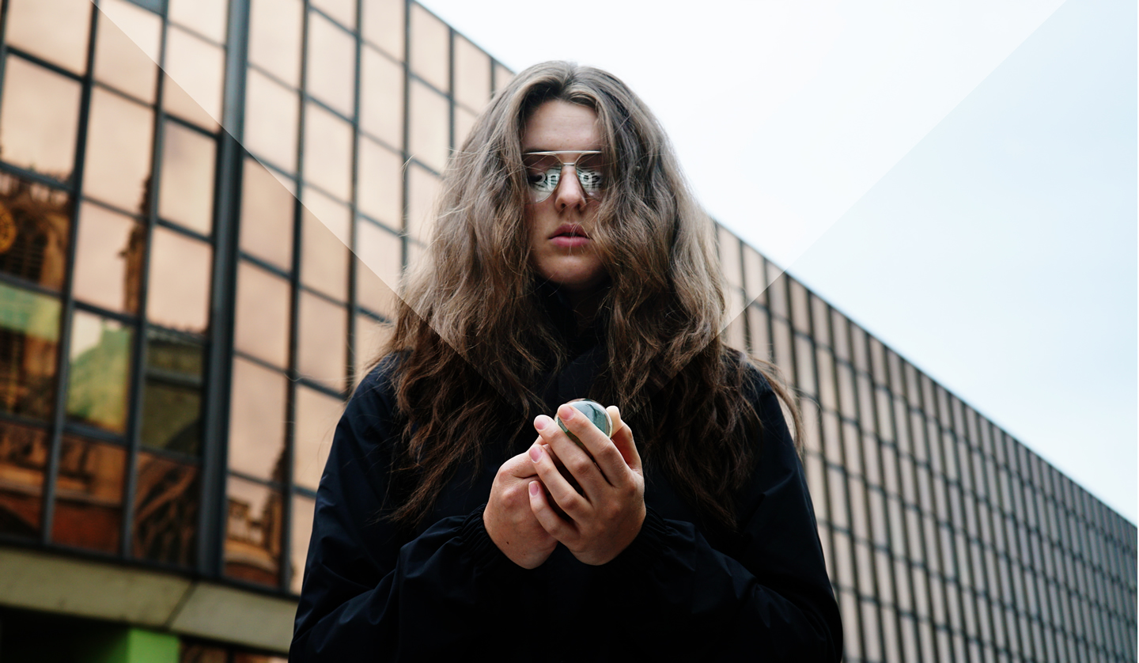

**Internationally renowned artists Blast Theory are inviting** **the people of Hull to imagine the city 80 years from now, as part of a science fiction project for Hull UK City of Culture 2017**

* Blast Theory asks people of Hull ‘what does your future look like?’ as *2097: We Made Ourselves Over* development phase begins
* Over 60s and 18-24 year-olds invited to public workshops on 24 and 25 November where they can have their say
* Young people to participate in exchange trip to Aarhus, Denmark
* Twenty-five Year Six pupils from five schools across Hull already signed up to participate

Will the Humber Bridge still be standing? Will the city be flooded? What if machines grew all of your food at the press of a button? If technology allowed us to speak to animals, what would your dog say? These are just some of the questions which will be posed to participants at workshops being held on 24 and 25 November.

The results of these workshops will create the foundation of *2097: We Made Ourselves Over*, a project co-commissioned by Hull UK City of Culture 2017 and Aarhus European Capital of Culture.

Blast Theory is kicking off *2097* by interviewing ‘future experts’ – specialists in the study of climate change, technology, community and economics - to explore the possible opportunities and challenges the future might hold for each city.

Now, using these conversations as inspiration, Hull residents are invited to take part in workshops in which they will be challenged to invent a new skyline for the city; re-imagining everyday life and proposing new forms of living.

Twenty-five Year Six pupils from five schools across the city have already signed up to take part. They will come together to work with children from different neighbourhoods, comparing what they feel about where they live and what they’d like to change.

An open call has also begun to recruit over 60s and young people aged 18-24 from around the city to get involved in workshops at [C4DI](http://www.c4di.co.uk/) in Hull’s Fruit Market on Friday 25 and Sat 26 November, 10am-4pm. The young people who take part will have a chance to experience a free exchange trip to Aarhus in Denmark, to tour the city and compare experiences and hopes for the future.

Nick Tandavanitj, Blast Theory Artist, says: “From artificial intelligence to future food - we’re speaking to experts about what the challenges of the coming century might be. But this project is really about how we as individuals and we as a city can set our own course for the future - what it is that we want our lives to be like. So we’re inviting people from around the city to come to a workshop - to talk to us, write down and draw their ideas about what Hull could be like.”

Martin Green, CEO and Director of Hull 2017, added: “The Blast Theory workshops are another way that Hull residents can get involved in 2017 and shape the outcome of projects throughout the year. Bringing together different generations to talk about the areas they live in will no doubt inspire some fantastic ideas and concepts - we look forward to seeing what comes out of the sessions later this month.”

Blast Theory will use the ideas that come out of these public workshops as the starting points for transforming familiar neighbourhoods around the city into extraordinary science fiction landscapes for a series of exciting events in 2017.

Those interested in taking part in a workshop should register by completing an online form, [here](https://h2017.formstack.com/forms/2097) by Friday 18 November, or by contacting Blast Theory on 01273 413455. Places are limited. If the workshop is oversubscribed, places will be allocated at random. For everyone who applies, there will other opportunities to take part in the project over the coming year.

Sign up to receive updates about other ways to get involved in *2097: We Made Ourselves Over*, at [www.wemadeourselvesover.com](http://www.wemadeourselvesover.com)

***For further information, interviews and images, please contact Chloe Barker, Blast Theory PR Consultant, on 07921 866109 or at*** [***chloegudrun@live.co.uk***](mailto:chloegudrun@live.co.uk) ***or Hannah Clapham and Clair Chamberlain for The Corner Shop PR / 020 7831 7657 /*** [***hannahc@thecornershoppr.com***](mailto:hannahc@thecornershoppr.com) ***/*** [***clair@thecornershoppr.com***](mailto:clair@thecornershoppr.com)

**About Blast Theory**

Blast Theory has been making interactive artworks that invite you to question your place in society for 25 years. Renowned internationally as one of the most adventurous artists’ groups creating groundbreaking new forms of performance and interactive art, the group has created work for the Venice Biennale and Sundance Film Festival. Led by Matt Adams, Ju Row Farr and Nick Tandavanitj, the group’s work explores the social and political aspects of technology. Drawing on popular culture and games, the work often blurs the boundaries between the real and the fictional.

www.blasttheory.co.uk

@blasttheory

**About Hull UK City of Culture 2017**

**Hull UK City of Culture 2017** is a 365 day programme of cultural events and creativity inspired by the city and told to the world. Hull secured the title of UK City of Culture 2017 in November 2013. It is only the second city to hold the title and the first in England.

**Divided into four seasons**, this nationally significant event draws on the distinctive spirit of the city and the artists, writers, directors, musicians, revolutionaries and thinkers that have made such a significant contribution to the development of art and ideas.

The Culture Company was set up to deliver the Hull 2017 programme and is an independent organisation with charitable status. It has raised £32 million, with over 60 partners supporting the project, including public bodies, lottery distributors, trusts and foundations and local and national businesses. Key contributions are coming from: **Host City** – Hull City Council; **Principal Partners** - Arts Council England, BBC, Big Lottery Fund, East Riding of Yorkshire Council, Heritage Lottery Fund, KCOM, KWL, Spirit of 2012, Yorkshire Water and the University of Hull; **Major Partners** –Associated British Ports, Arco, BP, the British Council, Green Port Hull, Hull Clinical Commissioning Group, MKM Building Supplies, P&O Ferries, Paul Hamlyn Foundation, Sewell Group, Siemens, Smith & Nephew and Wykeland Group.

68 per cent of the funding is dedicated to public facing activities, including the widest range of cultural events in every corner of the city, with a further 11 per cent for legacy and contingency. More than £5 million is being invested in volunteering, learning and community engagement. £1.6 million is being invested to ensure a legacy after 2017. This includes capacity building, such as supporting existing events so they can grow, staging curtain-raiser events, developing future programming for after 2017 and building a new platform to support a unified ticketing system for the city.

Hull 2017’s International Partners are: Aarhus, Denmark, which is European Capital of Culture 2017; Reykjavik, Iceland; Rotterdam, The Netherlands; and Freetown, Sierra Leone (twinned with Hull). These relationships are reflected in a number of events throughout the year.

For information go to [www.hull2017.co.uk](http://www.hull2017.co.uk)

Follow us on **Twitter** @2017Hull **Instagram** @2017hull **Facebook** HullCityofCulture

**About Aarhus European Capital of Culture**

Aarhus and the 18 other municipalities in Central Denmark Region celebrate our year as European Capital of Culture in 2017.

The title European Capital of Culture (ECoC) represents one of the most prestigious and prominent cultural events in Europe. Every year, two EU countries are appointed as host countries for the European Capital of Culture. In 2017 Pafos in Cyprus has also been nominated as ECOC. Copenhagen was the first Danish city to host the European Capital of Culture in 1996, and it will be many years before a Danish city can boast the title again.

European Capital of Culture Aarhus 2017 is deeply rooted in strong regional cooperation across the entire region. Royal patronage: HM Queen Margrethe II of Denmark. Official opening: Aarhus, Denmark, Saturday 21st January 2017

www.aarhus2017.dk/en/

Follow us on Social Media: **Facebook:** Aarhus 2017 – European Capital of Culture **Twitter:** @Aarhus2017 **Instagram:** @aarhus_2017

