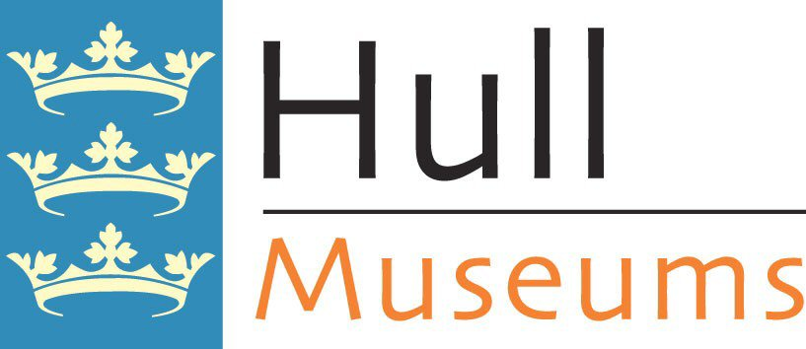

FILMING AGREEMENT

This form is a legal agreement between Hull Museums and (name of organization) requesting permission to reproduce items in the permanent collections of Hull Museums.

Reason:

Date & Time of Filming:

Conditions:

(name of organization) agrees the following:

- Filming will only be for the reasons stated on this form. Any other use will require a written agreement from Hull Museums and additional fees paid.

- Filming will not take place until a signed filming agreement is in place.

- Filming in stores, or where it is necessary to open gallery display cases, will be at the discretion of the curator in charge, who will supervise at all times. If the curator feels that objects in the collection are at risk, permission to film will be withdrawn

- Any damage to objects or facilities by the film crew will be the liability of the (name of organization), who will be responsible for all conservation or replacement costs.

- Acknowledgement must be made to Hull Museums in the finished programme in the following format ‘(name of museum): Hull Museums’.

Curator Signature: Date:

Declaration

I agree that any images, drawings, photocopies, or reproductions in any format, of items in the permanent collections of Hull Museums, produced by myself or my organization, or supplied by Hull Museums, may not be used without the written permission of Hull Museums.

Signature: Date:

Print Name:

