- Arts & Culture

  - Introduction
Arts & Culture is one of the key themes of Hull 2017, made up of three aims and their accompanying objectives:
- Aim 1: To produce a high-quality, exemplary programme of arts, culture and heritage, helping to position the UK City of Culture as a quadrennial national event
  - Objective 1: Deliver a 365-day programme that is ‘of the city’ yet outward looking, and which includes 60 commissions.
  - Objective 2: Improve understanding and appreciation of Hull’s heritage.
- Aim 2: To develop (new and existing) audiences for Hull and East Riding’s cultural offer locally, regionally, nationally and internationally
  - Objective 3: Increase total audiences for Hull’s arts, culture and heritage offer.
  - Objective 4: Increase engagement and participation in arts and heritage amongst Hull residents.
  - Objective 5: Increase the diversity of audiences for Hull’s arts and heritage offer.
- Aim 3: To develop the capacity and capabilities of the cultural sector
  - Objective 6: Develop the city’s cultural infrastructure through capacity building and collaborative work undertaken by/with Hull 2017 and its partners.
‘Back to Ours’ will be evaluated, referencing these aims and objectives, as well as identifying additional outcome areas not covered in the above, but linked to the project-specific aims and objectives (see Chapter 1).
  - Contribution to Overall Hull 2017 Programme
The ‘Back to Ours’ project consisted of four festivals that ran throughout school half terms across eight key venues in the North, East and West of the city. Across all festivals, performances toured the city in a strategic network, totalling 109 individual performances.
Events were ticketed, with prices ranging from £2.50 - £7.50.
Of the performances that formed part of ‘Back to Ours’, one was commissioned specifically for the event: Yvette was a one woman show that explored themes of gender, sexuality and growing up.
Table X: Festival Information
Festival | Dates
1 | 22 – 25 Feb 2017
2 | 30 May – 4 Jun 2017
3 | 31 Oct – 5 Nov 2017
4 | 13 – 18 Feb 2018

  - Quality of Back to Ours
To assess the quality of Back to Ours several questions were incorporated into the evaluation of the event. This included recognition of Arts Council England’s (ACE) Creative Case for Diversity and its Quality Metrics, as well as additional exploration linked to Heritage Lottery Fund (HLF) outcomes, which have been explored above in Section 2.1.
    - Creative Case for Diversity
ACE’s mission is ‘great art and culture for everyone’. They state that this can only be achieved through funding work that promotes and embeds diversity.
To assess how ‘Back to Ours’ promoted and embedded diversity, equal opportunities data was collected across the Core Project Team (see Appendix 1) and Audiences (see Section 2.9 and Appendix 22)
In reflecting on the equal opportunities data collected on the CPT, the youngest age group represented was 20-24 years and the oldest age group 40-44 years. As such, those guiding the project from the start were within adult age groups, above that usually termed “young people”.
In the CPT there was no disability representation or ethnic diversity, with all members selecting ‘White British’.
Peer assessors generally felt that diversity was achieved to some level across the project, taking into account the programming and community engagement strategies implemented by the CPT. The variety of events in the programme itself was also mentioned, with peer assessors suggesting that this made the festival accessible to a diverse audience.
“The festival engaged those not normally included, those not keen to get involved, it was successful in making families with young children feel comfortable.”
“It looks so far as though diversity has been taken into account and addressed through the programming and engagement strategies.”
“I think one of the things Back to Ours will do is to try its absolute best to include everyone, so everyone can come in at different angles.”
(Peer Assessors)
Peer Assessors also mentioned individual performances that successfully represented diversity in terms of their cast and content. Specifically, ‘Bedtime Stories’ and ‘Pillow Fight’ were seen to represent ethnic diversity effectively through having a mixed race cast.
“It was nice to see a range of performers from such different cultural backgrounds.”
“I think it was particularly nice to have a brother and sister of different races.”
(Peer Assessors)
Peer Assessors suggested that ‘SKIN’ effectively tackled gender themes, encouraging audiences to think about what it means to be male or female and societal pressures in this regard.
“I feel like diversity was a theme in itself and it was clearly represented in the range of ethnicities and physical body types in the cast. And of course the theme of gender - and what it means to be male and female was really interesting. I think it was sensitively explored and visually beautiful.” (Peer Assessor)
Peer assessors also felt that ‘Drip’ explored sexuality in a subtle and thought-provoking way, alongside other issues such as gender and socio-economic status.
“It explored gender, sexual orientation and at times socio-economic status and it did so in a subtle yet thought provoking way.”
“The whole sexuality theme was really interesting it was normalised and at the same time it really added to the feeling that you were living the experience with him.”
(Peer Assessors)
Feedback suggests that ‘Meet Fred’ encouraged audiences to reflect on and discuss themes and issues such as disability and the benefits system.
“He was going through life and we were going through it with him. It’s fantastic.”(Chat with Gran: Audience Member)

This potential to create dialogue through engaging content should be taken into consideration in the development of future projects and the ‘Back to Ours’ artistic programme, given that Hull 2017 aims to challenge perceptions of disability.
    - Quality Metrics
Following the guidelines for ACE Quality Metrics, the ‘Back to Ours’ evaluation asked the Quality Metrics of three respondent groups:
- The CPT (pre-festival 1 and post-festival 3);
- Peer Assessors (pre and post-event); and
- Audiences (post-event).
The average score out of 10 for each respondent group is presented in Table X overleaf. Please note, where N/A is represented in the table, this question was not asked of respondents.
On average, the Quality Metrics scored a minimum score of 5.5 out of 10, with the most frequent score being 8 out of 10. This suggests that Back to Ours was seen as being of high quality overall.
In terms of the CPT, the average score across all metrics increased from 8.2 to 8.4 out of 10, indicating that the ‘Back to Ours’ generally aligned with expectations.
The research suggested that this was due to the level of engagement with the community during the planning stage of the festival, which was seen as unusual for projects of this scale. The CPT also spoke about how the planning process was under constant review to ensure that the project adapted to feedback from a wide range of stakeholders.
“I think very few community arts projects take as much guidance and lead from the community people as Back To Ours does in its programming and engagement.”
“A lot of consideration went in to the process and this was constantly interrogated and revisited throughout.”
(CPT members)
There was also a clear sense of faith in the ability of the wider team working on ‘Back to Ours’, which ensured the rigour and quality of the project.
“The team worked well of thinking through every element.” (CPT member)
Peer Assessors in general, seem to have felt the reality of ‘Back to Ours’ had slightly exceeded the expectations they had at pre-delivery stage in some areas, whilst not meeting their expectations in other areas. Nine of the twelve Quality Metrics received a greater average score from peer assessors after attending the event and three received a marginally lower score.
The Quality Metrics where ‘Back to Ours’ least delivered, from the viewpoint of Peer Assessors (who were chosen for their specialist knowledge of events such as these and are used to attending many high quality arts events as part of their work) were:
- Distinctiveness: It will be / is different from things I’ve experienced before (7.4 out of 10);
- Challenge: It will be / is thought-provoking (7.9 out of 10);
- Originality: It will be / is ground-breaking (8.0 out of 10);
- Risk: The artists are really challenging/challenged themselves with this work (8.1 out of 10).
Peer assessors cited their professional experience of attending similar events, which meant they couldn’t score higher in terms of distinctiveness and originality. In terms of risk, it was felt that the artists at ‘Back to Ours’ were performing well-rehearsed touring productions rather than new pieces of work, which mitigated the risk to some extent.
Peer assessors were most positive about the local impact of ‘Back to Ours’ post-event with all assessors scoring the maximum possible -10 out of 10. The concept of using community venues as performance spaces was clearly supported by professionals in the sector, who felt that it made arts and culture events more accessible to those who are potentially disengaged.
“It was quite clear that a number of people in the audience were not regular attenders of arts and culture and probably wouldn't be unless you were doing interventions like this.”
“It's important to take art into the community to make it accessible for everyone. I knew some young people in the audience from a previous project which were from disadvantaged backgrounds and I was happy to see them there.”
“The more I see local communities using these kinds of venues for local engagement, the more I understand just how important it is to pursue these kinds of initiatives.”
(Peer Assessors)
Audience feedback indicated a preconception that performances would be of lower quality due to their setting within a community venue, however audience members were surprised about the professionalism and high level of production. Indeed, feedback suggests that the experience of ‘Back to Ours’ exceeded audience expectations in terms of quality.
“I thought it was amazing, I wasn’t really expecting that.” (Audience member: Chat with Gran)

“I don't know. I just think because of the location, because we're in a school, I sort of thought it would just be a bit of a predictor, a bit kind of low budget, but it's amazing so far. It's really professional and really creative activities going on.”(Audience member: Chat with Gran)

“It's not that it's always the case, but I think there’s maybe a perception that it will be a lower standard performance, a bit more amateur.” (Audience Focus Group Respondent)
Audience members also reflected on the excellent facilities within the venues and how effective they were as performance spaces.
“It’s a really, really good facility. Would definitely come again.” (Audience member: Chat with Gran)
“Because they're new buildings, they've got the most fantastic purpose-built theatre spaces. When I was in school, you'd be more like an assembly hall. They've got proper theatres! It's really plush.” (Audience Focus Group Respondent)
“When I came, I thought, well, this is better than I thought. I wasn't expecting it to be as open as it was. I saw the band there, with two supporting acts, as well. The acoustics is really good.” ((Audience Focus Group Respondent)
“I thought the Freedom Centre in particular was very impressive as a space to see a band, it was a great venue.” (Audience Focus Group Respondent)
There was however some negative feedback around the lack of tiered seating at certain venues raised by Peer Assessors and Artists, who felt that this affected the audience’s viewing experience. This appeared to be a particular issue at Hotel Paradiso performances, where some audience members chose to stand to get a better view.

“We really struggled with that venue… People at the back couldn't really see because we were all on the flat. So we'd have been better if we had a raise, or the audience had some temporary raising with some stage deck.”
“It’s different because obviously it's not tiered seating, which is a disadvantage.”
(Artists)
“The space was very usable but could have been thought out a bit better - for example raised seats. I did struggle to see and when it's purely a show about spectacle that's tough.”
“I couldn't see the work that was going on on the stage when I was seated… If you were using the space again, either there needs to be a stage for the performers to elevate them, or there needs to be some kind of temporary raising of seats for the audience.”
(Peer Assessors)
Audience members also spoke about the quality of the performances, suggesting that they were excellent value considering the low ticket cost. Many commented on the skill of the performers themselves and their ability to engage the audience.

“I remember it made me cry. And I came away and I thought, who thought dancing could bring you to tears. It was so powerful. And the way their bodies told the story.” (Audience Focus Group Respondent on SKIN)
“I don’t even think I thought of anything else the whole time I was there, I was completely mesmerised by her.” (Audience Member: Chat with Gran respondent on ‘Joan’)
“I thought it was really mesmerising, it sort of helped you take yourself out of yourself for a good hour. I’m amazed that the physical strength and the coordination and I don’t think you’d, anybody could anticipate really how much work would have gone into making that as spectacular as it was.” (Audience Member: Chat with Gran respondent on ‘Tipping Point’)
From an audience perspective therefore, ‘Back to Ours’ appears to have successfully provided opportunities to experience high quality arts and culture performance in effective community venues in neighbourhoods across Hull.

Table X: ACE Quality Metric – Average Scores Across Respondent Groups
ACE Quality Metrics | CPT  Pre-Event  (n=2) | Peers  Pre-Event  (n=8) | CPT  Post-Event  (n=5) | Peers  Post-Event  (n=8) | Audiences  Post-Event Avg  (n=658)
Presentation: It will be / is well produced and presented | 9.0 | 7.8 | 7.8 | 8.5 | 9.2
Distinctiveness: It will be / is different from things I’ve experienced before | 8.5 | 6.8 | 8.6 | 7.4 | 8.5
Challenge: It will be / is thought-provoking | 8.5 | 8.2 | 8.0 | 7.9 | 7.5
Captivation: It will be / is absorbing and will hold my attention | 8.0 | 8.2 | 8.8 | 9.6 | 9.1
Enthusiasm: I will / would come to something like this again | 8.0 | 8.8 | 9.0 | 9.5 | 9.5
Local impact: It is / is important that it's happening here (in Hull) | 9.5 | 9.7 | 8.8 | 10.0 | 9.2
Concept: It will be / is an interesting idea | 8.0 | 9.4 | 8.5 | 9.3 | 9.2
Relevance: It will have/has something to say about the world in which we live | 7.5 | 7.7 | 8.0 | 8.9 | 7.4
Rigour: It will be / is well thought through and put together | 9.0 | 8.7 | 8.5 | 9.4 | 9.0
Originality: It will be / is ground-breaking | 8.0 | 7.3 | 8.3 | 8.0 | N/A
Risk: The artists are really challenging/challenged themselves with this work | 5.5 | 8.1 | 7.5 | 8.1 | N/A
Excellence: It will be / is one of the best examples of its type | 8.5 | 8.0 | 9.3 | 8.8 | N/A

Table X: ACE Quality Metric – Average Scores Across Audiences
ACE Quality Metrics | Audiences  Post-Event Festival 1  (n=0) | Audiences  Post-Event Festival 2  (n=96) | Audiences  Post-Event Festival 3  (n=280) | Audiences  Post-Event Festival 4  (n=282)
Presentation: It will be / is well produced and presented | N/A | 9.3 | 9.2 | 9.0
Distinctiveness: It will be / is different from things I’ve experienced before | N/A | 8.6 | 8.2 | 8.6
Challenge: It will be / is thought-provoking | N/A | 7.5 | 7.8 | 7.1
Captivation: It will be / is absorbing and will hold my attention | N/A | 9.3 | 9.0 | 8.9
Enthusiasm: I will / would come to something like this again | N/A | 9.4 | 9.5 | 9.5
Local impact: It is / is important that it's happening here (in the community) | N/A | 8.8 | 9.4 | 9.4
Concept: It will be / is an interesting idea | N/A | 9.2 | 9.3 | 9.2
Relevance: It will have/has something to say about the world in which we live | N/A | N/A | 7.6 | 7.1
Rigour: It will is well thought through and put together | N/A | N/A | 9.0 | 9.0
Originality: It will be / is ground-breaking | N/A | N/A | N/A | N/A
Risk: The artists are really challenging/challenged themselves with this work | N/A | N/A | N/A | N/A
Excellence: It will be / is one of the best examples of its type | N/A | N/A | N/A | N/A

  - Ticket Analysis for Back to Ours
Back to Ours was a paid ticketed event, with a total of 21,817 tickets available:
- Of the 21,817 that went on general sale, 12,466 were sold across the four festivals.
- 3,954 were locked to distribute amongst Hull residents (via community groups), partners and staff.
Table X below shows that ticket sales peaked at Festival 4 with 4,505 sold, which equates to 36.1% of all sales.
Table X: Ticket data ‘Back to Ours’
Excludes Guests and VIPs | Festival 1 | Festival 2 | Festival 3 | Festival 4 | Total
Total tickets sold | 2,711 | 2,934 | 2,316 | 4,505 | 12,466
Comps | 178 | 81 | 226 | 194 | 679

  - ‘Back to Ours’ Attendance
Of the audience survey respondents, 29% had attended a previous ‘Back to Ours’ festival at the time they were interviewed, with 19% having attended the festival in February, 14% in May and 9% in October. Women, respondents from Hull and respondents from the second most deprived areas of Hull were more likely to have attended at least one previous ‘Back to Ours’ festival, suggesting that the project has been successful in attracting repeat visitors locally and potentially family groups.
Survey data indicates that some audience members attended more than one show in the same festival (see Table X below).
- On average, 1 in 4 audience members attended two or more performances in the same festival.
- According to survey data, no audience members attended more than one show in Festival 1. This is perhaps due to the fact that the project was yet to build a reputation, so audience members were less likely to take a risk on booking tickets for multiple performances.
- Audience members at Festival 2 were the most likely to attend two performances, with 45% doing so.

Table X: Number of performances attended
No. of shows attended | Festival 1 Audience | Festival 2 Audience | Festival 3 Audience | Festival 4 Audience | Average
1 | 100% | 55% | 73% | 74% | 75.5%
2 | 0% | 45% | 16% | 17% | 19.5%
3 | 0% | 0% | 11% | 5% | 4.0%
4 | 0% | 0% | 0% | 3% | 0.8%

    - Capacity Filled
Across all festivals, an average of 57.1% capacity was filled. This varied hugely across shows however, with some Picture House screenings achieving as little as 6% capacity and live music acts Black Grape and Pigeon Detectives reaching 100% and 98% capacity respectively.
Some audience focus group respondents expressed disappointment that some of the ‘Back to Ours’ performances had low audience numbers. It was generally agreed that low attendance had a negative effect on the overall experience as it created a slightly uncomfortable atmosphere.
Festival 4 was the most successful in terms of overall venue capacity filled, with three quarters of all seats sold. Festival 4 also had the largest capacity in with 6,010 seats available compared to an average of 5,373 across the other festivals. This is potentially due to the raised profile and awareness of ‘Back to Ours’ as its reputation built throughout the year.
Table X: Total Capacity Filled
Festival | Total capacity | Seats sold | Capacity filled % | Value of sales | Average ticket cost
Festival 1 | 4,866 | 2,711 | 55.7% | £8,930 | £3.45
Festival 2 | 5,880 | 2,934 | 49.9% | £10,765 | £3.84
Festival 3 | 5,061 | 2,316 | 45.8% | £8,487 | £3.29
Festival 4 | 6,010 | 4,505 | 75.0% | £20,590 | £3.75
Total | 21,817 | 12,466 | 57.1% | £48,772 | £3.58

  - Demographics of Audiences
In comparing the demographic breakdown of audience for 'Back to Ours’ across the four festivals, here are a number of key differences: (see Tables X - X):
- ‘Back to Ours’ attracted a significantly higher proportion of females overall, with an average of 74% compared to 24.7% of males. Festival 2 was the least likely to attract males, with only 6.3%.
- Festival 2 attracted a slightly more diverse audience in terms of ethnicity, with 7.3% identifying as non-White British, compared to an overall average of 4.4% across festivals.
- The age of audiences in Festival 4 was slightly more diverse, attracting a larger percentage of respondents under the age of 35 (33% compared to an overall average 19.6% across festivals).
- Festival 4 was the least likely to have audience members limited by disabilities with 5.8% compared to an average of 8.5% across all festivals. This may correspond with the lower overall age of the audience at this festival.
- Festivals 1 – 4 attracted a similar percentage of Hull residents, with an overall average of 61%, indicating that ‘Back to Ours’ didn’t attract audience members from further afield as it grew in popularity.

Table X: Area of Residence
 | BTO Festival 1  (n=) | BTO Festival 2 | BTO Festival 3 | BTO Festival 4 | Average  (n=XXX)
Hull | 62.0% | 59.0% | 61.0% | 62.0% | 61.0%
East Riding | 30.0% | 33.0% | 31.0% | 34.0% | 32.0%
Rest of UK | 8.0% | 7.0% | 7.0% | 4.0% | 7.0%
Overseas | 0.0% | 0.0% | 0.0% | 0.0% | 0.0%
Table X: Gender
 | BTO Festival 1  (n=77) | BTO Festival 2  (n=96) | BTO Festival 3  (n=280) | BTO Festival 4  (n=282) | Average  (n=735)
Male | 28.6% | 6.3% | 36.5% | 27.4% | 28.2%
Female | 70.1% | 89.6% | 63.5% | 72.6% | 71.1%
Transgender | 0.0% | 1.0% | 0.0% | 0.0% | 0.1%
Prefer not to say | 1.3% | 3% | 0.0% | 0.0% | 0.5%

Table X: Employment Status
 | BTO Festival 1  (n=0) | BTO Festival 2  (n=96) | BTO Festival 3  (n=280) | BTO Festival 4  (n=282) | Average  (n=658)
Employed / working full or part time | N/A | 66.7% | 64.4% | 68.4% | 66.4%
Self-employed | N/A | 7.3% | 9.3% | 7.9% | 8.4%
Unemployed | N/A | 2.1% | 3.6% | 1.1% | 2.3%
On a government scheme | N/A | 0.0% | 0.0% | 0.0% | 0.0%
Looking after family / home | N/A | 3.1% | 5.0% | 5.3% | 4.8%
Unable to work | N/A | 1.0% | 2.5% | 1.5% | 1.9%
Retired | N/A | 13.5% | 10.6% | 10.1% | 10.8%
Student | N/A | 2.1% | 3.8% | 4.9% | 4.0%
Prefer not to say | N/A | 4.2% | 0.9% | 0.8% | 1.3%

Table X: Ethnicity
 | BTO Festival 1  (n=77) | BTO Festival 2  (n=96) | BTO Festival 3  (n=280) | BTO Festival 4  (n=282) | Average  (n=735)
White British | 97.4% | 89.6% | 94.5% | 94.7% | 94.3%
White Other | 1.3% | 4.2% | 3.5% | 2.9% | 3.1%
Mixed/Multiple Ethnic | 0.0% | 2.1% | 0.3% | 0.8% | 0.8%
Asian/Asian British | 0.0% | 1.0% | 0.4% | 0.5% | 0.3%
Black/Black British | 0.0% | 0.0% | 0.0% | 0.0% | 0.0%
Other ethnic background | 0.0% | 0.0% | 0.0% | 0.4% | 0.1%
Prefer not to say | 1.3% | 3.1% | 1.3% | 0.8% | 1.3%
Table X: Age
 | BTO Festival 1  (n=77) | BTO Festival 2  (n=96) | BTO Festival 3  (n=280) | BTO Festival 4  (n=282) | Average  (n=735)
16-17 years | 1.3% | 1.0% | 0.0% | 2.7% | 1.3%
18-19 years | 0.0% | 0.0% | 1.2% | 0.9% | 0.8%
20-24 years | 1.3% | 1.0% | 1.8% | 6.0% | 3.7%
25-29 years | 1.3% | 4.2% | 4.9% | 7.9% | 5.2%
30-34 years | 7.8% | 8.3% | 11.1% | 15.5% | 12.1%
35-44 years | 33.8% | 33.3% | 30.5% | 32.8% | 32.1%
45-54 years | 23.4% | 24.0% | 25.8% | 16.0% | 21.6%
55-64 years | 22.1% | 20.8% | 14.6% | 9.8% | 14.3%
65-74 years | 6.5% | 4.2% | 5.0% | 6.8% | 5.7%
75+ years | 0% | 0.0% | 1.8% | 1.0% | 1.1%
Prefer not to say | 2.6% | 3.1% | 3.3% | 0.6% | 2.2%

Table X: Disability
 | BTO Festival 1  (n=77) | BTO Festival 2  (n=96) | BTO Festival 3  (n=280) | BTO Festival 4  (n=282) | Average  (n=735)
Yes – limited a little | 7.8% | 7.3% | 5.1% | 3.0% | 4.9%
Yes – limited a lot | 1.3% | 2.1% | 4.5% | 2.8% | 3.2%
No | 88.3% | 87.5% | 89.5% | 93.4% | 90.6%
Prefer not to say | 2.6% | 3.1% | 1.0% | 0.8% | 1.3%

  - Mapping of Audiences

Back to Ours
As ‘Back to Ours’ was a ticketed event, there is postcode data linked to all those who booked a ticket. This is the most comprehensive post code data set linked to the event, so has been used to map the audiences that came to ‘Back to Ours’.
Hull City Council’s Business Intelligence Team have undertaken a post code analysis of this data set on behalf of Hull 2017, which shows (see Tables X – X and Maps 1 to 3) the following from those that could be successfully matched to a post code:
- 9 in 10 (91%) were from a HU post code area, with very much smaller representations from YO, DN, LS and S post code areas;
- The top eleven post code districts in descending order were HU5, HU7, HU8, HU9, HU4, HU17, HU16, HU13, HU6, HU3, HU10;
- 61% of post codes were in the Kingston Upon Hull local authority and much of the remainder from East Riding of Yorkshire local authority (32%); and
- The wards most commonly represented were Avenue, Holderness, Hessle, Kings Park and Bricknell.
For Tables showing a more comprehensive breakdown of postcode date, see Appendix 9.
Table X: Back to Ours - Post Code Area Festivals average
Postcode Area | Postcode Name | Count | Percentage
HU | Hull | 719.8 | 91.0%
YO | York | 16.8 | 2.0%
DN | Doncaster | 15.3 | 2.0%
LS | Leeds | 4.5 | 1.0%
S | Sheffield | 3.3 | 0.0%

Table X: Back to Ours - Post Code District Festivals Average
Postcode District | Count | Percentage | Postcode District | Count | Percentage
HU5 | 153 | 20.0% | HU16 | 41 | 5.0%
HU7 | 81 | 10.0% | HU13 | 34 | 4.0%
HU8 | 78 | 9.0% | HU6 | 31 | 4.0%
HU9 | 63 | 8.0% | HU3 | 31 | 4.0%
HU4 | 48 | 6.0% | HU10 | 28 | 4.0%
HU17 | 41 | 5.0%

Table X: Back to Ours – Hull & East Riding Post Code Sector Festivals Average
Postcode Sector | Count | Percentage | Postcode Sector | Count | Percentage
HU5 3 | 74 | 10.0% | HU8 0 | 24 | 3.0%
HU7 4 | 40 | 5.0% | HU8 8 | 24 | 3.0%
HU5 4 | 33 | 4.0% | HU9 3 | 24 | 3.0%
HU8 9 | 29 | 3.0% | HU5 5 | 23 | 3.0%
HU7 3 | 28 | 3.0% | HU16 5 | 22 | 3.0%
HU4 6 | 27 | 3.0% | HU4 7 | 22 | 3.0%

Table X: Back to Ours - Local Authority Festivals Average
Local Authority Area | Count | Percentage
Hull | 479 | 61.0%
East Riding | 256 | 32.0%
Hull and ER Sub Total | 734 | 93.0%
Other Local Authorities | 47 | 7.0%

Table X: Back to Ours - Hull & East Riding Wards Festivals Average
Ward | Local Authority | Count | Percentage
Avenue | Hull | 83 | 12.0%
Holderness | Hull | 37 | 5.0%
Hessle | East Riding | 34 | 5.0%
Kings Park | Hull | 33 | 5.0%
Bricknell | Hull | 30 | 4.0%

Map 1: Post Code Mapping – Back to Ours from Hull Festival 1

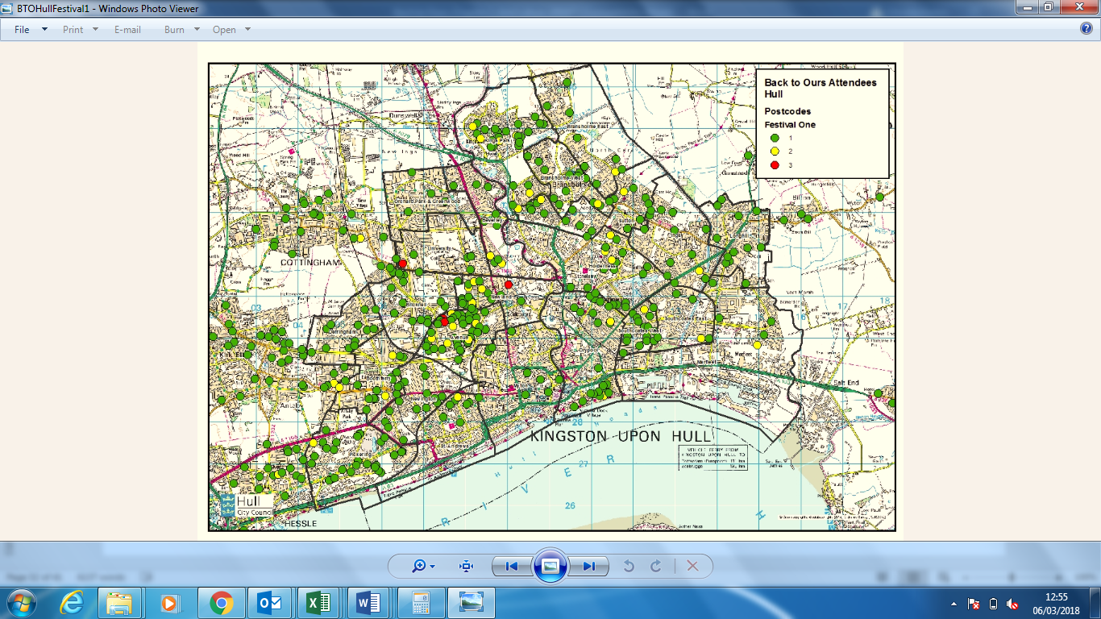
Map 2: Post Code Mapping – Back to Ours from Hull Festival 2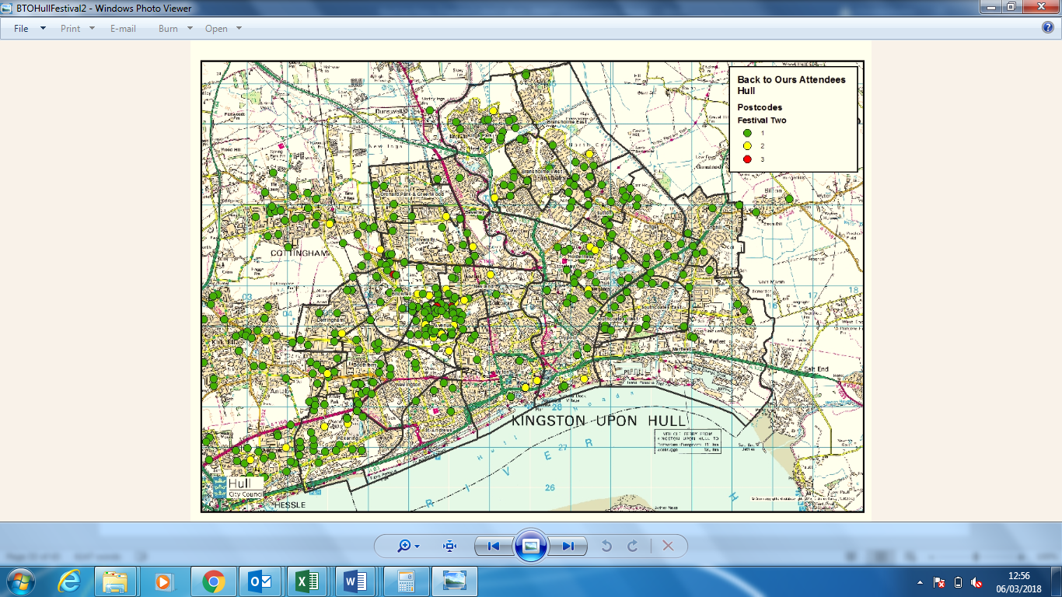
Map 3: Post Code Mapping – Back to Ours from Hull Festival 3
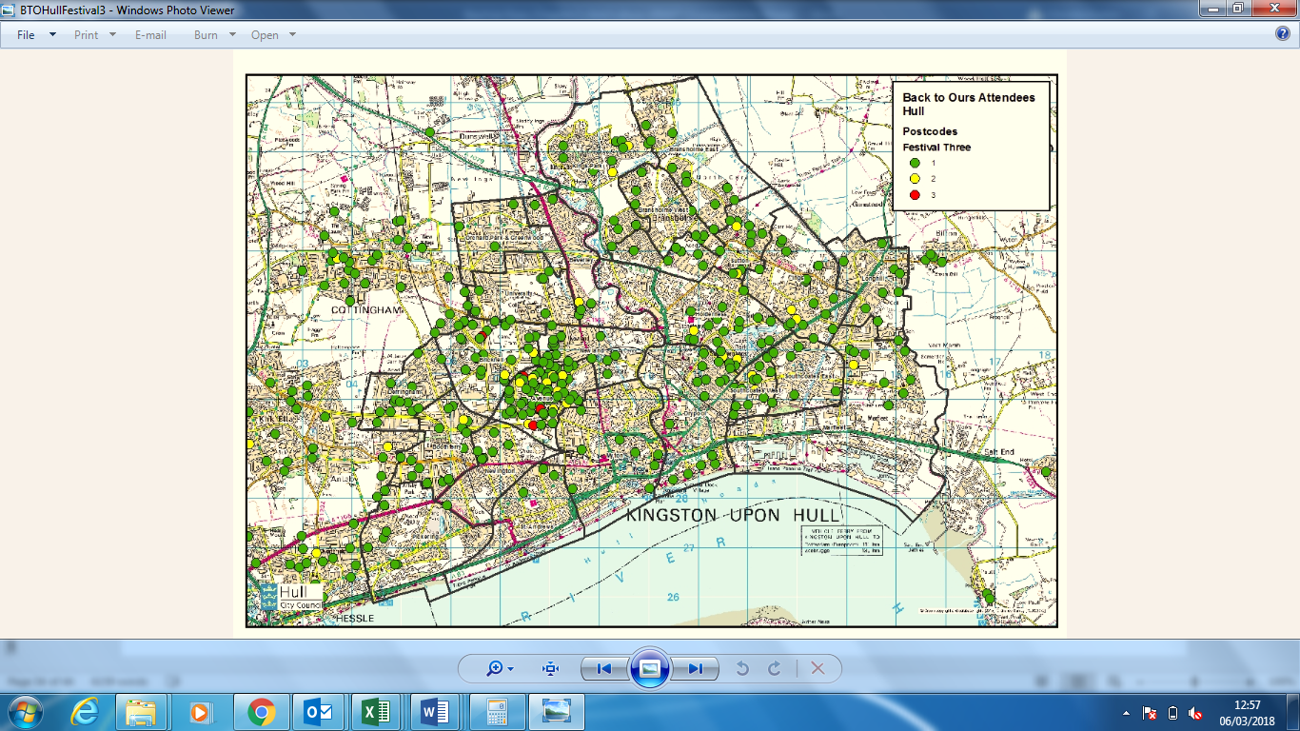
Map 4: Post Code Mapping – Back to Ours from Hull Festival 4
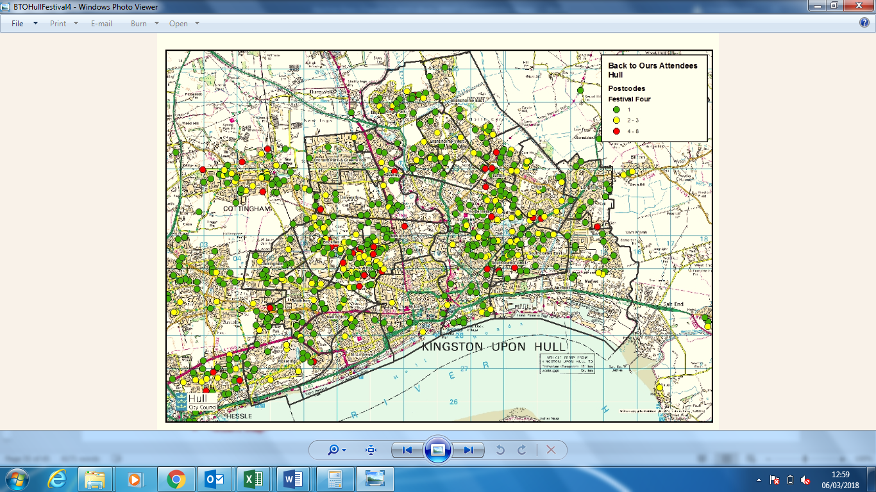
Map 5: Post Code Mapping – Back to Ours East from Hull LSOA
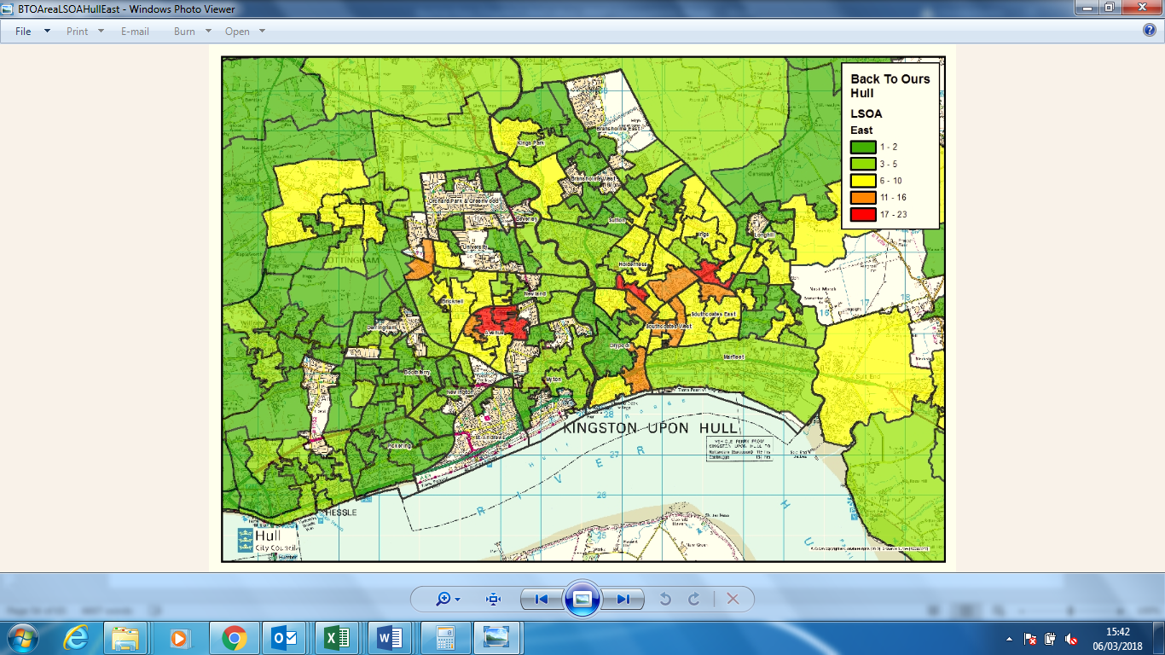

Map 6: Post Code Mapping – Back to Ours North from Hull LSOA
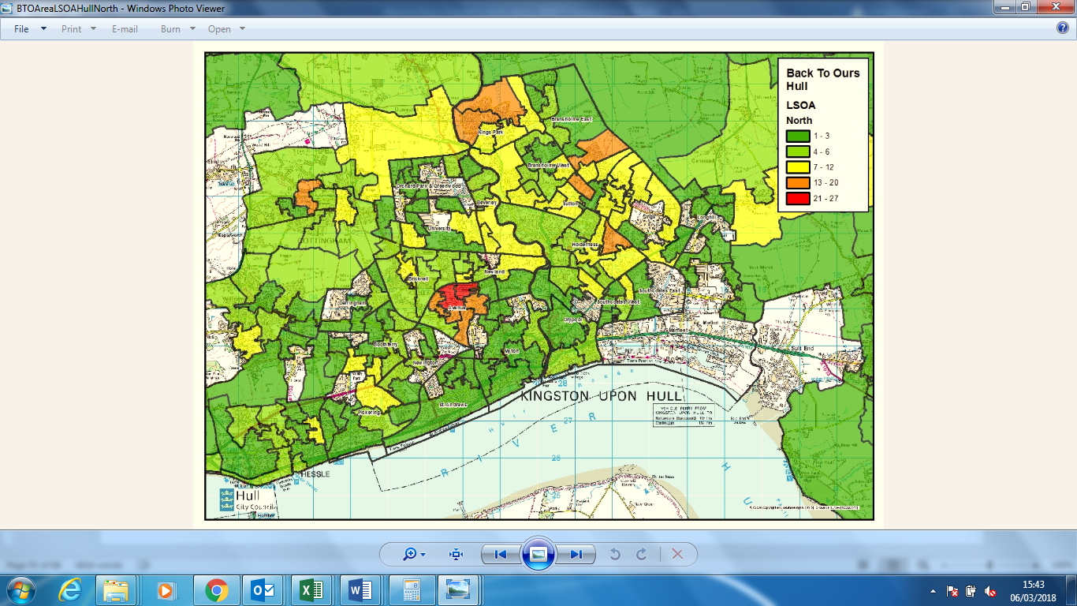
Map 7: Post Code Mapping – Back to Ours West from Hull LSOA
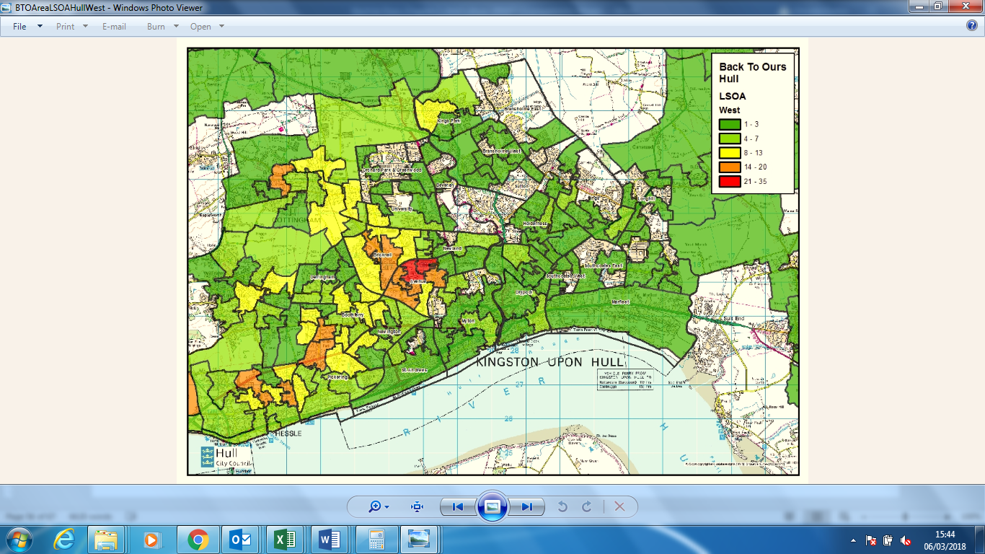

    - Post Code Mapping
Overall, ‘Back to Ours’ reached a wide spread of audiences throughout Hull, indicating that it was successful in reaching all areas of the city as a whole.
Given that one of the primary aims of ‘Back to Ours’ was to provide opportunities for people to engage with arts and culture events in their own neighbourhoods, the festival looked to target those in the local areas surrounding the venues in the North, East and West of the city.
Although the numbers closest to the venues do not necessarily represent a large percentage of total audience, Maps 5 – 7 show that the project achieved higher density of audience numbers from areas local to venues in the North, East and West of the city.
In all areas, the Avenues ward represented a high density of audience numbers. Historical data shows that this area of Hull is the most engaged with arts and culture, so are willing to travel to attend events.
North venues attracted the most audiences from the following wards: (See Map 6):
- Kings Park;
- Bransholme West;
- Sutton;
- Holderness; and
- Avenues.
East venues attracted the most audiences from the following wards (see Map 5):
- Southcoates East;
- Southcoates West;
- Drypool;
- Avenues; and
- University.

West venues attracted the most audiences from the following wards (see Map 7):

- Avenues;
- Pickering; and
- Bricknell.

3.10.3 Indices of Deprivation
The Indices of Deprivation are prepared using the Lower Super Output Area (LSOA) geography, which has the dual benefits of consistent size throughout England, and being stable over time so that changes in deprivation levels can be measured.
There are 32,844 LSOAs in England (166 in Kingston upon Hull). Deprivation scores are calculated for each LSOA and they are then ranked from 1 (most deprived) to 32,844 (least deprived). The rankings are often reported as deciles of deprivation from 0-10% (most deprived), 10-20%, 20-30%, etc. and 90-100% (least deprived).
It should be noted that:
- The Indices of Deprivation measure relative deprivation, not absolute.
- Not all residents of deprived areas are deprived, and not all deprived people live in deprived areas.
Utilising the post code data for Hull attendees of ‘Back to Ours’ festivals 1-4 and Hull 2017 overall, attendees have been broken down by deprivation deciles (see Tables X-X).
Table X: Deprivation Decile – ‘Back to Ours’ Festival 1
 | Hull Attendees  (n=77) | All Hull Residents | Difference: Hull Attendees vs. All Hull Residents
10% Most Deprived | 24.1% | 45.1% | -21.0%
10%-20% Deprived | 7.0% | 7.7% | -0.7%
20%-30% Deprived | 16.4% | 11.8% | +4.6%
30%-40% Deprived | 15.9% | 10.8% | +5.1%
40%-50% Deprived | 15.2% | 9.7% | +5.5%
50%-60% Deprived | 7.2% | 6.3% | +0.9%
60%-70% Deprived | 8.4% | 4.6% | +3.8%
70%-80% Deprived | 5.1% | 3.4% | +1.7%
80%-90% Deprived | 0.7% | 0.6% | +0.1%
90%-100% Deprived | 0.0% | 0.0% | 0.0%

Table X: Deprivation Decile – ‘Back to Ours’ Festival 2
 | Hull Attendees  (n=96) | All Hull Residents | Difference: Hull Attendees vs. All Hull Residents
10% Most Deprived | 19.6% | 45.1% | -25.5%
10%-20% Deprived | 11.2% | 7.7% | +3.5%
20%-30% Deprived | 12.9% | 11.8% | +1.1%
30%-40% Deprived | 17.4% | 10.8% | +6.6%
40%-50% Deprived | 15.1% | 9.7% | +5.4%
50%-60% Deprived | 8.4% | 6.3% | +2.1%
60%-70% Deprived | 9.8% | 4.6% | +5.2%
70%-80% Deprived | 4.5% | 3.4% | +1.1%
80%-90% Deprived | 1.1% | 0.6% | +0.5%
90%-100% Deprived | 0.0% | 0.0% | 0.0%

Table X: Deprivation Decile – ‘Back to Ours’ Festival 3
 | Hull Attendees  (n=280) | All Hull Residents | Difference: Hull Attendees vs. All Hull Residents
10% Most Deprived | 21.6% | 45.1% | -23.5%
10%-20% Deprived | 9.0% | 7.7% | +1.3%
20%-30% Deprived | 16.0% | 11.8% | +4.2%
30%-40% Deprived | 19.4% | 10.8% | +8.6%
40%-50% Deprived | 16.3% | 9.7% | +6.6%
50%-60% Deprived | 5.9% | 6.3% | -0.4%
60%-70% Deprived | 7.9% | 4.6% | +1.1%
70%-80% Deprived | 3.1% | 3.4% | -0.3%
80%-90% Deprived | 0.8% | 0.6% | +0.2%
90%-100% Deprived | 0.0% | 0.0% | 0.0%

Table X: Deprivation Decile – ‘Back to Ours’ Festival 4
 | Hull Attendees  (n=282) | All Hull Residents | Difference: Hull Attendees vs. All Hull Residents
10% Most Deprived | 19.7% | 45.1% | -25.4%
10%-20% Deprived | 8.4% | 7.7% | +0.7%
20%-30% Deprived | 16.9% | 11.8% | +5.1%
30%-40% Deprived | 15.1% | 10.8% | +4.3%
40%-50% Deprived | 14.6% | 9.7% | +4.9%
50%-60% Deprived | 7.6% | 6.3% | +1.3%
60%-70% Deprived | 8.6% | 4.6% | +4.0%
70%-80% Deprived | 7.1% | 3.4% | +3.7%
80%-90% Deprived | 1.9% | 0.6% | +1.3%
90%-100% Deprived | 0.0% | 0.0% | 0.0%

Table X: Deprivation Decile – ‘Back to Ours’ Festivals total
 | Hull Attendees  (n=735) | All Hull Residents | Difference: Hull Attendees vs. All Hull Residents
10% Most Deprived | 21.3% | 45.1% | -23.8%
10%-20% Deprived | 8.7% | 7.7% | +1.0%
20%-30% Deprived | 15.5% | 11.8% | +3.7%
30%-40% Deprived | 16.9% | 10.8% | +6.1%
40%-50% Deprived | 15.3% | 9.7% | +5.6%
50%-60% Deprived | 7.3% | 6.3% | +1.0%
60%-70% Deprived | 8.7% | 4.6% | +4.1%
70%-80% Deprived | 4.9% | 3.4% | +1.5%
80%-90% Deprived | 1.2% | 0.6% | +0.6%
90%-100% Deprived | 0.0% | 0.0% | 0.0%

Table X: Deprivation Decile – All Hull 2017 events
 | Hull Attendees  (n=1,858) | All Hull Residents | Difference: Hull Attendees vs. All Hull Residents
10% Most Deprived | 26.70% | 45.1% | -18.40%
10%-20% Deprived | 8.9% | 7.7% | -1.2%
20%-30% Deprived | 13.70% | 11.8% | -1.90%
30%-40% Deprived | 13.90% | 10.8% | -3.10%
40%-50% Deprived | 14.00% | 9.7% | -4.30%
50%-60% Deprived | 9.00% | 6.3% | -2.70%
60%-70% Deprived | 8.00% | 4.6% | -3.40%
70%-80% Deprived | 4.80% | 3.4% | -1.40%
80%-90% Deprived | 1.00% | 0.6% | -0.40%
90%-100% Deprived | 0.00% | 0.0% | 0.00%
This data shows that of the four festivals, the first ‘Back to Ours’ has been the most successful in attracting residents from the most deprived areas of the city:
- Festival 1 attracted 4.5% more residents from the 10% most deprived LSOAs than Festival 2, 2.5% more than Festival 3 and 4.4% more than Festival 4;
- In comparison to Hull 2017 events overall, ‘Back to Ours’ was less successful in attracting residents from the 10% most deprived LSOAs, achieving 21.3% compared to Hull 2017’s 26.7%.
- The most highly overrepresented decile for ‘Back to Ours’ overall was the 30 %– 40% deprived.
Despite this success in diversifying audiences, relative to the population of Kingston Upon Hull, residents from the 10% most deprived deciles are still under-represented by 23.8% with the ‘Back to Ours’ audience. This indicates that although steps have been taken to remove barriers to engagement, more consultation needs to be done to explore further into what would encourage attendance to events.
    - Barriers to Engagement
The following barriers to engagement were identified in consultation with non-audience members in the local areas surrounding the ‘Back to Ours’ venues:
- Lack of time
There was a perception in some respondents that they didn’t have enough time to attend events, with some mentioning that working full time made the festival inconvenient for them.

“I’d go watch it when it’s on but I work full time so I’m not always there to see it.”

“Because I work as well you see now, so it’s just getting the time.”
(Audience mini interviews)

- Lack of awareness
Some respondents said that although they’d heard about ‘Back to Ours’, they didn’t know much about it or when it was on.

“I’ve seen it, but I don’t know about it.”

“I’ve seen advertisements for it but I’ve never looked into it.
I just didn’t really get what it was all about to be honest.”
(Audience mini interviews)

- Mobility
An older couple said that their concerns around parking at the venues had put them off going to ‘Back to Ours’ because they had mobility issues and don’t go out very often.

“Sometimes it's being able to get parked up somewhere, because we're not as mobile as we'd like to be.” (Audience mini interview)

- Lack of interest
There was a clear lack of interest in some respondents, who said they wouldn’t attend ‘Back to Ours’ because the programme didn’t appeal to them and it wasn’t something they would usually do.

“Culture, it's marvellous for the people that want to go and see it, but we don't.” (Audience mini interview)
- Having someone to go with
Some respondents said would only ever attend arts and culture events if other family members took them or they were part of a bigger group.
These findings suggest that increased awareness of ‘Back to Ours’ in terms of parking access, the range of performance dates and times and the programme itself has the potential to boost attendance in those who are disengaged. As such, it is recommended that the festival marketing explores how to communicate these elements more widely to potential audiences.
  - Group Composition
    - Post-Event Surveys
Within the post-event audience surveys for ‘Back to Ours’, audiences were asked about their group size and the ages of people within their group (see Tables X & X):
Table X: Group Size
Size of Group | Back to Ours  (n=735)*
Mean Group Size | 3.6
Mode Group Size | 4.0
Table X: Group Size – Adults and Children
Size of Group | Back to Ours  (n=735)*
Children | 1.0
Adults | 2.6
Mean Group Size | 3.6
This data suggests that ‘Back to Ours’ was successful in engaging a family audience with an average group size of 3.6, made up of 2.6 adults and 1 child (see Chapter 5 Section 6.3.3 for further detail).
  - Intentions to Attend More Events & Activities
Intentions to attend or participate in other events and activities programmed for Hull UK City of Culture 2017 were tested across audiences.
Responses show that 86.6% of audience members had been to, taken part in or were planning to attend other activities programmed for Hull 2017.
Table X: Future Intentions to Attend UK City of Culture 2017
 | Back to Ours (n=735)*
Yes | 86.6%
No | 8.3%
Not Sure | 5.1%
When comparing by different demographics:
- Those from outside Hull and East Riding were 23% less likely to be planning to attend or participate in other Hull 2017 activities or events, suggesting location is a potential barrier to engagement for these visitors.
- Those from the most deprived areas of Hull were 7% less likely to be planning to attend or participate in other Hull 2017 activities or events compared to the least deprived, suggesting that they face a greater number of barriers to engagement than those from more affluent areas of the city.
  - Attendance & Participation – Arts & Culture
In order to identify first-time visitors and lapsed attenders / participants within the people attending ‘Back to Ours’ audiences were asked if they had attended or taken part in a range of arts, cultural and heritage events and activities in the previous 12 months.
Overall, 93.2% had attended a museum, gallery or other historic attraction and 92.5% had attended a creative, artistic, dance, theatrical or music event or performance in the last 12 months. 56.8% had taken part in a creative, artistic, dance, theatrical or music activity or spent time doing a craft in the last 12 months.
Although this suggests that many of the audience were engaged, therefore not necessarily the target audience for this project, there were indications that prior to 2017, these groups were not as open to taking part in arts and cultural events:
“We very rarely go to any of this sort of stuff, it’s because of the City of Culture that we’re out and about seeing this sort of thing.” (Chat with Gran: Audience Member)
Furthermore, survey data suggests that those from the most deprived areas were less likely to have participated in arts and culture activity, suggesting that ‘Back to Ours’ had provided and opportunity to do so in a non-threatening and for some, familiar environment.
Table X (overleaf) presents the percentage that had not attended or taken part in any arts, cultural and heritage events or activities in the previous 12 months; as well as the most popular arts, cultural and heritage events and activities attended or taken part in, from the previous 12 months.
This data shows that:
  - Respondents were much more likely to have attended an arts and culture activity or event than participated in one. 2.2% said that they hadn’t attended compared to 73.5% who said they hadn’t participated.
  - Respondents were most likely to have attended a museum or historical attraction in the last 12 months and least likely to have attended the opera.
  - The second most popular arts and culture event attended was music events (78.5%) closely followed by outdoor events (77.2%).
  - ¾ of respondents had attended a film in the last 12 months (74.9%).
  - Respondents were most likely to have participated in visual arts and crafts (11.7%) and least likely to have taken part in opera, with 0% of respondents selecting this activity.
Table X: Attendance & Participation – Previous 12 Months
 | Activities Attended  (n=735) | Activities Taken Part in (n=735)
None of these | 2.2% | 75.3%
Ballet/Dance | 42.5% | 7.2%
Circus | 28.6% | 0.7%
Literature/Spoken Word/Poetry | 35.0% | 1.8%
Museums/historical attractions | 87.8% | 3.5%
Film | 74.9% | 1.4%
Outdoor events | 77.2% | 8.8%
Theatre | 72.9% | 3.9%
Music | 78.5% | 6.8%
Opera | 14.1% | 0.0%
Heritage/local history events | 63.4% | 3.2%
Festivals | 74.2% | 7.0%
Visual arts/crafts | 56.4% | 11.7%
Comedy | 53.9% | 1.8%

  - Cultural Sector Development
‘Back to Ours’ was reported to have positively impacted on the professional development of the CPT; Venue Partners; Delivery Partners and Artists, with all claiming to have learnt new skills or developed existing skills further, built new partnerships and benefited from a collaborative approach to working.
    - Skills Development
Amongst the CPT, Venue Partners and Delivery Partners, the most likely skills to have been gained or developed were:
- Project Development
- Creative / Artistic Skills;
- Project Management;
- Audience Development;
- Marketing and / or Social Media;
- Production & Technical Skills;
- Health and Safety;
- Community Engagement; and
- Monitoring and Evaluation.
There was general agreement amongst the CPT that the scale of ‘Back to Ours’ and their level of involvement and responsibility within the project was much greater than anything they’d worked on before. Although the team acknowledged that ‘Back to Ours’ was a demanding project to work on in terms of commitment and hours spent, everyone gave positive feedback about the experience.
“It's been great personally to feel a part of what we've achieved with this so far.”
“For me personally, it’s kind of one of the biggest thing I have ever done and the fact that it all went well and it all went smoothly, was the biggest achievements I have ever done.”
(CPT members)

Venue Partners also reported wider learnings as a result of taking part in ‘Back to Ours’ including:
- An insight into how touring productions work;
- The opportunity to network with other venues across the city and in the local area;
- Making relevant contacts in the industry to help continue using venues as a performance space; and
- A better awareness and broader definition of arts and culture events.
Venue leads also felt that their wider staff teams had developed new skills and knowledge, for example caretakers and technicians became much more open to pushing the boundaries of their venues and facilities throughout the project, when in the beginning they showed doubts and reservations.
One Venue Lead stated that working on ‘Back to Ours’ had helped them gain valuable experience if they were to pursue a career in arts and culture in the future.
“When we went to the head caretaker this time with the circus idea, he looked up and he went, “Yeah, great, let’s do it.” Twelve months ago, if you’d said this is gonna come into a space like this, people might’ve gone, “No, that’s too much hassle, how do we know that’s gonna work?” (Venue Partner)
For Delivery Partners, ‘Back to Ours’ provided the opportunity to work in new environments, which boosted confidence and increased the ability to work creatively and flexibly.
“The events allowed our staff to be exposed to differing audience types and gain confidence dealing with people in a controlled and non threatening environment.” (Delivery Partner)
    - Legacy for ‘Back to Ours’ Venues
The CPT were keen to develop skills in the Venue Partners so that they could continue to offer arts and cultural events in their spaces following the ‘Back to Ours’ project.
The CPT feel that one of the main successes in this regard, is that the perceived barriers to putting on shows at community venues have been broken down and that the managers of these spaces have been surprised at what they can do.
“That’s been a huge success because we there were a lot of barriers there to get into schools and using the spaces, and that’s been knocked down, that barrier, definitely.”
“I think a lot of the venues have been surprised by what their own spaces can do.”
(CPT Members)
Venue Partners agreed that the project had helped them learn more about the capabilities of their venues, which has increased their confidence in hosting events independently from ‘Back to Ours’. Indeed, the knowledge developed through being involved in the planning and organisation of the festival has resulted in one venue staging a performance following ‘Back to Ours’.
“ [Back to Ours has] given me a bit of an insight into what our potential is.”
“We’ve just had a show on the back of Back to Ours.”
“I’ve already started to kind of look at different kind of events myself now, that can attract different people.”
(Venue Partners)
The research indicated that there was a positive shift in perceptions of the ‘Back to Ours’ venues. All Venue Partners reported that the project helped to raise the profile of their space and for some venues, this has already led to greater membership figures and increased bookings for their facilities.
“That kind of lifts our profile everywhere, you see, so that’s really good for us.”

“So I’ve had bookings for private parties in the function room where the event was.”

(Venue Partners)

This change in perception was reflected in the audience feedback. Many expressed surprise at how good the facilities were – particularly in the newer school buildings. Indeed, when asked to compare the facilities at ‘Back to Ours’ to city centre venues, 26.4% rated them as better and 43.3% said they were the same. Less than ¼ of audience members felt the facilities at ‘Back to Ours’ venues were worse than those in the city centre (24%).
“This is the first I’ve been to Archbishop Sentamu and it is fantastic.”
“I’ve only ever been here by day before and it’s totally transformed it.”

(Chat with Gran: Audience members)
    - Collaboration & Partnership Development
‘Back to Ours’ provided many opportunities for those working on the project to collaborate with other individuals and organisations. This was true of CPT members, Artists, Venue Partners and Delivery Partners.
All parties felt that they had built new relationships and developed pre-existing relationships, which meant an increase and diversification in their professional networks and in some cases, access to a wider client base.
“Working with Production Managers who have events outside of City of Culture, has given us an opportunity to expand our client base and access new events.” (Delivery Partner)
Most relationships that were built were ones that the individuals wished to utilise again in future, and in some instances were already doing so on new projects.
Particularly amongst Artists and Delivery Partners, there was a sense that the collaborative approach to working on ‘Back to Ours’ was an enjoyable process, with some suggesting that this will challenge the way they work in the future.
    - Additional Outcomes
Partners also reported additional benefits as a result of working on ‘Back to Ours’.
The CPT in particular felt that their experience of the project had helped them to develop professionally, reporting a greater confidence in their own abilities and in working on similar projects in the future.
For Venue Partners, many spoke about the opportunity to be involved in a City of Culture project and were proud to have played a part in the celebrations.
“[I] Felt fully involved with a truly special year in Hull's history.”
“I just found it exciting to be part of it. That's the thing, like our little contribution to the Hull city of culture and the fact that we've been able to have a part in it.”

“For them [the staff] to be able to say, well I’ve been involved in City of Culture has been a great thing for them.”

(Venue Partners)

Artists also reported a number of additional outcomes, including:
- Improved professional profile and opportunity to network;
- Confidence to work flexibly and be adaptable to new surroundings and audiences;
- A greater understanding of Hull and its communities;
- Successfully reaching a more diverse audience; and
- Building new relationships with technical and logistics delivery partners to take forward to future projects.

In addition to the above, some Artists spoke about new ways of working as a result of being involved in ‘Back to Ours’. One artist was impressed with the support they received from the CPT and front of house staff during the live delivery of the festival and decided to work towards recreating this environment in future projects. Another said that ‘Back to Ours’ demonstrated to them that they could adapt their stage and setting to better connect with audiences, which is something they previously hadn’t considered.

“To have a great team, to create the environment for a great team, which we do normally as a company, but in this case also with the environment outside our own family and all the other collaborators...I want to work towards those kind of environments everywhere I go.”

“Now, I'm thinking I might do that periodically in different rooms too, because as far as connecting to the audience it was much, much clearer because I could actually see them.”
(Artists)

  - SWOT Analysis – Arts & Culture
To summarise the key learnings from the above evaluation of Arts & Culture outcomes, the key strengths, weaknesses, opportunities and threats have been identified and placed within a SWOT Analysis (see Table X).
Table X: SWOT Analysis – Arts & Culture
STRENGTHS OF BACK TO OURS | WEAKNESSES OF BACK TO OURS
Key contribution to Hull 2017 artistic programme with 109 separate events across four festivals.  Valuable professional development opportunities for Venue Partners, Delivery Partners, Artists and CPT as well as wider venue staff.  Perception amongst peers, partners and audiences of high quality performances and the experience of ‘Back to Ours’ exceeded expectations for many audience members.  Community venues proved to be effective and appropriate to host arts and culture performances.  Programme appealing to a diverse audience and diversity explored through content of selected performances, identified by both peer assessors and audience members.  Successfully engaged with families with predominately female audience members and a significant proportion with children.  High density of audience numbers achieved from local areas surrounding festival venues and 9 in 10 audience members had HU postcodes, indicating success in reaching local audience. | Lack of engagement with a male audience and an underrepresentation of the most deprived areas of Hull.  Attendance and participation data indicates that the audience appears to be engaged, suggesting that more work needs to be done to target those who are not regular attenders of arts and culture.  Audience members expressed disappointment that some of the ‘Back to Ours’ performances had low audience numbers. It was generally agreed that low attendance had a negative effect on the overall experience.  Average of only 57.1% capacity was filled across all festivals.  Lack of tiered seating at some venues affected audience viewing experience.
OPPORTUNITIES IDENTIFIED BY BACK TO OURS | THREATS IDENTIFIED BY BACK TO OURS
New partnerships developed by Venue Partners, Artists and Delivery Partners to be utilised for future projects.  Positive changes in perceptions of community venues by audience members.  Venue Partners have developed skills and confidence to host arts and culture events independently of ‘Back to Ours’ in the future.  Explore word of mouth marketing and volunteer recommendation to target male audience members and those aged 55 and over.  Raise awareness about parking and accessibility and range of performance dates and times available to tackle remaining barriers to engagement. | Perception the performances would be of low quality due to the use of community venues.  Barriers to engagement still remaining, including a perceived lack of time, lack of interest / awareness, mobility concerns and having someone to attend events with.

