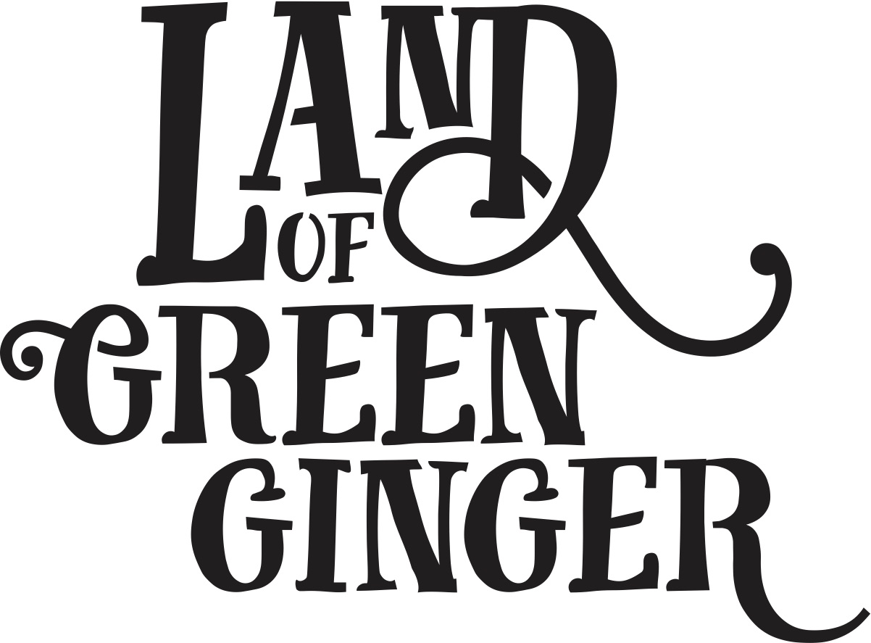

**Illustrator Initial Sketch**

Please provide a rough sketch for **one** of the below descriptions. Each of the descriptions surround the narrative of one of the Acts of Wanton Wonder that took place as part of the Land of Green Ginger project - **7 Alleys**.

**About 7 Alleys**

7 Alleys is an East Hull myth that formed the basis of the first Act of Wanton Wonder in the Land of Green Ginger project.

The myth goes that in East Hull there was a mysterious alley, near to Hull Prison. The alley was made up of a network of six individual alleys, with a seventh and final alley that only appeared under certain circumstances, revealing all manners of wondrous phenomena.

Children would play around the alleys, daring each other to go further in, facing fears of rumoured ghosts, strange mists, and unexplained noises, edging ever closer to finding the magical seventh alley.

The Alleys were covered over in 2002 when Hull Prison expanded, but the myth lives on in the memory of many from the area.

For Land of Green Ginger the 7th Alley was revealed in a large scale outdoor performance in East Park.

**Submission Information**

Please select one of the below descriptions to illustrate. You may submit sketches for both descriptions if you wish.

Your sketch does not need to be a literal representation of everything contained in the below descriptions and should instead provide your own illustrative interpretation of the text.

Your sketch can be submitted in black and white, or full colour. It can be created digitally, or hand drawn. However, it must be submitted digitally by email in a format that can be opened without use of specialist programmes, e.g. jpeg, pdf.

Please submit your sketch by email to [maddie.maughan@hull2017.co.uk](mailto:maddie.maughan@hull2017.co.uk) no later than **9am on Monday 12 February**.

**Sketch Option 1**

**An Invitation to Join the Search for the 7 Alleys - Horse and Carriage**

A beautiful black horse and carriage is driven round a downtrodden housing estate. The driver - a man aged 45-60, clad in donkey jacket and flat cap - delivers an invitation to a young girl outside of her house. The invitation is presented on beautiful scroll. The edges of the parchment are singed, and the scroll is tied with a red ribbon. Other children and family members gather to watch the horse and carriage passing by their house. They seem to recognise the carriage. Some months previous the same carriage had visited and messages in bottles were delivered to nominated residents. This time, the carriage delivers an invitation to join the search for the 7th Alley.

**Sketch Option 2**

**The 7th Alley is Revealed**

A gang of children aged 9-12 years old are playing down the 7 Alleys. Each Alley brings a new dare to overcome. The gang have made it to the final alley. No one ever has. They’ve only ever heard rumours.

A shining light and glittering sparks appear from the mist - a ghostly figure spins arounds above their heads and showers the gang with burnt-edged book pages falling from the sky. The pages hold a riddle, another clue – headed by an illustration of a horse and carriage on one side, and of a wild boar on the other.

Below is text from the 7 Alleys show, which was read for this particular scene:

*Ashen wields a book of life*

*Every book page made of ice*

*When Ashen flies the Heavens open,*

*From the skies her pages floating*

*Each snowdrop one word of a story*

*Ashen claws to catch them falling*

*pages & words fly from her hands*

*prophesies & legends from distant lands*

*Reach to the sky to capture them all*

*Catch each fragment heaven-sent*

*Grasp all words before they fall*

*before they melt, before the story ends*