**These workshops for women** are part of PRS Foundation’s Composer Residency

**Women in Music Hull**

A series of music workshops for women by women

Part of PRS Foundation’s Composer Residency programme in Hull, Women in Music Hull offers workshops with visiting successful female songwriters, musicians and a sound engineer, working in partnership with The Warren, Creative Voice and Kingston Youth Centre.

A diverse range of women experienced in the music industry will work with women making music in Hull.

Workshops are open to young people and some are open to women of any age. All workshops are free.

**Artists:**

* Hannah Miller and Raevennan Husbandes (from the band Moulettes) – Songwriting intensive workshop, covering various ways into songwriting
* Nadine Shah – Songwriting workshop, bring something you’re working on or just your creativity
* Caroline Adcock - Workshop teaching people the basics of sound engineering from how to plug everything in, to how the desks work and how to get the best out of a gig for musicians.
* Michelle Scally-Clarke (Dub Poet) – songwriting with emphasis on words and lyrics
* Ali Bullivent (Singer/Songwriter) – Songwriting workshops and elements of harmony singing

**Women in Music**

programme in Hull, for Hull UK City of Culture 2017, in partnership with

The Warren, Creative Voice and Kingston Youth Centre.

PRS for Music Foundation’s New Music Biennial residency programme

is generously supported by Hull UK City of Culture,

Paul Hamlyn Foundation and Arts Council England.

[www.newmusicbiennial.co.uk](http://www.newmusicbiennial.co.uk)

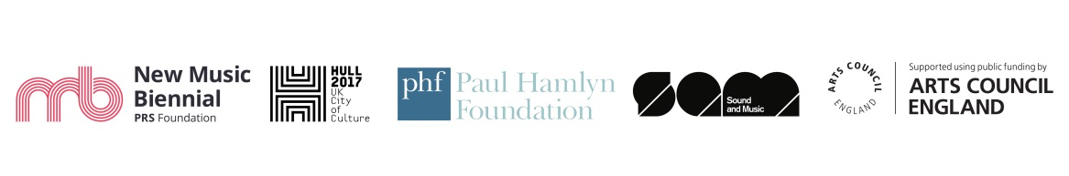

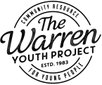  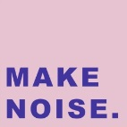

  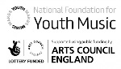

|  |  |  |  |  |  |
| --- | --- | --- | --- | --- | --- |
| **Date** | **Time** | **Artist** | **Subject** | **Venue** | **Age restrictions** |
| Sat 24 March | 2-4pm | **Moulettes (Hannah Miller and Raevennan Husbandes)** | Songwriting session 1 (for women of all ages) | The Warren | all ages |
| Sun 25 March | 11-4 pm | **Moulettes (Hannah Miller and Raevennan Husbandes)** | Songwriting session 2 (for women of all ages) | The Warren | all ages |
| Mon 26 March | 6-8pm | **Moulettes (Hannah Miller and Raevennan Husbandes)** | Songwriting (for young women) | Kingston YC | age under 19, or under 24 if you have a disability |
| Wed 28 March | 2-4pm? | **Nadine Shah** | Songwriting session for young people | The Warren | age up to 25 |
| Wed 28 March | 2-4pm? | **Caroline Adcock** | Basics of sound engineering for young people | The Warren | age up to 25 |
| Wed 28 March | 6-8pm? | **Nadine Shah** | Songwriting session for all ages (could be continuation from earlier) | The Warren | all ages |
| Wed 28 March | 6-8pm? | **Caroline Adcock** | Sound engineering for all ages (follows on from afternoon session) | The Warren | all ages |
| Fri 6 April | 2-4pm | **Michelle Scally Clarke** | Songwriting (for young women) | Kingston YC | age under 19, or under 24 if you have a disability |
| Sat 14 April | 2-4pm | **Michelle Scally Clarke** | Songwriting (for women of all ages) | The Warren | all ages |
| Sun 15 April | 2-4pm | **Ali Bullivent** | Songwriting (for women of all ages) | The Warren | all ages |
| Sat 21 April | 2-4pm? | **Ali Bullivent** | Songwriting (for young women) | The Warren | all ages |