COMMENTS from CARE HOMES that we are working with to respond to Turner Prize

FERNLEIGH GROUP

In response to Lubaina Himid's*Five*

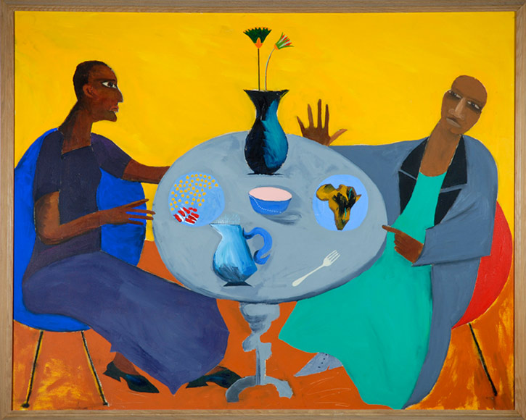

Jug.

What's that? That there?

Bacon. Beans.

I wouldn't eat it.

Banana! Looks brown. Yellow.

A jug with flowers.

There's bacon.

A fork

No knife

Bowl for sugar. Sugar bowl.

Friends. I think they're friends.

Happy.

Talking about holiday. Scotland.

Then Wales.

Home in time for pudding! 2:30!

Lovely.

Oh! The tea trolley! Time for a cuppa...

Rosalind Nashashibi's *Two Tribes*



What's it supposed to be?

Green.

Green always reminds me of grass.

It's like a wall. A tree.

The trunk.

There's a bee.

The bee and the tree.

FERENS & PICKERING GROUP

Andrea Buttner’s *Untitled (Three Kings)*

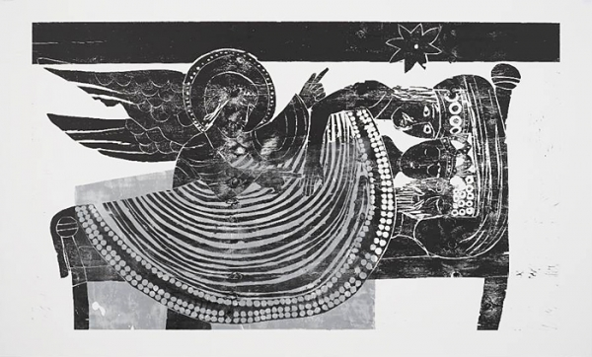

They’ve got that straight hair do, haven’t they?

A beard.

Dark blue

and it comes a bit higher.

A family together.

Could be sleeping on a child’s bed. Definitely a child’s bed.

The middle one isn’t happy. The one on the right isn’t.

The one on the left has a wickedness in him.

One is wickedness

Two is quieter

Three is wickedness

It draws me in on it.

And then there’s this one.

It has wings

And yet its not very robust.

Not and angel, let’s put it that way.

Lubaina Himid’s Five



Five fingers.

Five things on the table.

Some chocolate, I like chocolate.

A wafer.

Looks like a slaughtered animals’ head.

A bit queer.

Sugar and milk in the bowls.

Snowballs on the table.

A fork.

A yam.

A yam gone off.

Could be girlfriend and boyfriend.

Could be mother and son.

One is pushing the other away.

Having an argument, or

Making one up by the looks of his face.

Greedy

Summat funny

It’s about enjoying the interest.