Text for ticket holder email

Subject: Last day to book Radio 1 Big Weekend Travel

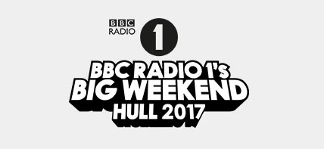

Hi there,
LAST CHANCE TO BOOK YOUR TRAVEL TO BIG WEEKEND! BOOKING CLOSES TODAY AT 5PM
The event organisers have been in touch with the following travel information:
"As previously advised, ticket holders are required to purchase a ticket for the official Shuttle Bus/Park & Ride services to get to the event site. This is to ensure that all ticket holders can get to and from the event site as safely and smoothly as possible and reduce congestion in the local area.
SOME SERVICES ARE SOLD OUT, SO YOU ARE ADVISED TO BOOK NOW, TO ENSURE THAT YOU CAN BOOK YOUR PREFERRED DEPARTURE POINT.
Shuttle Bus services will be priced at £13 per person. Secure parking will be available at Park & Ride sites for an additional charge of £7.50 per car.
WHAT LOCATIONS DO SHUTTLE BUS/PARK & RIDE OPERATE FROM?
Take a look at our information guide which outlines details of where you can board Shuttle Bus / Park & Ride services across Hull & East Yorkshire before booking as well as full service terms and conditions.
HOW TO BUY YOUR SHUTTLE TICKETS...
Booking is open and you will find the booking links on our information guide online.
Please be aware that transport tickets must be purchased in advance and we strongly recommend that you book early to ensure you are able to select your preferred option. Booking closes TODAY at 5pm.
We’re looking forward to seeing you soon."
We hope you enjoy the event!
Best Wishes,
Ticketmaster Customer Service

