**WELCOME!**

Published by [**Antony O’Brien**](http://www.greenginger.org/author/antony-obrien/).

03 April 2017

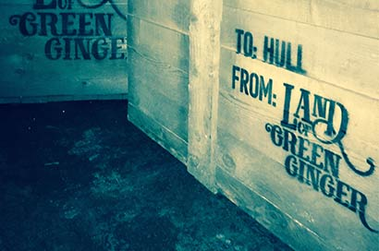

We thought it was about time we moved with the times and set up our own website – we’re glad you could join us and hope you like it. and set up our own website – we’re glad you could join us and hope you like it.

In case you’re wondering ‘why now?’ (which a few of our members have been asking), we received a phone call a few weeks ago, asking us to be involved in an extremely unique investigation.

During work to the city centre back in February, contractors discovered what they thought was solid flooring, but actually turned out to be the roof of a [**previously undiscovered underground chamber**](http://www.hulldailymail.co.uk/mystery-of-the-crates-found-in-hidden-chamber-under-hull-s-land-of-green-ginger/story-30244419-detail/story.html). Now, there’s nothing particularly unusual about this in broad terms; Hull is relatively well-known for it’s complex subterranean world, and previous discoveries – such as [**Ye Mecca Smoking Café**](http://www.hulldailymail.co.uk/hull-8217-s-secret-underground-smoking-cafe-revealed/story-29635689-detail/story.html) last year, and various tunnels assumed to be used for smuggling – have been well-documented.

However, this one contains a large number of crates, all stamped with the words ‘To Hull, from Land of Green Ginger.’ As anyone who follows our work knows, we have a huge interest in the myths and legends surrounding this very uniquely-named street – have a look at [**The Story**](http://www.greenginger.org/the-story/) to find out where this came from.

We are very much looking forward to getting into the vault and seeing what’s down there – we’ll try and keep you as up-to-date as possible through our [**News**](http://www.greenginger.org/news/) section, [**Facebook**](https://www.facebook.com/greengingerfellowship) and [**Twitter**](https://twitter.com/greengingerhull) pages.

**ACTS OF WANTON WONDER ARE COMING**

*Investigation Update*

Published by [**The Green Ginger Fellowship**](http://www.greenginger.org/author/greenginger/).

08 April 2017

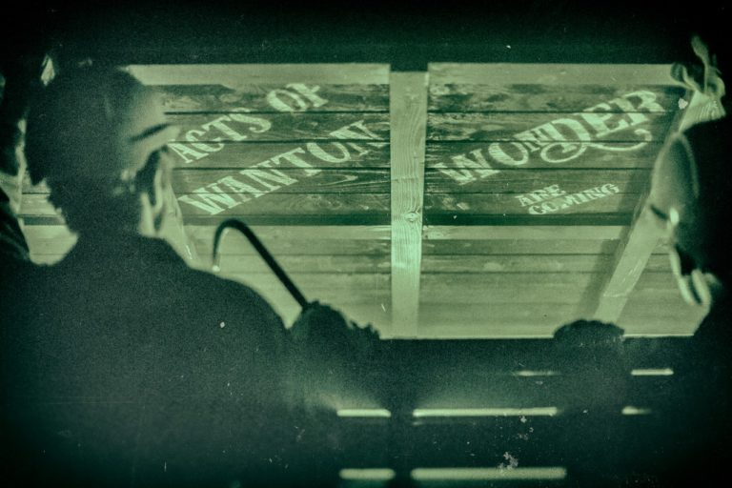

As previously reported, we have been asked to investigate a discovery of a large number of crates in an underground vault between Land of Green Ginger and Whitefriargate. After being contacted by Lucie McCarthy, Principal Archaeologist at Humber Archaeology Partnership, and Hull City Council, myself and Antony were invited in to examine whether they could be opened and what could be inside.

We were guided down to the vault through a network of tunnels – which was particularly fascinating to us, as many are either infrequently or never open to the public – we led to a large brick chamber filled with wooden crates of differing sizes, all stamped with the same mark, ‘*To Hull, from Land of Green Ginger*.’

Having looked reasonably substantial on close external inspection, we made the decision to open one of the crates to further examine what might be inside. The lid was remarkably easy to prise off with a crowbar, but almost instantaneously, a rumbling sound came from inside, followed by smoke – an unforeseeably strong reaction.

We evacuated the immediate chamber while the smoke dispersed, to find the contents of the crate had disappointingly vaporised on opening. However – and here it becomes particularly fascinating – the words ‘***Acts of Wanton Wonder Are Coming’*** were left seared on the inside lid. We are unsure as to whether this previously existed, or it was left as a result of the vaporisation.

In light of this, we have made a decision to move the crates to our HQ before attempting to open any more, for our own safety and that of the public, as well as for the sake of preserving whatever might be inside. As yet, we have no clear idea why they’re here or what it all means, but we do know we’ll carry on investigations until we find some sort of answers.

If anyone sees anything unusual across the City, or the Land of Green Ginger mark, please contact us via our [**Facebook page**](https://www.facebook.com/greengingerfellowship/) or on [**twitter.**](https://twitter.com/GreenGingerHull)

Thanks, Allison.

**CRATES SAFELY AT HQ!**

*Investigation Update*

Published by [**The Green Ginger Fellowship**](http://www.greenginger.org/author/greenginger/).

11 April 2017

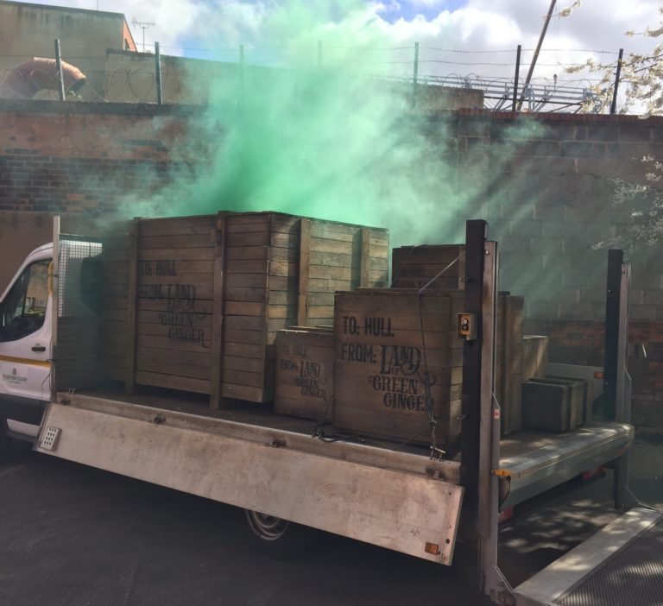

Good evening everyone!

It’s another late night for me as I’ve been at HQ all day preparing the site for investigation. We’re all very happy to finally have the crates safely here, and we’ll start our explorations in the morning – yes, I know, but we’re all absolutely worn out and we’ve waited this long…

As reported in the media over the past few days, our crew have been painstakingly moving the crates from Land of Green Ginger to our secure headquarters. We can confirm, as witnessed publicly, that a number of the crates have displayed unusual behaviours, including emitting the sound of galloping horses and chiming bells, a thick, green smoke and the unmistakable smell of ginger. This leaves us in no doubt that Acts of Wanton Wonder are coming as previously indicated, but how, when and why remains a mystery – for now.

We are very grateful to those of you who have contacted us with your reports of unusual occurrences across the city – do follow us on [**Facebook**](https://www.facebook.com/greengingerfellowship/) and [**twitter**](https://twitter.com/GreenGingerHull) for the most up-to-date news on our work. Richard and Pauline will be taking the lead on the immediate practical investigation as it’s very difficult for me with the grandchildren at home all over Easter, but I’ll certainly be overseeing as much as time (and Jean) allows.

Thanks again for all your best wishes –

Antony.

**BELLS, RIDDLES AND VOICES**

*Investigation update #2*

Published by [**Antony O’Brien**](http://www.greenginger.org/author/antony-obrien/).

16 April 2017

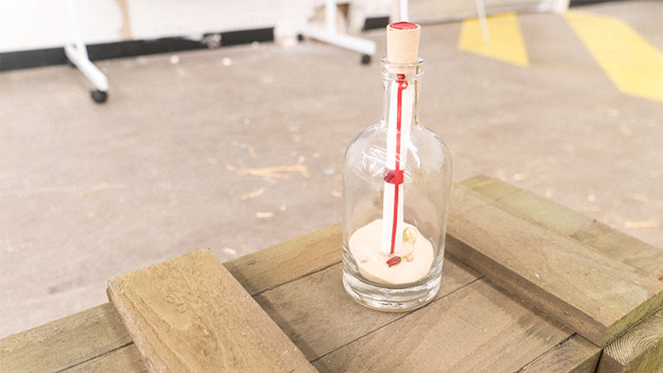

‘An interesting week’ would not be a sufficient phrase for the events of the past seven days. Apologies for not putting my thoughts down sooner, but I quite literally have not had time or opportunity given recent occurrences.

As you’ll no doubt know, we finally managed to move the crates from Land of Green Ginger to our (very grandly nicknamed) HQ over the course of last Monday and Tuesday. I was mainly at home with the grandchildren while Jean was at work, so our crew managed the task for us, as efficiently as ever. I suspect most people do forget that, alongside our work for The Fellowship, we are also ordinary people with jobs and responsibilities; anything we do is perused purely for love and fascination of the areas in which we study, but it does mean we are sometimes unable to commit as intensely as we would like from time to time.

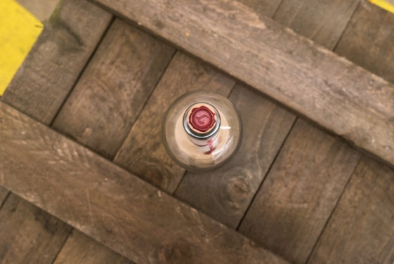

To be brief; a couple of hours after officially opening the investigation on Thursday morning, we started to experienced strange noises coming from one particular crate. Richard, Pauline and I were all witness to this after Pauline first identified them using a stethoscope, and Richard also felt the vibrations of the sound through the wood – they varied, but chiming bells and what sounded like muffled, indecipherable voices were distinctly heard. It’s difficult to describe, but we weren’t frightened, or even disconcerted…it simply felt to us like the sounds were trying to tell us something, a message they needed or wanted us to hear.

After further discussion, we made a joint decision to open the crate. I don’t mind admitting, we had no idea what to expect and were absolutely braced for some sort of disaster. However, there were no explosions, fireworks or ethereal spectres – slightly to Richard’s disappointment.

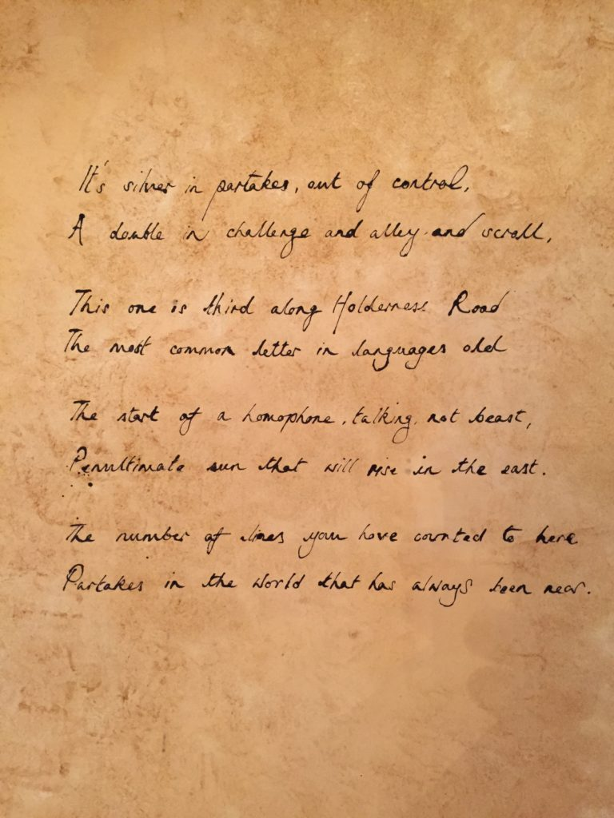

This has been well-read on social media now, but for the sake of documentation, what we found is pictured above; a single glass bottle topped with wax sealing, bearing either the number 7 or the letter L. What we initially thought might be some sort of messaging inside was a sheet of calico, sealed with the same or similar wax. Upon careful opening and unwrapping, we uncovered a piece of parchment with the following writing –

*It’s silver in partakes, out of control,*

*A double in challenge and alley and scroll,*

*This one is third along Holderness Road,*

*The most common letter in languages old,*

*The start of a homophone, talking, not beast,*

*Penultimate sun that will rise in the east.*

*The number of lines you have counted to here,*

*Partakes in the world that has always been near.*

Our obvious thoughts were that this was some sort of riddle, a clue or pointer to what lies next. Parts seemed to make sense, but not as a whole – the imagery is complex in places, with symbolism relating to a whole host of ideas. Is it a number riddle? Not entirely. It seems to be an amalgamation of different combinations of clue, playing on numbers, language and repetition to reveal itself.

Which leads me to this – where are we now? This is the part gives me pleasure and disappointment in equal measure, and probably why I have put off sharing it with you all until so late. I am delighted to say that we have, at last, solved the riddle. It took me the entirety of last night researching – coupled with the input from social media and Jean, who managed to untangle the line that was eluding me – but it is, at last, clear. The frustrating part is that we cannot share the answer with you. Not quite yet. There are things we need to put in place and preparations must be made.

I wish to personally apologise in advance for your inevitable disappointment, but the reasons will become clear sooner rather than later. There is far more left to unveil and we must do this properly, with the respect and attention required.

Keep watching.

With all warmest wishes - A

**FREEDOM CENTRE CRATES**

*Investigation Update #3*

Published by [**Antony O’Brien**](http://www.greenginger.org/author/antony-obrien/).

20 April 2017

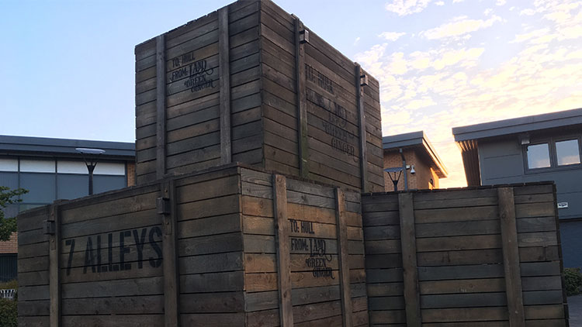

I do hope everyone had a wonderful Easter. There’s always something very special about this time of year, in more ways than one at the moment. We can’t tell where the next piece in the puzzle is coming from!

Richard and Pauline are still beavering away on their investigations on the crates found near Land of Green Ginger. I’m actually going down to meet them tomorrow and go through some of their findings, so I’ll try and transcribe some of those conversations for your interest. They do send me regular emails so I’m well aware of how things are progressing – reports and footage so far are more tangible than anything we have previously tackled, which is incredibly exciting.

Parallel to this, Allison has been engaged in a slightly more active role as a core investigator again, which we’re all thrilled about. Allison of course was a co-founder of the GGF, but decided to take some time out a number of years ago. We’re currently finding ourselves stretched to capacity for the first time in as long as we can remember, so we’re delighted she’s decided to leap back into the fray and lead on the investigation and monitoring of the crates which appeared at The Freedom Centre yesterday morning. We’ve both been there for part of the day today, and have again witnessed the intermittent ongoing music from one of the crates. No smoke at present, although we have fire extinguishers on hand and Tony at the Freedom Centre has been keeping an eye on them for us when we’re unable to be on site.

We’re currently puzzling over why the crates have been left at the Freedom Centre of all places. They very clearly state East Park on the outside, which would tie in perfectly with our deductions over the riddle (that repetition of *‘partakes’* could only really point to one thing), but there’s no clear connection between the two. It would be very helpful if anyone had any ideas on this.

And as if this wasn’t all, I’m currently engaged in making plans for our search at the beginning of May. I’m delighted so many of you want to join us, and the long-range forecast looks bright (if you trust them); please, don’t forget to join Jeremy’s events page on Facebook if you’re planning on coming, it would be wonderful to get a sense of support from the local community.

We’ve had a lot of messages regarding what we’re expecting to find on our search. The honest, brief answer is – we don’t know. If you don’t know the stories and legends surrounding the 7 Alleys, we suggest you familiarise yourselves with what might – or might not – cross our paths. We certainly know it to be a strange world, and one which, if it chooses to reveal itself to us, will bring the unexpected and wondrous in equal measure.

I will do my utmost to keep you all informed.

All best –

Antony.

**NEW MEMBERS JOIN THE GGF!**

*Formally welcoming Mike and Alec*

Published by [**The Green Ginger Fellowship**](http://www.greenginger.org/author/greenginger/).

25 April 2017



Good evening everyone.

Life takes us on some strange twists and turns, doesn’t it?

The Green Ginger Fellowship started out as a blazing and practical passion for investigating the urban myths and legends which beguiled us entirely. We would spend months discussing and debating, often putting our lives in danger chasing investigations that no one else would give credence to apart from us – but as the years progressed, this thirst became somewhat tempered by the realities of working life, raising families and so on and so forth.

We have always been passionate of course, but just in a slightly more low-key way than when we first began. That is why it’s a delight to reconnect with people studying in similar fields, experts who have devoted their lives to exploring similar themes and cases with the same thirst for answers.

It occurs to us that we are currently busier than we have ever been. We have Richard and Pauline investigating the crates found near Land of Green Ginger back in February, and Hana and Allison monitoring the crates at the Freedom Centre. Jeremy is running our social media, and I am doing my upmost to move between everyone and conduct my own research in between. Other members are keen to be practically involved of course, but we are ever aware that the realities of life get very much in the way.

After spending a fascinating evening with Dr. Alec Gill and Mike Covell at their talk last Wednesday, it occurs to us that we need more capacity to deal with the impending Acts of Wanton Wonder upon us. For that reason, we are delighted to announce we have asked them both to join the Green Ginger Fellowship as honorary members – and even more delighted to say that they have both agreed.

They will be attending meetings where possible, bringing their wealth of knowledge to our ongoing investigations as well as contributing to our social media and website as guest writers.

This is a very exciting new stage for The Fellowship, and we wish you all thanks for your ongoing support.

All best for now –

Antony.

**THE SEARCH DRAWS CLOSER**

*Investigation Update #4*

Published by [**The Green Ginger Fellowship**](http://www.greenginger.org/author/greenginger/).

01 May 2017

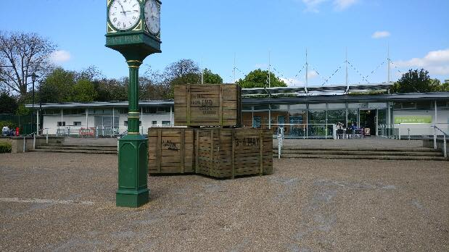

Good morning everyone and a very happy May Day to each and every one of you.

Today we look forward to the week with anticipation, excitement and a healthy dose of nerves. We’re delighted so many of you are joining us on the search for the 7 Alleys and draw strength from your support and intrigue.

From discovering the riddle in the crate at HQ, everything has pointed to East Park, galvanised by the appearance of Land of Green Ginger marks in and around the park over the last week. Amidst all this, I don’t mind admitting our confusion as to why the crates appeared on Preston Road; then Allison reminded me of this. Are you aware if the story of the Screaming Skull of Burton Agnes Hall? Please don’t proceed if you’re of queasy disposition…

Katherine Griffith was the youngest of three sisters, a daughter of Sir Henry Griffith who built the Burton Agnes Hall. The story goes that Anne had watched the building of the new house and could talk and think of nothing else; it was to be the most beautiful house ever built. When it was almost finished, Anne went one afternoon to visit the St. Quintins at Harpham about a mile away, but near St. John’s Well was attacked and robbed. She was brought home to Burton Agnes, but was so badly hurt that she died a few days afterwards.

Sometimes delirious, sometimes absolutely lucid, she told her sisters that she would never rest unless part of her could remain ‘*in our beautiful home as long as it shall last’*. She made them promise that when she was dead her head should be severed and preserved in the Hall forever, and to pacify her, the sisters agreed. However, when Anne died she was buried in the churchyard.

Then, as anyone could have predicted, the ghost walked and scared the absolute life out of everyone. Remembering Anne’s dying words, the sisters took counsel with the vicar and eventually agreed that the grave should be opened. The skull was brought into the house and so long as it was undisturbed, the Hall was peaceful and untroubled. Over the years, many attempts have been made to get rid of it – it was once thrown away and another time it was buried in the garden, but always the ghost walked with tremendous noise and upheaval. The skull is still in the house, built into one of the old walls (most probably in the Great Hall), and all is peaceful.

This may seem a strange analogy, but this story actually tells us a great deal. The increasingly unpredictable behaviour of the crates – smoking, distorted noises as reported by members of the public – suggested they were trying to tell us of their unease, and so it seemed a logical decision to take them where they were crying out to be. For now, peace seemingly reigns at East Park – but for how long?

The reappearance of the horses and carriage yesterday has shown us that the 7 Alleys are gathering strength to reveal themselves to us. We must be vigilant and take care of ourselves and each other – do take note of [**our suggestions for the preparations you must make before joining us**](http://www.greenginger.org/7-alleys-faqs/) and if you haven’t yet registered, please indicate [**on our events page**](https://www.facebook.com/events/192777627900955/) and tell us what night you may be joining us.

With all best for now –

**THE 7 ALLEYS REVEAL THEMSELVES**

*Investigation Update #5*

Published by [**The Green Ginger Fellowship**](http://www.greenginger.org/author/greenginger/).

07 May 2017



***‘Mystery creates wonder, and wonder is the basis of man’s desire to understand’ –* Neil Armstrong**

Friends, colleagues – everyone;

It seems appropriate today to title this piece with a quote from another man lucky enough to have travelled other worlds.

Shifting mists, The White Lady, Bubblegum Boy – who guessed the 7 Alleys would reveal themselves to us with such emotion and expression? For many it was a profoundly moving experience and, among open mouths, rapt attention and trepidation, a number of us were also moved to tears with the sheer enormity of it all.

When I was young, we had a neighbour called Mrs Schumann. We’d only ever see her sporadically – my father used to refer to her as ‘the shadow’. She rarely spoke, and my brother was convinced she was some sort of alien, travelling earth to take human souls back to her own planet (and yes, I don’t mind admitting I lost some sleep over this theory!).

There was some sort of emergency one afternoon and we had to briefly stay with Mrs Schumann. I still remember the feeling in my stomach even now as I stood on her doorstep, 9 years old with my brother beside me, like the world was tilting slightly and nothing would ever be the same again.

It turned out that we were right in a way; she wasn’t a visitor *from* but rather *to* other worlds – an archaeologist. She showed us photos of medieval foundations and Roman-age skulls and coins, weaving stories about excavating floors at the Una Vida great house in Chaco Canyon and uncovering a medieval village in Wharram Percy. I remember being struck with a sudden understanding of something greater than I’d ever known before, the weight of history and that feeling of it becoming tangible.

I’m sure you’re probably wondering where this story is leading, but indulge me – Mrs Schumann changed the course of my life in a way the search for the 7 Alleys has. It’s impossible to articulate what we witnessed; for those who took part, the Alleys have seared a part of themselves onto us and we carry that on, almost imperceptibly altered. These myths and legends hold a special place in the hearts of many, from those who played the alleys as children to those who are just discovering the interweaving stories for the first time.

We’re beginning to understand, we think, the importance of the crates amongst all this. They appear to be the signifiers of impending wonder, dropping clues of what’s to come– think of them as snowdrops heralding spring, or in some Celtic mythologies, an owl heralding departure to another realm. Alongside the excitement of this week, Richard and Pauline are still very much occupied with opening and cataloguing the main cache at GGF HQ and we’re studying extensive footage of the 7 Alleys for indicators of what might be coming throughout the year, across the city.

The first Act of Wanton Wonder has shown itself, and we know there are more to come – follow, enquire, prepare, and, as a certain James (the one with the giant peach) once said, ‘*there are a whole lot of things in this world of ours you haven’t started wondering about yet.’*

Do take care of yourselves, and keep on following our investigations as much as time allows – we always welcome your thoughts  on our [**Facebook page**](https://www.facebook.com/greengingerfellowship/) and [**twitter**](https://twitter.com/GreenGingerHull). A final thanks to you all for joining us on the search, and to our friend John Broadley for capturing this beautiful image.

All best for now –

A

**STRANGE GOLD OBJECT FOUND…**

*Another yield from another crate - but what could it be? Gold Nose investigation update #1*

Published by [**Antony O’Brien**](http://www.greenginger.org/author/antony-obrien/).

18 May 2017

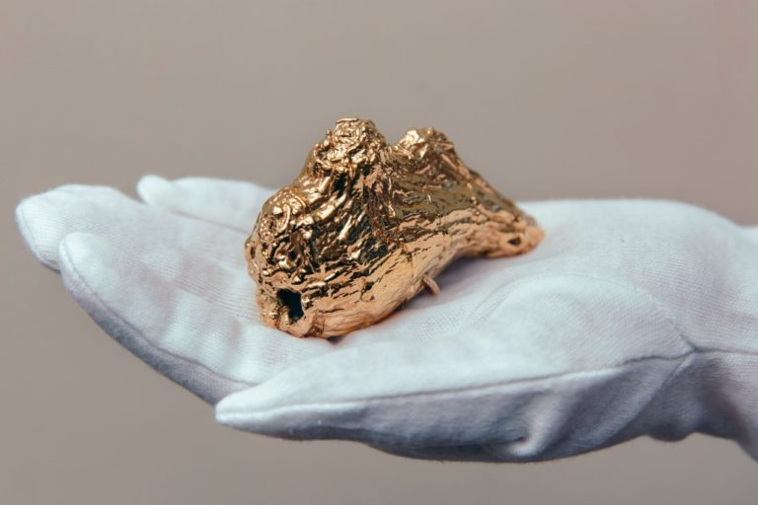

Up to press we’ve had little to report until the bigger picture starts to reveal itself. However, I am thrilled to write that, this morning, we have uncovered something truly extraordinary.

To summarise briefly; I received a (very excited) call earlier asking me to go straight to HQ as soon as possible. On arrival, one of the larger crates was open – clearly in the middle of investigation – and the smell of ginger was immediately discernible. Both Richard and Pauline confirm it became apparent immediately on opening and hadn’t dissipated over time; on the contrary, it remained at a consistently high level. Contents logged from the crate are as follows:

An undefinable gold object (pictured).

Look closely at the image; hardly visible, but there are two braided silk ties on either side of the object – woven through – and our testing confirms it is indeed solid gold, not lustre, leaf or plating like we first suspected.

Have you ever seen anything like this before? Does it ring any bells? We are delighted to confirm that we have positively identified the object within the past hour, but we’re not going to tell you what it is just yet – as our followers are as ‘ever curious’ as we are, we thought we’d have some fun with your thoughts. The person closest to the answer will win a special prize (to be disclosed tomorrow), so put your research hats on and have a guess – if it’s weird, wonderful and seemingly improbable, then you’re probably along the right lines.

Good luck everyone!

Antony

**AND THE ANSWER IS…!**

*Gold Nose investigation update #2*

Published by [**Antony O’Brien**](http://www.greenginger.org/author/antony-obrien/).

24 May 2017

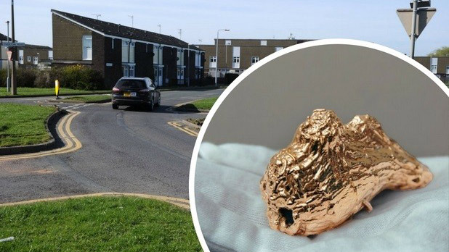

Good morning everyone!

Has anyone seen the [**Hull Daily Mail**](http://www.hulldailymail.co.uk/the-strange-tale-of-the-gold-nose-of-green-ginger-found-in-bransholme/story-30349332-detail/story.html) today? If you have, you’ll know the secret is well and truly out and we can positively identify our strange gold object as…the Gold Nose of Green Ginger! This is a truly extraordinary find and one which we always assumed had been consigned to legend, so it’s utterly awe-inspiring to have it here in front of us.

Huge thanks to everyone for chipping in their thoughts about what it could be. We’ve had lots of fun reading through them all, although we must admit, some were slightly more credible than others! No one hit the nail quite on the head, but we’d like to offer the tickets to the first person who suggested it might be a nose – that’s you, Neil Porter! Well done!

Do send us a message to claim your tickets to the History and Mystery night in July and we hope you have a wonderful time.

So the question is; could this be the beginnings of another Act of Wanton Wonder? Only time will tell. All we can do at the moment is carry on with our research, ask questions and remain, as always, ever curious about this remarkable discovery.

All best –

Antony.

**THE PLOT THICKENS…**

*Gold Nose investigation update #3*

Published by [**Antony O’Brien**](http://www.greenginger.org/author/antony-obrien/).

26 May 2017

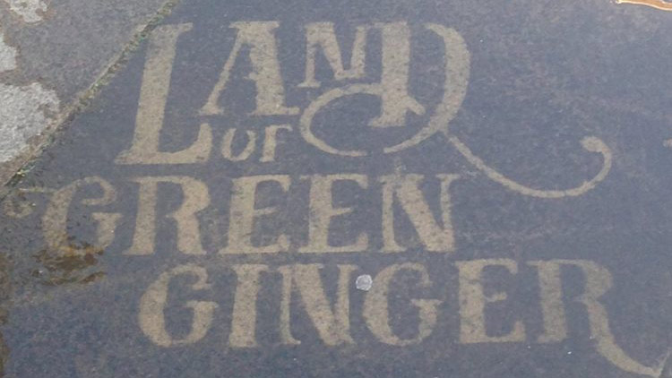

A VERY interesting morning after an exciting week here at HQ.

We received a post from North Point this morning inviting us up to the shopping centre to have a look at something unspecified. Unsure what to expect, we arrived to be greeted by fresh Land of Green Ginger marks, all wet despite the dry weather and at each entrance to the shopping centre.

A hoax, perhaps? Doubtful; someone would have to go to a lot of trouble to avoid being seen. And what would the point be? After close inspection we can confirm they are absolutely identical in every way to the marks that appeared at East Park prior to the search for the 7 Alleys.

Does this indicate North Point is going to be the scene of the next Act of Wanton Wonder? When we look at the discovery of the Gold Nose and the riddle left behind by the 7 Alleys – which appears to point to Bransholme – it appears entirely likely. But then again, the crates at the Freedom Centre didn’t indicate what we initially thought, so our current guess is as good as yours…we can only wait with anticipation.

Antony.

**NEW CRATE FOUND ON LONGHILL**

Published by [**The Green Ginger Fellowship**](http://www.greenginger.org/author/greenginger/).

29 May 2017

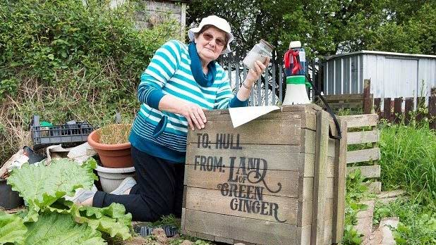

Thanks to everyone for the messages about this [**Hull Daily Mail article**](http://www.hulldailymail.co.uk/mystery-land-of-green-ginger-crate-unearthed-in-hull-pensioner-s-shed/story-30351808-detail/story.html), we weren’t aware of it until this morning.

We’re slightly surprised this went straight in the paper without us knowing anything about it, but we’re pleased to say we’re now directly in touch with Margaret and are advising her on looking after the crate properly.

Cheers, Allison

**NORTH POINT SHOPPING CENTRE?**

*Gold Nose investigation update #4*

Published by [**The Green Ginger Fellowship**](http://www.greenginger.org/author/greenginger/).

01 June 2017

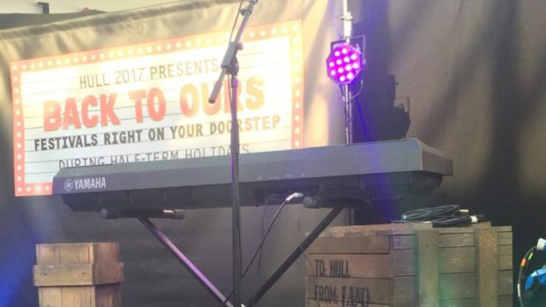

A very quick blog post for today; lots of people have reported seeing crates during the Back To Ours festival at North Point Shopping Centre this week. We WERE planning to send some crates over there, but not until next week.

Did anyone else see the crates? Or know if they’ve been put there as a joke or some other reason we’re missing? They were sighted during a Word on the Street event and then during a gig by a band called Audio Subscene…

We’re about to head up there and have a look, so we’ll keep you updated. Cheers all, Allison.

**MORE CRATES…AND THIS TIME IT IS US!**

*Gold Nose investigation update #4*

Published by [**Antony O’Brien**](http://www.greenginger.org/author/antony-obrien/).

05 June 2017

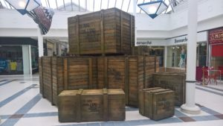

At last – some crate appearances we’re able to take credit for!

During investigations on the central cache, we were particularly drawn to a crate that smelled strongly of ginger – this, of course, went on to yield the Gold Nose of Green Ginger.

We also found what appeared to be a large amount of shop fittings. Given Louise’s kind offer of an empty shop unit for displaying the Gold Nose, we took the decision to move crates to North Point Shopping Centre to and fit the shop up with what we uncovered.

As explained in last week’s Hull Daily Mail article by Mike, the Nose was considered nothing more than an urban myth until it was discovered during excavations to lay the foundations for the first houses on Bransholme 50 years ago. Legend claims those who came into contact with it were blessed with unexplainable and plentiful good luck, so it was thought to be hidden away until it could be fully understood.

Our intention is to bring the Gold Nose back to the area for people to experience this remarkable piece of history. Will its fabled good luck rub off? Who ‘nose’!

All best for now,

Antony and team.

**THE GOLD NOSE OF GREEN GINGER IS COMING HOME TO BRANSHOLME**

*Gold Nose investigation update #5*

Published by [**Antony O’Brien**](http://www.greenginger.org/author/antony-obrien/).

09 June 2017



What a beautiful day to confirm that The Gold Nose of Green Ginger will be brought back to Bransholme in just over a week.

There is much to prepare before this historical landmark returns home, but we do hope you’ll all pay it a visit while it’s housed at North Point. Jean’s particularly looking forward to testing the legendary theory of the good luck it’s said to bring, she’s already managed to sit on her glasses and smash a plate and it’s not even lunchtime!

All best for now,

Antony.

**DISAPPEARING CRATES AND JJ’S PHOTOGRAPHS…**

*Gold Nose investigation update #6*

Published by [**Antony O’Brien**](http://www.greenginger.org/author/antony-obrien/).

15 June 2017

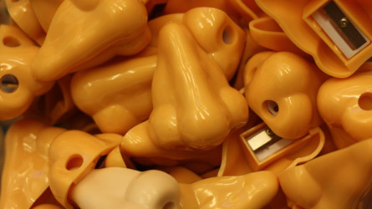

Preparations to receive the Gold Nose of Green Ginger are almost complete!

Some of you may have noticed a lack of crates at North Point Shopping Centre as from today, and there’s a very good reason for that; their contents have been utilised in the build of the display space ahead of the Gold Nose arriving on Saturday. All will soon be revealed…

Meanwhile, JJ’s been spending a rare day off testing out his photography skills (I think he’s rather sick of my archaic BlackBerry images). Any ideas what these might be?

Answers on a postcard!

Antony

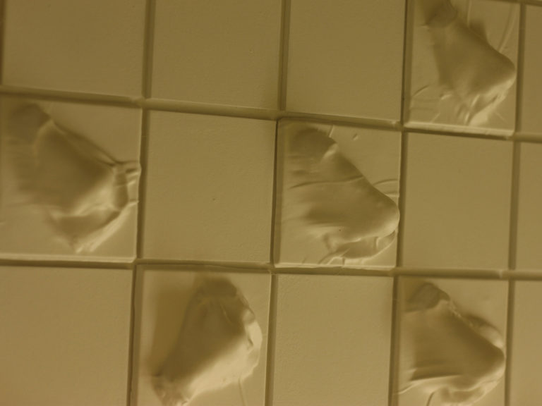



**THE GOLD NOSE OF GREEN GINGER IS RETURNED TO BRANSHOLME**

*Gold Nose investigation update #7*

Published by [**The Green Ginger Fellowship**](http://www.greenginger.org/author/greenginger/).

18 June 2017

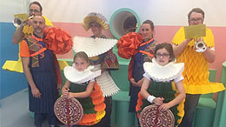

It is finally here!

The Gold Nose of Green Ginger is now safely at North Point Shopping Centre for two months, then it will be given to the city of Hull for safekeeping. How incredible to think that something considered just a myth has been rediscovered and given back to the area it came from.

We had the deep honour of seeing the Nose Guardian come to Bransholme on Saturday morning, arriving in her horse and carriage with The Gold Nose of Green Ginger on its ceremonial pole. What a welcome! Trumpet players and banner bearers in their bespoke costumes, waiting to lead amazed onlookers to the opening of the new display space for the Nose.

I had a lot of fun in the space. I looked at the Gold Nose VERY close up and even made a wish on it (no, I cannot tell you what it was or it will not come true!). I also spent some time in the Secret Pocket – a very peaceful place to sit – and shared a secret with the Nose. It is a very bright, happy space and amazing to see the Nose Guardian make such a passionate speech about all the good luck legend says the Nose will bring.

You can buy nose-themed things in the shop, and my daughter bought a gold pencil which she hasn’t let go of since. I have also promised to bring her back on a Wednesday, between 3pm and 4pm, where you can learn to play the nose flute.

I am very happy to be part of bringing the Gold Nose back to Bransholme. What a very special day for us all.

Hana G.

**KCOM, A CRATE AND REDIFFUSION?**

Published by [**The Green Ginger Fellowship**](http://www.greenginger.org/author/greenginger/).

21 June 2017

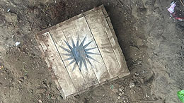

Really exciting news yesterday!

KCOM engineers found a crate on Beverley Road. It has the Land of Green Ginger mark on the side, and a sun or star symbol on the lid.

We hadn’t seen it before, so we asked people on social media whether it was something they recognised. There were some differing suggestions, but the overwhelming answer was that it is the Rediffusion logo.

I hadn’t ever heard of Rediffusion, so I’ve done a bit of research over the last 24 hours.

**Rediffusion was a business which distributed radio and TV signals through wired relay networks. The name ‘Re-diffusion’ literally means ‘broadcasting again’.**

**Hull was one of the first cities in the UK to receive relayed Radio Channels via the Rediffusion Network, as early as 1928.**

**In 1954 the Government gave the go-ahead for commercial television to start and Rediffusion formed a new company which went on the air (in 1955) from the ITV transmitters at Croydon. The station became the mainstay of commercial television broadcasting for the London and south east area through to 1968, and is  remembered for the** [**Rediffusion Star**](http://www.greenginger.org/rediffusionstar/) **which became the symbol for the whole group in 1967.**

**By the time of Rediffusion’s demise in the mid-80’s, Rediffusion Hull boasted the UK’s largest subscriber base of over 48,000 customers.**

**Rediffusion made a massive contribution to the broadcasting, electronics and music industry worldwide over its 60 year life.**

This was really all I came up with after wading through lots of facts and technical information I didn’t really understand. I’d be interested to hear anyone else thoughts on the new crate / Rediffusion / memories?

Tally :)x

**HAVE YOU SEEN THIS MISSING PIECE?**

Published by [**The Green Ginger Fellowship**](http://www.greenginger.org/author/greenginger/).

28 June 2017

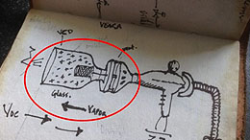

We’re looking for this missing piece of equipment – have YOU seen it?

We’ve established that Rediffusion had a secret research arm that was working on something called Project VEAR. We found a number of pieces of machinery in the crate that KCOM discovered on Beverley Road, but it won’t work without the missing piece shown in James’ granddad’s notebook (circled).

Can you all please keep your eyes peeled? It might be tucked away in an attic or garage, or you might walk past it every day and not realise how significant it is.

**WE’VE FOUND IT!**

Published by [**The Green Ginger Fellowship**](http://www.greenginger.org/author/greenginger/).

01 July 2017

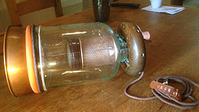

Do you remember the missing piece we were looking for?

A lady called Iris contacted us through our Facebook page yesterday. She had something very similar to the picture in James’ notebook that she took when they were clearing out the Rediffusion offices on Beverley Road; she’s been using it as a vase for the last twenty-five years.

She’d been toying with the idea of throwing it away, but her husband Tommy said it looked unusual and that they should keep hold of it – good job really! Apparently Tommy’s a bit of a hoarder who always thinks everything might come in handy for something.

We immediately knew it was the missing piece because of the copper cable saying ‘VEAR’ attached to the wiring. Iris has very kindly let us take it and pass it over to Re-Rediffusion to complete their voice extraction machine, which we did after stopping off over the road for a celebratory ice cream at Pickering Park. Pretty good day all round!

Tally x

**RE-REDIFFUSION HIT THE NEWS**

Published by [**The Green Ginger Fellowship**](http://www.greenginger.org/author/greenginger/).

03 July 2017

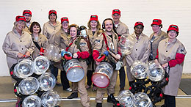

Our friends at Re-Rediffusion [**have hit the local paper today**](http://www.hulldailymail.co.uk/whats-on/whats-on-news/secret-research-group-returned-2017-157042) and they’re looking good.

If you want them to collect your voices message us through our [**facebook page**](https://www.facebook.com/greengingerfellowship/) and we’ll pass your request on for you ..

Cheers, JJ

**THE LONGHILL BURN**

*Hope Can Grow Through Fire and Water*

Published by [**Antony O’Brien**](http://www.greenginger.org/author/antony-obrien/).

06 July 2017

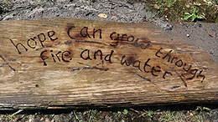

Those following our story may well remember Margaret Cranwell who [**unearthed a crate in her allotment shed**](http://www.hulldailymail.co.uk/news/hull-east-yorkshire-news/mystery-land-green-ginger-crate-73626) back in May, taking the story to the paper and bypassing us somewhat. She said the crate has been in her shed since she took over the allotment site in the 1970s, but she’d merely thrown a tablecloth over it and used it for piling her tools on.

The contents of the crate were as follows:

* A jar of ashes
* A megaphone covered in ribbons
* A constitutional document for the formation of a “guild” of local residents.

Although reasonably scathing about working with ‘*a bunch of hippies*’, Margaret approached us a number of weeks ago for some advice; since then, we’ve been liaising closely with her to try and decipher the meaning behind the contents. Our prevailing thought from the outset has been that the jar of ashes may well hold the key to another Act of Wanton Wonder, alongside The Search for the 7 Alleys in East Park and the Gold Nose.

We may well be experts in our field, but we certainly don’t mind admitting when we need some specialist help from time to time. With this in mind, we contacted a group we know called the Fire-Smiths, specialists in celebratory and ceremonial fire-making, hoping they might take the lead on the investigation or at least point us in the right direction.

After scrutinizing the ashes under a microscope and going through various experimental processes, they finally combusted and left the wording ‘*hope can grow through fire and water’ (*pictured*)* seared into the ground. Resultantly, the Fire-Smiths have started to develop plans for The Longhill Burn, a ceremonial bonfire.

The idea is around the synergy of opposites and what shouldn’t work together, but does (Jean would probably say this about us). Longhill is imbued with themes of water, and the ashes seem to indicate that bringing a Fire-Rite to the area will only energise the collective purpose of the local community.

And what of the guild mentioned in the document? Well, Margaret has been working on bringing together a group who’ll be working alongside the Fire-Smiths. “The Longhill Hosts” will be spreading the word and helping friends, neighbours and other local residents to make their contribution to the Longhill Burn as follows:

* Water, collected from the streets named after rivers.
* Any piece of wood, however small – a pencil, a wooden spoon, a chair – to add to the fire.
* Answers to the question ‘What gives you hope?’ All answers will be collectively burned at The Longhill Burn so their combined power and energy is released.

So in short, we’ve been moving at break neck speed to try and uncover the secrets behind Margaret’s mystery crate. We’ve made an [**event page**](https://www.facebook.com/events/149974495561891/?acontext=%7B%22ref%22%3A%22106%22%2C%22action_history%22%3A%22null%22%7D), so do let us know if you’re coming to see our beautiful bonfire.

All v best

Ant.

**DO YOU WANT YOUR VOICES COLLECTED?**

Published by [**The Green Ginger Fellowship**](http://www.greenginger.org/author/greenginger/).

10 July 2017



Do you want your voices collecting this weekend?

Re-Rediffusion are on the hunt for gatherings and shindigs this Friday and Saturday, 7-8pm ONLY. Whether it’s a Bat Mitzvah, family BBQ or your regular Saturday night knees up, they want to hear from you.

So if you want to make a noise and potentially be part of Hull’s Supervoice, give us a message on our [**Facebook page**](https://www.facebook.com/greengingerfellowship/) and we’ll book you in.

Cheers, Allison

**THE FIRE-SMITHS ARE HERE!**

Published by [**The Green Ginger Fellowship**](http://www.greenginger.org/author/greenginger/).

11 July 2017

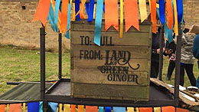

Has anyone spotted the Fire-Smiths in and around Longhill over the last couple of days?

They’ve been out collecting answers to the question ‘*what brings you hope?’*, and making preparations ahead of the [**next Act of Wanton Wonder**](https://www.facebook.com/events/149974495561891/?acontext=%7B%22source%22%3A5%2C%22page_id_source%22%3A1463635730345209%2C%22action_history%22%3A%5B%7B%22surface%22%3A%22page%22%2C%22mechanism%22%3A%22main_list%22%2C%22extra_data%22%3A%22%7B%5C%22page_id%5C%22%3A1463635730345209%2C%5C%22tour_id%5C%22%3Anull%7D%22%7D%5D%2C%22has_source%22%3Atrue%7D) this Saturday.

If you see them, go and say hello – they’ve very friendly. And who knows, you might even get a cup of tea…

Allison

**TINY CRATE FOUND IN EMBERS OF LONGHILL BURN**

Published by [**The Green Ginger Fellowship**](http://www.greenginger.org/author/greenginger/).

19 July 2017



After The Longhill Burn, we were alerted to something unusual discovered by the Fire Smiths in the embers of the bonfire –

Video Player

What does it mean? Does the fact the crate is so small hold any significance? What are the noises inside? How did it survive the fire?

Here goes another mystery…!

**GROWING CRATE?**

Published by [**Antony O’Brien**](http://www.greenginger.org/author/antony-obrien/).

04 August 2017



A very quick update for you all…

There has been some debate over the past couple of weeks about whether the small crate found in the embers of [**The Longhill Burn**](http://www.greenginger.org/act-iii-the-longhill-burn/) (please see previous blog) has grown or not.

A number of Fellowship members believe it has. I on the other hand, judging it by eye, believe it has remained entirely the same size and the confusion is down to incorrect recording of measurements. This can occasionally happen when people aren’t entirely focussed, or when excitement at such a discovery clouds their pragmatism somewhat.

We are monitoring the small crate as closely as capacity will allow, but can confirm it has not exhibited any other strange behaviours – smoking, moving, emitting strange noises and etc. We will keep you updated if/when this happens.

Thanks all –

A.

**THE NOSE GUARDIAN SPEAKS!**

Published by [**The Green Ginger Fellowship**](http://www.greenginger.org/author/greenginger/).

08 August 2017



Not sure if people saw it, but there was an article by Jade, The Nose Guardian, in the [**Hull Daily Mail**](http://www.hulldailymail.co.uk/news/hull-east-yorkshire-news/whats-like-gold-nose-green-286923) today. We love this picture of her with Mary, one of the regular visitors to The Gold Nose of Green Ginger at North Point. Under two weeks now until The Nose is returned to the city for safekeeping, so if you want to make a wish…do it soon! All the details and opening times etc are [**here.**](http://www.greenginger.org/the-gold-nose-of-green-ginger/)

**HOW DO YOU BECOME A NOSE GUARDIAN’S ASSISTANT?**

Published by [**The Green Ginger Fellowship**](http://www.greenginger.org/author/greenginger/).

12 August 2017



We can’t believe The Gold Nose of Green Ginger is only on display at North Point Shopping Centre for one more week – it’s gone so quickly!

[**After the piece in the Hull Daily Mail earlier this week with Jade, The Nose Guardian**](http://www.hulldailymail.co.uk/news/hull-east-yorkshire-news/whats-like-gold-nose-green-286923), Allison went to have chat with Jess Aylen to find out how she ended up as one of The Nose Guardian’s Assistants, what her job’s about and what she’s enjoyed most over the past two months.

**Why did you want to become a Nose Guardian’s Assistant?**

I guess because it was such an intriguing and unusual thing to be a part of. I love working in the community and Jade, The Nose Guardian, is actually my best friend.

We’ve known each other for 13 years now after meeting while we were studying at Wyke College, and I really wanted to support her at The Gold Nose of Green Ginger. I’ve also worked in Bransholme previously and love the community spirit here.

**What’s been your best moment of The Gold Nose of Green Ginger so far?**

There’s been so many. The opening procession in June was fantastic and really exciting because it was new to everyone – it’s not every day you get to walk around Bransholme with a tray of noses!

I really love the lunchtime concerts we’ve been hosting and the clarinet quartet in particular was very uplifting.

On a personal level, it’s been incredible to work alongside our costume designer. He made all of the costumes for The Gold Nose of Green Ginger – which are incredible – using paper pleating techniques. I’ve been so excited to learn some of his amazing skills and start to conquer some of the designs.

We’ve made so many friends and heard so many stories over the past couple of months. Just last week, a gentleman brought all of his metal detecting finds from all over Europe in to show us. And Mary, one of our regular visitors, is a joy. She’s been coveting our hats so we made her a similar miniature version, a bit like a fascinator.

**What are the main qualities you need to be a Nose Guardian’s assistant?**

Difficult one! I’d say practicality, because we have to manage all of the day-to-day background logistics of The Gold Nose of Green Ginger, the stuff that people don’t always see.

It’s also really important to be friendly and creative, because it’s so hands-on and we end up making a lot of different things.

**What advice would you give someone who wants to be a Nose Guardian’s assistant?**

Learn as much as you can about The Nose (or noses in general) and come and visit us! We’re here until Friday 18 August, so if there’s anything you want to know and you think this might be a career choice for you in the future, we’re more than happy to answer questions and give any advice.

**What’s next for you?**

I’ve got a lot of regular jobs I do every year. When The Nose is returned back to Hull for safekeeping, I’ll hang up my Nose Guardian Assistant’s hat and work on a winter parade in Lincolnshire.

You never know, maybe I’ll even have a bit of a break after our closing ceremony on August 19!

The Gold Nose of Green Ginger Leaving Procession will be taking place from 11am next Saturday – please join us to say goodbye and wish the third Act of Wanton Wonder well on the next part of its adventure (and visit before Friday if you want to make any last-minute wishes, share any secrets or speak to The Nose Guardian and her assistants). Opening hours for the space are [**here.**](http://www.greenginger.org/the-gold-nose-of-green-ginger/)

Tally :)x

**THE GOLD NOSE TRAVELS ON**

*(For Now!)*

Published by [**The Green Ginger Fellowship**](http://www.greenginger.org/author/greenginger/).

24 August 2017

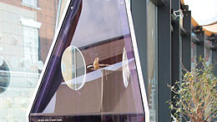

Hi everyone!

On Saturday, we joined together to see The Gold Nose of Green Ginger off in a fitting farewell from North Point Shopping Centre to Hull History Centre.

If you haven’t read Jean’s poem documenting the discovery of The Nose and its memorable residency at North Point over the summer, have a read [**here**](http://www.greenginger.org/the-gold-nose-of-green-ginger/). We thought it summed it all up rather nicely!

The Gold Nose is now at Hull History Centre for the foreseeable future until it moves on to somewhere else. At this point we don’t know where that’ll be, but you’ll all be the first to know when we do…

Tally x

**SMOKEY CRATE SURPRISES RICHARD AND PAULINE**

Published by [**Antony O’Brien**](http://www.greenginger.org/author/antony-obrien/).

29 August 2017

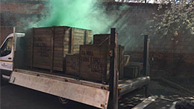

During conversations with Jean this afternoon, I was reminded of this quite extraordinary footage from the beginning of our investigations back in April/May.

It serves as a stark reminder of just how far we have come in the search for Acts of Wanton Wonder of the past months. The crates  continue to surprise and delight, but we’re rather getting used to their many unpredictable behaviours. I doubt whether any of us would bat an eyelid

at a crate smoking or moving of its own accord now!

Ant

**TINY CRATE GROWS AND GROWS…AND GROWS**

Published by [**The Green Ginger Fellowship**](http://www.greenginger.org/author/greenginger/).

09 September 2017

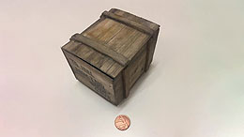

There’s been much debate between Fellowship members over this, but – well, what do you think?

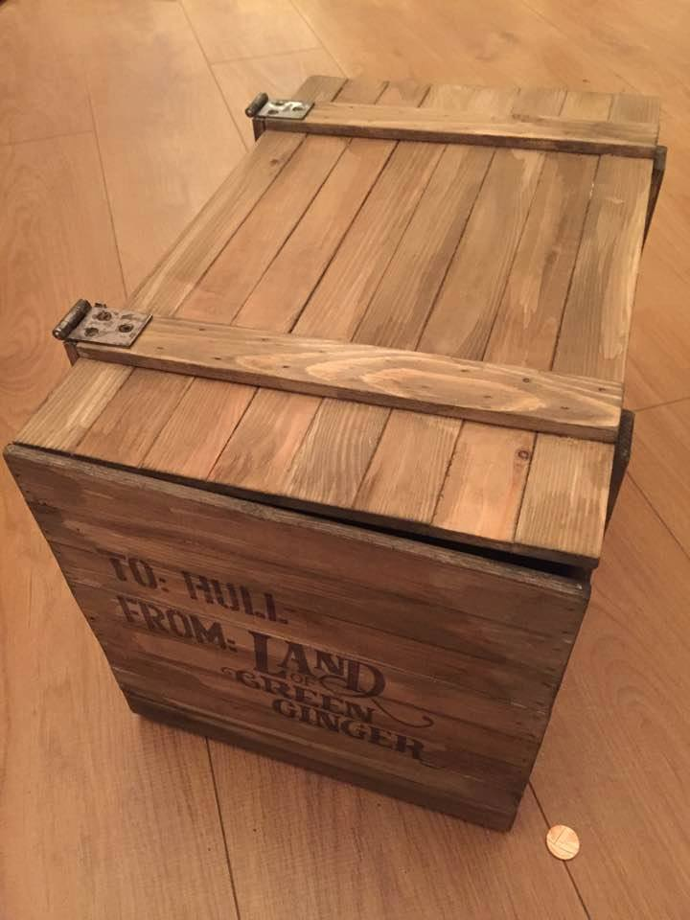

Martin has been monitoring the tiny crate found in the embers of The Longhill Burn on a daily basis. The picture on the left shows the crate on the day we found it. The picture on the right shows the crate on Thursday. We can absolutely confirm that CCTV footage shows nothing untoward or suspicious, and the crate has been in a controlled and monitored environment since we found it back in July.

There’s been various theories from members – imprecise starting measurements, the wood swelling because of the weather and etc – but given the sheer exponential increase in size, these have now been discounted. The crate continues to emit periodic noises we can’t quite pinpoint. They don’t seem to be in any order or sequence that we can determine.

There’s a great deal of excitement from Fellowship members who believe in the paranormal, but some of our more sceptical members have voiced consternation as to how safe the crate is to continue to house. Martin’s observations haven’t flagged up anything of great concern as yet – it seems only as though the crate is trying to tell us something.

We’ll keep you updated!

Tally :)x

**RE-REDIFFUSION: WHO, WHY AND WHERE?**

Published by [**The Green Ginger Fellowship**](http://www.greenginger.org/author/greenginger/).

12 September 2017



***We asked James Crumpton – one of the founding members of Re-Rediffusion -the reasons behind re-forming and what Rediffusion means to him almost forty years after the company closed its doors in Hull.***

My granddad used to work for Rediffusion, so that presence has always been very much there in my life. He used to tell me stories about his colleagues and I have really strong memories of the switch in his house, just inside the window in the front room. I used to fiddle with it when I was little, and he’d tell me off. Most people you speak to remember Rediffusion – by the time they closed in the mid-80’s, Rediffusion Hull had the UK’s largest customer base of nearly 50,000 customers. It was a huge part of most people’s daily lives.

It really began when my granddad left me a notebook when he died – I just didn’t realize it at the time.  It never really made much sense, filled with drawings and sums and squiggles I couldn’t make head nor tale of, and the letters *PV* and *8864* written on the inside. I always thought it was someone’s initials and a date, never assuming it could be anything more telling. I looked through it every now and then hoping to find a clue, but it didn’t make any sense.

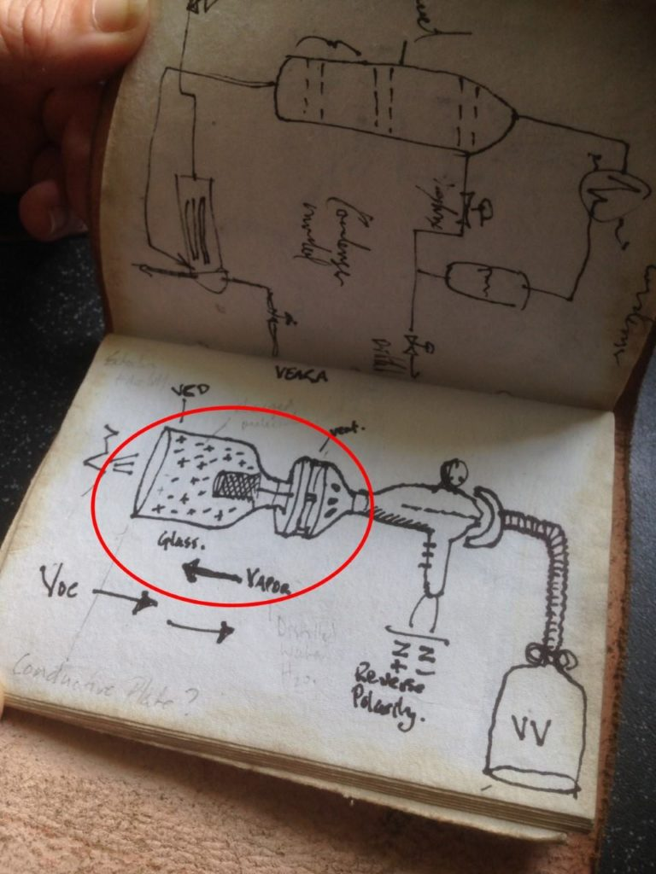

Everything moved very quickly when KCOM found the crate under the old headquarters on Bev Road. When other people started to come forward – like Vanessa and her story about her Uncle Jim working for something called Project VEAR – it all started to fall into place. PV wasn’t someone’s initials – it was the code for a secret project they’d been working on.

We decided to form Re-Rediffusion with the ambition of completing the work that Project VEAR had begun in the 1930’s. It just seemed like the right thing to do, like we’d been brought together through the Fellowship’s investigations for this purpose. It was also a great opportunity to find out more about what my Granddad had been up to when he was my age; when I’d assumed he was taking my Nan to tea dances and growing veg in his allotment, he was actually helping to invent something incredible, something that might be able to bring voices from across the whole city together in one place.

Exciting as it’s been, trying to create something that was designed in the 30s hasn’t been without its challenges and we’ve had to do some serious experimentation. Being nearly ninety years on, a lot of the parts aren’t widely available any more so we’ve been working with our VEARO’s (the trained engineers working on the project) to find alternatives that can be used safely.

It’s been really good fun, and most people have been completely open to having their voices collected. However, the vapour, once charged with vocal components, can get quite dangerous to work with, so we’ve had to get a whole load of protective kit together to make sure nobody comes into contact with raw vocal molecules. One of our VEARO’s forgot to put his wrist gaiters on and ended up with a buzzing arm for a week; downside of the job!

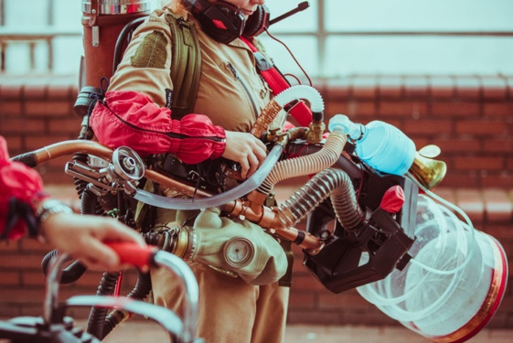

The original Project VEAR was top secret, and it’s been difficult getting some people to share information. Other people have been more eager to help, which has been a god send; with a bit of charm and persuasion we’ve got all the information we need, and now the VEARA (Voice Extraction and Rediffusion Apparatus) is fully operational and has been all over the city collecting voices.

We’re currently in the process of mixing the charged vocal vapour we’ve collected together, seeing what happens when people’s voices are given the chance to mingle. Then we’ll begin work on the delicate distillation process.

By the end of the month we’ll know if it’s possible to find, capture and bottle the very essence of Hull’s Voice and source of its power. And then all will be revealed!

**VOICE PARK ANNOUNCED!**

Published by [**The Green Ginger Fellowship**](http://www.greenginger.org/author/greenginger/).

16 September 2017

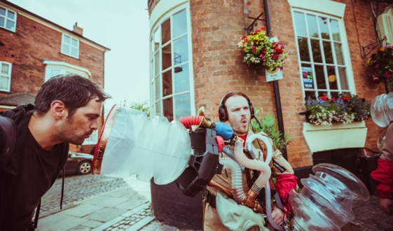

The truth is out there!! We’re SO excited that Re-Rediffusion have finally uncovered their plans for all the voices they’ve been collecting throughout the summer.

Have a look at our [**Facebook event**](https://www.facebook.com/events/118456515521684/?acontext=%7B%22source%22%3A5%2C%22page_id_source%22%3A1463635730345209%2C%22action_history%22%3A%5B%7B%22surface%22%3A%22page%22%2C%22mechanism%22%3A%22main_list%22%2C%22extra_data%22%3A%22%7B%5C%22page_id%5C%22%3A1463635730345209%2C%5C%22tour_id%5C%22%3Anull%7D%22%7D%5D%2C%22has_source%22%3Atrue%7D) for all the details, and we’re looking forward to seeing you all playing with the undoubtable power of Hull’s huge voice!!

Tally x

**TINY CRATE MOVED TO PICKERING PARK**

Published by [**The Green Ginger Fellowship**](http://www.greenginger.org/author/greenginger/).

19 September 2017

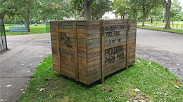

Well tiny crate isn’t much of a tiny crate any more…

As you all know, Martin’s been monitoring tiny crate really carefully, ever since we found it in the embers of The Longhill Burn. It caused a few disagreements within the Fellowship, with some people claiming he’d taken the original measurements wrong, etc etc, and others backing his observations up wholeheartedly.

ANYWAY; there’s no arguing with this. We came back yesterday after the weekend, and tiny crate had not only practically doubled in size over the space of two days, but was also being incredibly vocal. After an emergency meeting, we decided to try and learn from some of the lessons of the past Acts – the crates that appeared at the Freedom Centre in April quietened immediately when we sent them to East Park, so we wondered if sending tiny/not so tiny crate to Pickering Park – as per the writing on its side – might calm it down a little. Antony always uses that [**analogy about the ghost of Katherine Griffith**](http://www.burtonagnes.com/The_Hall/The_Ghost.html) to explain it, which makes perfect sense to me – things need to be in the right place sometimes, don’t they? It’s kismet.

We’re monitoring the crate regularly for unpredictable behaviours, but please feel free to message us if you happen to be passing and notice anything strange you want to report – sounds, smoke, movement and etc. Nothing surprises us any more!

Thanks all and have a great evening.

Tally :)x

**FOOTPRINTS IN LAND OF GREEN GINGER**

Published by [**Antony O’Brien**](http://www.greenginger.org/author/antony-obrien/).

23 September 2017

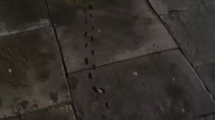

When I woke up yesterday morning and checked the Green Ginger Fellowship Facebook page, I was rather stumped to see these images in our inbox. Tiny footprints, seemingly winding from a grate in the wall and down a drain in Land of Green Ginger.

My first thought, as it so often and cynically is, was ‘hoax’. You’d be surprised at how many of these we get, being the sort of organisation we are. But then, why would someone go to the trouble of stealing out in the dead of night, painting tiny footprints on the ground, taking photos and sending them to us? It seems like an awful lot of trouble for a small ruse.

I also wondered if the images had been manipulated in some way, but JJ assures me they haven’t.

After a call-out on Facebook, a lady left us a wonderful message as follows:

***‘As a small child (about 1970-ish), I visited Tessymans leather suppliers in Land of Green Ginger. My Dad was a shoe repairer as were several generations before him. His great-grandad had a shoe and boot making business on High Street and the man in Tessymans was Fred Houlton. (I think) He took me into the cellar and asked if I’d ever seen a river flowing inside a house. Taking up a section of the wooden floor boards he said ‘there, look. There’s the river Hull’. Water was flowing just beneath the cellar floor. Tessymans was a magical place, similar to Olivanders inside. Tiny footprints don’t surprise me at all. It’ll be the elves wondering where all the shoemakers have gone.’***

How vivid is this? So my question is; does anyone know anything about Tessymans? Or have any research that can verify this quite remarkable story? A brief internet search hasn’t thrown anything up, but I’ll start some serious research tomorrow when Jean goes to dancing.

With thanks –

A

**TINY FOOTPRINTS CONFIRMED IN PICKERING PARK**

Published by [**The Green Ginger Fellowship**](http://www.greenginger.org/author/greenginger/).

03 October 2017

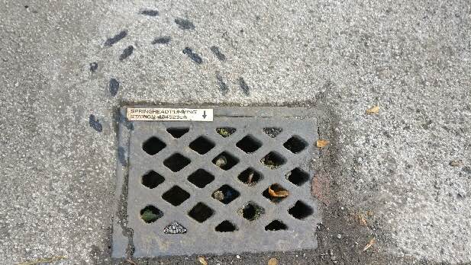

We received a number of reports about footprints in Land of Green Ginger and Pickering Park over the past week, but Voice Park was so all-consuming that we didn’t really get a chance to follow them up.

Last night we received another message on our Facebook page, so Antony and Jean took a detour into the park on their way to ballroom dancing this morning. Lo and behold; footprints. And not *just* footprints, but also a small sign with what appears to be a distance in centimetres between Pickering Park and Springhead Pumping Station.

Antony’s been out all day following up leads at Bransholme, East Park and Land of Green Ginger again, so we’ll catch up tomorrow and hopefully see what he has to update us with.

Regards –

Martin

**THE LIGHT IN THE TOWER**

*The story so far*

Published by [**Antony O’Brien**](http://www.greenginger.org/author/antony-obrien/).

05 October 2017

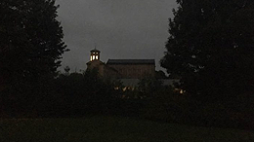

A brief recap of the last day:

After confirmed sightings of tiny footprints and signs pointing to Springhead Pumping Station, Jean and I decided to go up there yesterday afternoon to see if we could find anything to aid our investigations.

The most evident sign of something unusual was a clear Land of Green Ginger mark outside the front gate. We stayed for a while, but nothing else seemed to be jumping out at us apart from the odd car passing and children playing down the road – we decided to take the photos back to the rest of The Fellowship and try again in the evening.

On visiting at around 7pm, we immediately noticed a light in the tower of the Pumping Station. I couldn’t recall having ever seen it before – but then I don’t often go out that way – so we asked some passing dog walkers whether they’d ever noticed it. They all seemed surprised and said no.

This afternoon, we secured confirmation that Yorkshire Water will allow us into the building to investigate further. It could be nothing; but then equally, it could most definitely be *something*…

We’ll keep you posted.

A.

**THE SPRAWLING MICROPOLIS**

Published by [**Antony O’Brien**](http://www.greenginger.org/author/antony-obrien/).

06 October 2017

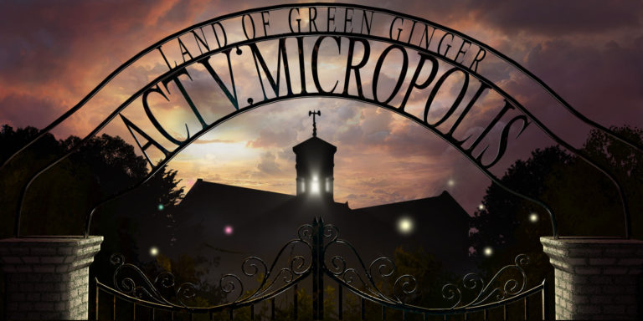

The most exciting, quite extraordinary news.

As we reported yesterday, we were informed of a Land of Green Ginger mark appearing outside the gates of Springhead Pumping Station and a light in the top tower that no-one could recall having seen before.

We got in touch with Yorkshire Water, who very kindly humoured our concerns and agreed to let us into the Pumping Station to investigate further. Thank goodness they did! What a discovery!

It would appear that a huge community of tiny people has been beavering away right under our very noses, taking the rubbish we discard and using it to build a sprawling city of their own.

Hotels, restaurants, gyms, butcher’s shops…it’s all there, inhabited by a thriving community; a miniature version of our own world, built within the Pumping Station over – what? Years? Perhaps even decades.

This can surely only be a fifth Act of Wanton Wonder, and one you simply have to see to quite believe. [**Let us know if you’re able to join us.**](https://www.facebook.com/events/1929135153779960/?acontext=%7B%22source%22%3A5%2C%22page_id_source%22%3A1463635730345209%2C%22action_history%22%3A%5B%7B%22surface%22%3A%22page%22%2C%22mechanism%22%3A%22main_list%22%2C%22extra_data%22%3A%22%7B%5C%22page_id%5C%22%3A1463635730345209%2C%5C%22tour_id%5C%22%3Anull%7D%22%7D%5D%2C%22has_source%22%3Atrue%7D)

A.

**AN UNOPENABLE CRATE**

Published by [**The Green Ginger Fellowship**](http://www.greenginger.org/author/greenginger/).

11 October 2017

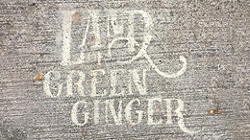

All of the crates in our cache have their quirks, but we haven’t had one that simply *won’t* open before.

Richard and Pauline drew our attention to it on Friday afternoon, when they reported a certain crate that just refused to budge. We tried everything from crowbars to kind words, but nothing worked. And of course you know what it’s like – the more something won’t open, the more you need to see what secret it’s holding…

On Monday, we eventually made a decision to drill some holes in the side to see whether we could make anything out. Nothing at first, and then when our eyes adjusted, we could just make out tiny artefacts; clothes, personal possessions, furniture.

Almost simultaneously, we received notification from a youth centre close to Springhead Pumping Station that a Land of Green Ginger mark had appeared in their car park, so, working on the same principle of connecting two things that need to be brought together to unleash their power, we did just that.

The crate is currently in the car park of the youth centre with the LOGG mark – watch this space!!

Tally :)x

**MICROPOLIS CRATE COMES TO LIFE**

Published by [**Antony O’Brien**](http://www.greenginger.org/author/antony-obrien/).

13 October 2017

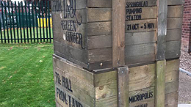

Good afternoon, all.

As you’ll remember, Tally last updated you on a crate from our cache that was completely unopenable. I’m sure you all know how I feel about damaging ANY evidence, but after trying every which way to get into it, we made the decision to drill holes in the side so we could see what was going on.

The crate was placed at the site of a reported Land of Green Ginger mark at Ainthorpe Youth Centre, where we left it to gestate and see what secrets – if any – would be revealed.

This morning, Hana and Allison sent some video footage of what they’d captured whilst on a monitoring shift. It seems some of the tiny people from Springhead Pumping Station may well have popped back to collect some of their belongings and furniture from the crate, stopping to have a rather good time while doing it!

We’re continuing our observations, but just had to share this with you all

Happy weekend, as ever. We hope it’s as joyful as this footage.

A.

**THE MICROPOLIS OPENS**

Published by [**Antony O’Brien**](http://www.greenginger.org/author/antony-obrien/).

23 October 2017



You may well remember the footage we posted of the tiny people having a rather good time in the crate we left outside Ainthorpe Youth Centre the other day.

Well, despite Hana, Tally and Allison watching it practically around the clock, it appeared that activity was rapidly decreasing. We assumed they had perhaps taken what they needed, and moved the crate to Springhead Pumping Station to see whether that would have any markable effect at all.

On Saturday, Micropolis finally opened its doors to the public. We were overawed by how many of you came to greet the miniature community and explore all corners of their incredible world – thousands, to be precise. But perhaps the most salient question remains; would you partake in a Rolling Rat Kebab…?

The tiny people have kindly agreed to keep their doors open daily until Sunday November 5, at which point they will revert back to the somewhat inconspicuous lives they much prefer. Take advantage of their hospitality while you can. Full details, as always, are [**here.**](https://www.facebook.com/events/1929135153779960/?acontext=%7B%22source%22%3A5%2C%22page_id_source%22%3A1463635730345209%2C%22action_history%22%3A%5B%7B%22surface%22%3A%22page%22%2C%22mechanism%22%3A%22main_list%22%2C%22extra_data%22%3A%22%7B%5C%22page_id%5C%22%3A1463635730345209%2C%5C%22tour_id%5C%22%3Anull%7D%22%7D%5D%2C%22has_source%22%3Atrue%7D)

A.

**WHO ARE THE LITTLE PEOPLE OF MICROPOLIS?**

Published by [**Antony O’Brien**](http://www.greenginger.org/author/antony-obrien/).

30 October 2017

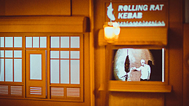

I’ll be the first to admit that my knowledge of tiny folk was not extensive prior to starting this short piece of research.

To be clear, neither myself nor my colleagues at the Fellowship know what category the tiny folk inhabiting Springhead Pumping Station fit into. They are neither faerie nor di sma, brownies nor patupaiarehe. They are, it seems, what they are – a self-contained community of miniature people. We know they traverse the city using drain networks to gather our rubbish, using it to build their own homes and amenities. Gauging the size of the Micropolis, it would appear they’ve been doing this for years and years, unknown and unnoticed.

I thought it might be useful to look briefly at the history and meaning of little people throughout history – if we can’t reflect on the past in meaningful ways, how can we begin to understand the present and/or shape the future?

This, so far, we know:

Little people have been part of the folklore of many cultures in human history, including Ireland, Greece, the Philippines, the Hawaiian Islands, Flores Island and Indonesia.

Many native legends of North America tell of a race of “little people” who live in woods near sandy hills and near rocks located along large bodies of water. They play mischievous pranks on people – such as singing and then hiding when a passer-by searches for the source of the music – although it’s claimed that they love children. Some stories even tell of little people rescuing children from what they view to be less than adequate parents.

Tommyknockers – not from Stephen King’s novel, but of a far earlier derivation – are little folk in the legends of Wales, often considered to be troublemakers. Interestingly Wales is the site of the Great Orme Caves which, when uncovered, showed ancient mining with tools too gargantuan for humans. Does this perhaps prove existence of a giant culture alongside that of a much smaller one?

Certainly legends have an interesting way of sharing events and truths in the context of magic, aiding their transition on to future generations. The Icelandics, for example, have a fascinating attitude to elves; they associate them with rock, like the Norwegians see trolls as giants who turn to rock. There have even been instances where road building/repair has been diverted because of the need to move large groupings of rocks and not wanting to disturb the little folk.

Was the role of tiny folk to work in caves because of convenient physicality and had the ability to see in the dark? It may be a very real possibility. We can perhaps assume that the relationship between them and the giants may have been one of mutual assistance in order to dig the caves out (giants) and mine within small spaces in the dark (wee folk).

Rocks – associated with both the miniature and the huge – certainly show what some Native American tribes even recalled – ‘*they did the mining – not us.*’ – and who built the original megaliths?

In August 2005, a tiny mummified body was found in the ancient Persian village of Makhunik (now Iran). The 25-centimetre long mummy was well-preserved and covered by a thin layer initially believed to be caused by mummification techniques, but later confirmed to be skin.

The discovery quickly added fuel to rumours already in existence about a ‘dwarf’ city in Kerman province, with parallels being drawn to Lilliput City described in Swift’s *Gulliver’s Travels*. Reports started filtering through of homes and buildings excavated in the ancient village with walls only 80cm high; although this has been strenuously denied by archaeologists, it remains a point of great debate.

Talking of literature, who of course could forget Pratchett’s the Nomes? The Borrowers? Tom Thumb? Whilst researching, I came across a list of books compiled by author Conn Iggulden – Jean is a big fan of his work – about the tiny people to be found in books. I found this quote particularly interesting:

‘*Perhaps because we’ve all been small, books about tiny people are perennial favourites. Which of us hasn’t imagined having a tiny character we could take to school in a pocket?’*

I can still remember as a young man watching Land of the Giants, wondering what it would be like to be transported to another planet, finding myself out of place and only able to travel using the ubiquity of drains; the excitement of ‘what if?’

There is a fascination with an idea of a miniature existence alongside our very own, the notion that, as Hamlet once so eloquently said, ‘*there is more to life than is dreamed of in our philosophy, Horatio*.’ We are so occupied with every day life, with social media, with the reams of TV channels streaming into our front rooms and bedrooms; is it any wonder that in this age of more distraction and less reaction, we might have forgotten the more magical elements of life calling out to us?

One thing is for certain; where we can open our ears and eyes, hearts and minds, the truly extraordinary is never far away.

**HAPPY HALLOWEEN!**

Published by [**Antony O’Brien**](http://www.greenginger.org/author/antony-obrien/).

31 October 2017



We all know someone who loves to celebrate Halloween. But where have our creepy customs come from? And why do we carve pumpkins and dress up?

Halloween or Hallowe’en (a contraction of All Hallows’ Evening), also known as Allhalloween, All Hallows’ Eve, or All Saints’ Eve, is  observed every year in a number of countries on, of course, October 31 – the eve of the Western Christian feast of All Hallows’ Day, also known as All Saints’ Day.

The origin of the festival is widely disputed, and there are both pagan and Christian practices that have evolved into what Halloween is today.

Some believe it originates from the Celtic pagan festival of Samhain, meaning ‘Summer’s End’ which celebrated the end of harvest season.

Gaels believed that it was a time when the walls between our world and the next became thin and porous, allowing spirits to pass through, come back to life on the day and damage their crops. Places were set at the dinner table to appease and welcome the spirits. Gaels would also offer food and drink, and light bonfires to ward off the evil spirits.

The Christian origin of the holiday is that it falls on the days before the feast of All Hallows, which was set in the eighth century to attempt to stamp out pagan celebrations. Christians would honour saints and pray for souls who have not yet reached heaven.

But why do we dress up?

In the 11th century, the Church had a tradition called ‘souling’, which is seen as being the origin of trick-or-treating. Children go door-to-door, asking for soul cakes in exchange for praying for the souls of friends and relatives. They went dressed up as angels, demons or saints. The soul cakes were sweet, with a cross marked on top and when eaten they represented a soul being freed from purgatory.

In 16th century Ireland, Scotland and Wales, people went door-to-door in costume asking for food in exchange for a poem or song. Many dressed up as souls of the dead and were understood to be protecting themselves from the spirits by impersonating them.

By the 19th century, souling had given way to *guising* or *mumming*, when children would offer songs, poetry and jokes – instead of prayer – in exchange for fruit or money.

The now popular phrase ‘trick-or-treat’ was first used in America in 1927, with the traditions brought over to America by migrants. Guising gave way to threatening pranks in exchange for sweets.

After a brief lull during the sugar rations in World War Two, Halloween became a widespread holiday that revolved around children, with newly-built suburbs providing a safe place for children to roam.

The carving of the humble pumpkin originates from the Samhain festival, when Gaels would carve turnips to ward off spirits and stop fairies from settling in houses.

A theory that explains the Americanised *‘Jack O’Lantern*’ comes from the folkloric story of Stingy Jack, who fooled the devil into buying him a drink. He was not let into heaven or hell – and when he died, the devil threw him a burning ember which he kept in a turnip. The influx of Irish migrants to North America in the 1840s could not find any turnips to carve – as was tradition – so they used the more readily available pumpkin into which they carved scary faces. By the 1920s, pumpkin carving was widespread across America, and Halloween was a big holiday with dressing up and trick-or-treating.

And here we are in 2017. Jean and I are currently being scared witless by two very tiny vampires of our own, so we’d better go and feed them before they try and feed on us! Whatever you celebrate and how you celebrate it – stay safe and have a wonderful time.

Happy Halloween!

Ant.

**GREEN GINGER PREPARES TO UNLEASH**

Published by [**The Green Ginger Fellowship**](http://www.greenginger.org/author/greenginger/).

04 November 2017



We have had various reports of crates and Land of Green Ginger marks appearing along the route we think Land of Green Ginger is going to be unleashed – have you seen them? We are particularly flummoxed by how one managed to get on top of Hudgells!!

Please keep your reports and photos coming in to us. We cannot investigate all of them, but it is so invaluable for us to be able to gather all of this information.

Hana.

**A MESSAGE FROM MICROPOLIS**

Published by [**The Green Ginger Fellowship**](http://www.greenginger.org/author/greenginger/).

06 November 2017

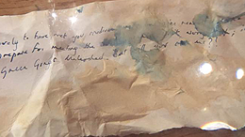

Last night, the tiny people of Micropolis closed the doors of Springhead Pumping Station on the outside world. They’ve been incredibly generous allowing us all into their Micropolis for the past fortnight, but they need a bit of time to get back to normal now.

JJ found a tiny piece of paper tucked into the back of his shoe last night. None of us have eyesight good enough to read such small writing – PLUS part of it was spoiled because of the rain – so we asked Richard to study and decipher it. It reads as follows:

**Lovely to have met you medium giants, but we’re ready for some peace and quiet now – and we need some time to prepare for meeting the *REAL* giants. Don’t worry though, it’s merely an adieu; we’ll be seeing you all at Green Ginger Unleashed. But will you see us…?**

When JJ and Hana were helping to secure Springhead Pumping Station last night, they reported seeing a very orderly queue of tiny people disappearing through a mouse hole carrying various belongings with them. Tracing the exit, they were then witnessed climbing back into the crate in the grounds; we transported the crate back to HQ for monitoring this morning but all remains quiet so far – they’re probably worn out!

Who knows what they’ll get to next? Keep your eyes peeled at Green Ginger Unleashed – and look out for footprints and signs of tiny mischief!

Tally :)x

**THE DAY IS HERE!**

Published by [**Antony O’Brien**](http://www.greenginger.org/author/antony-obrien/).

11 November 2017



Dear all.

In just over five hours, Land of Green Ginger will reveal itself to us in a huge unleashing of power, magic and colour.

Little remains to be said, other than [**make sure you’re prepared**](http://greenginger.org/) in terms of parking, travel and other vital practicalities, and embrace what you will experience this evening.

With all good wishes and excitement,

Antony and the GGF team

**Project Round-ups**

**ACT I – 7 ALLEYS**

It all starts here; [**a crate opened in April that bore the message ‘*Acts of Wanton Wonder are coming*‘**](http://www.hulldailymail.co.uk/investigation-launched-into-mysterious-crates-discovered-in-land-of-green-ginger-vault/story-30252458-detail/story.html).

After transporting everything across to our HQ and starting investigations, one of the crates was found to contain a bottle with a riddle inside. With help from Facebook followers, we were able to work out the answer; 7 Alleys, East Park. But would people join us to find out what lay beyond?

Plenty of people had seen the Land of Green Ginger mark around East Park, as well as the beautiful horses and carriage parading around the area and dropping invitations off. The crates had also been less unpredictable since we moved them to East Park from the Freedom Centre, which seemed to indicate we’d done the right thing. We just hoped our instincts would be right and the 7 Alleys would choose to reveal themselves to us in some way.

**The Search for the 7 Alleys**

**May 3 – 6**

Holderness Road quietened slightly and the sun started to drop behind the trees. East Park became suddenly eerily still; a family packed up their picnic, children started the slow walk home with footballs under their arms and school in the morning.

People gathered at the gates, talking amongst themselves and trying to get a glimpse into the park beyond. Our last-minute preparations were now in place, but nerves were still frayed; what if we’d got it wrong? What if nothing appeared and people – including us – had to go home disappointed?

When the gates opened, everyone gathered in a semi-circle, nervous and unsure. Some of them had invites from the 7 Alleys themselves, others had learned through word of mouth, Facebook and twitter that something would hopefully be happening here this week.

The last of the sun disappeared and people talked amongst themselves in hushed voices. Then we heard hooves trotting, cantering, galloping; we all turned to look, pushing through each other as two black horses made the approach. They pulled a carriage behind them, a violin player playing solemnly on the back.

Some people were lucky to be chosen to ride in the carriage, and the remaining thousands waited until the signal was given, beginning the long journey through the line of trees. Some people moved away to take photographs of themselves against the lights and some stopped to observe the searchers on the grass before melting back into the crowd. Eventually we came together, the cold and mist woven between us, and waited to see what would happen next.

The last person filtered eventually into the next world. Tall structures punctured the skyline, figures only just visible in the dark. People pulled jumpers around themselves, and held their children’s hands a little tighter.

The 7 Alleys were now open.

There was a drumming beat of music and we craned our necks to look up at the blacksmith and his endless, showering fire. *This is our gang*, it told us. *We are forged here*. But who dared to steal fire from the dragon’s lair?

Barely time to catch our breath before being invited to run the second alley gauntlet. Another dare – this time, don’t disturb the sleep of the hanging smuggler in the rising mist.

The third took us to the sea, the Humber estuary, to a violent storm and lives lost. Did we know where the cargo was swallowed up, where it now lies?

The phantom train swerved violently through the fourth alley with the end in touching distance. Would make it home? We held our nerve, took a deep breath and set sail for magic.

Then Bubblegum Boy was there. We held him in the light of the moon, balloon at the ready, but never looking him in the eye. A hundred hands lifted up, globes ready to take on the sky and fly. And then they were gone, invisible dots going who knows where.

Prison wall loomed, towers spiking the gloom – would we jump and climb? And what will happen if the sirens called? Eyes tight shut, don’t think of bombs or the dust cloud falling on us all. The skyline lifted suddenly, windows empty and burning.

We moved up the 7th Alley, the final pathway, showered in paper as the White Lady guided us home. She span and twisted as the fire-lined alley seared our faces, illuminating every last detail as we walked together into the blackness. Words dropped on us like snowdrops, burnt-edged and prophetic.

7 tasks completed, 7 alleys passed. The pathway closed behind us as we walked back to our own world, sharing stories about what we heard and saw and felt. Into the cold darkness as that world faded back and ours began again.

Our search for the 7 Alleys is difficult to put into words, and this doesn’t even begin to do it justice. We were incredibly lucky to experience such a rare and beautiful journey into the world of some of the oldest East Hull myths, and we thank everyone who had faith in our investigations and joined us to experience the first Act of Wanton Wonder.

**ACT II: THE GOLD NOSE OF GREEN GINGER**

**THE GOLD NOSE OF GREEN GINGER**



Good evening everyone!

On Saturday, we waved farewell to The Gold Nose of Green Ginger as it began its journey to a residency at Hull History Centre. So; where does one begin to document the events of the past two months? The Gold Nose brought a great deal of intrigue, conversation and heart to a lot of people, and I don;t mind admitting I was struggling to put this into words.

Thankfully, Jean has recently undertaken a writing class as part of her birthday resolutions (every year we try and learn something new), so she saw fit to pen a poem about the discovery of The Nose and its journey thus far. I think this explains it all much better than I could manage, and with a great deal more sophistication. Without further ado:

**THE GOLD NOSE OF GREEN GINGER**

by Jean O’Brien

*Found in a ginger-smelling crate, The Nose first came to light.*

*Made of gold, from who knows where, its legend burning bright.*

*Some say it travelled from the East, on cargo ships of spice.*

*Some say The Wild Boar turned it up, a fateful throw of dice.*

*Some say its filled with magic to bring good luck to all,*

*While others claim coincidence, where fortune dares to fall.*

*First spoken of in Bransholme’s build, some fifty years back now,*

*When unsuspecting workmen found a casket in the ground.*

*They pulled it up and found within, The Gold Nose lying there,*

*A legendary artefact of warm and golden glare.*

*It lasted merely days under the widespread media eye*

*Before it disappeared again, though no one knows quite why.*

*Adrift in mists of legend’s sprawl, the treasure was thought lost –*

*(or taken by light-fingers at the general public’s cost).*

*And so The Nose slipped once again from general interest,*

*considered urban myth, a joke, a tale of mere spindrift;*

*Until the smell of ginger started flowing through the air,*

*No obvious origin, save for the large crate standing there.*

*When we started to investigate, we found nestled inside,*

*an odd-shaped object gleaming bright, with shop fittings beside.*

*We ran a competition asking people what they thought,*

*With answers like some gold ginger? A fairy boat? A cot?*

*And someone even guessed it, the answer left to linger –*

*Could it be? Of course it could! The Gold Nose of Green Ginger!*

*And after that, the interest went straight up through the roof*

*With disbelief that urban myth could turn out to be truth.*

*So North Point got in touch and asked if they could be the host*

*And bring the treasure home and display it for two months.*

*We agreed, and took them up on their extremely kindly offer*

*And started to move in to the shop unit that they proffered.*

*On June 17, a special day, a horse and carriage brought*

*The Nose Guardian, two assistants and The Gold Nose to the door,*

*And solemnly they processed with The Gold Nose on a pole*

*To tell the world the legendary treasure had come home.*

*There it stayed for two whole months –  62 gold days –*

*And opened up its doors for folk to visit, wish and stay.*

*With nose-themed crafts, a story time and lessons in nose flute,*

*Tea and biscuits, live concerts and nose parties to boot!*

*But most importantly perhaps, the public made their wishes,*

*And found the secret pocket to take time out and just listen.*

*It didn’t take too long for tales of good luck to come through,*

*Bingo wins, good school reports and lottery scoops accrued.*

*Some quite specific, others broad; all wished for different things,*

*Hoping that The Gold Nose would see fit to give them wings.*

*The Gold Nose of Green Ginger space brought chat and heart and fun,*

*But sadly after two months, the time to move had come.*

*On a Saturday in August, they solemnly processed*

*Once more, The Gold Nose through North Point, to its new place of rest.*

*A short bus ride surrounded by keen well-wishers and friends,*

*A fitting farewell party to mark a happy end.*

*And surrounded by some special guests of all denominations,*

*Hull History Centre took The Nose amid great celebration.*

*The Lord Mayor welcomed it for safekeeping in the city*

*And thanked The Nose Guardian before the welcoming committee.*

*For The Gold Nose wouldn’t be so safe without all her attention,*

*And that of her assistants, and the volunteers who ventured*

*Into the Nose Space every week, five days out of seven,*

*And followed it right to the end, to its brand new location.*

*So there it stands for all to see and make their wishes on;*

*The Gold Nose of Green Ginger, bringing hope and good fortune.*

*Who knows what lies in store for it? Adventures to explore,*

*For now we’re just glad that it’s here, at long last lost no more.*

**August 2017**

**ACT III – THE LONGHILL BURN**

**What is Hope?**

***If you keep hope alive, it will keep you alive…***

From ancient times, people have recognized that a spirit of hope had the power to heal afflictions and helps them bear times of great suffering, illnesses, disasters, loss, and pain caused by the malevolent spirits and events.

Elpis (Hope) appears in ancient Greek mythology with the story of Zeus and Prometheus. Prometheus stole fire from the god Zeus, which infuriated the supreme god. In turn, Zeus created a box that contained all manners of evil, unbeknownst to the receiver of the box. Pandora opened the box after being warned not to, and unleashed a multitude of harmful spirits that inflicted plagues, diseases, and illnesses on mankind. Spirits of greed, envy, hatred, mistrust, sorrow, anger, revenge, lust, and despair scattered far and wide looking for humans to torment. Inside the box, however, Pandora also discovered and released a healing spirit named Hope.

In short, wherever there is darkness, there is hope. The two cannot exist without each other.

In the week prior to The Longhill Burn, the Fire-Smiths asked people what makes them hopeful.

*January. Watching old people dance. Disco music. Chocolate.*

The answers were as eclectic and unpredictable as you’d expect. The Fire-Smiths were always clear that they wanted to collect these hopes and burn them; there is something galvanising in flames, the idea of burning hopes collectively to harness their collective power. Fire of course has great symbolism throughout history, including forging will and determination – from a spiritual perspective, fire represents our passions, compulsions, zeal, creativity and motivations.

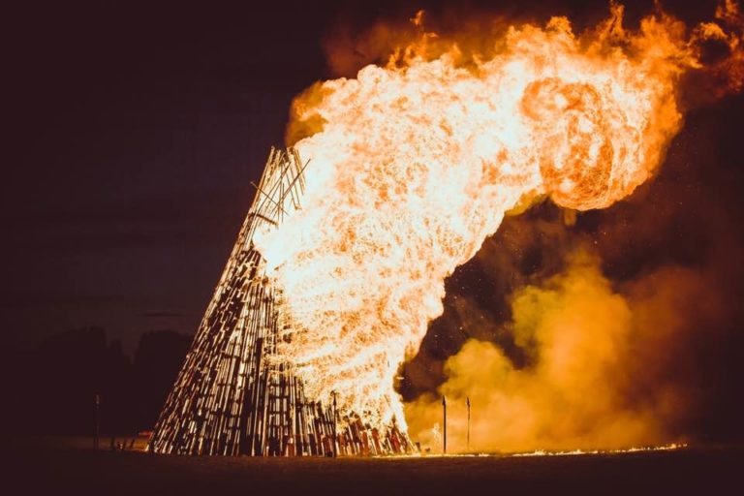

To start at the beginning:

The news of the Longhill crate first became public back in May, when Margaret Cranwell reported a crate in her allotment shed. It had always been there, but she hadn’t taken much notice of it until the interest in our investigations.

She opened it to reveal what looked like a jar of ashes, a megaphone covered in ribbons and a constitutional document inside for the formation of a “guild” of local residents.

When the article came to our attention, we started working with Margaret to try and decipher the meaning of these items. We believed the jar of ashes might well hold the key to another Act of Wanton Wonder, following in the footsteps of The Search for the 7 Alleys in East Park and the legendary Gold Nose of Green Ginger, currently displayed at North Point Shopping Centre until Friday August 18.

With this in mind, we contacted a group called the Fire-Smiths, specialists in celebratory and ceremonial fire-making, to investigate further.

After scrutinizing the jar of ashes under a microscope, pouring water on them and attempting to light them, they finally combusted and left the ambiguous wording ‘*hope can grow through fire and water’* seared the wood beneath them.

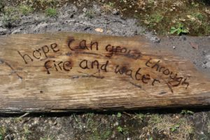

This led the Fire-Smiths to develop plans for The Longhill Burn, a ceremonial bonfire intended to bring the community together in collective purpose.

Margaret also brought together a group of local people – in accordance with the instructions found in the crate – who worked closely alongside the Fire-Smiths to create the event. They helped to spread the word, supporting friends, neighbours and other local residents to make their contribution to The Longhill Burn.

The people of Longhill were asked to bring their hopes, a small piece of wood for the fire (no bigger than a chair) and phials of water from those streets named after water (thinking here about the synergy of opposites, and how water and fire can be viewed as making each other stronger rather than cancelling each other out).

At the start of The Longhill Burn, the Fire-Smiths and Longhill Hosts continued to collect answers (about 500 on that night alone!) to the question ‘what gives you hope’, placing them in the crate found on Margaret’s allotment.

The Fire-Smiths built a beautiful bonfire with a hole-shaped heart. When people had finished contributing, the hopes were processed through the crowd in the wake of a marching band and a shoal of silvery fish, lifted up into the heart of the bonfire where they were set on fire to release their combined power and energy.

When the bonfire started burning, the fireworks started. Slowly at first and then more dramatically, they burst out in time to ‘*Love Is In The Air’*, people singing along and joining hands with the people next to them. There was an incredibly euphoric atmosphere as around 2500 people came together to sing, dance and enjoy the work of the Fire-Smiths.

The party carried on as the bonfire slowly burned itself out, with more celebrations as the band carried on playing.

But what next?

After the burning of the crate, the Fire-Smiths and The Green Ginger Fellowship found something quite unusual in the embers of the bonfire – a perfect, unscathed miniature crate. As you can see from the video, Tally got quite a shock when she opened it…

What does it mean? We don’t quite know. Could it be something to do with the voice collecting by Re-Rediffusion? Could one of the collected voices have got stuck in the crate? But why is it so small?

More questions to find answers to…

**IV: RE-REDIFFUSION’S VOICE PARK**

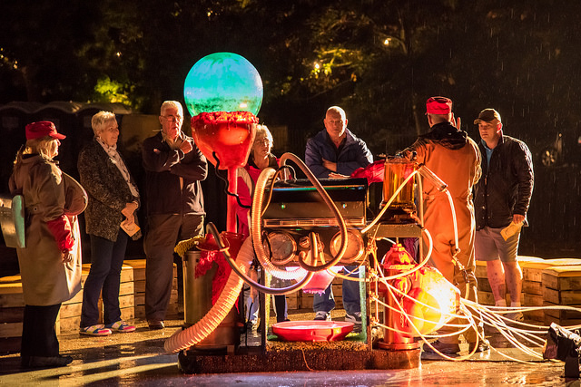

Thanks to all of you who came to Voice Park over the past week, from both ourselves and all the members of Re-Rediffusion. We hope you enjoyed playing with the power of Hull’s voice, walking amongst it and making your own *Essence de Voix* for those times when you might need that BIG HULL VOICE behind you.

Antony was going to do a closing essay about the power of voice and hearing – though he still might do, he’s quite enjoying the research! – and then we came into the office to this voicemail from James, which, well, sort of summed it all up perfectly really.

**ACT V :MICROPOLIS**

Published by [**The Green Ginger Fellowship**](http://www.greenginger.org/author/greenginger/).

06 November 2017



Last night, the tiny people of Micropolis closed the doors of Springhead Pumping Station on the outside world. They’ve been incredibly generous allowing us all into their Micropolis for the past fortnight, but they need a bit of time to get back to normal now.

JJ found a tiny piece of paper tucked into the back of his shoe last night. None of us have eyesight good enough to read such small writing – PLUS part of it was spoiled because of the rain – so we asked Richard to study and decipher it. It reads as follows:

**Lovely to have met you medium giants, but we’re ready for some peace and quiet now – and we need some time to prepare for meeting the *REAL* giants. Don’t worry though, it’s merely an adieu; we’ll be seeing you all at Green Ginger Unleashed. But will you see us…?**

When JJ and Hana were helping to secure Springhead Pumping Station last night, they reported seeing a very orderly queue of tiny people disappearing through a mouse hole carrying various belongings with them. Tracing the exit, they were then witnessed climbing back into the crate in the grounds; we transported the crate back to HQ for monitoring this morning but all remains quiet so far – they’re probably worn out!

Who knows what they’ll get to next? Keep your eyes peeled at Green Ginger Unleashed – and look out for footprints and signs of tiny mischief!

Tally :)x

**ACT VI: LAND OF GREEN GINGER UNLEASHED**

Dear all.

For almost a year now, we have lived and breathed Land of Green Ginger. From the cache of crates discovered under the city back in April, we have found ourselves on an adventure leading to six unforgettable Acts of Wanton Wonder; 7 Alleys in East Park, The Gold Nose of Green Ginger in Bransholme, The Longhill Burn, Re-Rediffusion’s Voice Park in Pickering Park, Micropolis in Springhead Pumping Station, and the culminating Land of Green Ginger Unleashed, roaring through the city centre last night.

One thing I have been mulling over recently; how long since we have all been children?  For myself and Jean, some fifty years now.

When we first moved into our home – almost four decades ago now – I found a rocking horse I was given on my fifth birthday. I remember it vividly; his shiny red bridle. The coarseness of his hair through my fingers. When I rode that horse, I was John Wayne, The Lone Ranger, Rawhide Kid. When I sat on his back, I wasn’t in our front room; I was free and anything was possible. I called him Mr What, after the Grand National-winning horse of that year.

You might well wonder where this story is going. When we were clearing out to move, I came across Mr What. I’d forgotten he was there, thrown up in the attic with a blanket over him, long-neglected since adult life took over. And yet, the moment I saw him, it was like yesterday again – the excitement of sneaking down early to find him, set out by the window with a yellow bow on his neck. His smell. The uncomplicated, pure magic of him taking me everywhere and never moving an inch.

In many ways, Land of Green Ginger has been like rediscovering Mr What. When we were first called in to look at the crates, we treated it like any other investigation, but it quickly became apparent that this was absolutely no ‘ordinary’ experience. It was unpredictable, but somewhere in the back of our minds, strangely familiar; like finding a childhood toy you know every corner of, but haven’t seen for decades.

It is easy, perhaps, to get involved in the intricacies of everyday life. What to have for tea, who’s picking the children up, what shopping we need…the swift onset of all-consuming technology means we’re no longer only occupied with our own lives, but that of others too – a blur that has us all jostling for a mythical projection of what’s expected of us.

All this time, Land of Green Ginger has expected nothing from us, save for a curiosity and willingness to open our minds to the what *could*happen. In many ways, it has done the impossible: made a group of somewhat grizzled, slightly cynical investigators believe in magic again. The little people beneath the pavements. The sheer power of our individual voices.  The living, breathing legends spun out of the darkness.

We believe Land of Green Ginger Unleashed is the final Act from Land of Green Ginger, comprising everything we have learnt and seen over these eight months. Who knows if it will return? For now, the childhood toys have been packed up back into the attic, waiting to be re-discovered with the same sense of joy. And that’s the wonderful thing about magic; it never goes away. It just waits to be found.

Thanks to each and every one of you for supporting. And more than anything, for believing.

Yours, as always,

Antony.

