**Contents page**

**Introduction**Story Box Circus is a ground-breaking programme which uses circus to improve the health and wellbeing of older participants.

The project brings the excitement and wonder of the circus directly into care homes and day centres and provides an opportunity for residents and carers to have fun together, learn new skills and try something new.

**How it all begun**

Story Box Circus began as part of a two-year programme of performing arts residencies in care homes led by Magic Me and hosted by award-winning housing providers Anchor. The project enabled Upswing to develop their work and practice for a care home audience including those with dementia.

In October 2017, Upswing collaborated with six care providers in Hull to deliver a multi-sensory circus experience. Commissioned by Hull UK City of Culture 2017, Story Box Circus visited each care provider for two days – transforming a space into a magical circus environment and offering staff training, a participatory circus workshop and a high-quality performance.

**When planning Story Box Circus, we responded to the knowledge that:**

There is a desire by older people to challenge themselves – to be brave and try something new. Story Box Circus challenges older people and their carer’s expectations of what they can physically achieve.

*“I realise I have been underestimating my customers” - Marcia Forsythe Manager, Silk Court Care Home*

The adapted use of circus disciplines, such as juggling and contact work, enables staff and residents to find different ways to relate to each other. Circus supports the interaction and co-operation between participants and staff.

*“We’ve done a lot of activities before, but this one was the best. It was brilliant.” Participant, 2017*

Flexibility – there is no ‘one-size-fits-all’ approach to bringing circus into a care home, therefore we work closely with each home in the run up to the activity. We are very sensitive to the fact that we are entering somebody’s home, and work hard to make sure any activities cause minimal disruption to established routines.   
  
*“Ooh, I feel like a child again!” Participant, 2016*

Working with all abilities – Our Artist-Educators are trained and experienced in working with a range of abilities and moods, adapting where and when necessary.

*“I want to run away with the circus.” (Participant, Story Box Circus, 2016)*

**About Upswing**

Upswing is one of Britain’s leading contemporary circus companies and the only diverse-led national circus organisation in the UK. The company was founded by artistic director and Clore Fellow Vicki Amedume in 2006 and is now a registered charity with regular support from Arts Council England.

Our vision is a better world, shaped by great art, forged by the fearless imagination of circus. Our mission is to create multi-disciplinary performance that celebrates the circus art form; excavates its emotional depths and physical possibilities; and engages diverse artists, participants and new audiences in its creation and enjoyment.

‘*Upswing has a superb track record as a company doing pioneering work. They are breaking new ground in the world of circus*.’ Oona King, Patron

We aspire to produce inspirational work that not only transforms the conventional perception of circus but also makes a difference in everyday lives whether young or old.

Our work is inspired by universal questions and contemporary issues and driven by our ethos of respect, inclusion and innovation.

**Story Box Circus Handbook**

This booklet has been created to enable and inspire care homes and day care centres to try out some simple circus games and exercises, all drawn from Story Box Circus.

The exercises are designed to be carried out by staff even if they have no previous circus training. However, we do suggest taking some time - an hour or two should be sufficient - to practice the exercises before attempting them with a group.

All these exercises can be done sitting down, but can also be done standing up should the participants want to. The exercises are designed as a progression enabling everyone to participate at a level that is suitable for their ability, and enabling the activities to be done multiple times as there is always room to learn more. The vast majority of older people will be capable of taking part in most of the activities outlined but if you are in any doubt at all, speak to your manager or participants’ physiotherapist and share the workshop outline in this guide. Above all, the sessions are great fun and we regularly hear from staff and participants how much they surprised themselves and each other, discovering new talents and generally having a great time.

*“As activity coordinators, you can get a bit stuck in a rut sometimes and feel like you run out of ideas. We do a lot with them – take them swimming, take them bowling and do movement classes… but we have been given so many ideas from your work today. We will definitely be doing the parachute exercise, that was so much fun.”* Activity Coordinator, Fern Leigh Day Centre 2017

**How to use the Handbook**

Each activity is described as a progression, starting with simple movements and actions that require very little verbal instruction, as most participants will be able to follow visual cues. Each activity will include a ‘Variations’ section that adds to the skills, requiring increasing complexity in motor skills and in instruction. With your knowledge of your participants it is worth briefly trying out the variations and choosing which are most appropriate for your group.

The activities in the guide alternate between partner and solo activities, to foster both individual empowerment and social connection. When pairing up, participants can work with each other or with a member of staff. When pairing participants with each other consideration should be given to the need to move wheelchairs or chairs. We have found with some older groups, particularly those with complex needs, that we have greater success working in pairs.

**How to get the best out of a session**

This will be a new experience for most, if not all, of the participants, so must be offered in a way that allows them to engage at a level that is comfortable and non-threatening; something that is interesting and optional rather than something they have to do.

It is useful to let people know in advance what the activity might be. Not giving enough notice for activities often generates anxiety. We have included some images on our website available for download that you can include (for example a simple poster) as a way to entice interest. Giving advance notice also alerts relatives and visitors so they can choose to join in too.

Always demonstrate the exercise to allow participants to follow visually as well as listening to simple verbal instructions. Participants get the most out of these sessions when the staff join in, moving around the group and taking the time to work one-on-one with participants.

It is ok to get things wrong, the goal of the session is to try something new, not to become perfect at doing the skill. Keep encouraging them and remember the goal is to spend some time together and to have fun.

Remember not everybody likes to join in, the sessions are incredibly fun to watch - for some being there to soak up the atmosphere, listen to the music, or watch from a distance may be all they want to do.

**Getting in the mood**

Part of the joy of Story Box Circus is not just in the playfulness but also in recreating the sense of occasion that a trip to the circus inspires. We have some links at the end of this Handbook to where you can buy many of these items.

Feeling brave? Staff or activity coordinators can dress up as though they are in the circus – and welcome everybody to Story Box Circus at the beginning of the session!

**What you will need**

No of staff: At least two members of staff to lead the workshop session

No of participants: We have found a ratio of 1:8 workshop leaders to participants works well but some people with more complex needs or restrictions may need extra support in the sessions. We highly recommend inviting family members and other staff to join the sessions to support.

Venue requirements: A large room capable of seating the group comfortably. The size of the room you have available will dictate the group size.

Duration: You know your residents better than we do, so can judge how long they will enjoy taking part in activities. We have found that with variations, each activity can last 45-50 mins. This is usually enough to get into the skill without over-tiring participants. However, feel free to try snippets of activities one-on-one once people have been introduced to the equipment. This could happen at tea time or in a quiet moment. If you have more time, then combine a couple of activities together for a longer session.

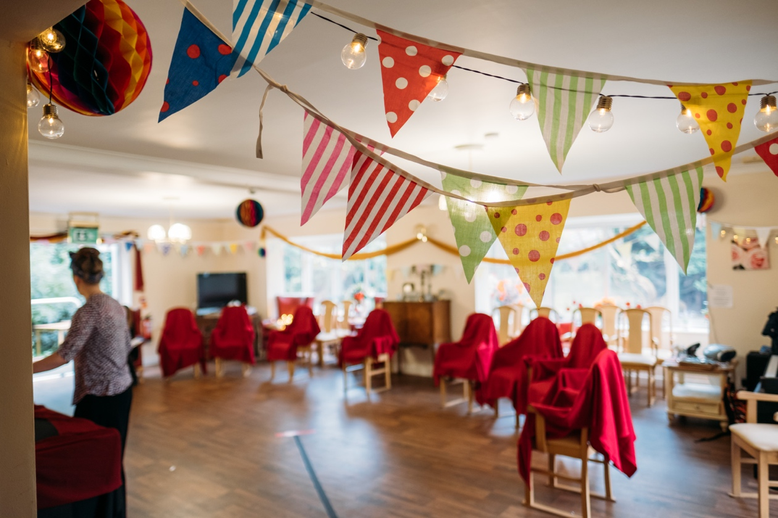

Setting up the room: The room should be set up in a semicircle of chairs for participants, leaving ample space between chairs for workshop leaders, family members, volunteers or staff to stand behind, or sit next to participants.

Chairs need to be supportive, encouraging people to sit upright and have the freedom to move the upper body. Wingback chairs often restrict people’s ability to see each other, which can cause problems for this activity.

Music is an important part of creating an atmosphere. We used a mix of genres from classical to soul and pop. We wanted a mix of nostalgic favourites and new tracks. You can check out our playlist here ([Story Box Circus Spotify Playlist](https://open.spotify.com/user/dso1hb77af80gfujsv51fxxue/playlist/3kVJaxcjDr09yp4Uyyd1N0)), however we suggest you experiment to find what works for your group.

**Opening the session**

Arriving as strangers in each home we visited, we created an opening ritual that allowed us to introduce ourselves and begin the session. You will most likely be working with people you know but a moment of coming together enables everyone to arrive and feel acknowledged and included from the beginning.

Once everyone is seated find a distinctive track that can be used to signal the start. We used [‘Circling’ by Four Tet](https://open.spotify.com/track/3d7pfME4tbOQRtV1Xr310X). A length of bunting was passed by the workshop leader to each person in the circle in turn, taking a moment to greet and welcome each individual to the session, whilst slowly forming a connection between the whole group. Once everyone is connected the leader gathers the bunting so it passes through everyone’s hands, you can try winding it around your body to make the gathering playful.

Tips: Some participants might need help to feed the bunting through their hands, others might keep it on their lap. This exercise provides a nice sensory experience.

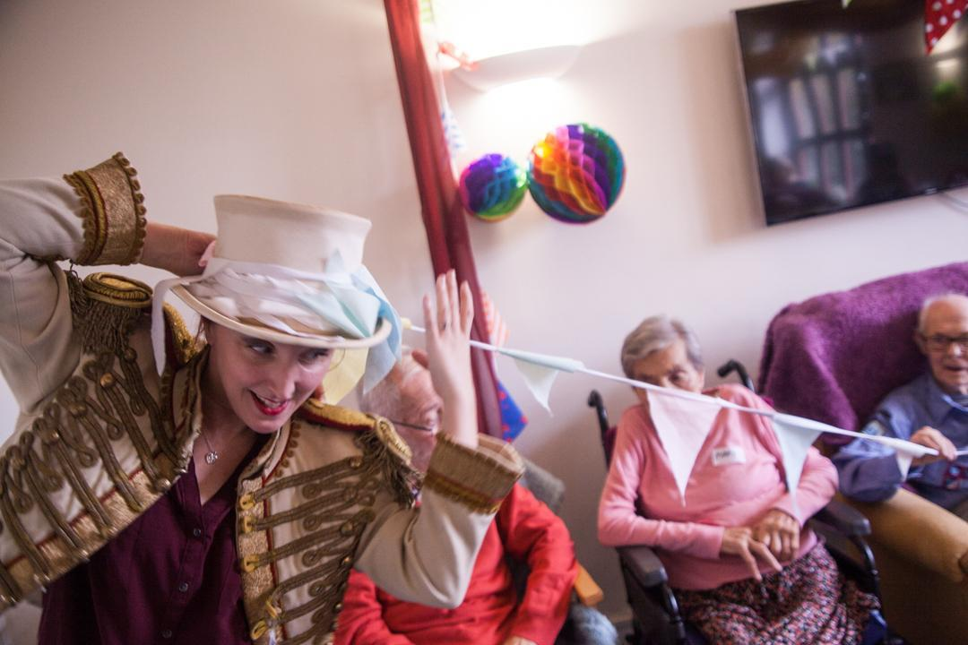

**Push Hands** 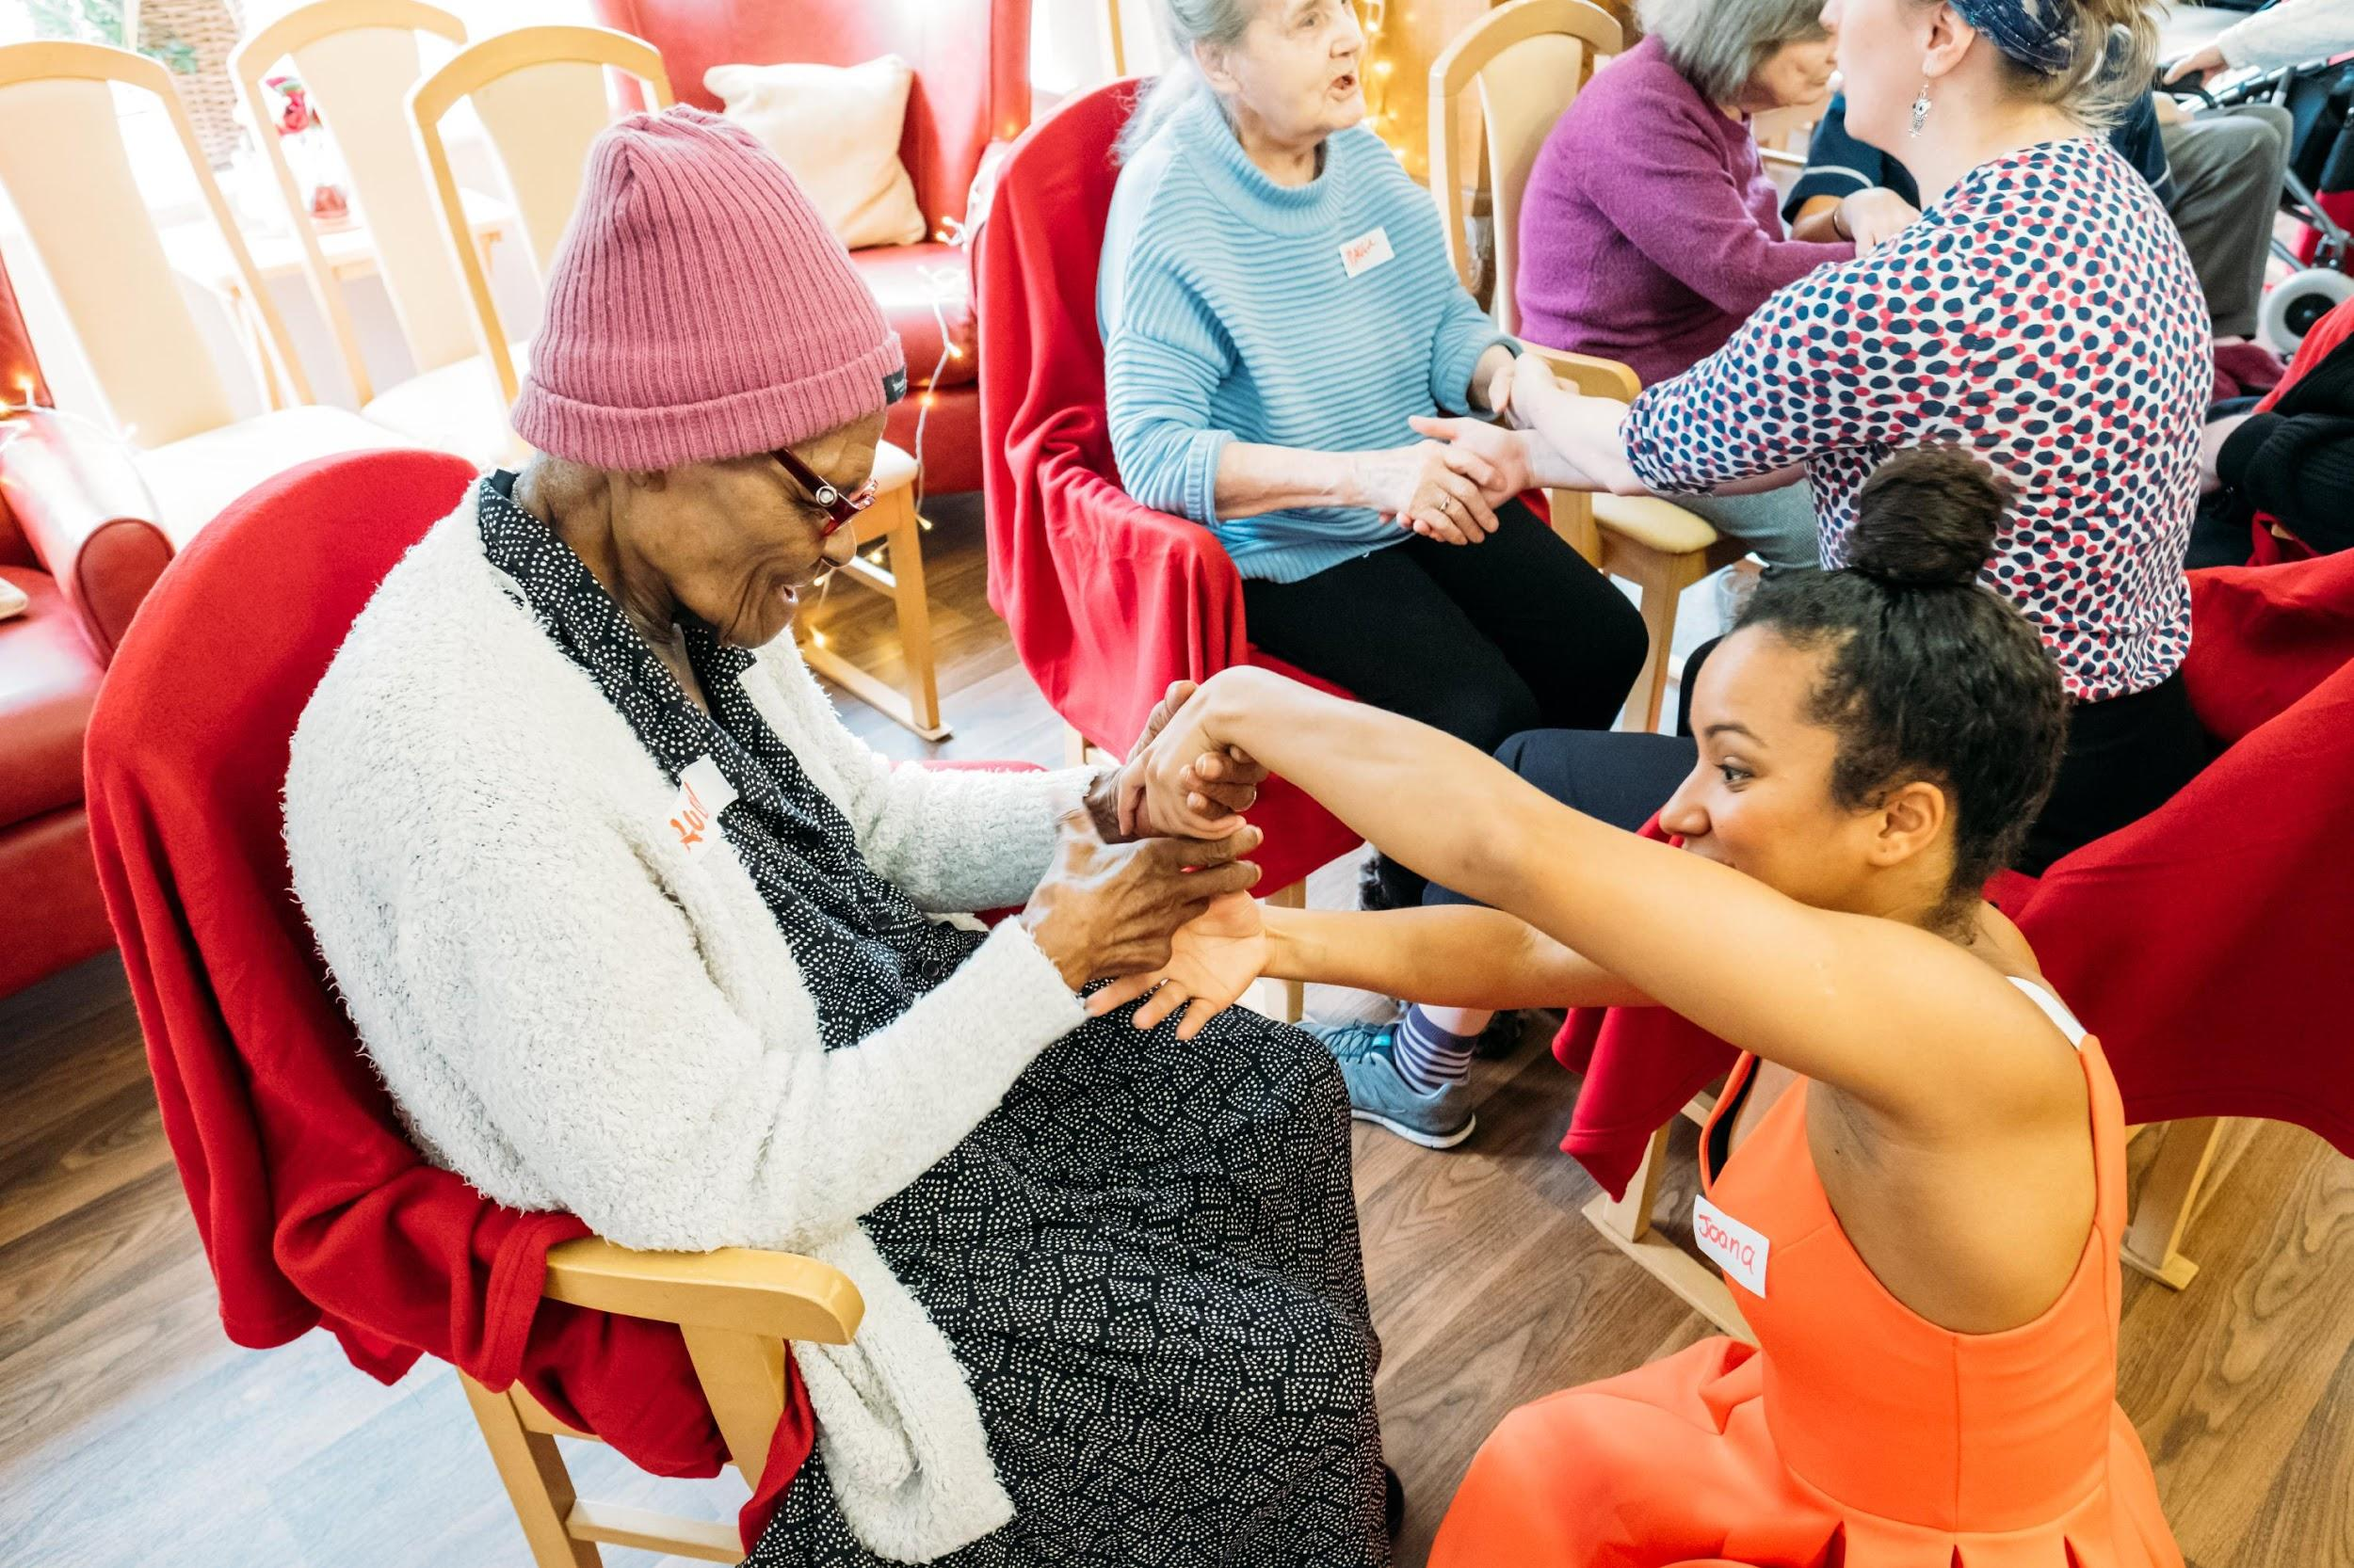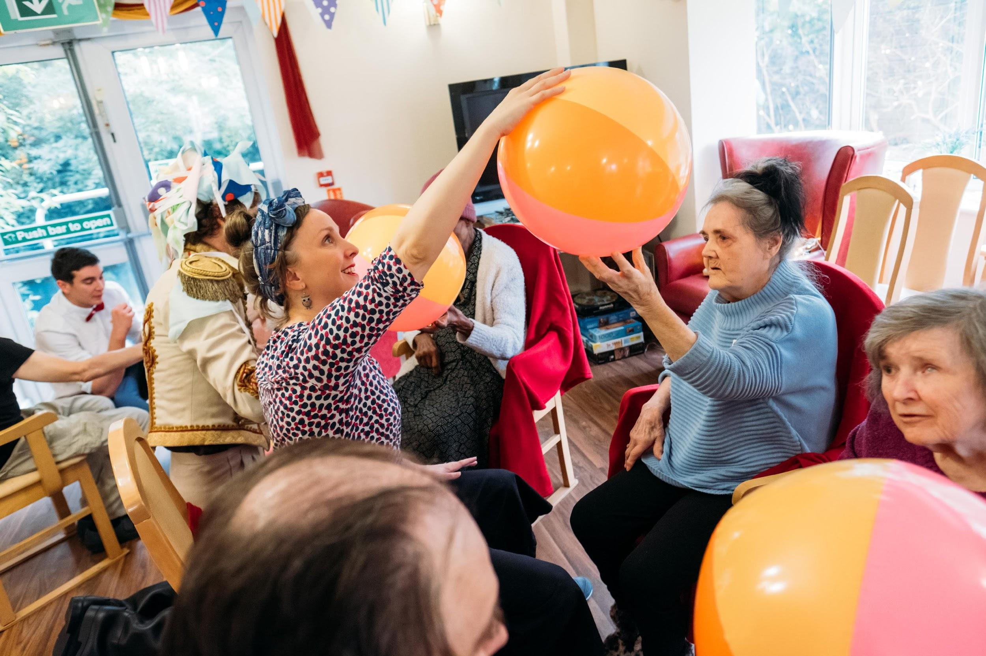

This next exercise is based on 'hand to hand', a circus discipline based on trust, coordination and your ability to work with your partner. This exercise brings in some of those elements. Additionally, it trains responsiveness to touch and being comfortable with others.

What you do:

* The participants start sitting facing each other
* Shake hands like normal to greet hello with the person opposite. Then swap the holding hands to do the same.
* Place the palms of their hands together, pushing gently against each other so they feel the contact.
* They begin to move their hands, keeping the touch light or allowing their contact to push into the partner’s hands, responding to the contact that is given as well as initiating changes of direction, the game is to stay in contact with each other.

Variations

* + The participants start sitting facing each other with a beach ball/balloon squeezed between their palms pushing gently against each other so they feel the contact.
  + They begin to move, keeping the ball between their hands, the games is not to keep the ball moving but not to let it drop.
  + Try to draw a circle when the ball is in between the two, try other shapes such as a triangle, a square, straight line.
  + Sitting in pairs facing each other pass the ball from one person to another either rolling to each other or gently tossing
  + The pairs slowly move apart from each other and gently pass the ball between them.
  + Beginning with one ball or balloon, bat it into the air. The games is to keep the ball off the floor. Add more balls/balloons until you have four or five in the air. The workshop leader needs to stay on their feet to make sure everyone gets a chance to bat the ball up into the air.

Tips:

Remember to have a short rest in between games, bring arms down and have a shake out.

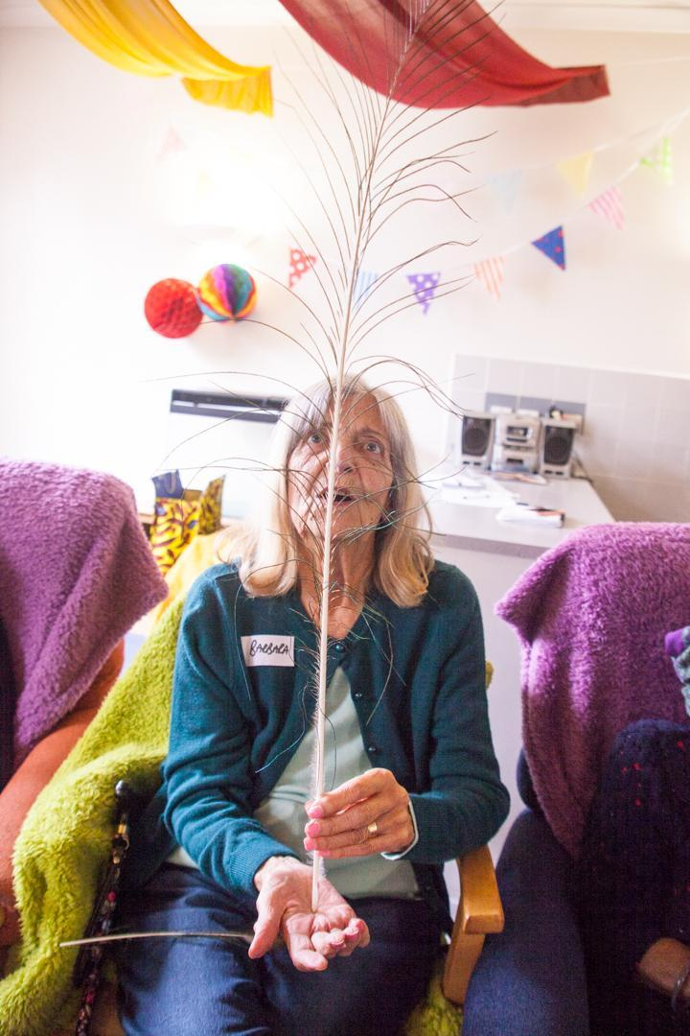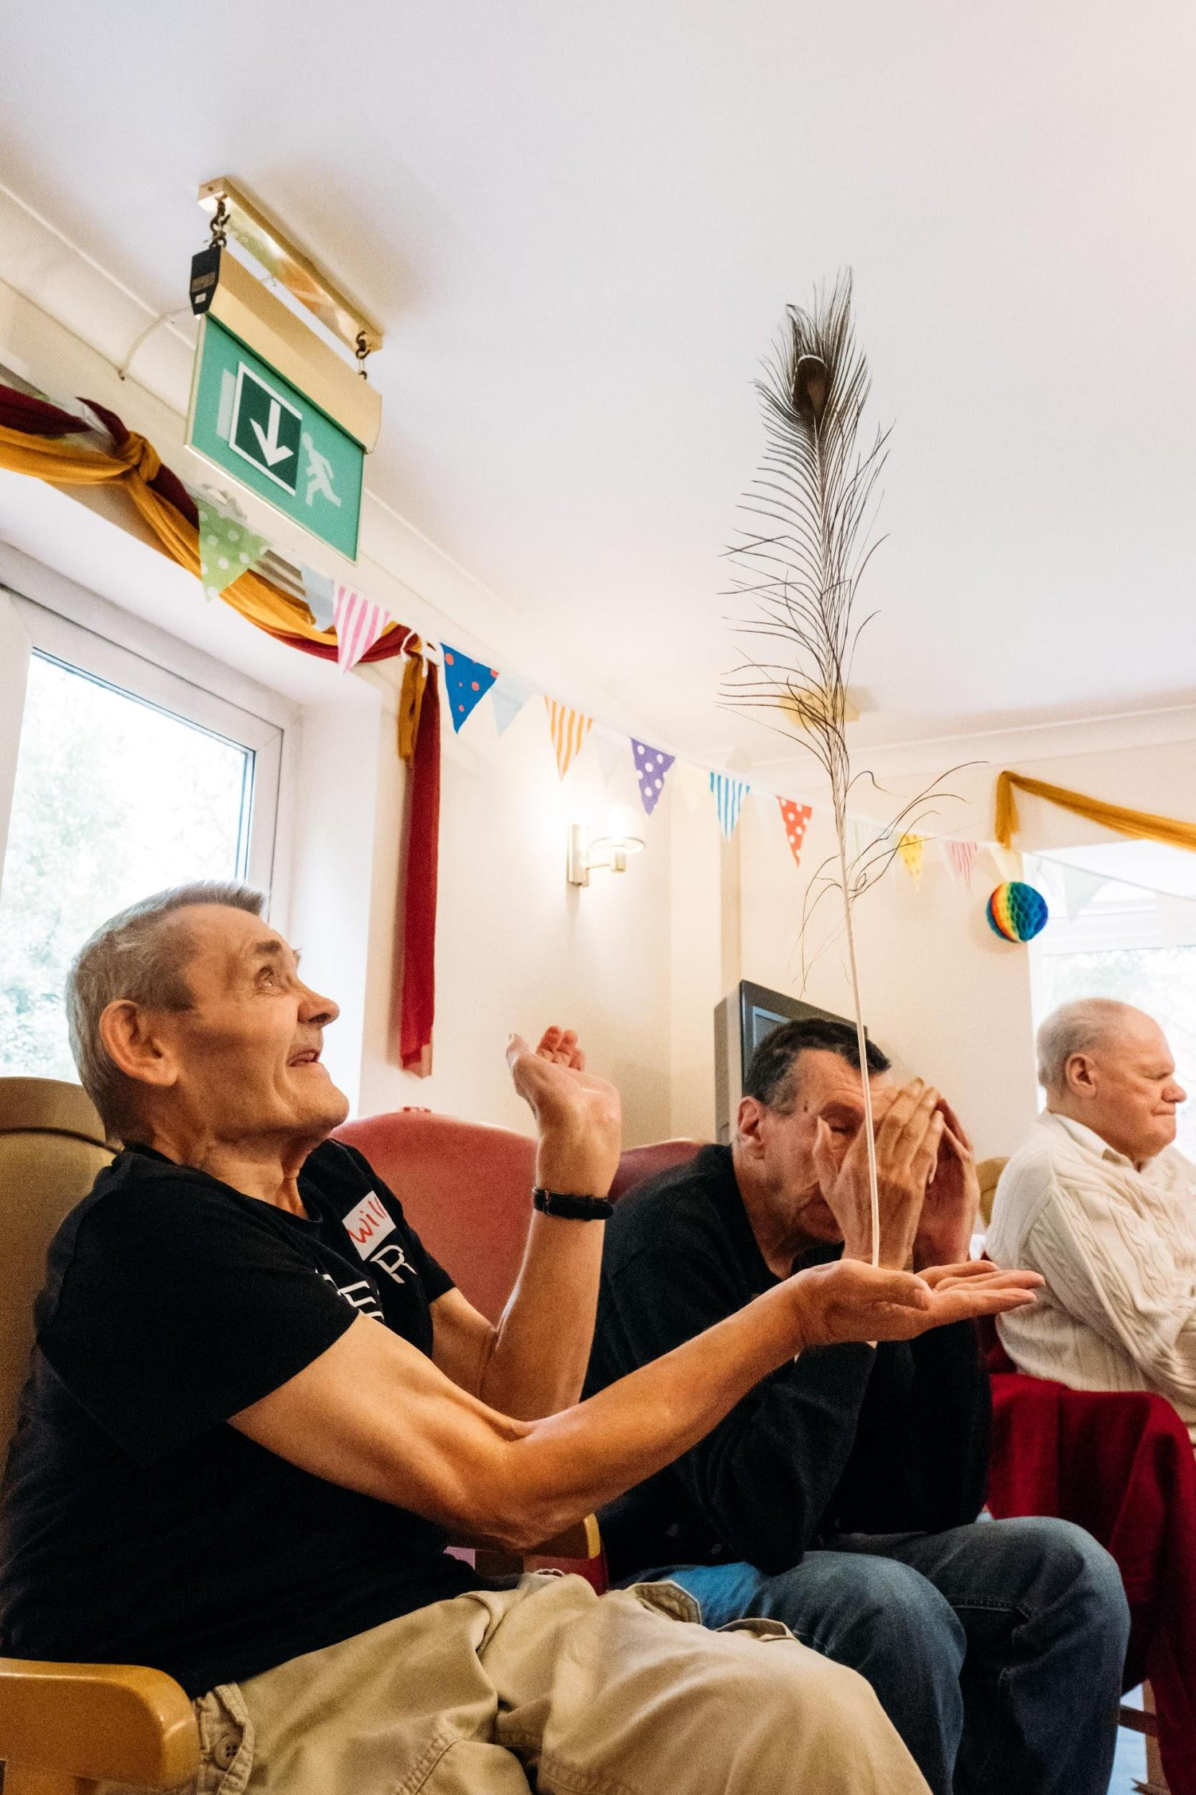

**Feather balancing**

Feather balance is not only fun, it helps build hand-eye coordination, balance, body and spatial awareness.

What you need:

* One approx. 24-inch straight peacock feather for each person (A balloon on a stick may also be appropriate if you cannot find anywhere that sells peacock feathers)

What you do:

* Take a peacock feather
* Place the lower point on the palm of your outstretched hand. The feather should be pointing upwards as vertically as possible
* If the feather falls to the left, your hand should slowly move to the left to counterbalance
* Gently move your hand to counter whichever direction the feather is falling. This can be a gentle movement as it is light and will fall slowly
* The secret to balancing the feather is to watch the ‘eye’ pattern at the top of the feather. Watching the top of the feather gives more visual clues about the direction it will fall to help the brain coordinate your hand to keep the object upright.

Variations:

* Try different points of balance
* The back of each hand, one finger, an elbow, a foot, if a participant can’t move a part of their body offer suggestions for another part or ask them which part would they like to balance the feather on
* Try making the feather jump from one hand to the other hand (remember to keep your fingers closed tight against each other and the hand open)
* Try making the feather jump from hand to foot
* Stand up and sit down with the feather balanced on the hand
* With one feather between two people try making the feather jump from one person’s hand to another.

Tips:

A staff member can assist by placing the feather in a participant’s palm – then gently let go with your other hand so the object is now freely standing upright.

If you see anybody struggling with the feather balancing exercise, we’ve found a good way to support the participant is to say, ‘is it ok to put our hand under your hand?’ and then support their hand with balancing the feather.

**Scarf Juggling**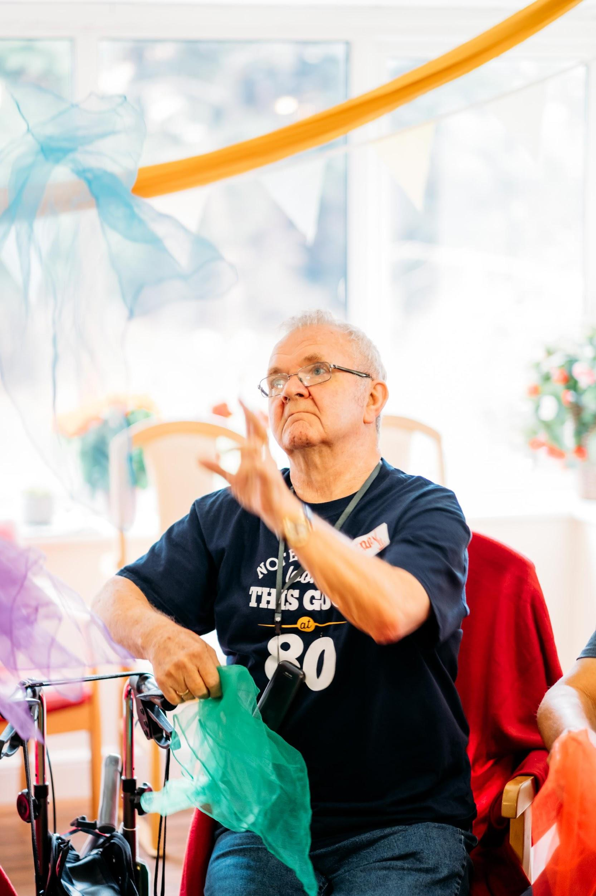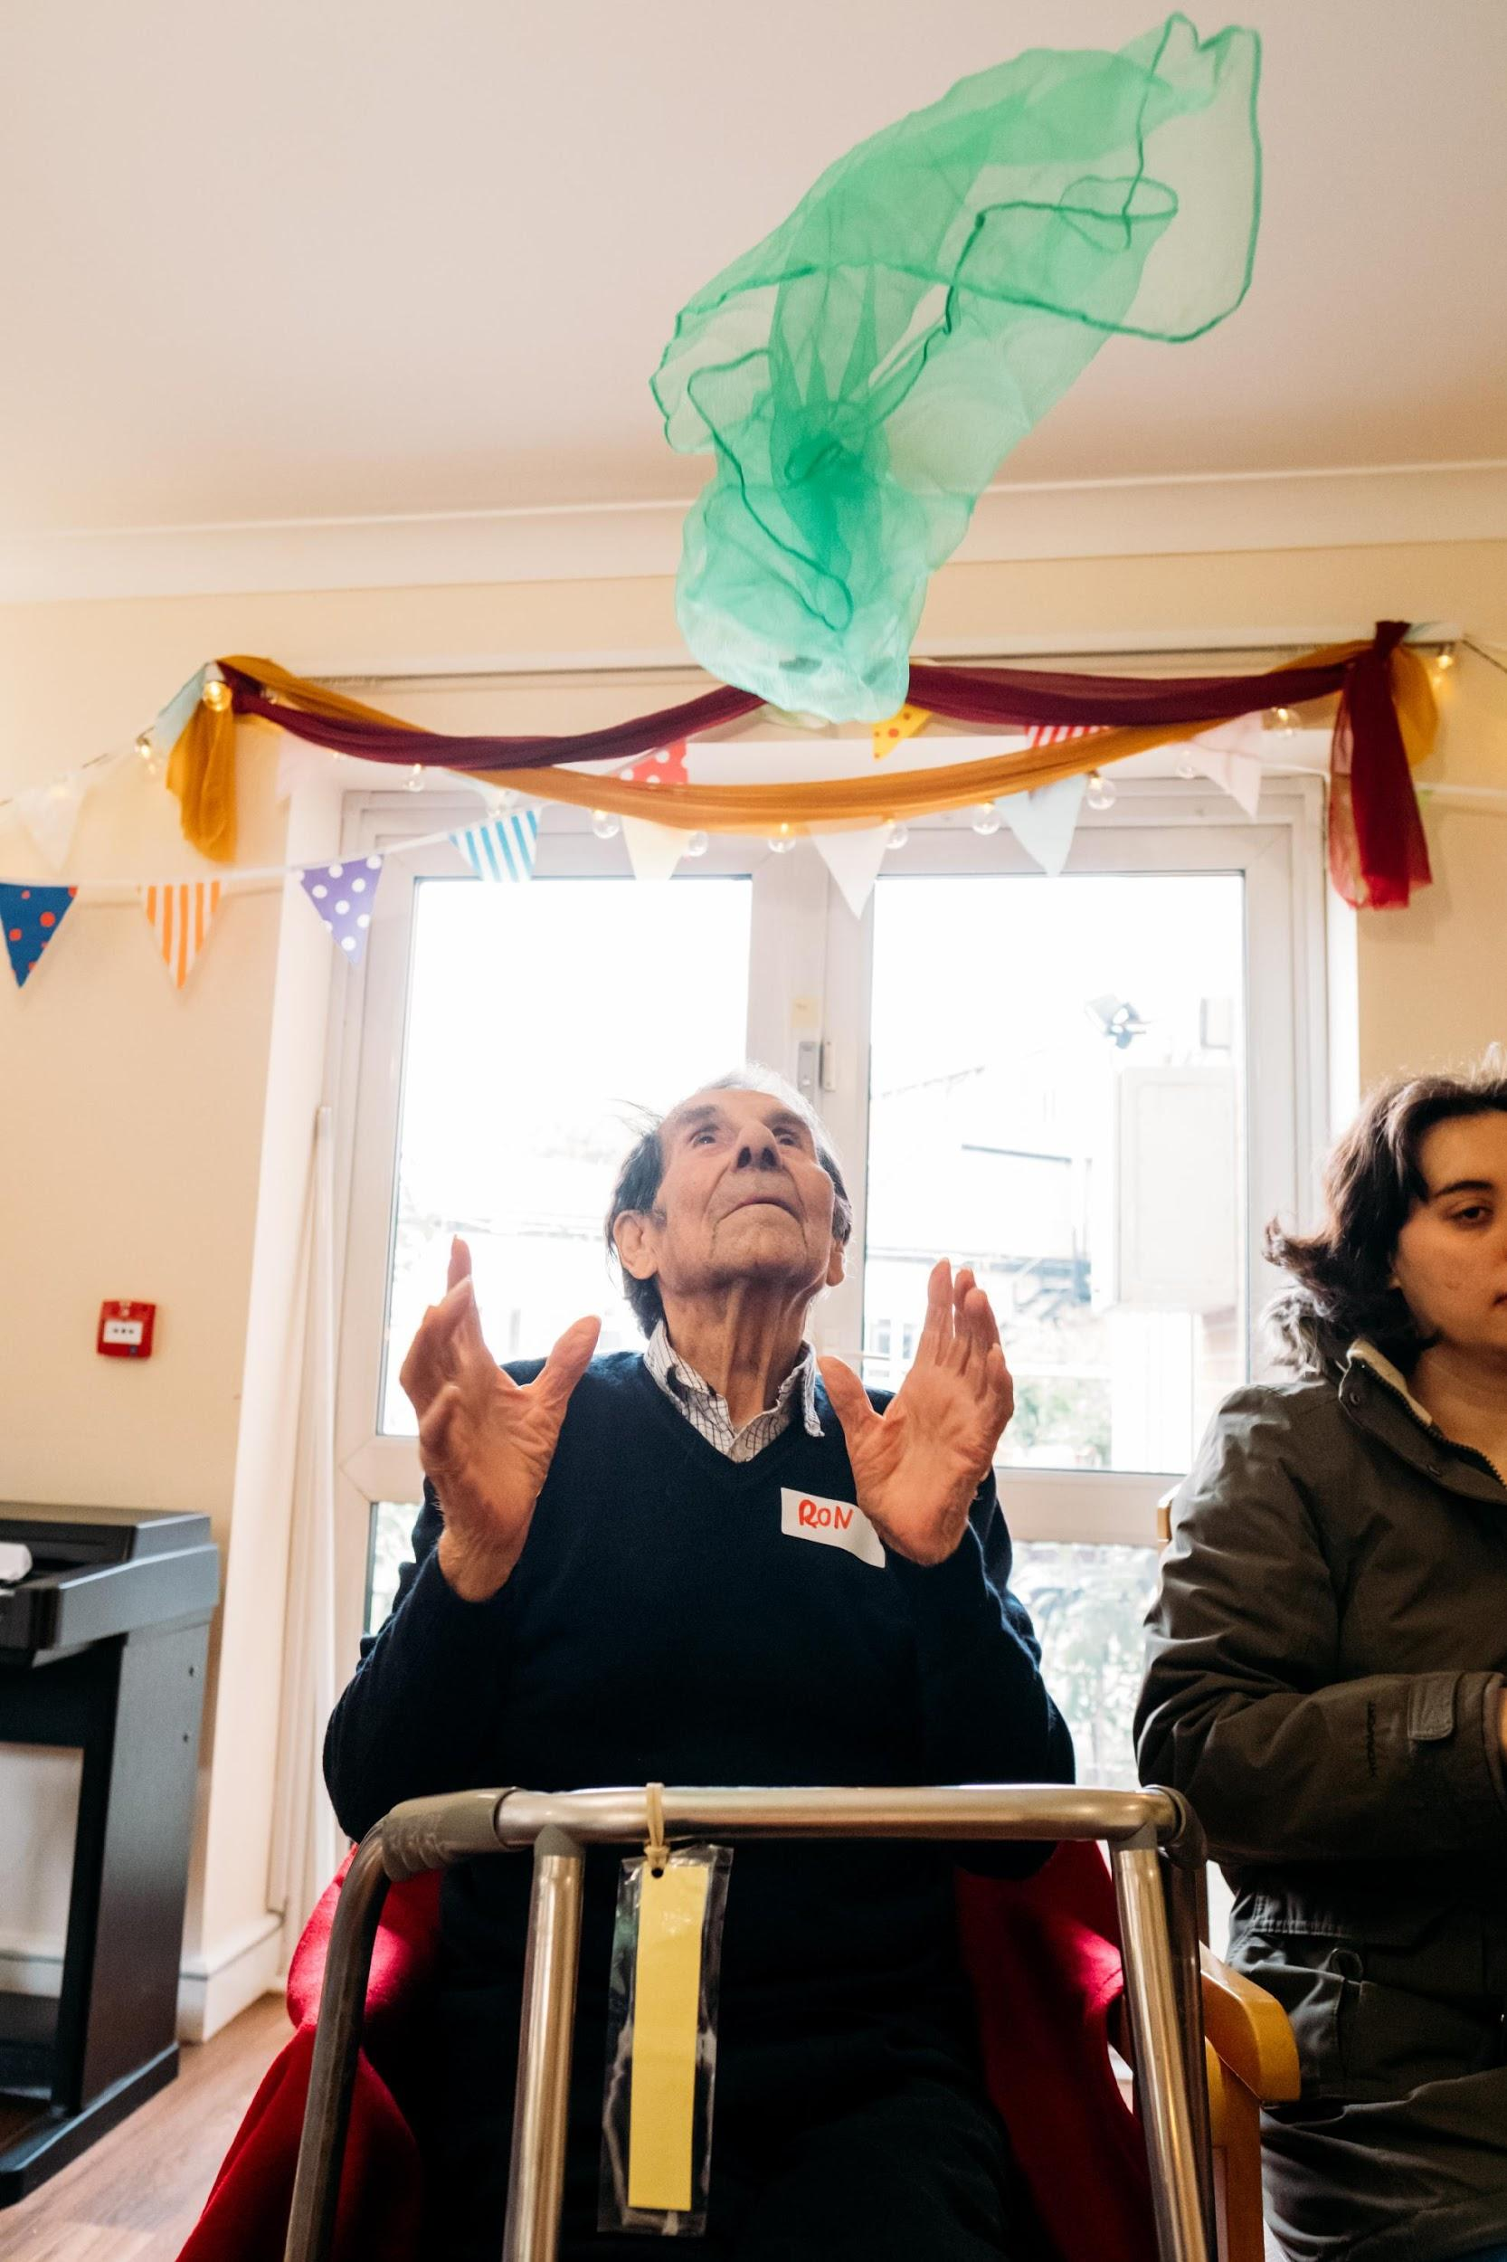

Using scarves is the easiest way to learn to juggle as their lightness makes them slow moving. These games are precursors to learning how to juggle with balls, but are great fun and useful for getting some upper body exercise and exploring dexterity and hand/eye coordination.

What you need:

* 3 juggling scarves per person (ideally each of the 3 will be a different colour)

What you do:

* Each person holds a single scarf by the corner.  The ideal grip is between thumb and forefinger, but you can use whatever grip is most comfortable
* Toss the scarf into the air with the palm of your hand facing outwards (like you are waving goodbye to someone) as it drifts down try and catch it in the same hand
* See if you can you toss the scarf in the air and catch it twice in a row? Three times? Try with the other hand
* Now try throwing the scarf from one hand and catching with the other (the trick is to toss the scarf as high as you can to give you time to catch with the other hand as it drifts down).

Variations:

* Hold 2 scarves, one in each hand. Toss them both straight up in the air at the same time. Can you catch them with the same hand that threw the scarves?
* Try a 2 scarf exchange. Hold a scarf in each hand. Throw a scarf from your right hand. When it reaches as high as it will go, then throw the scarf from your left hand. You then catch the first scarf in your left hand and the second in your right.  The throws and catches should follow a nice rhythm (throw, throw, catch, catch). Do not throw or catch both scarves at the same time - instead practice the “exchange”. Some slow-paced music may help you find the rhythm to space out the throws. When you have that, practice starting from your left hand.

Group and partner games:

* Sit across from a partner, each with a scarf.  Each person throws his or her scarf at the same time. The aim is to catch your partner’s scarf
* Have the group seated in a circle (this games works best with group sizes from 5-12).  Each person must have a scarf. On a signal, each person tosses their scarf in the air to the right. They catch the scarf thrown by the person on their left.  Continue until each person has his or her own scarf back.

Tips:  
If a participant is struggling to use two or three scarfs, you might try to use one scarf to play a game of catch. We’ve found the reflex it takes to catch the scarf is quite rewarding and some participants really take pleasure in this one-on-one play. The scarves are also colourful and tactile objects and some people just like to explore the sensation of touching them.

*“We have already got some scarfs ordered and will go and collect some peacock feathers from the park. They are already planning how we can continue this when you’ve gone” Activity coordinator, 2017*

**Juggling games**

What you need:

* 1 small, soft juggling ball per person

What you do:

* Let each person hold onto the juggling ball feeling its weight, squeezing the ball and rolling it between their hands
* Throw and catch the juggling ball with two hands, low then higher. Try and see if you can clap your hands before you catch the ball
* Throw the ball from your left hand to your right and back again, you can vary the height and speed of the throw
* Try balancing the juggling ball on different parts of your body; your head, elbow, back of your hand, on your foot, the top of your head.

Variations:

* Try holding onto the ball by squeezing it in various places e.g. in your armpit, behind your knees, in your elbow, under your chin
* Try squeezing the ball under your chin then letting it roll down your chest into to your hands
* Start with everyone sitting in a circle. The workshop leader has two balls of two different colours. One ball is passed to the left and the other to the right, The ball can be tossed, rolled or handed to the next person. You can encourage the passing to become as elaborate as possible - try balancing the ball on the arm or knee, try passing the ball under your leg or around the back. Turn it into a race to see which of the coloured balls completes the circle first.

*“It was all good. It must have taken some doing. I enjoyed every bit of it.” Participant, 2017*

**Bringing the session to a close**

[‘Demi Lune’ by Rene Aubry](https://open.spotify.com/track/5UxqittIQWkpieqdK8CLjL) is a calming piece of music to wrap up. Finish each session with this simple 5-minute cool down.

Sitting in a chair, start with the shoulders - slowly raise shoulders to ears and lower down again. Slowly rotate the shoulders around. Look upwards and then let your chin tip gently towards your chest. Give yourself a big hug. Reach up for a big stretch and a yawn.

We would pass the bunting back around the group and gather it as a closing ritual, but you can find your own: perhaps getting everyone to link hands, perhaps a song?

At the end of the session you have a chance to talk about the session and gather feedback with everyone who took part. Say thank you to make sure everyone leaves on a high.

**Where to buy items for your own Story Box Circus**

**Juggling equipment**  
Oddballs is England’s oldest juggling shop and has a wonderful selection - <https://www.oddballs.co.uk/>   
  
**Peacock feathers**  
Any peacock feathers will do! We bought ours from Amazon - <https://www.amazon.co.uk/gp/product/B01M26PYII/ref=oh_aui_detailpage_o05_s00?ie=UTF8&psc=1>   
  
**Bunting**Our designer used vintage style bunting, which can be bought from Amazon -   
<https://www.amazon.co.uk/Vintage-Floral-Washable-Bunting-Pennants/dp/B000H9HS18> **Lights**We found that having a selection of fairy lights made the event feel more special. Good quality, reasonably priced fairy lights can be found at <https://www.christmastimeuk.com/c/Fairy-Lights/1100100>





Supported by The Baring Foundation.