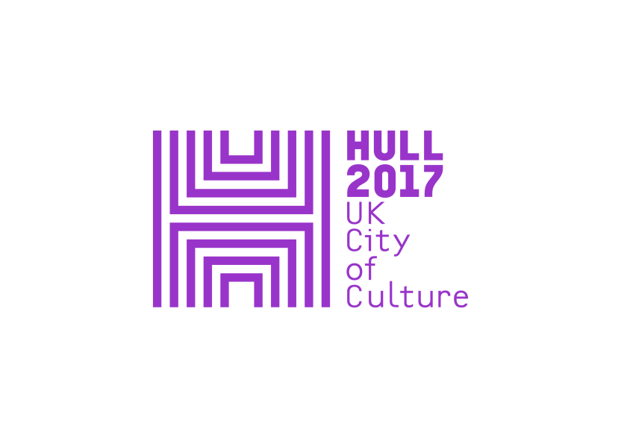



Last chance to see...
dreamthinkspeak’s ONE DAY, MAYBE
ONE DAY, MAYBE the latest show from site responsive theatre company dreamthinkspeak, must close on Saturday 1 October.
What the critics said:
★★★★ ★★★★ ★★★★
“BRILLIANTLY CONJURED” “A TRIUMPH” “DAZZLINGLY PERFORMED”
i news Sunday Telegraph The Observer

★★★★★ ★★★★
“AN EXTRAORDINARY EXPERIENCE” “SPECTACULAR” “SPLENDIDLY ATMOSPHERIC”
The Stage Hull Daily Mail Plays to See

ONE DAY MAYBE centres on the UK launch of a Korean global technology company on the 30th anniversary of the Korean Sixth Republic. The company pioneers and develops a range of new technologies for international governments and multinational commercial organisations, including gaming experiences and interior navigation apps.
For each performance, the company throws open its doors to the general public. The audience is invited to access the public areas as well as the private offices and laboratories where they are allowed to test and participate in the technologies that are being developed.
ONE DAY, MAYBE is inspired by the May 1980 Democratic Uprising in Gwangju, South Korea, that paved the way for democratic rule and the birth of the Sixth Republic in 1987. It shines a light on the brutal interrogations that followed, but is set largely in the present day and looks at the modern world we all inhabit from the perspective of May 1980, imagining those who died as spirits who return to witness the results of their sacrifice.
What if they could step into the shoes of the young people alive today and see the same world that we see? What would they make of the world we live in? Would they see an exciting world of global economic expansion, rapid technological development and freedom of expression?
As the audience is drawn deeper into the labyrinthine technological world they have entered, they find themselves slipping between past, present and future, tumbling back to the aftermath of May 1980 before stumbling forward towards a bright but uncertain future.
Artistic Director Tristan Sharps leads a company of over 30 Korean performers and 50 collaborators to create a multi-layered series of audience journeys, mixing live performance with film and installation, ranging from pioneering technology to ancient ritual.
Tickets are available from www.hull2017.co.uk/onedaymaybe.
For further information contact: Anna Arthur (anna@annaarthurpr.com) or Joanna Hawkins (joanna@annaarthurpr.com).

LISTINGS INFORMATION
DATES: Until 1 October 2017
TIMES: Tuesday – Friday 6pm, 6.30pm, 7pm, 8.15pm, 8.45pm, 9.15pm
Saturday & Sunday 1pm, 1.30pm, 2pm, 3.15pm, 3.45pm,4.15pm, 6pm,
6.30pm, 7pm, 8.15pm, 8.45pm, 9.15pm
No performances on Mondays
LOCATION: KASANG CORPORATION, Hull City Centre: KASANG
PRICES: Ticket prices: £18.50 full / £10 concessions
BOOKING: www.hull2017.co.uk/onedaymaybe

CLICK HERE FOR PRODUCTION PHOTOS

