**JOHN HARRIS'S SCHEDULE FOR THE DAY**

**Arrive at Fruit Humber Street at 9am**

**10am – 10:20am: Welcoming remarks with John Harris**

**FRUIT, Humber Street**

Niki leaves at 10:10am half way to go to 1@thedock for How Arts can Save the NHS. See session agenda and bios. John finishes the welcoming notes. See skeleton script for welcome.

**11:00 – 11:45: You’re only here for the Culture:**

**FRUIT, Humber Street**

See notes on session.

**12:30 – 13:30: Lunch**

**Hull Minster**

**13:30 – 14:00: Guardian Live: Anywhere but Westminster with John Harris on the Future of the North**

**Hull Minster**

Introduced by Nikki Bedi

**14:00 - 14:20: John Harris in Conversation with Stewart Arnold of the Yorkshire Party**

**Hull Minster**

**18:30 – 18:45: Goodbye and Thank you for coming**

**Hull Minster**

**18:45: Taxi back to the station.**

# **10am: John Harris and Nikki Bedi introduce the day: FRUIT**

# **Hello and Welcome:**

# Welcome to Substance Future Forum: a creative enquiry into the culture, creativity and future of the North.

# John: I’m from the North.

# Nikki: I’m not from the North.

# Introduce yourselves.

# NIKKI.

# We will be chairing some of the discussions and introducing others today.

# You should have in your bags, in your hands or round your neck a schedule of the day - if you haven’t picked one up you can grab one after this just next door at the registration table for Humber Street Gallery. You’ll need to show this to get into each session so please don’t lose them. If you do head with your ticket for the event back to Humber Street Gallery.

# As you might notice today does not happen in one place.

# The map and street signs should be able to guide you to each of your sessions.

# Most of it sits on Humber Street, where you are now. Lunch, however, will take place across the main road at Hull Minster (point right).

# As you will also notice the sessions do not happen at the same time – some rooms are also bigger than others with C4DI Theatre being the smallest, seating just 50 – whilst the other spaces hold pretty much all of you.

# People are here for different reasons and some sessions will appeal to some much more than others. This is an active day. You will be going from place to place. It’s so active I am going to get ready now to chair the first session. So I will leave in the capable hands of John.

# JOHN.

# If you have any queries throughout the day do ask one of the very friendly volunteers who are so illuminous you can’t miss them. They will either answer your question, or find someone who might be able to.

# Your Substance Future Forum Hub will be next door at Humber Street Gallery where staff will be throughout the day if you need further information about anything.

# We also have coffee points situated along Humber Street. One at Nibble, another at Thieving Harry’s and another at Humber Street Gallery. If you show your Substance pass you will receive a cup of coffee or tea.

# You’ll also see a campaign shop on the map presented by Hack & Host that you can visit throughout the day and view their manifesto.

# Sessions are presented from a whole range of partners such as Guardian Live, BBC Academy, British Council, Hack & Host, Arts Council England – who have all come up some meaty and excellent discussions. The panellists come from the north, the entire country and overseas. This is a conversation about the culture, creativity and the future of the north – you do not have to be northern to have an opinion.

# The sessions are 45 minutes long. This is not a long time. If you want to know more about someone, something or feel like the person you saw speaking could be your new best buddy - use the coffee points to have a discussion further about the session. If you find a group of you wanting to talk further – take it to the gallery or Thieving Harry’s. The day is yours to use as you wish.

# If there’s only three of you in a session because you are the only three that bought tickets to hear more about that session. Don’t worry. Do sit at the front and make it a conversation. This might happen at some points in the day, it might not. The main thing is the right people are in the room.

# By the end of the day we will know who the next UK City of Culture is as it is announced directly after this, the Future Forum. At 8pm we will come back here, Fruit, to party in true northern fashion, delighting in Hull Pi and a few free drinks, whilst The Resident’s Association providing absolutely banging tunes.

# Along your way today, don’t miss Marshmallow Laserfeast: *A Collosal Wave*. Roll VT. **SHOW MLF A COLLOSAL WAVE TRAILER: 1 MINUTE.**

# Also, don’t miss *Where do we Go from here?* By Jason Bruges Studiowhich should also be marked on your maps in the form of orange little robots. ROLL VT. **SHOW JASON BRUGES WHERE DO WE GO FROM HERE TRAILER. 54 SECONDS**

# **If you are still here Saturday then make sure you get yourself to City Hall for Substance Live: The Future of the North. With this killer line up of the most exciting and inventive musicians the north have to offer: ROLL VT. SHOW TRAILER FOR SUBSTANCE LIVE: 1 MINUTE 9 SECONDS.**

# **JOHN HARRIS: PRESENT A SHORT 2 MINUTE PRECUROSOR ABOUT WHAT HE WILL TALK ABOUT AT 1:30PM.**

# Now please head off to your first sessions – if I don’t see you at lunch I’ll see you before then. Then again, you don’t have to head off to the first session – if you wanted to just have a chat with someone you haven’t seen for a long time. Go and do that – this is your day – make as much of it as possible.

**You’re only here for the Culture**

*What’s the point of a city of Culture?*

What are the measures of success for a city of culture? How does this manifest and what is the promise in relation to the reality? Are they brilliant examples of culture as a change agent or an apology in disproportionate levels of arts funding? The panel will be comprised of representatives from cities of culture and also those instrumental to their succe

**Chair John Harris**

**Pete Massey: Arts Council England (Director North)**

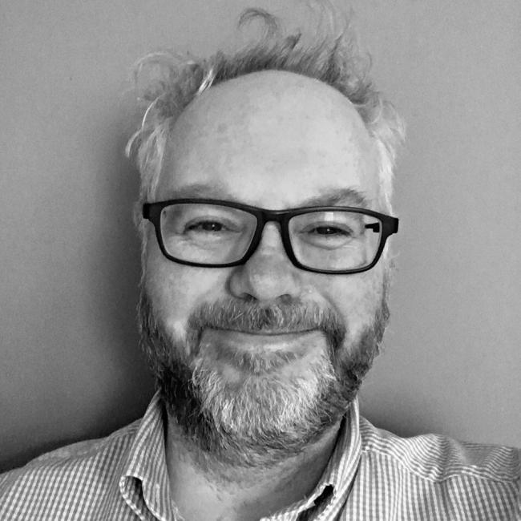

**Chris Baldwin: Creative Director: Galway 2020: European Capital of Culture**

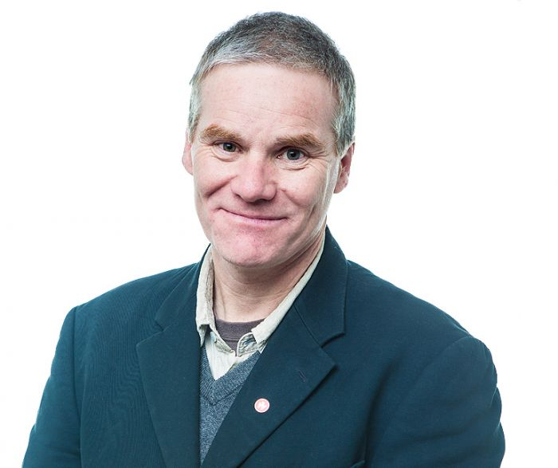

**Paula Murray, Creative Director at Croydon Council**

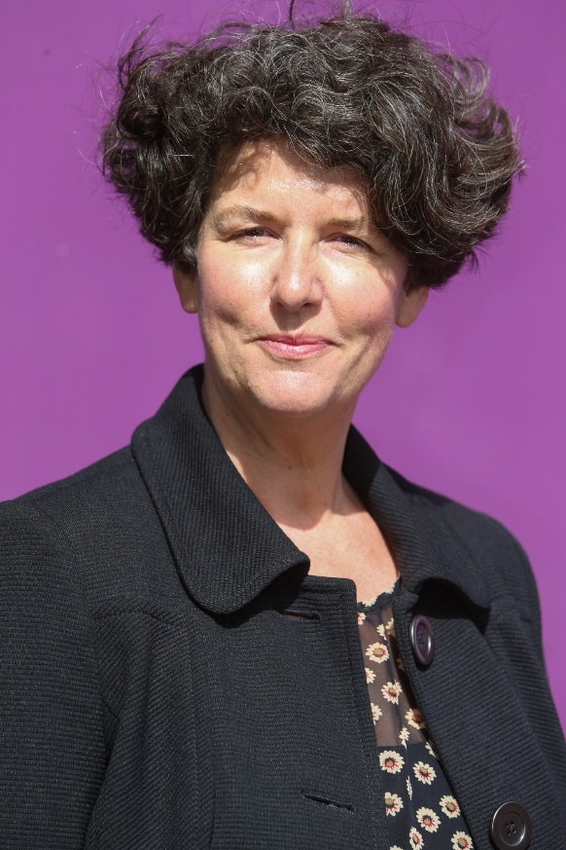

Paula is currently Creative Director at Croydon Council, and is responsible for the shaping of a cultural programme for the Borough as part of the significant regeneration there.  This includes working on the £30m refurbishment of the Fairfield Halls and leading the Boroughs bid to be the London Borough of Culture.

Before joining Croydon Council, Paula was at Brighton & Hove City Council, where she worked for 18 years, latterly as Assistant Chief Executive, developing the city’s cultural and tourism offer.

**Shona McCarthy**

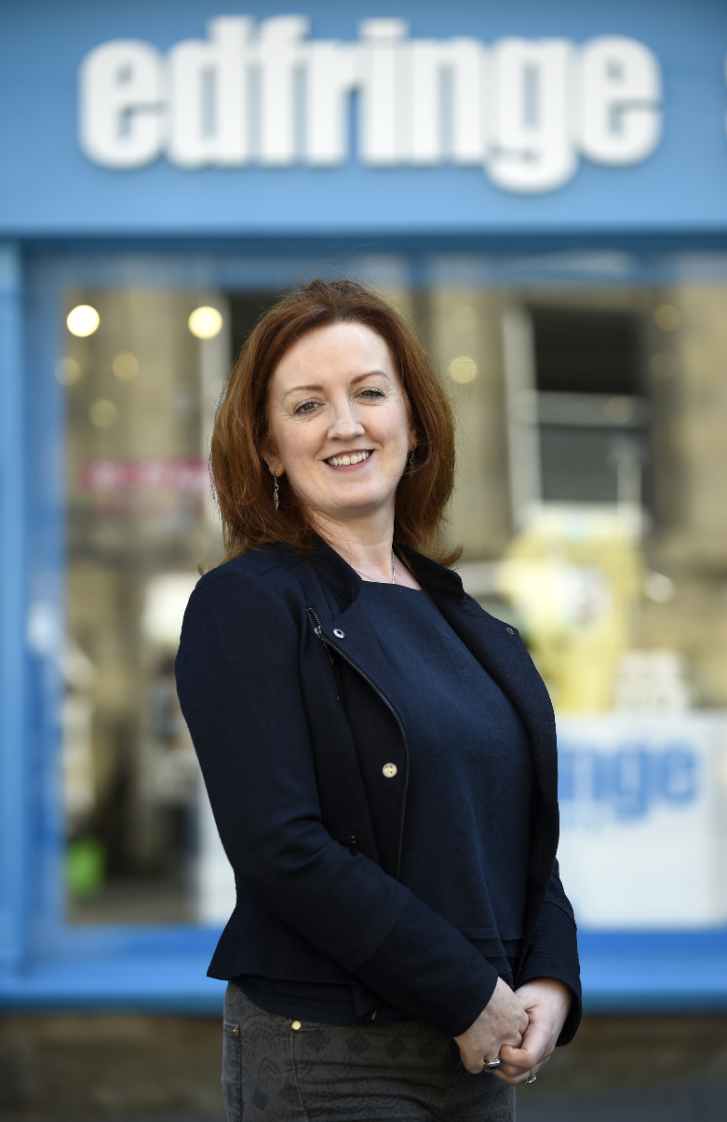

Shona 2017 Biog – longer version

Shona McCarthy is the Chief Executive of the Edinburgh Festival Fringe Society - the charity that underpins the Edinburgh Festival Fringe, the largest arts festival in the world. Originally from County Down, Shona has dedicated her career to championing and developing arts and culture.

From 2011 to 2014 she was Chief Executive of the Culture Company, leading on Derry-Londonderry’s transformational year as UK City of Culture, creating and delivering a world-class, citywide cultural programme for 2013. Prior to that she was Director of the British Council Northern Ireland leading a team of 40 to oversee international programmes of work across schools, arts and Higher Education, to build positive international cultural relations. She was the CEO of Imagine Belfast, heading up Belfast’s bid to be European Capital of Culture and was Head of Exhibition at the Northern Ireland Film Council.

Shona spent many years as Chief Executive of Cinemagic Film Festival for young people and the Foyle Film Festival. In 2007 she was the recipient of a NESTA cultural leadership award which enabled her to live and work in India with Seagull Foundation for the Arts in Calcutta, and in 2014 she received an Eisenhower Fellowship. As well as her Fringe commitments, Shona is also Chair of Oh Yeah Music Centre in Belfast, and Walk the Plank, a Salford-based Creative agency specialising in spectacular outdoor arts and pyrotechnics.

Shona 2017 Biog – short version

Shona McCarthy joined the Edinburgh Festival Fringe Society as Chief Executive in March 2016. From 2011-2014 she was Chief Executive of the Culture Company, leading on Derry - Londonderry’s transformational year as UK City of Culture. Prior to that she was Director of the British Council Northern Ireland. She also spent many years as Chief Executive of Cinemagic Film Festival for young people; and the Foyle Film Festival; and was Head of Exhibition at the Northern Ireland Film Council. Shona has 25 years’ experience of working in senior leadership positions and was awarded a prestigious Eisenhower Fellowship for Innovation in 2014.

**Martin Green: CEO & Director**

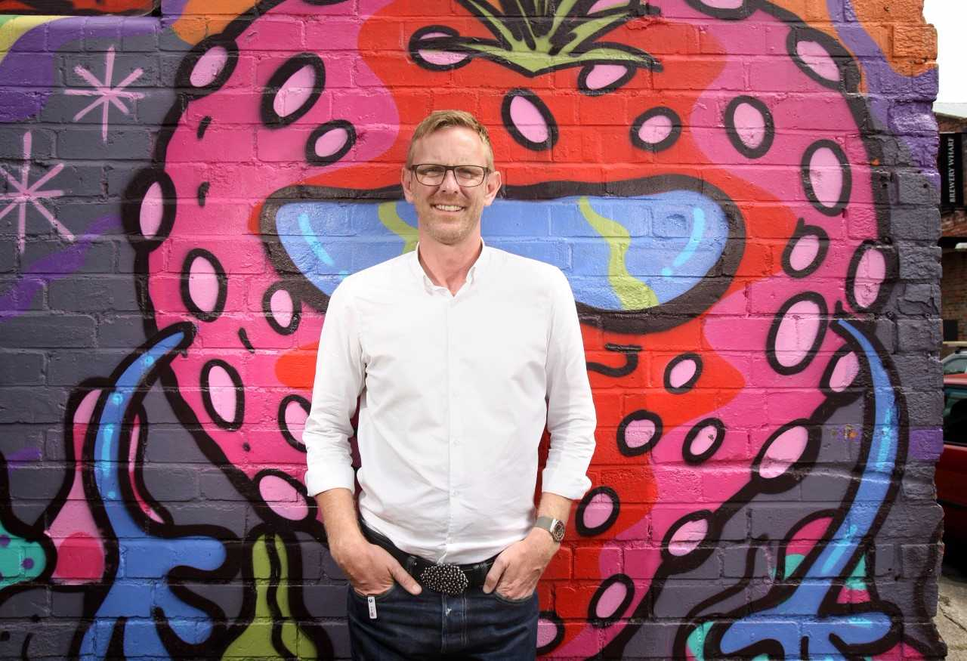

**Martin Green, Chief Executive & Director, Hull: UK City of Culture 2017**

Martin Green has earned an international reputation for delivering world class, large-scale events. As Head of Events for then Mayor of London Ken Livingstone, he produced more than 60 events each, including the City’s New Year’s Eve celebrations.

In 2007 as Director of events for AEG Live he was part of the team that opened the O2 venue – formerly the Millennium Dome – in London. In 2008 Martin was appointed Head of Ceremonies for the London 2012 Olympic and Paralympic Games, where he oversaw the delivery of the Welcome and Medal ceremonies, Torch relays and Opening and Closing Ceremonies of the Games.

He recruited Danny Boyle and other artistic directors and hand-picked the artists, production and back-of-house teams that showcased the best of British culture on a global stage. Martin masterminded the opening ceremony of the 2014 Tour de France Grand Départ. As Executive Producer, he worked alongside Welcome to Yorkshire to create an occasion that promoted the beauty and character of Yorkshire to audiences around the world. His latest post as Director of Hull UK City of Culture 2017 sees him leading the delivery of a curated 365 day programme of transformative Culture as a major regeneration programme for Hull and the UK’s cultural quadrennial.

Martin is an inaugural member of the Circle of Cultural Fellows at King’s College London and sits on the Board of the The Space, a digital commissioning and development agency, founded by the BBC and Arts Council England. Martin is an advisor to the ceremonies team at the Tokyo 2020 Olympic and Paralympic Games, to Birmingham’s bid for the 2022 Commonwealth games and the Executive Producer of Edinburgh’s Hogmanay celebrations 2017.

Session Agenda and Questions:

**You're only here for the Culture!**

**11am: Fruit, Humber Street, Hull.**

**45 minutes long**

***What’s the point of a city of Culture?***

What are the measures of success for a city of culture? How does this manifest and what is the promise in relation to the reality? Are they brilliant examples of culture as a change agent or an apology in disproportionate levels of arts funding?

**Chair: John Harris**

Panellists:

**Pete Massey:**Arts Council England (Director North)

**Chris Baldwin**: Creative Director: Galway 2020: European Capital of Culture

**Paula Murray:** Creative Director at Croydon Council

**Shona McCarthy:**Chief Executive of the Edinburgh Festival Fringe Society

**Martin Green:**CEO & Director Hull UK City of Culture

* What is the point of a city or capital of cultures?

* Have you ever seen a successful city of culture?

* How would you define that success?

* Have you ever seen a city of culture get it wrong?

* What does a city need to do to get it right?

* Who are city of culture projects for?
* Considering the decisions taken around European Capital of Culture what is next in terms of larger cities and their ambitions to emulate the transformative successes that so benefitted Liverpool and Glasgow?

* What is the future of the UK city of culture project?

**In Conversation with Stewart Arnold: Yorkshire Party**

**14:00 (directly after Anywhere but Westminster)**

**Hull Minster**

Stewart could you explain a little about the background to the Yorkshire Party?   
  
You’ve talked previously about Yorkshire’s very special, separate sense of identity and community… can he expand on that?  
  
How has Brexit affected the party and devolution prospects?  
  
Has the questioning of national identity post-Brexit, giving the regions a chance to push their agenda, do people now identify more with being from Yorkshire than from being art of Britain?  
  
When former chancellor George Osborne asked regional leaders to send him their proposals for devolution deals in 2015, he received five rival suggestions from across Yorkshire. “We just thought people in Yorkshire hated everyone else – we didn’t realise they hated each other so much” said David Cameron, not realising he was being recorded ahead of a speech in Leeds.  
How has this changed in the last two years, is there more unity?

Sheffield are holding out for a separate Sheffield City region deal, which has been signed off by the government with a mayor overseeing a combined authority of £900m over 30 years - why does Stewart believe in a county wide devolution rather than city regions, like Sheffield or Manchester?  
  
How much of this desire for autonomy is driven by an increasing sense of detachment from Westminster, and the feeling that those who make decisions have no real idea of what life is like locally?  
  
There has been strong support from the business community, but how would devolution affect the arts and culture of the region?

**18:30: Closing Remarks – thank you! FRUIT**

Stick around for the party at 8pm. You will know your next UK City of Culture at in the next hour!

Yourself and Nikki in taxi back to the station