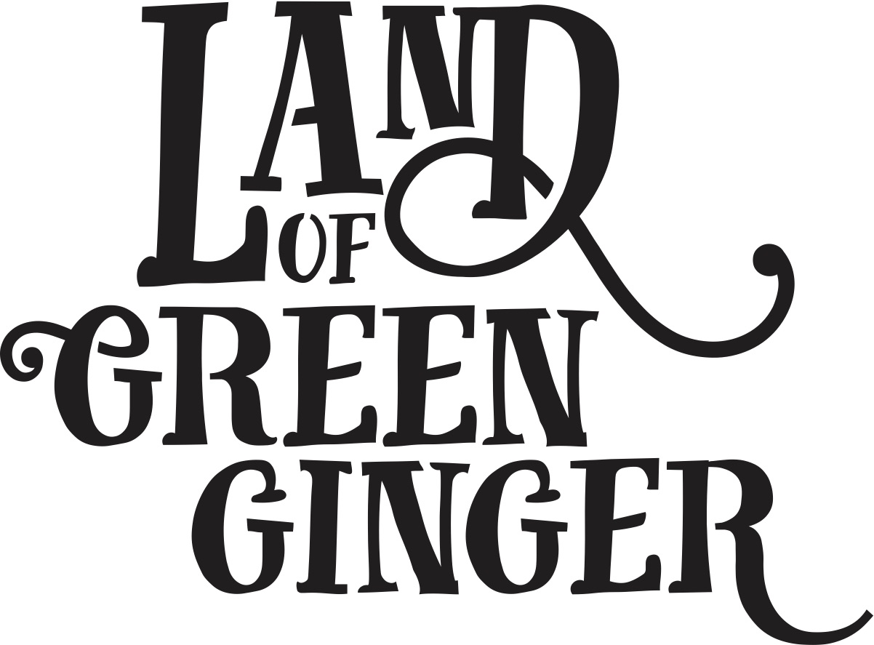

LAND OF GREEN GINGER UNLEASHED

Thank you for being part of Land of Green Ginger Unleashed.

**Terms and conditions of Membership of Land of Green Ginger Unleashed Ensemble**

If a member leaves the building without permission or does not gain entry, Hull 2017 cannot be held responsible for the member’s safety.

For the duration of any programme/project **Hull 2017** is running, all members must adhere to the organisation**’**s Drugs and Alcohol Policy which means zero tolerance in relation to anyone using/taking drugs or alcohol. A drug is any substance, other than food, that changes the way the body thinks, acts or feels.

At all times, members must adhere to an acceptable level of behaviour during all activities.

Would you be happy to be contacted to take part in research about your experience with Land of Green Ginger Unleashed?

Yes  No

Do you agree to let us photograph/film you as part of Land of Green Ginger Unleashed for documentation purposes?

Yes  No

Signature: _______________________ Date: _____________________

**Ensemble Member**