- Background to ‘Back to Ours’

  - Introducing ‘Back to Ours’
‘Back to Ours’ is a festival of touring performances that visits community venues in the North, East and West of the city during school half terms. This report will present the findings of the first ‘Back to Ours’ festival in February.
This chapter will present the concept, project aims and objectives, the venues that took part and the approach taken to monitoring and evaluating the project as a whole.
    - The Concept of ‘Back to Ours’
The ‘Back to Ours’ project set out to create a series of temporary performance venues within existing community facilities, transforming spaces that disengaged audiences are already familiar with and feel safe in.
The spaces are turned into venues that can cater for an inspiring night out at the theatre to see a comedian, watch an incredible musician or see some world-class dance.
Using a ‘strategic touring’ approach but at a local neighbourhood level, ‘Back to Ours’ seeks to bring about such a strong and unexpected cultural intervention that it makes local people feel very proud of their part of the city, whilst also increasing their confidence to go out and explore similar events elsewhere and in the city centre.
    - Aims and Objectives of ‘Back to Ours’
‘Back to Ours’ had the following project-specific aims and objectives:
- Aim 1: Overcoming isolation
- Objective 1: People feel more engaged in their local community and have a true sense of pride in the contribution they make.
- Objective 2: People engage in inclusive community activity (particularly isolated and/or lonely people).
- Objective 3: People enjoy their engagement in the community and have fun.
- Objective 4: People feel empowered and confident to join more groups and activities in art, culture & heritage (suboutcome).

- Aim 2: Inspiring events
- Objective 5: People are inspired and empowered to get (more) involved in their communities.
- Objective 6: Inclusive events enable groups to connect and have fun. Events also effectively engage local media (suboutcome).
- Aim 3: Wellbeing
- Objective 7: People's personal wellbeing increases through participation.
- Aim 4: Disability
- Objective 8: Positive change in the perception of disabled people in communities (by both disabled and non-disabled people).
- Objective 9: Disabled people are better able to participate in activities in the local community.
- Aim 5: Connecting generations
- Objective 10: People from different generations are motivated to take part in more community activities together.
- Objective 11: People of different generations recognise that they are part of the same community and feel more connected to each other (suboutcome).
- The ‘Back to Ours’ Venues
If the project was to be accessible in the North, East and West of the city respectively, the core creative team cast a wide net to find suitable venues within the community. The team first approached schools because they had the size required to receive productions on the scale of what was in mind for the artistic programme.
After the school venues were on board, the team then approached other spaces, including pubs, community centres and North Point Shopping Centre.
After consultation, a definitive list of eight venues across the city became designated performance spaces for the ‘Back to Ours’ festivals:
Table 7: Back to Ours Venues
NORTH | Kingswood Academy
NORTH | Winifred Holtby Academy
NORTH | North Point Shopping Centre
EAST | Freedom Centre
EAST | Archbishop Sentamu Academy
WEST | Sirius Academy West
WEST | Hymers College
WEST | William Gemmel Club

Figure 13: ‘Back to Ours’ Partner Venue Map
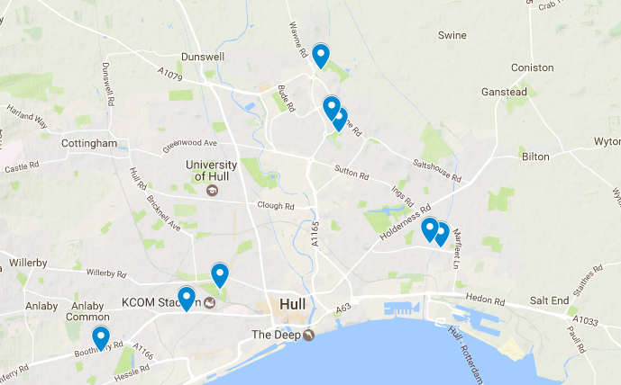

  - Festival 1 Performances
Table 8: Performance Descriptions
Show | Description
The Story of Mr. B | Ages 3+. This surprise-filled puppet show, set in a giant pop-up book, tells the story of Mr. Bumblegrum. This grumbling character goes on a colourful journey through the seasons, as we turn from one page to the next.
Picture House (Willy Wonka, Matilda, Fantastic Mr Fox) | Ages 0+. Dive into the magical world of Roald Dahl with three of his best tales brought to life in our Picture House.
Joan & Hekima | Ages 12+. Performed by drag king champion Lucy Jane Parkinson, history’s greatest gender-warrior takes to the stage, dragging up as the en she defies in this multi-award winning show.
Mark Thomas: The Red Shed | Ages 14+. Multi-award winner Mark Thomas tells the story of where he first started to perform – a red wooden shed aka Wakefield’s Labour Club – in celebration of its 50th birthday.
The Pigeon Detectives | Ages 14+. Ahead of the release of their new album, platinum-selling Leeds indie-band The Pigeon Detectives are coming to a venue near you to perform exclusive new material from their fifth album, Broken Glances.
Meet Fred | Ages 14+. Fred is a two-foot cloth puppet who fights prejudice everyday. Fred just wants to be part of the real world to get a job and meet a girl, but when threatened with losing his PLA (Puppetry Living Allowance), Fred’s life begins to spiral out of control.
Ceri Dupree & Gogglebox | Ages 18+. C4 Gogglebox favourites Jenny and Lee join female impersonator Ceri Dupree, bringing Lady Gaga, Amy Winehouse and Cher to the west Hull club as part of his One Man, 14 Women show.

Area | Venue | Date | Performance
WEST | Sirius Academy West | 22 Feb | Story of Mr B
WEST | Sirius Academy West | 23 Feb | Picture House (Willy Wonka, Matilda, Fantastic Mr Fox)
WEST | Sirius Academy West | 24 Feb | Meet Fred
WEST | Hymers College | 25 Feb | Joan & Hekima
WEST | William Gemmel Club | 23 Feb | Ceri Dupree & Gogglebox
NORTH | Kingswood Academy | 22 Feb | Meet Fred
NORTH | Kingswood Academy | 25 Feb | The Red Shed
NORTH | North Point Shopping Centre | 23 Feb | The Pigeon Detectives CANCELLED
NORTH | North Point Shopping Centre | 25 Feb | Joan & Hekima
NORTH | Winifred Holtby Academy | 23 Feb | Story of Mr B
NORTH | Winifred Holtby Academy | 24 Feb | Story of Mr B (relaxed performance)
NORTH | Winifred Holtby Academy | 25 Feb | Picture House (Willy Wonka, Matilda, Fantastic Mr Fox)
EAST | The Freedom Centre | 25 Feb | The Pigeon Detectives
EAST | Archbishop Sentamu Academy | 22 Feb | Picture House (Willy Wonka, Matilda, Fantastic Mr Fox)
EAST | Archbishop Sentamu Academy | 23 Feb | Meet Fred
EAST | Archbishop Sentamu Academy | 23 Feb | Joan & Hekima
EAST | Archbishop Sentamu Academy | 24 Feb | The Red Shed
EAST | Archbishop Sentamu Academy | 25 Feb | Story of Mr B
Table 9: Festival 1 schedule
  - Methodology to Monitoring & Evaluation
The following sections outline the approach taken to monitoring and evaluation (M&E) for ‘Back to Ours’.
    - Project Monitoring
As with all Hull 2017 projects, a Project Monitoring Workbook was kept to record all key outputs for ‘Back to Ours’, namely:
- Production details;
- Core Creative Team roles and Equal Opportunities data;
- Artist Equal Opportunities data;
- Audience numbers and Equal Opportunities data;
- Digital engagement with project; and
- Partner types.
    - Project Evaluation
Project evaluation focused on research and consultation with key respondent groups who experienced ‘Back to Ours’, either as someone who worked on the event, someone who attended as an audience member, or someone who was involved in one of the performance venues.
Key respondent groups consulted were:
- Core Creative Team (CCT);
- Venue Partners;
- Audiences.

A full write up of all the research and consultation with these key respondents are provided in Appendices 1-5, however, a summary is provided within the table below.
Table 10: Research and Consultation on ‘‘Back to Ours’’ Evaluation – Festival 1

Respondent Group | Research Methodology | Research Type | Sample Size
Creative Core Team | - Pre-event online survey  - Post-festival 1 depth interview | - Quantitative and qualitative  - Qualitative | - 1 (33% of population)  - 3 (100% of population)
Audiences | - Post-event survey (online/F2F)  - ‘Chat with Nan’ groups  - Token counts  - Emoji paddles | - Quantitative and qualitative  - Qualitative  - Quantitative  - Quantitative | - 77  - Approx 55  - 1489  - 279
Venue partners | - Pre-event online survey  - Post-festival 1 depth interview | - Quantitative and qualitative  - Qualitative | - 6 (75% of population)  - 8 (100% of population)

  - Report Structure
This report focuses on the outcomes from the first of three ‘Back to Ours’ festivals. The M&E for this project, like with M&E for Hull 2017 as a whole, has two main areas of exploration:
- Process Evaluation; and
- Outcomes Evaluation.
    - Chapters
Chapter 2 of this report focuses on the Process Evaluation, presenting learnings and recommendations across a range areas of interest:
- Motivations;
- Concept and Creative Development;
- Project Management;
- Production Management;
- Marketing & Communications
- Audience Satisfaction; and
- Accessibility.

Chapters 3 to 5 focus on the outcomes of ‘Back to Ours’, broken down by the five key themes of the M&E Framework for Hull 2017:
- Chapter 3: Arts & Culture;
- Chapter 4: Place making and;
- Chapter 5: Society & Wellbeing.
The key learnings of the project so far are summarised at the end of each chapter.

