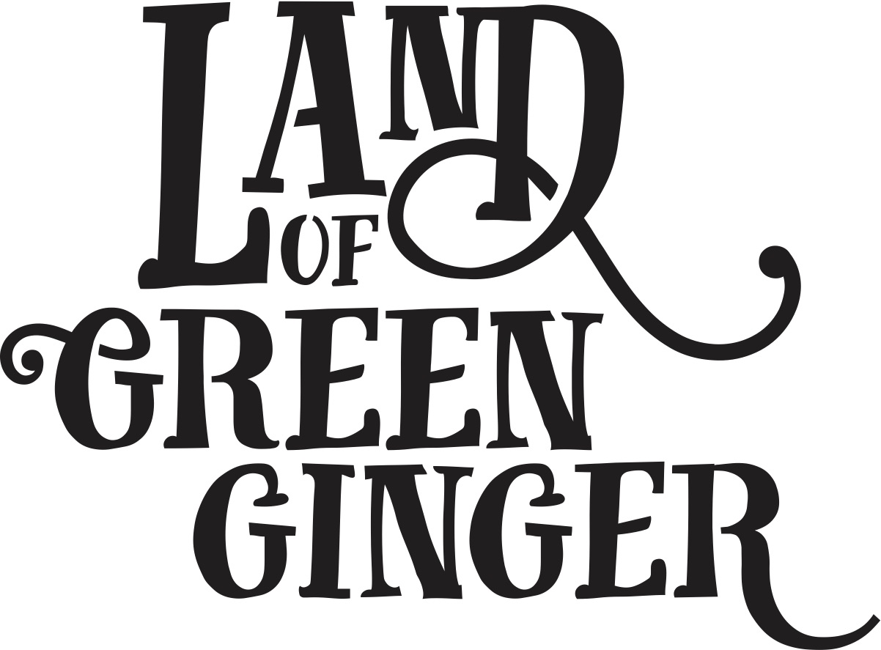

**Book**

**Project Plan**

**Summary**

Throughout the year Hull 2017’s ground-breaking community engagement project, Land of Green Ginger, invited Hull’s residents to immerse themselves in a magical citywide story, inspired by and celebrating the spirit of Hull.

In 2018, the Land of Green Ginger story will culminate in a seventh Act of Wanton Wonder – a beautiful book.

The Land of Green Ginger book will tell the stories of the project, the narrative as it took place and the stories of the local people it touched. It will be the record of City of Culture as lived by the residents of the city and as informed by their imagination and creativity.

This project plan outlines the formats, timescales and budget for delivery of the Land of Green Ginger book.

**Style**

245mm x 170mm

72 pages

4pp cover on 300gsm

72pp inner on 120gsm

Full colour throughout.

Special leather touch cover with gold foiling.

Perfect bound finish.

**Distribution**

On Thursday 14 June crates containing books will be delivered to schools across Hull and a mass storytelling moment will take place in every school.

In the week following (Monday 18 June) books will be delivered to every house in Hull via Royal Mail.

There will be a “launch-style” activity at The Big Malarkey Festival on Saturday 23 and Sunday 24 June with performers interacting with audiences and giving out books and related giveaways.

**Quantities**

x118,500 for postage to reach every home in Hull.

X6,500 extra books printed for schools, Big Malarkey and other distribution.

**Total 125,000**

**Print Timescales**

To ensure the book is printed ready for delivery in the week of 11 June, the following deadlines will be in place:

|  |  |  |
| --- | --- | --- |
| **Date** | **Action** | **Lead** |
| W/C 12 February | Illustrator shortlisting | Maddie & Katy |
| W/C 12 February | Illustrator appointed | Maddie, Katy, Illustrator |
| W/C 12 March | Draft manuscript and full brief delivered for illustrator to start work | Maddie, illustrator |
| W/C 26 March | First draft sketches complete, feedback given | Illustrator |
| W/C 26 March | Final manuscript complete and submitted to illustrator | Katy |
| Friday 6 April | Confirm booking with Royal Mail | Marketing lead |
| Friday 13 April | Quantity of books for print decided and addendum for print and Royal Mail drawn up | Marketing lead |
| Friday 27 April | Printing booked. | Marketing lead |
| Thursday 3 May | Final illustrations complete.  Illustrations, manuscript and design brief submitted to designer. | Illustrator  Marketing lead |
| Friday 4 May | Design returned for proofing.  Feedback. | Designer |
| Friday 4 – Monday 7 May | Final proofing | All |
| Tuesday 8 May | Book sent to print. | Producer |
| Thursday 31 May | Print complete. Delivery of 118,500 books to Royal Mail. | Printers |
| Friday 1 June | 6,500 delivered to Hull 2017 (TBC) for schools distribution | Printers |
| Mon 11 – Wed 13 June | Schools deliveries | Producing |
| Thursday 14 June | Mass storytelling | Schools |
| Monday 18 June | Royal Mail delivery of books | Royal Mail |
| Saturday 23 – Sunday 24 June | Moment at The Big Malarkey Festival | Producing |