Appendix 20:
Local Business Survey Analysis

  - Introduction
Following the completion of ‘Made in Hull’ research was undertaken with local businesses, in collaboration with Hull BID (a not for profit organisation that exists to help businesses in the city sustainably grow and progress). Hull 2017 have been continuously liaising with Hull BID to spread key information about events in 2017, and encourage local businesses to open more and later to support these events.
    - Local Businesses Survey
In order to establish how local business had chosen to engage, or not, with the opportunity of ‘Made in Hull’; and what impact the event had on their businesses, a post-event survey was put together. The survey looked at the following:
- Whether businesses change opening days and times to respond to ‘Made in Hull’;
- Impact on businesses of ‘Made in Hull’, with a focus on perceptions of whether it was positive or negative; changes in turnover and profit on the previous year; staffing; and footfall; and
- Overall sentiment amongst businesses towards the event.
    - Distribution and Response
Hull BID distributed the survey to its member businesses via an online survey link, as well as delivering paper copies to some businesses. The survey was in the field from 10 – 27 January 2017.
In total 72 businesses responded to the survey.
  - Profile of Businesses
Businesses were asked to provide their names, solely as a way to track who had and had not completed the survey. Analysis of the business types represented within the respondent groups is provided in Table X.
Within retail responses, the majority were clothing and footwear shops. However, there were also gift and jewellery shops, specialist food shops, supermarkets, grocery stores, and shopping centres.
Within professional services there were law firms, property services, banks, accountants and hairdressers.
Table X: Business Types Represented Amongst Respondents
Category | Number
Retail | 34
Professional Services | 9
Bars | 6
Support Centres | 4
Fast Food | 4
Cafes | 2
Hotels | 2
Visitor Attractions | 2
Restaurants | 2
Unknown | 8
TOTAL | 72
Of these, the businesses of most likely to be impacted by an event like ‘Made in Hull’ are Bars, Fast Food, Cafes, Hotels, Visitor Attractions and Restaurants (as part of the Visitor Economy). Retail may also represent a likely sector to be impacted by an event such as ‘Made in Hull’:
- 18 businesses are Bars, Fast Food, Cafes, Hotels, Visitor Attractions;
- 34 businesses are Retail.
13 of the businesses who responded were situated outside of the HU1 area, or their post code was unknown. Those who had provided a post code were predominantly in HU2 (n=4), with one in HU4.
  - Opening Hours
Only 30.6% (n=22) said they had changed their opening hours for ‘Made in Hull’. Of these, most changed their opening hours on the first day of the event to coincide with the fireworks. More businesses changed their opening hours later in the week, presumably as a response to the increasing crowds.
Figure X: Business Changes to Opening Hours
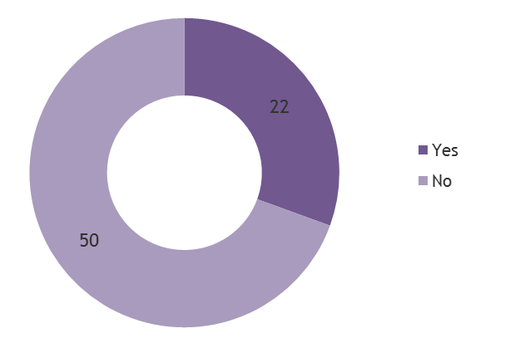
Figure X: Business Changes to Opening Hours by Day
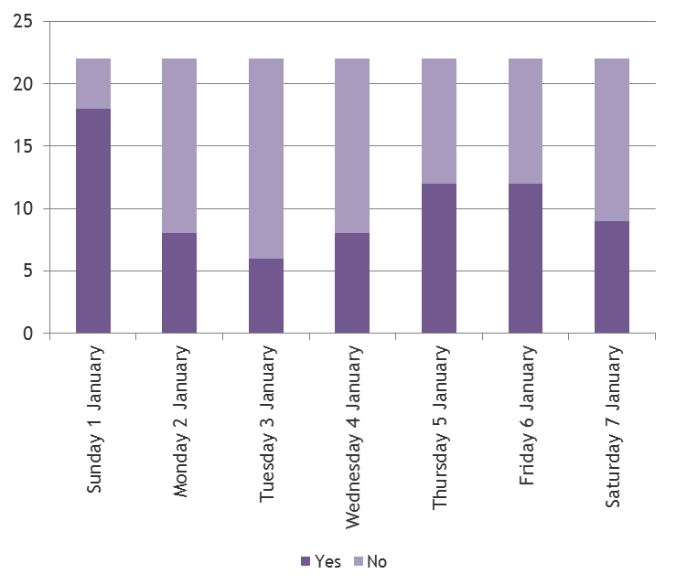
When looking at the same data by Visitor Economy businesses and Retail businesses those in the Visitor Economy were more likely to have increased their opening hours, and those in Retail less likely.
Table X: Change in Opening Hour by Type
Category | % who changed opening hours
All respondents | 30.6%
Visitor economy respondents | 55.6%
Retail respondents | 26.5%

  - Impact on Business
Over half said the event had had a positive or very positive impact on their business. 12% said it had made a negative impact.
Figure X: Impact on Business
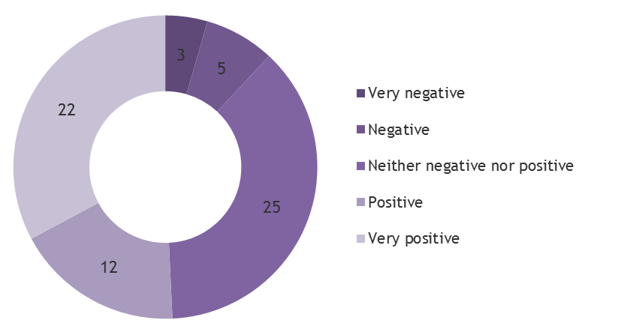

When looking at the same data by Visitor Economy businesses and Retail businesses those in the Visitor Economy were more likely to have changed their opening hours, and retail businesses less likely.
Table X: Impact on Businesses
Category | % who said ‘Made in Hull’ had a +ive or very +ive impact on their business
All respondents | 50.8%
Visitor economy respondents | 66.7%
Retail respondents | 52.9%
When asked to provide an explanation for their rating, there were a number of reasons provided. However, the most common were:
- Increased footfall / passing trade: cited by 60.4% (n=32) of those providing a reason;
- Increased trade / sales: cited by 13.2% (n=7) of those providing a reason;
- Positive atmosphere in the city: cited by 13.2% (n=7) of those providing a reason; and
- Increased awareness / diversification of businesses customers: cited by 9.4% (n=5) of those providing a reason.
Some businesses stated that they had feedback from their clients to say that it had positively impacted on their businesses; and two businesses (both national chains) reported having to call more stock in from other branches in the area to satisfy demand.
In terms of the negative responses, 9.4% (n=5) stated that the event or ongoing works within the city centre had prevented customers from accessing their business and 3.7% (n=2) felt it had caused problems with traffic.
The Visitor Economy and Retail businesses that stated the event had a negative or very negative impact on their business were either closed on Sunday 1 January, or in one case for the whole week because the road closures prevented their business from operating; or did not change their opening hours on Sunday. The businesses that opened the rest of the week did not open later, all closing between 5pm and 6pm. Ongoing works in the city affected their business because of orange barriers around the entrance, or areas being dug up.
In the case of Retail businesses there was a few mentions that the increased footfall seemed to be of more benefit to eating and drinking establishments, though this was by no means the experience of all retailers.
    - Impact on Turnover & Profit
When asked directly about the impact on trade, most said their turnover had increased compared to January last year.
Figure X: Change in Turnover
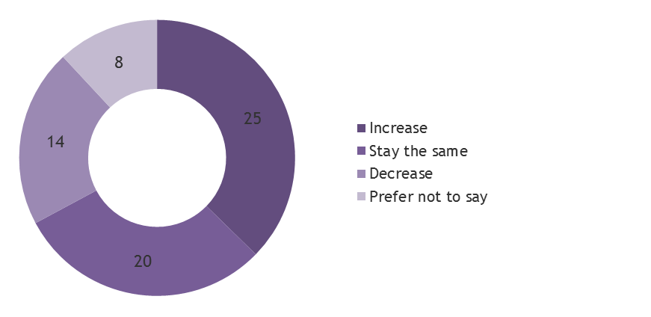
Figure X: Change in Profit
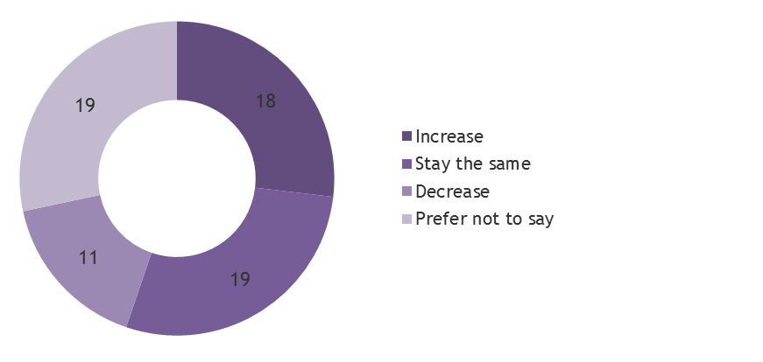
When looking at the same data by Visitor Economy businesses and Retail businesses those in the Visitor Economy seemed to enjoy increases in both turnover and profit more so than both Retail businesses and the respondent group as a whole, particularly in terms of turnover. Negative changes in turnover and profit did not seem to be affected significantly by sector.
Table X: Change in Turnover
Category | +ive change in turnover | -ive change in turnover
All respondents | 37.3% | 20.9%
Visitor economy respondents | 50.0% | 22.2%
Retail respondents | 44.1% | 20.6%
Table X: Change in Profit
Category | +ive change in profit | -ive change in profit
All respondents | 26.9% | 16.4%
Visitor economy respondents | 50.0% | 16.7%
Retail respondents | 26.5% | 14.7%
On average (where data was supplied), businesses said they had increased turnover by 81%. The biggest percentage increase was 567% and the biggest decrease was 100%.
In actual terms, based on the figures supplied by businesses, turnover increased on average by £6,115.
On average profits increased by 146% (where data was supplied).
In actual terms businesses said they’d made an extra £645.50 on average.
    - Impact on Staffing
40.3% (n=27) of businesses said they had given staff extra hours to staff; 41.8% (n=28) said they had not given extra staff hours; and 17.9% (12) preferred not to say:
- 14.9% (n=10) gave staff between 1 and 10 hours extra;
- 6.0% (n=4) gave staff between 11 and 20 hours extra; and
- 9.0% (n=6) gave staff between 21 and 30 hours extra.
There were 7 other businesses that gave a greater number of staff ours than those quoted above, as shown by Figure X.
Figure X: Increases in Staff Hours
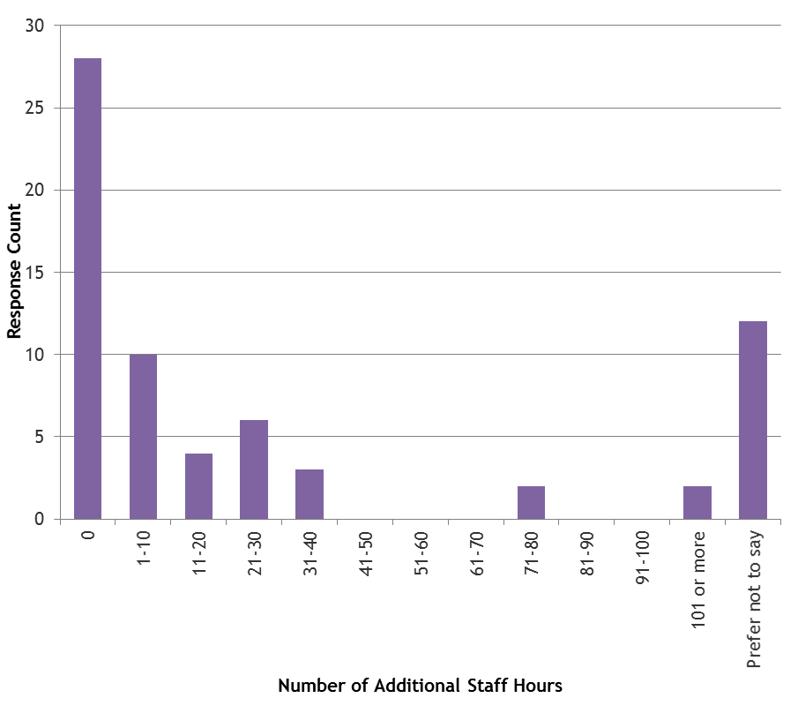
11 of the 27 (40.7%) businesses giving extra staff hours were in the Visitor Economy:
- 27.3% (n=3) of these gave staff between 11 and 20 hours extra;
- 18.2% (n=2) of these gave staff between 1 and 10 hours extra;
- 18.2% (n=2) of these gave staff between 21 and 30 hours extra; and
- 18.2% (n=2) of these gave staff between 71 and 80 hours extra.
13 of the 27 (48.1%) businesses giving extra staff hours were in Retail:
- 46.2% (n=6) of these gave staff between 1 and 10 hours extra;
- 23.1% (n=3) of these gave staff between 21 and 30 hours extra; and
- 15.4% (n=2) of these gave staff between 31 and 40 hours extra.
Only 2 businesses (3.0%) said they had employed additional staff during ‘Made in Hull’; one had employed two extra staff, the other had employed just one. Staff were given, on average, an extra 6.3 hours each. Both were Retail businesses.
    - Impact on Footfall & Bookings
28.4% (n=19) said the event had coincided with an increase in customers or room bookings, and 28.4% said it had stayed the same.
Figure X: Change in Footfall & Bookings
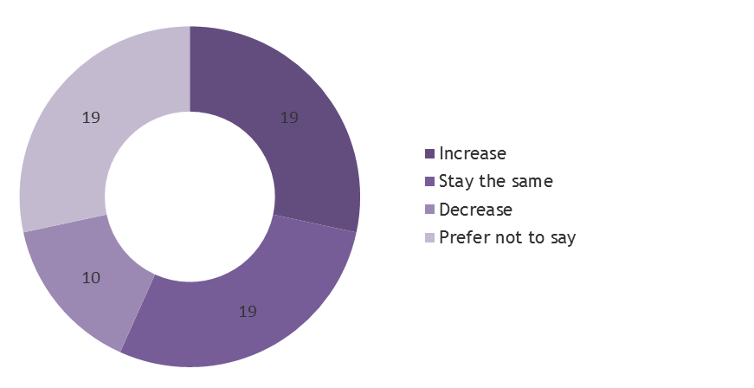
When looking at the same data by Visitor Economy businesses and Retail businesses both enjoyed significantly higher footfall or bookings than respondents on the whole. Negative changes in footfall and bookings seemed to have been felt most by Visitor Economy businesses and least by Retail businesses.
Table X: Change in Footfall & Bookings
Category | +ive change in footfall and bookings | -ive change in footfall and bookings
All respondents | 28.4% | 14.9%
Visitor economy respondents | 38.9% | 22.2%
Retail respondents | 35.3% | 8.8%
  - Sentiment Towards ‘Made in Hull’
Businesses were also asked to give their feedback on ‘Made in Hull’ as audience members. Overall, they rated it highly, giving it 4.5 out of 5 on average.
Figure X: Rating of ‘Made in Hull’
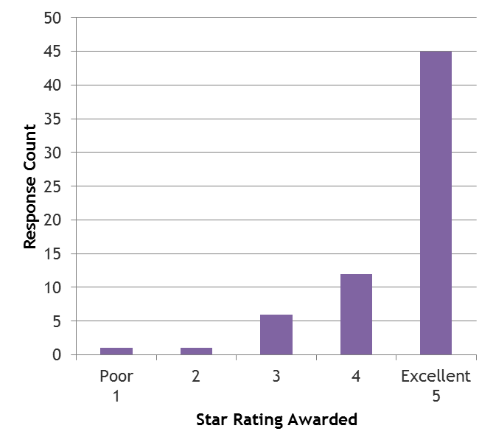
Visitor Economy businesses were much more likely to give the event 5 stars than Retail businesses (83.3% vs. 61.8%).

