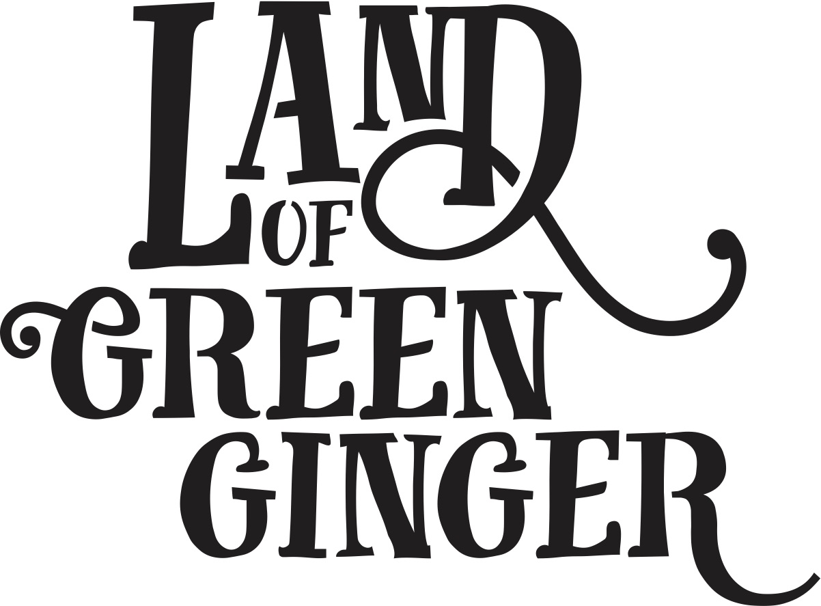

**Illustration Drafts Feedback**

**Descriptions**

**Opening Pages**

**Pg 1 (Right-hand Page – gutter left of illustration (RH – GL))**

*There once was a Land that nobody believed existed.  And every day people passed by it or around it or over it or through it, but never once saw it or felt it or heard it or knew any person or thing in it.*

A cross-section slice through image. Above ground the Land of Green Ginger street with people going about their business. Underground a vault full of Land of Green Ginger crates. The vault is dark and dusty with red-brick walls. The crates are all shapes and sizes – the “To: Hull From: Land of Green Ginger” stamp can be seen on most of them. They are dusty and old looking and they emit a magical green glow, which shows in some way that they have just “awoken”.

Lovely. Would perhaps lower the bottom section a bit. We’ve decided that the last page in the book will be this same image, but instead of the characters ignoring each other they will be our characters from the stories and they will be acknowledging one another. Underground there will be just one crate subtly glowing.

Therefore – the characters need to be reflected in this first illustration. They’re going about their business, not paying attention to one another.

Underground all of the crates should be emitting magic.

**Pg2 (RH – GL)**

*Until, one day, the Land revealed itself…*

A baffled looking man in his 60’s wearing a green boiler suit and green hardhat is shining a torch on a crate that has been opened in the underground vault. A number of magical, yet strange objects seem to have burst out from inside the crate in a cloud of green smoke, which is more magical than sci-fi! Things that could be bursting from the crate could be gold noses, tiny black horses, books, bells, wolves and mice – some of these things could be in the smoke rather than physical if that makes sense! We’re toying with the idea that perhaps the man can’t neccesarily see these magical things, but can see the smoke, and if it’s possible displayed on the inside of the lid are the words “Acts of Wanton Wonder are coming…”.

Great! Maybe there are also some flying books, and book pages, a scroll wrapped in red ribbon – any other hints to things to come…

**Punctuation 1 (Left-hand page – Gutter right of illustration (LH – GR))**

These punctuations will occur between each Act as a recurring point in the story, mainly centring around the heralding moments of the real-life story. These will be double page spreads.

For this first one we’d love to see a rough of the front page of the local newspaper – Hull Daily Mail” with the headline “Mysterious Crates Appear at Freedom Centre”. If you search 7 Alleys in Assetbank you’ll come across the black horse and carriage next to a stack of crates at Freedom Centre – a picture of that on the front page would be great. For now we’ll see how that feels, and we’ll add more detail in the next phase.

This is perfect. Would be great to make that ‘7 Alleys’ crate a bit more prominent.

In order to give a bit more context we’d like to add the beginnings of subheading to each of these HDM front pages. This one should read:

Headline - “**Land of Green Ginger crates appear at Freedom Centre”**

Subheading – “Following the discovery of a vault of crates under the city... (trail off)”

We’d like to keep these as single pages now, as we love the title page images you did, so it’d be great if you could do one of these for the single page opposite in each section – these will be detailed out in the full book descriptions.

Title page – Illustration of this riddle page - [https://hull2017.sharepoint.com/:b:/g/EQB_pfgcA9FJrS8u-qSeQTkB8BNVVXjTy7RB5umsyKD0Wg?e=cXMdPI](https://hull2017.sharepoint.comb:/g/EQB_pfgcA9FJrS8u-qSeQTkB8BNVVXjTy7RB5umsyKD0Wg?e=cXMdPI) – the side that says “7 ghost stories on a ghost page” and as much of the text as you can get in or just the beginnings and then trailing off.

**Act II: Gold Nose of Green Ginger**

**Pg1 (RH – GL)**

***This could be presented as a split image, or if you can get it all in one illustration then great!***

*XXXX is the manager of a pawn brokers at North Point Shopping Centre in Bransholme. Usually the shopping centre is a hive of pasties, frozen foods, cheap haircuts, vape sticks, and mobile phone accessories. A steady stream of customers visit daily, some buying, some selling, some browsing, some just whiling away an afternoon.*

*Recently a new place has opened opposite the pawn brokers. It displays something called the Gold Nose of Green Ginger and is manned by an odd group of people in colourful pleated costumes. XXXX has a shop full of gold, but for some reason people seem to be more interested in the Nose. XXXX wouldn’t be surprised if it was part of that City of Culture thing, but then again, it’s unlikely they’d bother coming to somewhere like North Point.*

Top section shows the main thoroughfare of North Point Shopping Centre, which opens out from the pawn brokers on one side and Nose space on other. The pawn brokers displays a selection of jewellery, bits of tech (iPads, phones, etc.) and posters in the window stating that they buy gold for cash.

The centre is busy with people doing their shopping – an elderly couple, someone in their 60’s in mobility scooter, mums pushing buggies with young children, a North Point security guard, etc.

A woman in her mid-late twenties, wearing gold jewellery and dressed casually leans against the front of the pawn brokers staring across at the Nose space. She puffs on a vape stick and looks bored/sceptical/disinterested.

Across the way is the Gold Nose of Green Ginger (to make this clear the wording ‘Gold Nose of Green Ginger’ could be displayed across the entrance to the space, though it wasn’t in reality). There are a few people in the space chatting with the costumed staff, looking around the space, looking at the Nose with great interest, some holding/reading yellow pamphlets. The staff (maximum of 3) are cheery and proud, showing their customers around. The customers look interested/bemused/aghast/some sceptical. The Nose can be seen behind its magnifying glass – perhaps its gold is sparkling and eye catching.

*NB: The types of shoppers, and the costumed staff are in all of the images, so do have a good look through to pick out the styles. Throughout this Act it would be great to show a mix of the ones in the pleated colourful costumes, as well as the ones with the primary coloured aprons with plastic noses attached.*

The feel of this is great. It captures the feeling that the Nose might have just arrived and the bustle of the opening ceremony. If possible, it’d be good to show the two shops (Cash 4 Gold and Gold Nose) as being opposite, and to get a clearer visual of the Cash 4 Gold woman.

**Pg2 (RH – GL)**

*It’s still here, and week by week more and more people are drawn to spend time in the Nose place. They don’t seem to sell anything much, but they don’t half make a racket. Each day there’s something new happening nose flute practice, craft activities, live music and dancing – all the while the kids are running riot.*

*XXXX hasn’t bothered to go across him/herself, s/he’s too busy in the shop, but yesterday Fred came in with a nonsense story about a bingo win. S/he’s noticed that the girls who used to come and fuss and fawn over the rings and jewellery and gold in the pawn shop have stopped crossing his/her door. Now they’re always over the road dancing with the Guardian, hanging off her every limb and vying for her attention They’re just as noisy as ever, only now they’re pouring tea for the old ladies, reading stories to the little ones and helping to keep the place tidy.*

Clear illustration of the Nose space from outside showing a lunchtime concert with four brass players playing from the space to outside. Three school girls aged 12-14 in uniform are dancing with The Nose Guardian, an elderly lady and a toddler outside of the space. Some are wearing plastic noses over their own noses, The Nose Guardian (this is the main girl in the photographs with the short hair) is playing a nose flute along with the band. There are small groups of people watching. The costumed characters are amongst it all – chatting to passers-by and dancing themselves.

It’s busy and noisy and chaotic, but full of joy and fun.

Female character from pawn brokers can be seen watching, only this time she looks surprised/interested/starting to come around to it.

Again – this is great! Only comment would be whether the Nose can be shown behind the magnifying glass in the background.

**Pg3 (RH – GL)**

*The stories are getting dafter and dafter. By now XXXX has heard of various folk’s wishes coming true - a long awaited pregnancy, a remission from arthritis, a win on the pools, a new job. Any minute now so and so (world leader) will come on the telly announcing world peace on the back of someone in Bransholme’s wish.*

*Eventually, at locking up time one day XXXX goes across to the Nose place and decides to have a look around this cabinet of curiosities, find the secret pocket, and what’s the harm in making a wish? After all, wouldn’t it be great if XXXX (wish to be decided).*

*THEY MAKE A WISH – hint to it and then leave for it to be revealed at Unleashed.*

It’s quiet in the Centre and the female character from pawn brokers has made her first step across the threshold of the Nose space. She looks around with great curiosity and decides to make a wish – writing on a piece of paper with disappearing ink, and posting it through a letter box in a padded yellow wall.

This is lovely. This will become Pg.4 now with her making a wish for a baby. See full descriptions for new pg. 3 and updated story.

**Act IV: Re-Rediffusion’s Voice Park**

**Pg 1 (RH – GL)**

*It’s a grey Sunday morning and Agnes is at Walton Street Market at the boot of a car browsing [SOMETHING which references the fact that she is quite shy].*

*A friendly man in a beige overall with a strange contraption on his back approaches her and asks if she’d like to donate her voice. She backs away from him and almost inaudibly says she couldn’t, she’s got no words to say, nothing of value, nothing that’s significant to anybody else.*

*The man reassures her that words aren’t necessary for the contraption – they are simply interested in vocal sounds. She’s finally coaxed into uttering the faintest squeak of an “aaah”. Agnes feels a pang of excitement, but it passes in a moment.*

*The man passes her a card and tells her to be sure to visit Voice Park to see the final product of the voice collecting.*

*Before she knows it she’s back on the bus with [the thing she’s bought].*

***This could be split into four separate scenes on one page.***

Walton Street Market is a big car boot sale that takes place twice a week on a big bit of hard standing land. (See Street View here - [https://www.google.co.uk/maps/@53.7494416,-0.375085,3a,75y,90h,90t/data=!3m7!1e1!3m5!1sogyqAfr6C-jjlOVUpZLSnQ!2e0!6s%2F%2Fgeo1.ggpht.com%2Fcbk%3Fpanoid%3DogyqAfr6C-jjlOVUpZLSnQ%26output%3Dthumbnail%26cb_client%3Dmaps_sv.tactile.gps%26thumb%3D2%26w%3D203%26h%3D100%26yaw%3D317.41733%26pitch%3D0%26thumbfov%3D100!7i13312!8i6656](https://www.google.co.uk/maps/@53.7494416,-0.375085,3a,75y,90h,90t/data=!3m7!1e1!3m5!1sogyqAfr6C-jjlOVUpZLSnQ!2e0!6s//geo1.ggpht.com/cbk))

Agnes is a lady in her mid-to-late 50’s. She is short and dumpy with mousey non-descript hair and wears boring colours like beige so as not to stand out in any way. She is painfully shy, mostly looking at the ground, barely making eye contact with anybody.

She is at the boot of a car when the friendly man dressed in a Ghost Busters-like costume. The man is a VEARO (Voice Extraction and Re-Rediffusion Operative) in his late 30’s, he’s tall and slim.

When he approaches Agnes she looks shocked and begins to back away.

Eventually he coaxes her into saying “aaah” into the machine (again, images of this in AssetBank should give you a good indication of how this looked in real life).

Agnes is then seen on the bus with a white plastic bag looking pleased with herself. In her hand is a business card that says “Voice Park” on it.

*N.B. Pictures of the Ghost Buster people are in the Assetbank link you were sent. You should be able to search “Voice collecting” and you’ll find them.*

Lovely! Would be great if the VEARO man could look a teeny bit older.

On the VEARO uniforms can you add a little logo badge with this logo on it? <https://hull2017.assetbank-server.com/assetbank-hull2017/action/viewAsset?id=12747&index=56&total=89&view=viewSearchItem>

**Pg2 (RH – GL)**

*A few weeks later, Agnes is taking a stroll through Pickering Park. In the distance near the old paddling pool she sees the glow of lights and people playing and hears the murmur of voices.*

*Not realising that this is the Voice Park that the man told her about, she can’t help but be lured in by what she sees and the welcoming people inviting her to come and play with Hull’s voice.*

It is dusk on a clear night in September and Agnes is crossing the bridge in Pickering Park. Lights and sounds (aaahs and ooohs and uh-hus) can be seen and heard in the distant paddling pool. At the end of the bridge there are two friendly VEAROs (without the contraption) at the gates to the Voice Park. Agnes makes her way through the gate.

*N.B. You can see the bridge straight ahead here -* [*https://www.google.co.uk/maps/@53.7311822,-0.4000759,3a,75y,90h,90t/data=!3m6!1e1!3m4!1siYRQposhi_MWO4GaU3Q1SQ!2e0!7i13312!8i6656?dcr=0*](https://www.google.co.uk/maps/@53.7311822,-0.4000759,3a,75y,90h,90t/data=!3m6!1e1!3m4!1siYRQposhi_MWO4GaU3Q1SQ!2e0!7i13312!8i6656?dcr=0)*. The paddling pool is to the left of the bridge through the green fence.*

Again, really lovely! Think it would work better if this image was flipped, so that Agnes almost has her back to the reader and is walking towards the gates and the VEAROs and towards glowing lights and the paddling pool in the in the distance beyond the gates.

**Pg 3 (RH – GL)**

*At the end of her journey around Voice Park one of the operatives carefully hands her a phial of elixir. She’s told this tiny phial contains the collective power of the voices of Hull distilled down to its most potent form. It is a special elixir that should be used in situations where you feel like you need the power of Hull’s voice behind you – a job interview, a presentation, a declaration of love. Simply rub the elixir onto the outside of your vocal chords and you will be given a powerful voice.*

Agnes is in the Voice Park sat in front of a strange looking barbecue which has steam coming from it. The VEARO man from the market carefully presents her with a small phial of elixir from the barbecue. She takes it and listens as he tells her the circumstances in which it should be used.

*N.B. You can see the barbecue, and phial demonstration in the video and images.*

Lovely!

**Pg4 (RH – GL)**

TBC

We have a description for this now, which will be included in the full descriptions.

**Act V: Micropolis**

**Pg 1 (RH – GL)**

*Dave is a solitary, isolated, grumpy man. He does the same things day and day out, never deviating from his plans.*

*For 40 years he has worked for Yorkshire Water as the night watchman at Springhead Pumping Station - a less romantic job than it sounds. He spends his evenings chasing away the kids running amok at the gates, grumpily freeing dogs from the site who’ve escaped from their dog walkers, making endless rounds of the building and only stopping for a cup of tea whilst he makes meticulous notes on the happenings of each evening.*

*Recently a flashing light in the tower has appeared, and it’s driving him mad. Perhaps he shouldn’t care, put his feet up and have a cup of tea, but it’s driving him round the bend, and nobody’s bothered to come and fix it.*

***Let’s try and do this with one scene setting image.***

Dave is in his late 50’s. He wears a yellow high visibility jacket, white hardhat, black cargo trousers and heavy duty work boots. He has white hair and a white beard. He is tall, and stocky with a beer belly showing underneath his clothes.

In the various illustrations he is seen shooing teenagers from the gates, sweeping up leaves outside the building and making notes.

In one of the illustrations he is seen looking up at the tower and the flashing light. He looks annoyed.

We love Dave! This is great.

**Pg 2 (RH – GL)**

*One night, whilst making his rounds he hears a loud crash in a room that leads to the light tower, which has always been off limits to him. Urgently he shoves his way through the locked door, and immediately trips over what seems to be a miniature lorry. He flicks on his torch and shines it upon a pile of discarded rubbish; then a trail of tiny footprints, then a tiny lit lamp post, and finally a miniature Springhead Pumping Station complete with a miniature version of himself chasing a spider out of the gates. He stands up and shines his torch around to discover a full bustling city in perfect miniature, filled with tiny people going about their business.*

This probably needs to be split into four illustrations on one page.

The story description here is fairly self-explanatory, each discovery shown in each illustration.

Would be great if this illustration could show more of the scale of Micropolis, so maybe from behind Dave - torch lighting the whole huge miniature city? See pics in Asset Bank – there are loads that show the height of it, but we love your interpretation of it!

**Pg3 (RH – GL)**

*Dave is so mesmerised that he stays all night, watching, exploring and scrutinising the complex workings of this beautiful but idiosyncratic town. He analyses the interactions of the little people and begins to see how every part of its inner workings depends on every other part. A realisation crosses him - that we are all tiny and insignificant, and yet the whole world could not function without each individual person.*

Dave is seen on hands and knees staring into the windows of the tiny town, watching the tiny people go about their lives, enamoured with the interactions between the people. So we see the scale of him close up to the micropolis (like massive eye up against tiny window).

Gorgeous!

**Pg4 (RH – GL)**

*Much to his dismay after reporting his discovery, Yorkshire Water decide to open the gates and allow the public in to see the Micropolis. For the first few days Dave spends his time berating members of the public for venturing into off limit areas of the station, touching and playing with things that aren’t supposed to be touched, running around excitedly, not watching where they’re going.*

*As time goes on, Dave relaxes slightly, realising that this place he has taken such good care of is hosting a wonder that is being enjoyed by thousands of visitors. He chats to people that visit because they saw tiny footprints at North Point Shopping Centre, East Park and Land of Green Ginger. Along the way he hears stories of old school friends, news of his cousin, anecdotes about a friend he lost touch with. He realises the interconnectedness of everyone’s lives and begins to understand that the people are the cogs that make a community work, and that everything is part of the bigger picture. (He decides to reach out to his cousin.)*

***Preferably just one image again here.***

Streams of people all ages, abilities, ethnicities, are seen wandering up the long path to Springhead Pumping Station. The gates are open and it somehow has a more welcoming feel than before. Dave is seen watching people with his arms folded, a frown on his face.

Inside the Micropolis Dave is seen waving his finger at people for touching bits of the Micropolis/trapsing mud/running round.

Eventually Dave relaxes and is next seen smiling and welcoming people into the Pumping Station – rubbing the heads of little ones, chatting to people.

*(Resolve for final illustration needs working out here.)*

Gorgeous!