
SLung Low
flood, part One, From The Sea: airstream tour
hull (multiple sites), 27th february – 04th march 2017
Monday 27th February | (1 site day)
Site Address | ASDA - Hessle Road  Hessle Road, Hull, HU3 4PE
Store Opening Hours | 07:00 Mon – 22:00 Sat; 10:00 – 16:00 Sun
Slot on Site | 16.00 - 20.00
Site Contact | Lisa Wilkinson  Community Champion  01482 596 600 Ext 201 or 222?
Parking Details | - Possibly park by central walkway?
Distance from Victoria Dock | 2.5 miles, approx 11 minutes
Other Info | - On arrival use colleague entrance to left of store to sign vehicles in on Parking Eye system, ring bell for entry.

Parling reference images

TOUR INFORMATION

SCHEDULE:
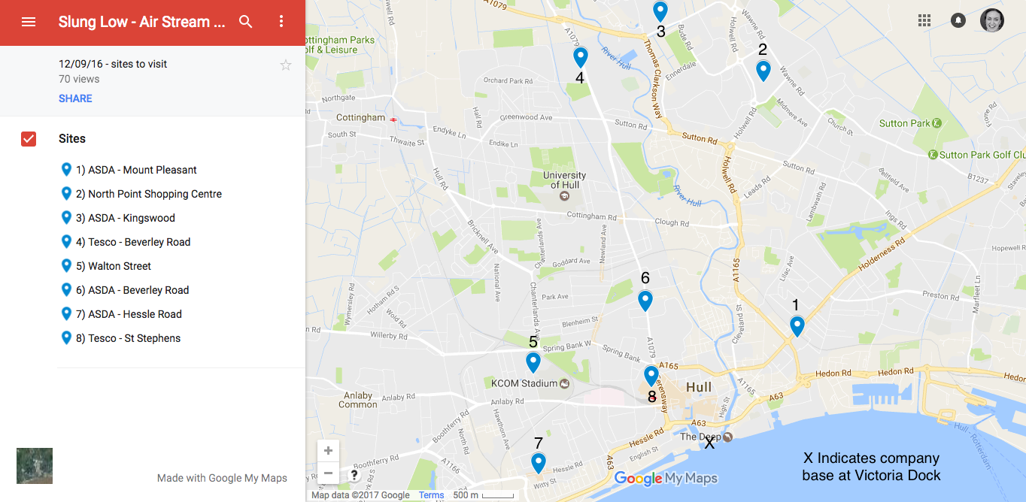
TOUR MAP
(Sites numbered not in location order)

The Airstream and towing vehicle will be parking overnight at company accommodation at Victoria Dock, and departing from there each day.
Tuesday 28th February | (1 Site day)
Site Address | Tesco St Stephens  110 Ferensway, Hull, HU2 8LN
Store Opening Hours | 06:00 Mon – 17:00 Sun
Slot on Site | 16.00 - 20.00
Site Contact | Claire Graham  Community Champion  07718 527327  5456@uk.tesco.com
Parking Details | - Park Airstream Just outside covered car park, near the St Stephens centre  - Area cordoned off in morning
Distance from Victoria Dock | 1.5 miles, approx 9 mins
Other Info | - Position on slight slope  - Sign in all vehicles at Customer service desk on arrival  - Met Karen Prynn on recce

Parking reference images

Wednesday 1st March | (2 Site day)
Site Address 1 | Walton Street Market  Walton Street, Hull, HU3 6JB
Store Opening Hours | 08:00 – 14:00 Weds & Sun
Slot on Site | 08.00 - 12.00
Site Contact | Steven Hess  Market Manager  07979 243253  s.shess@ntlworld.com
Parking Details | - We will be given a spot for the airstream on the day  - Arrive an hour early for set up
Distance from Victoria Dock | 2.9 miles, approx 9 mins
Distance to Site 2 | 3.5 miles, approx 12 mins
Other Info | - Steve in from 5.30am  - Car park wet and uneven  - Regular stall holders, downsized market for winter & low footfall

Parking reference images

Site Address 2 | ASDA Mount Pleasant  Mount Pleasant Hull, HU9 2BN
Store Opening Hours | 07:00 – 22:00 Mon to Sat; 10:00 – 16:00 Sun
Slot on Site | 16.00 - 20.00
Site Contact | Dave/Gary at AEJ Management  07713 367945  hullmount@aejmanagement.com  Landlord: Gina Cowgill  07736 126991  gina.cowgill@workman.co.uk  0161 828 5768
Parking Details | - Park airstream in front of walkway between DW Sports and Matalan towards Mount pleasant entrance  - Access to pedestrians from walkway, slightly raised  - 5 spaces cordoned off all day (Ring prior to visit to check)  - Parking eye registered ???????
Distance from Victoria Dock | 1.1 miles, approx 5 mins
Other Info | - Many loops with this one as Gina owns site but security manage it
Parking reference images | 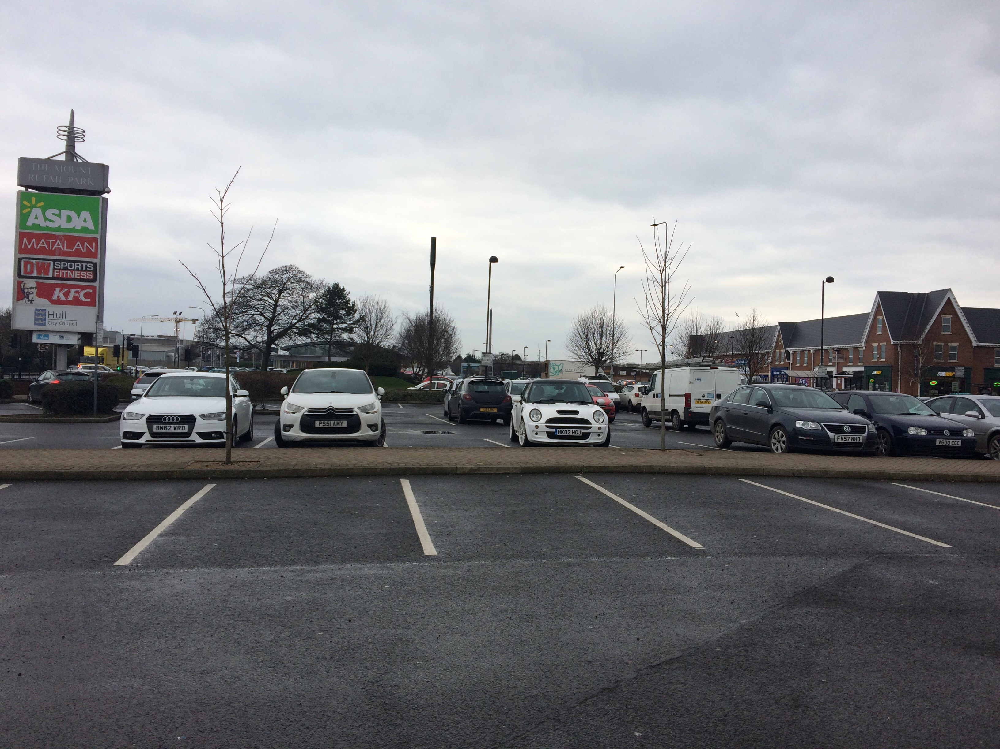

Thursday 2nd March | (1 Site day)
Site Address | Tesco Beverley Road  Hall Road, Hull, HU6 7XP
Store Opening Hours | 06:00 Mon – 00:00 Sat; 10:00 – 16:00 Sun
Slot on Site | 16.00 - 20.00
Site Contact | Trish Baldwin  Community Champion  07545 717381  trishbaldwincommunity@outlook.com
Parking Details | - Park Airstream in front of bollards opposite store entrance  - Make sure someone warns public from trolley area while reversing  - Plenty of parking space for transit van  - Met Andy Carter-Rigg on recce
Distance from Victoria Dock | 4.9 miles, approx 15 mins
Other Info | - Trish available

Parking reference images

Friday 3rd March | (1 Site day)
Site Address | ASDA Beverley Road  Beverley Road, Hull, HU3 1TY
Store Opening Hours | 07:00 – 23:00 Mon to Sat; 10:00 – 16:00 Sun
Slot on Site | 16.00 - 20.00
Site Contact | Geoff Wood  Store Manager  01482 222672 ext 201  gwood.s04543.uk@wal-mart.com
Parking Details | - Park airstream in row of bays on other side of Click & Collect signage  - No permit required for transit van  - We can use their loos!
Distance from Victoria Dock | 2 miles, approx 9 mins
Other Info | - Geoff available
Parking reference images | 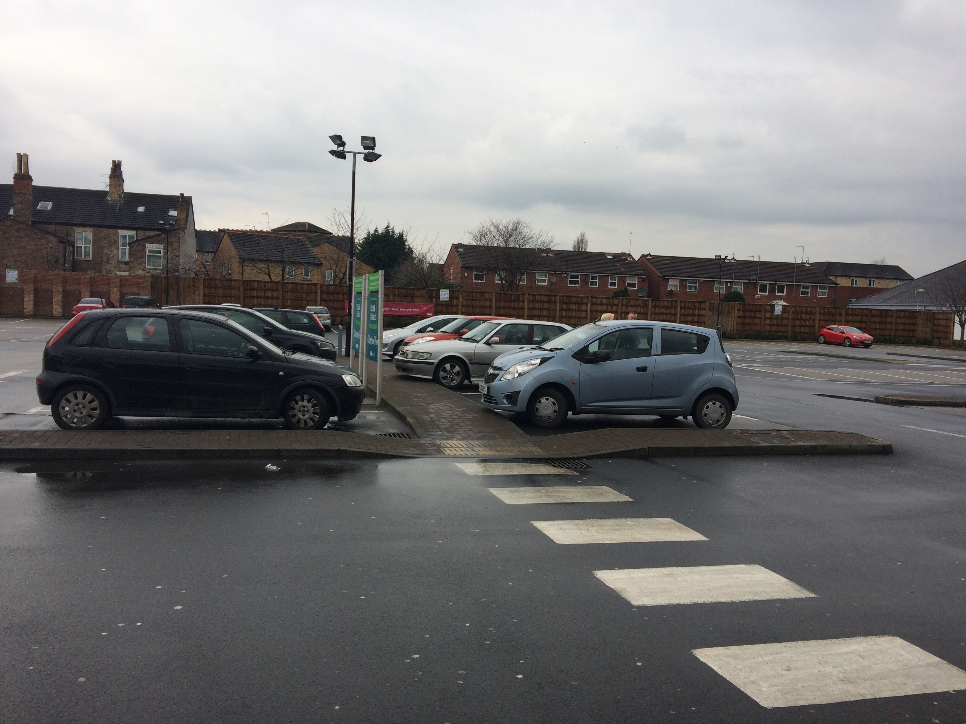

Saturday 4th March | (2 Site day)
Site Address | North Point Shopping Centre  5 Goodhart Road, Hull, HU7 4EE
Store Opening Hours | 08:00–18:00 Mon to Fri; 09:00–17:30 Sat; 10:00–16:00 Sun
Slot on Site | 11.00 - 15.00
Site Contact | Louise Smith  Centre Manager  07969 338255  louise.smith@northpointshopping.co.uk
Parking Details | -Park Airstream in front of grass at the East Car park, opposite store entrance, next to yellow box.  -5 spaces coned off prior to visit  - Park transit van anywhere free or security services behind building
Distance from Victoria Dock | 4.2 miles, approx 14mins
Distance to Site 2 | 1.8 miles, approx 7 mins
Other Info | - Louise available  - Centre Management offices on right by West entrance  - Can receive info on days footfall  - Access to North Point via ring road around the centre  - Area known for traffic - leave ample time  - Bransholme 50 exhibition open at centre

Parking reference images

Site Address | ASDA Kingswood  Kingswood Retail Park, Althorp Road, Hull, HU7 3DA
Store Opening Hours | 08:00 Mon – 22:00 Sat; 10:00 – 16:00 Sun
Slot on Site | 16.30 - 20.30
Site Contact | Geoff Brown  Community Champion  01482 830400 Ext 222  community_kingswood@asda.co.uk
Parking Details | - Park Airstream left of entrance next to police cabin, either on uneven surface or in front of bollards  - Bollards to be removed prior to visit  - Pass to be obtained for van window
Distance from Victoria Dock | 5.2 miles approx 16mins
Other Info | - Geoff available  - Tannoy announcements can be made

Parking reference images

