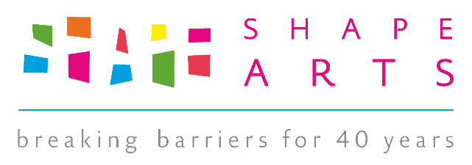

**Artlink Hull and Shape Arts (“Shape”)**

**Data Sharing Agreement for Adam Reynolds Memorial Bursary Exhibition**

**7 April – 1 July 2017 inclusive**

As part of this agreement, Shape Arts will be a delivery partner of Adam Reynolds Memorial Bursary Shortlist exhibition.

**Purpose**

The purpose of the agreement is to ensure that both parties will act in line with best data sharing practice and make clear to each other what data will be shared and how it will be treated once shared.

**Scope**

* **The data being collected is audience data relating to the ARMB Shortlist exhibition 2017. Both parties are sharing data as part of their funding agreements and the treatment of data is done in line with legal requirements to protect data and people’s privacy.** This will apply to those people attending and engaging with the exhibition in person and online

**What we will do jointly**

* Collect audience data in accordance with best practice in relation to surveying methods and so that the audiences are as well informed as possible about why they are being surveyed and what the data will be used for
* Retain this information until such time as it is no longer needed

**What Artlink Hull will do**

Make available to Shape the data of audiences who have engaged with the exhibition, as well as audience feedback for individual performances and runs. This includes:

* Postcodes
* Audience Finder surveys completed by Artlink Hull’s audiences which relate to the exhibition
* Footfall figures for the duration of the exhibition. This will include clarification as to whether these figures are estimated or exact.
* Audience segmentation / demographic information relating to exhibition audiences which may come from a source other than the Audience Finder surveys. This will include clarification as to whether this information is based on estimates (e.g. mean trends or averages) or exact information.
* Email addresses, gathered by Artlink Hull, of those who have opted in to receive communications from Shape
* Images/ footage taken of the exhibition by Artlink Hull or its contractors
* Any other relevant evaluation feedback, in any format

**Data Protection / Sharing**

* Artlink Hull will ensure that all data collection systems adopt 'good practice' under the Data Protection Act 1988 and Telecommunications (Data Protection and Privacy) Regulations 1999.
* Where audience members have opted in to receiving information about shows and future developments from Shape on the audience survey forms, Artlink Hull will make available to Shape those audience members’ full contact data to hold on its own marketing database, within one month of the end of the Adam Reynolds Memorial Bursary Shortlist exhibition.

**What Shape will do**

Make available to Artlink Hull the data of audiences of events relating to the exhibition, held at Artlink Hull, where booking has been managed by Shape. This includes:

* Postcodes
* Audience Finder surveys completed by Artlink Hull’s audiences which relate to the exhibition
* Audience segmentation/ demographic information relating to exhibition audiences which may come from a source other than the Audience Finder surveys. This will include clarification as to whether this information is based on estimates (e.g. mean trends or averages) or exact information
* Email addresses, gathered by Shape, of those who have opted in to receive communications from Artlink Hull
* Any footage/ images taken of the exhibition by Shape or its contractors
* Any other relevant evaluation feedback, in any format

**Data Protection / Sharing**

* Shape will ensure that all data collection systems adopt 'good practice' under the Data Protection Act 1988 and Telecommunications (Data Protection and Privacy) Regulations 1999.
* Where audience members have opted in to receiving information about shows and future developments from Artlink Hull, Shape will make available to Artlink Hull those audience members’ full contact data and booking data for them to hold on its own marketing database, within one month of the end of the Adam Reynolds Memorial Bursary Shortlist exhibition.

Note: it is not expected that the survey information could be used to identify individuals. Should such a situation arise, either party must notify the other and steps taken to ensure that identification does not occur.

Neither party will make the raw data available to third parties (other than surveys with Audience Finder) unless with the explicit agreement of the other, and it is done in line with best practice guidelines. For example as the result of a request by the police or other legal body.

This does not preclude the use of the data results to inform the work of either party.

Both parties agree to notify the other if the agreement is breached or if there are issues relating to the collecting and secure safeguarding of data relating to the Exhibition period. This is to ensure that people’s privacy and data is protected, given that this a general agreement and not an exhaustive list of points.

**We the undersigned are authorised to ensure this agreement is maintained and understood by those handling the data:**

For Shape Arts

Name……………………………………………………….

Signed………………………………………………………

Date…………………………………………………………

For Artlink Hull

Name…………………………………………………………

Signed……………………………………………………….

Date…………………………………………………………..

Both parties should retain an original copy for their records.