**The Philip Larkin Archive – a basis for an exhibition**

**Larkin the letter writer**

Philip Larkin was one of the last great literary letter writers of the 20th Century, but, beyond that, he was also probably one of the last great letter writers *per se*. Richard Bradford described Larkin as addictive and ‘almost fanatical’ in his approach to letter writing.

When he was not producing literature, working, socialising or sleeping, much of his time was given over to composing letters to friends, literary acquaintances, family or lovers. [Richard Bradford, *The Odd Couple*]

Larkin spanned an era where postal communication was the major form of inter-personal contact, beyond the face-to-face, for people of all walks of life and which offered them a form of expression different and arguably more richly expressive than that of the telephone, email or text. His was a world where the post was delivered two or three times a day, where a first class letter was almost guaranteed to be delivered within 24 hours, and where urgent communication took place by telegram, even if only to send forgotten birthday greetings. Larkin’s personal correspondence captured in great detail every single element of his complex life, from family, to lovers, to various kinds of literary expression. From time to time, it has to be said, they also contain some unsavoury political rhetoric and what would now be regarded as socially unacceptable, albeit entirely private, thoughts. Reading the letters brings the man alive again in every respect and reveals him to be a perceptive, sad, funny, grumpy, passionate, observant individual and, above all, a brilliant writer; *they represent Philip Larkin writ large.*

Some of Larkin’s correspondence, of course, is already very well known. When first published as *The Selected Letters* in 1992 they caused Larkin’s reputation to take a nose dive, partly because they revealed aspects of Larkin’s personality which sometimes shocked and dismayed those who thought they knew him well. This first publication was, however, somewhat selective as well as selected and ignored both Larkin’s correspondence with his long time lover, Monica Jones (subsequently published in 2010) and those to members of his family, particularly his mother Eva, of which some 8000 letters and related documents, are located within the Philip Larkin Archive at Hull History Centre. The published letters also omit altogether the vast correspondence from public figures and ‘fans’ which Larkin received and responded to in his capacity as Librarian at the University of Hull. Taken together, these currently unpublished sources form a rich, and as yet unseen vein of material that could be used to powerful effect within an exhibition and offer fresh perspective on Larkin the man and writer.

**Why the family letters are important**

* The represent the longest period of continuous correspondence that Larkin entered into and they are the only source of significant correspondence where both sides exist and are available
* They demonstrate an important ‘voice’ in Larkin but indicate something of a ‘joined-upness’ of Larkin’s personality - he shows more than a side of himself to his mother. In a sense, all elements of him are here
* They fill in gaps/unexplained features of the biographical narratives gleaned from other letters and sources. In fact, they provide a kind of ‘seam’ from which the context and the gaps in other letters  can be made sense of
* They indicate the importance of Larkin’s mother, Eva, to his life and work
* They also provide a means of ‘situating’ and providing a commentary on other ‘Larkinalia’, such as the vast number of photographs located within the archive (some of which were sent with letters)

**What the public and fan mail corrrespondence offers**

* Unpublished material and another aspect of Larkin’s letter writing prowess
* Humour
* Another side of Larkin – engagement with ‘fans’
* Reflections of/engagement with the City of Hull in a public capacity

**Some possible thematic uses of the Larkin correspondence within the Exhibition**

* *A day in the life….* Larkin was a very prolific letter-writer and spent a considerable proportion of most days writing a host of letters to various correspondents. It would be quite fascinating, for example, to take particular days on which significant (or perhaps not so significant but personal) events happened and demonstrate the way in which Larkin described and respondent to various people – sometimes the same response but delicately nuanced, sometimes very different (rage against his mother when writing to Monica, loving kindness when writing home, adolescent smut to Kingsley Amis, polite, admiring sincerity and gentle humour to Barbara Pym]
* *A month of Sundays…* Larkin was a creature of habit and ritualistically sat down to write a four page letter to his mother every Sunday morning. They depict life in Hull in the 1950s, 60s and 70s, when recreational options were much more limited.
* *A perspective on Hull and the East Riding*…..*’It’s a bit chilly here and smells of fish’*… Larkin’s letters describe his surroundings in great descriptive and emotional detail, sometimes more positively than might have been expected. They reveal Hull as he saw and lived it, especially in the 1950s, 60s and 70s. Combined with the photographic archive, they capture the changing landscape that Larkin lived through. Using the pre-1955 letters, the same could be done for Belfast.
* *What’s on the back of envelopes…..* It is not just the written content of Larkin’s letters which is fascinating, they are artifacts in their own right. Both he and his mother use different styles and colours of writing paper to amuse each other, and the envelopes document the changing style of postal communication over the years [war time economy envelopes in the 1940s letters, for example, lettercards, postcard depicting Hull in its earlier guises and the holiday destinations visited]. Larkin carried his mother’s letters round with him and frequently used the backs of the envelopes as convenient aide memoires, shopping lists, or reminders of tasks to complete. One contains the cricket scores noted down as he attended a Lords test match with Monica, another contains four lines of a poem not located anywhere else and suggestive of a railway journey.
* *Creature comforts…..* Larkin illustrated his letters (particularly those to his mother) with clever and amusing drawings, usually of seal-like creatures depicting him and her undertaking various activities [or imagined activities] in their day-to-day lives. They would present wonderful opportunities to display the comic, and often self-deprecating humour that Larkin so cleverly deployed.

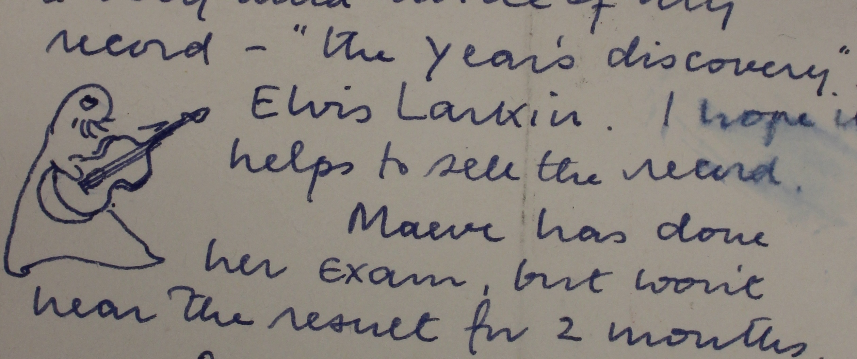

* *The Sutton Letters – all that jazz* ….. Larkin’s letters to his close childhood and adolescent friend, Jim Sutton, have been used as a major source of detail on Larkin’s youthful experiences and views in all of the published biographies. The letters span the period from 1939 to 1985, although the bulk of them end in 1951 after Sutton had made a disastrous visit to see Larkin in Belfast. The correspondence was taken up again a few years prior to Larkin’s death. The bulk of the correspondence discusses jazz records and their performances as well as the angst Larkin felt over his fiancé, Ruth Bowman. Sutton’s side of the correspondence has received very little exposure and offers additional insights in to Larkin’s personality and life in Coventry.
* *What puts me off marriage*….. Larkin defended his bachelor status with great energy, considerable guile but not with a lot of angst and this is revealed very powerfully in the correspondence. The awkward triangle between himself, his long term lover, Monica Jones and his library colleague and some time lover, Maeve Brennan is revealed is powerfully acted out in the various correspondences. Add to that, the presence of the other significant woman in his life, his mother Eva and the letters throw considerable light on Larkin’s almost life-long emotional dilemmas.
* *‘Dear Mr Larkin’….dealing with the fans*…. Larkin received a considerable amount of ‘fan mail’ and various requests for comment, personal appearances, book signings etc. His secretary. Betty Makereth, was very adept at keeping people at bay and many letters/requests went unanswered, though they were carefully filed away. However, on occasions Larkin did reply, often with considerable humour. A display based around this correspondence would reveal yet another aspect of Larkin’s character.