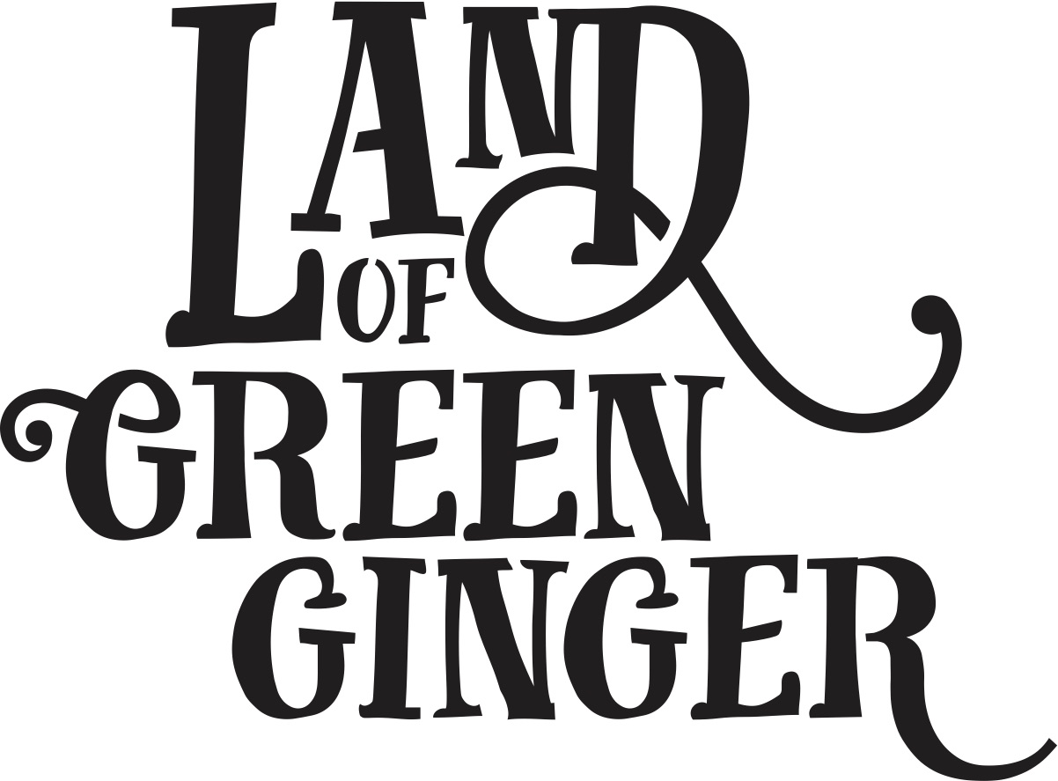

**Press Activity**

**Key Messages**

* The seventh and final Act of Wanton Wonder from Land of Green Ginger, this book tells the stories of the mysterious Land of Green Ginger and the stories of the local people it touched. It is a record of Hull UK City of Culture 2017 as lived by the residents of the city and as informed by their imagination and creativity.
* Throughout the year Hull 2017’s ground-breaking community engagement project, Land of Green Ginger, invited Hull’s residents to immerse themselves in a magical citywide story, inspired by and celebrating the spirit of Hull.
* Limited edition print.
* This special book is being delivered to every household in Hull in the week of 18 June as limited edition souvenir of the project that brought magic to Hull throughout 2017.
* Schools across the city involved in a mass storytelling of the Land of Green Ginger story on XX June. Schools continue to be inspired by the story through a series of resources and activities delivered throughout the week.
* Land of Green Ginger illustrator, Katy Riddell, will be in attendance at The Big Malarkey Festival, alongside her father and Children’s Laureate 2015-2017, Chris Riddell.
* Chris Riddell also opening new East Park library – TBC whether we include this.

**FAQs**

1. **Will I receive a Land of Green Ginger book?**

The Land of Green Ginger books have been delivered to households within the Hull boundary.

1. **When will I receive my copy of the LOGG book?**  
   Books will be delivered to all households within the Hull boundary between the 18th and 22nd June 2018
2. **Where can I buy a Land of Green Ginger Book?**  
   Books are limited edition. One per household in Hull. Books are not available to purchase separately.  
   L*and of Green Ginger Merchandise will be available at The Big Malarkey Festival 23rd – 24th June at East Park* ??
3. **Why did I receive the Land of Green Ginger Book?**

For the seventh act of wanton wonder from the Land of Green Ginger, limited edition books are being delivered to every single household in Hull.

1. **Why wasn’t a Land of Green Ginger Book delivered to my house?**Households outside the Hull catchment area are not eligible for a copy of the book.
2. **How can I get another copy of the Land of Green Ginger Book?**Books are limited edition. One per household in Hull. Books are not available to purchase separately.
3. **I don’t want to keep my copy of the Land of Green Ginger book, how can I return it?**

If you do not want to keep a copy of your Land of Green Ginger book, we’d love for it to be returned rather than thrown away. You can return books to the following locations:

The Pod at Hull Paragon Station

Hull Central Library?

East Park Library?

1. **Why hasn’t my school received a crate from the Land of Green Ginger?**

Schools across Hull were given an opportunity to sign up to be part of a mass storytelling of the Land of Green Ginger story on Thursday 14 June. If your school did not receive a crate this is because we did not receive an expression of interest from your school to take part.

**TEAM INBOX**

If you are getting in touch with a query about the Land of Green Ginger’s latest act of Wanton Wonder, please refer to the FAQs found on our website here:

**TIMELINE**

**Option 1**

Schools Deliveries and Reading: Thursday 14 June

Household Book Delivery: Monday 18 June

|  |  |  |
| --- | --- | --- |
| **Date** | **Activity** | **Type** |
| Monday 11 and Tuesday 12 June | Crates delivered to schools | Live (production) |
| Thursday 14 June | Horse and carriage photo call at Woodland Primary School  Mass Reading in schools | Press  Live |
| Friday 15 June | PR – Schools across Hull found LoGG crate containing books, mass storytelling took place.  School children now taking part in a series of activities inspired by the Land of Green Ginger.  [Image – horse and carriage delivery with crate] | Press |
| Monday 18 June | Books land on doorsteps | Live |
| Monday 18 June | Land of Green Ginger books have begun appearing on doorsteps of residents throughout Hull.  Limited edition books also to be donated to libraries across the city.  Announcement that LoGG illustrator, Katy Riddell will be at Big Malarkey Festival on Sunday 23 June.  Poss announcement that Chris Riddell (Katy’s dad) will be opening the new East Park library during BM Festival.  [Image – book on doorsteps] | Press |
| Saturday 23 June | LoGG presence at Big Malarkey  Chris Riddell opening of East Park Library (VIP) | Live  Live |
| Sunday 24 June | LoGG presence at Big Malarkey  Katy and Chris Riddell Q&A at Big Malarkey  Katy Riddell Illustrating Workshop | Live  Live  Live |
| Monday 25 June | PR: Katy Riddell at Big Malarkey, with LoGG crates if required.  Chris Riddell opening of East Park Library? | Press |

**Option 2**

Schools Delivery and Reading: Monday 18 June

Household Book Delivery: Monday 18 June

|  |  |  |
| --- | --- | --- |
| **Date** | **Activity** | **Type** |
| **Thursday 14 & Friday 15 June** | Crates delivered to schools | Live (production) |
| **Monday 18 June** | Horse and carriage photo call at Woodland Primary School  Mass Reading in schools  Books begin to land on doorsteps | Press  Live  Live |
| Monday 18 / Tuesday 19 June | PR – Schools across Hull found LoGG crate containgin books, mass storytelling took place.  School children now taking part in a series of activities inspired by the Land of Green Ginger.  LoGG books also appearing on doorsteps throughout city.  Limited edition books being donated to libraries.  -----------  Announcement that LoGG illustrator, Katy Riddell will be at Big Malarkey Festival on Sunday 24 June  Poss announcement that Chris Riddell (Katy’s dad) will be opening the new East Park library during BM Festival.  [Image – horse and carriage delivery with crate] |  |
| Monday 25 June | PR: Katy Riddell at Big Malarkey, with LoGG crates if required. |  |