**From stage to screen**

15:00 – 15:45 at Fruit

**Nikki Bedi –**07888723429

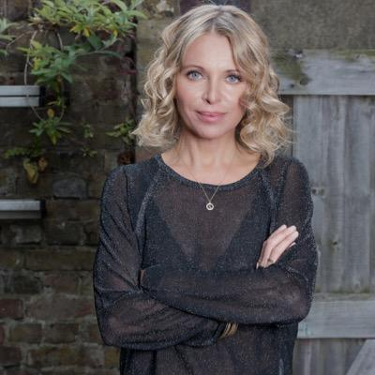 BBC televison and radio broadcaster with a passion for making arts and culture accessible.

**Lamia Dabboussy -** 07718 117 848

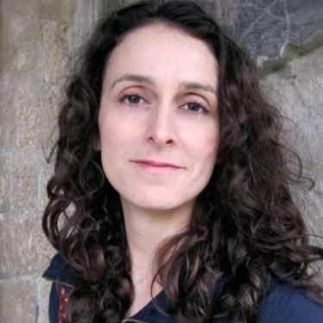BBC Arts- Lamia Dabboussy is the Editor for BBC Arts.

**Jeremy Routledge-** 07710 775630

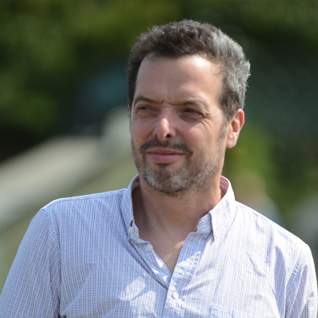Channel 4 Random Acts - Jeremy is co-founder of Calling The Shots based in the South West.

**Peter Groom - 0**7702157163

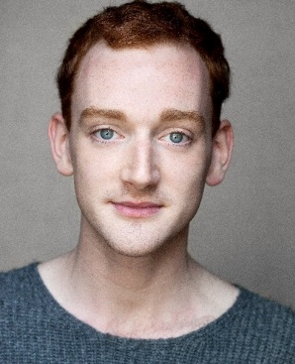 Newcastle based actor, dancer and choreographer working mainly with dance and theatre.

**Rocio Cano -** 020 8741 3929

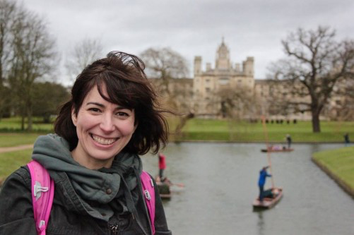 TV Producer who has worked mainly on arts and entertainment series.