How to avoid an identity crisis
11:30 – 12:15 at 1@the Dock
Dr Jo Byrne – 07540 232309
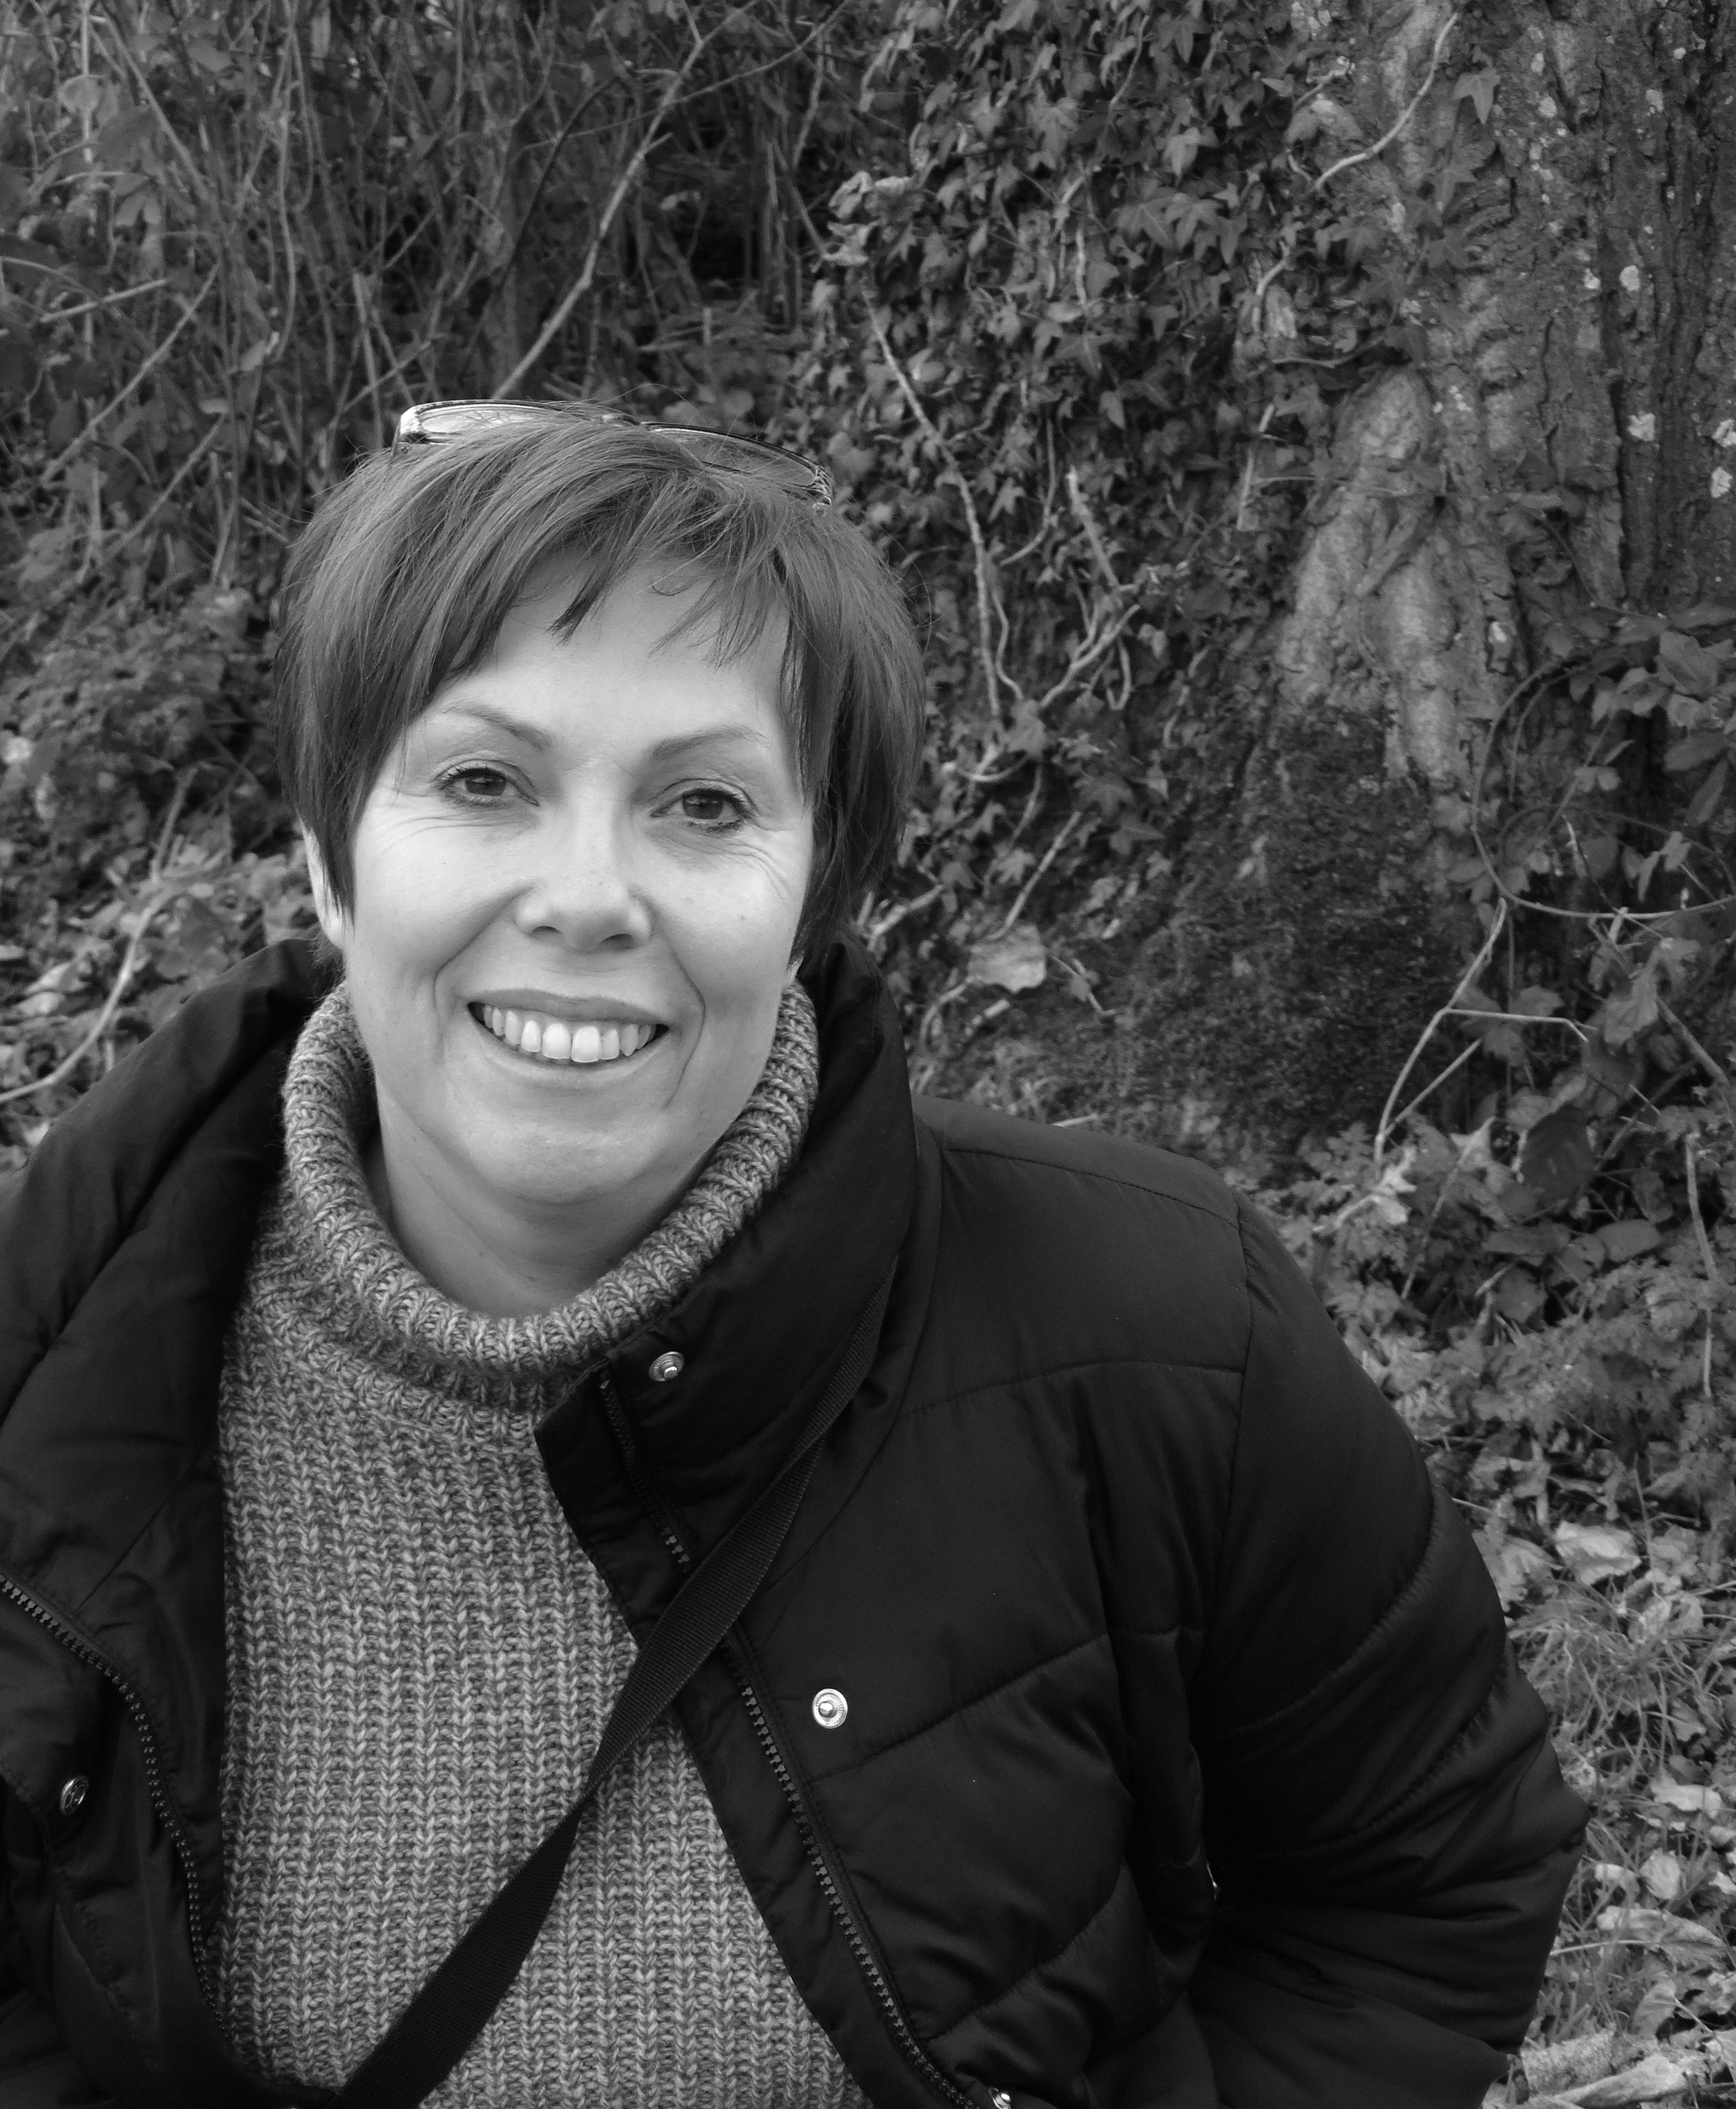 Research Manager, Culture, Place and Policy Institute (CPPI), University of Hull
Professor David Atkinson – 07775 650595
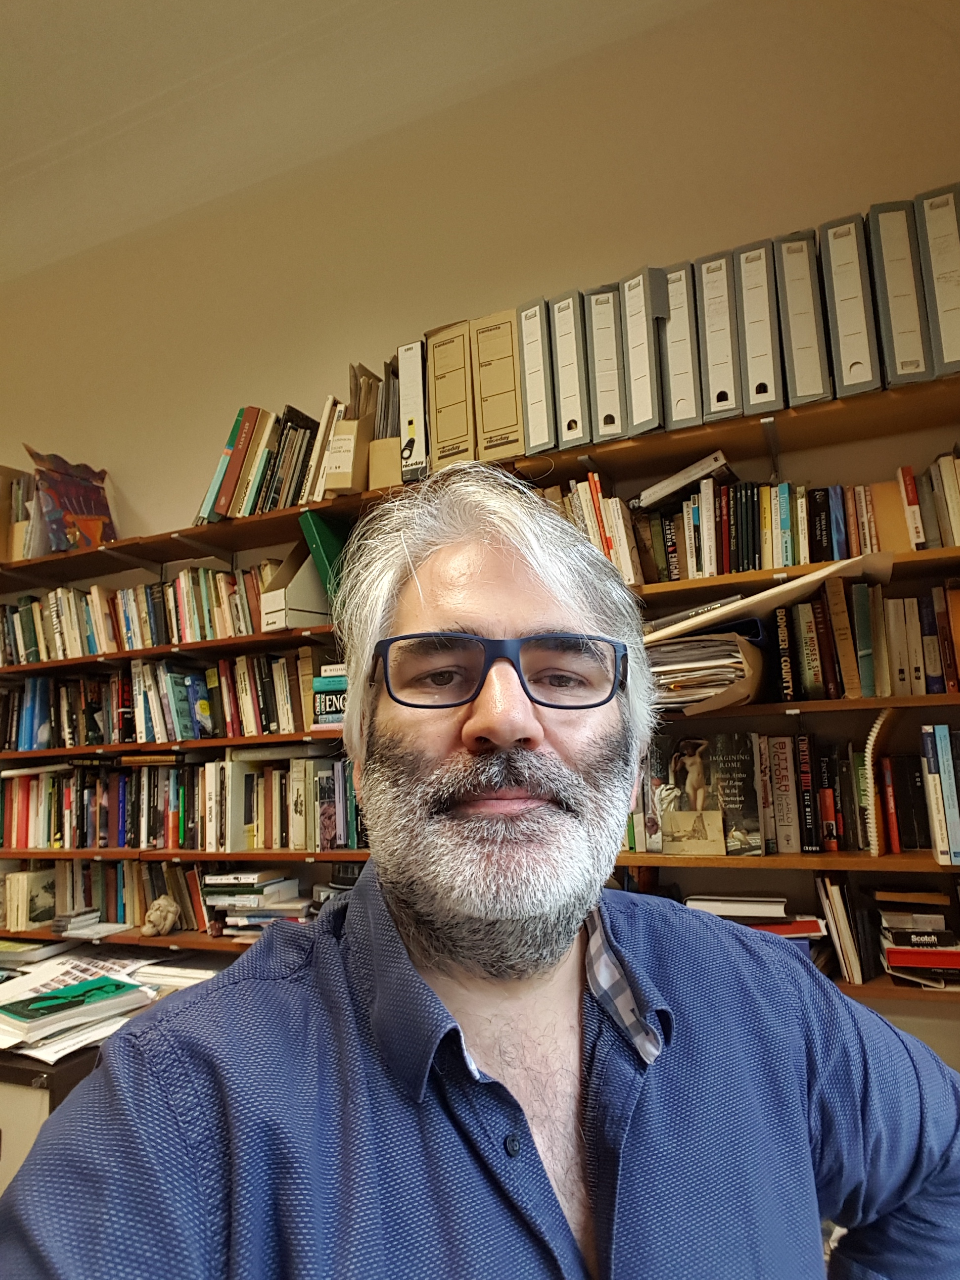 Professor of Cultural and Historical Geography, University of Hull
Lottie Gross - 07542116737
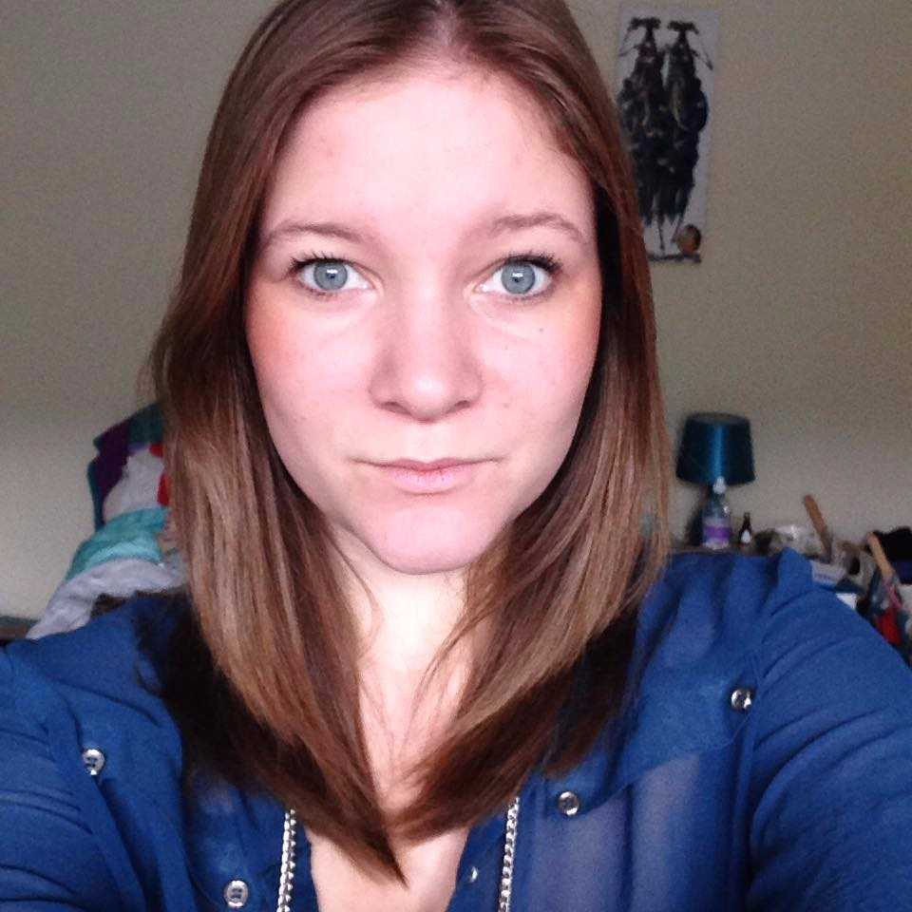 Travel editor, writer and photographer, currently editor of loveEXPLORING.com
Anthony Yates - ?
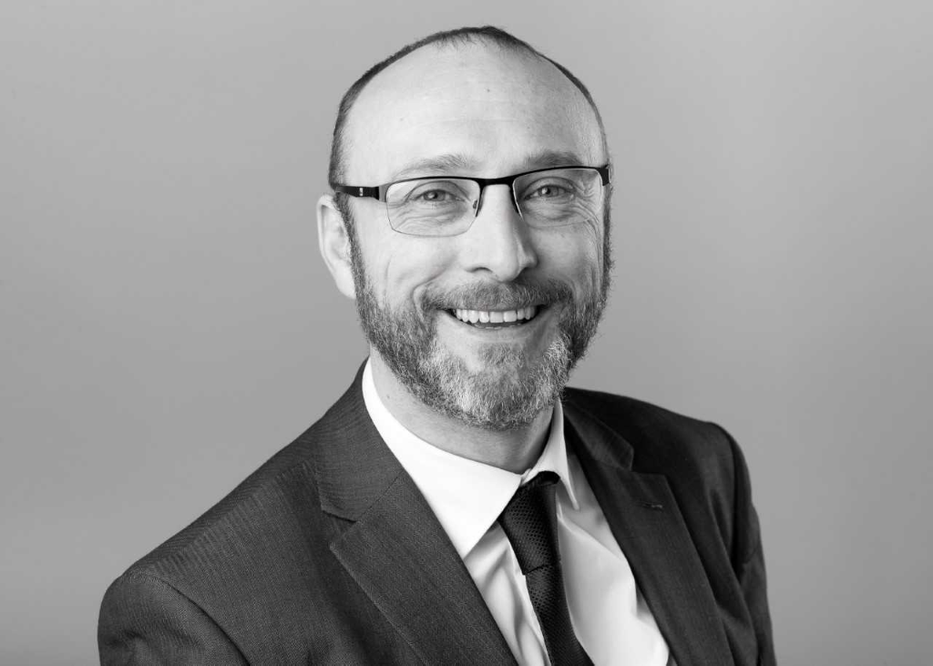 Joined Visit Hull and East Yorkshire (VHEY) in 2007 as the Visitor Economy Manger.
Emma Davidson - 07943554371
 London-based writer offering a unique perspective on fashion, art and culture
Julie Corbett - ?
 Hullness volunteer and Hull 2017 volunteer

