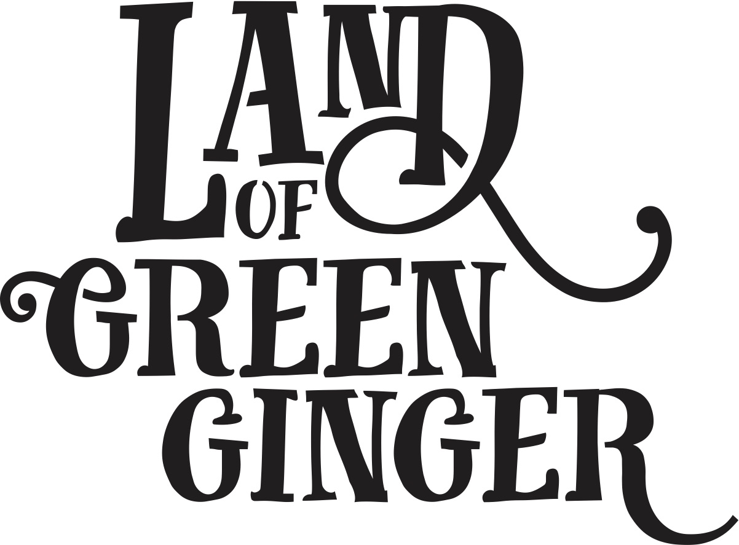

**Press Activity**

**Key Messages**

* The seventh and final Act of Wanton Wonder from Land of Green Ginger, this book tells the stories of the mysterious Land of Green Ginger and the stories of the local people it touched. It is a record of Hull UK City of Culture 2017 as lived by the residents of the city and as informed by their imagination and creativity.
* Throughout the year Hull 2017’s ground-breaking community engagement project, Land of Green Ginger, invited Hull’s residents to immerse themselves in a magical citywide story, inspired by and celebrating the spirit of Hull.
* Limited edition print.
* This special book is being delivered to every household in Hull in the week of 18 June as limited edition souvenir of the project that brought magic to Hull throughout 2017.
* Schools across the city involved in a mass storytelling of the Land of Green Ginger story on XX June. Schools continue to be inspired by the story through a series of resources and activities delivered throughout the week.
* Land of Green Ginger illustrator, Katy Riddell, will be in attendance at The Big Malarkey Festival, alongside her father and Children’s Laureate 2015-2017, Chris Riddell.
* Chris Riddell also opening new East Park library – TBC whether we include this.

**TIMELINE**

**Option 1**

Schools Deliveries and Reading: Thursday 14 June

Household Book Delivery: Monday 18 June

|  |  |
| --- | --- |
| Friday 15 June | PR – Schools across Hull found LoGG crate containing books, mass storytelling took place.  School children now taking part in a series of activities inspired by the Land of Green Ginger.  [Image – horse and carriage delivery with crate] |
| Monday 18 June | Land of Green Ginger books have begun appearing on doorsteps of residents throughout Hull.  Limited edition books also to be donated to libraries across the city.  Announcement that LoGG illustrator, Katy Riddell will be at Big Malarkey Festival on Sunday 23 June.  Poss announcement that Chris Riddell (Katy’s dad) will be opening the new East Park library during BM Festival.  [Image – book on doorsteps] |
| Monday 25 June | PR: Katy Riddell at Big Malarkey, with LoGG crates if required. |

**Option 2**

Schools Delivery and Reading: Monday 18 June

Household Book Delivery: Monday 18 June

|  |  |
| --- | --- |
| Monday 18 / Tuesday 19 June | PR – Schools across Hull found LoGG crate containgin books, mass storytelling took place.  School children now taking part in a series of activities inspired by the Land of Green Ginger.  LoGG books also appearing on doorsteps throughout city.  Limited edition books being donated to libraries.  Announcement that LoGG illustrator, Katy Riddell will be at Big Malarkey Festival on Sunday 24 June  Poss announcement that Chris Riddell (Katy’s dad) will be opening the new East Park library during BM Festival.  [Image – horse and carriage delivery with crate] |
| Monday 25 June | PR: Katy Riddell at Big Malarkey, with LoGG crates if required. |