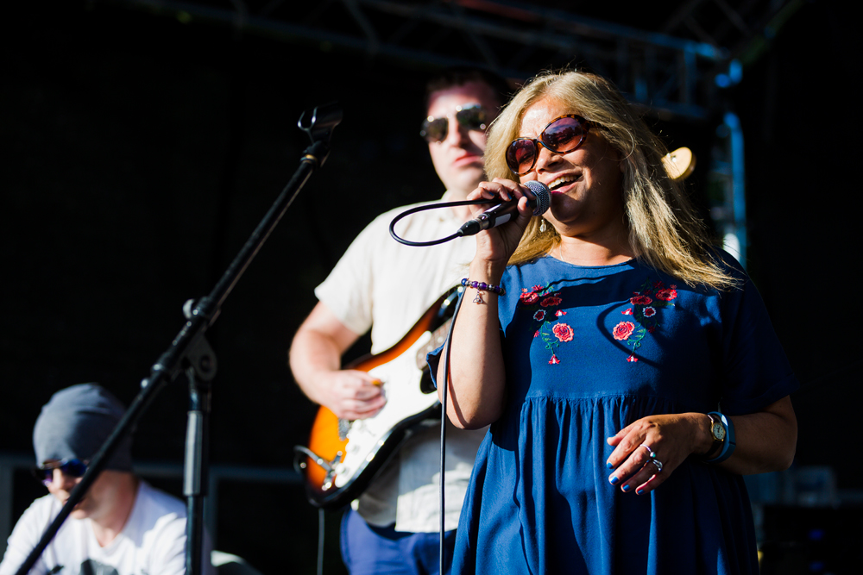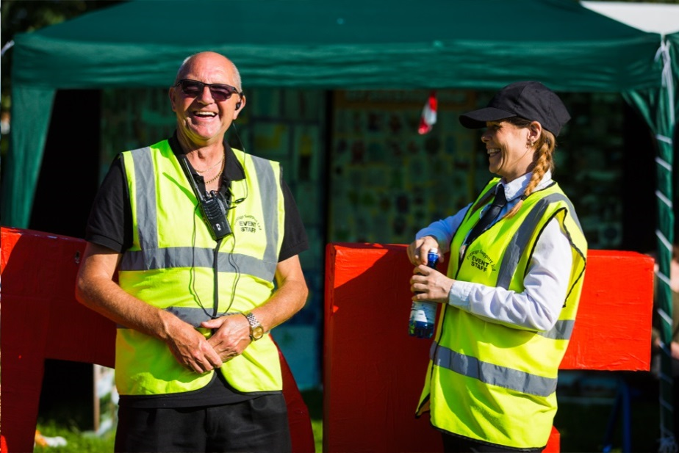**The Big Gig 2017**

“We attended as my son has additional needs but actually has no diagnosis or pathway through CAMHS and so slips through the net.   
  
He loved the graffiti. They were so patient and kind, especially as he struggles to maintain concentration and focus on any activity. So the fact they were able to engage him was amazing. He even wanted to go back!”

**Anonymous attendee**   
(taken from their feedback form)

“It was great. We loved seeing everyone up and dancing. The volunteers were so good at keeping on top of the litter and we didn’t find a single broken bottle the next morning. It was the best event we’ve ever seen in the park.“

Quote from one of the **Pearson Park Rangers**

“What a great day this has been, thank you so much for organising it.”  
  
**Councillor John Robinson**   
Hull City Council

“Saturday was AMAZING, thank you so much for letting us be a part of it. You guys did an amazing job of organising and I have nothing but admiration for all of your hard work! It really paid off because so much thought had been put into everything.“

**Natalie Barnes**  
Chair of Trustees, Special Stars

“I thought it was an utterly fantastic event. I advise large festivals on disability access and at The Big Gig I wasn't aware of any difficulties at all.  
  
What I thought was particularly great about the whole event is that it was an extremely inclusive event that reached a wide audience, whereas sometimes 'inclusive' events can market themselves to disabled people only and have the inadvertent effect of ghettoising the audience and performers, but that certainly was not the case on Saturday!”

**Paul Hawkins**   
Festival Project Manager, Attitude is Everything

“We’re so excited that we’ve come to a fully accessible and inclusive festival, which is so close to our home because Alistair was able to walk to here. We thought we could just pop home if he needed changing, but we don’t even have to do that because you’ve got a changing place. Alistair hasn’t stopped smiling and keeps using his talker to say “more, more, more, more”.   
He’s loving it! “

**Jennifer Skip**   
Mum of Alistair (who has Angelman Syndrome), aged 12