

**LOOK UP #10**

**FLOE**

**SECURITY**

**BRIEFING NOTES**

**8th – 10th December 2017**

**Security Briefing Notes**

**OVERVIEW**

**WHAT IS LOOK UP?**

Look Up is a year-long programme of artists’ works made specifically for Hull’s public places and spaces. Designed to challenge people’s perceptions of Hull and offer different ways to experience the city.

**WHAT IS FLOE?**

Floe is a large-scale projection event and soundscape by artists Anna Heinrich and Leon Palmer, that will ‘virtually’ transform and remodel the architecture and facade of The Deep. This ambitious work will be a dramatic, monumental, expression of the geological forces and biological processes which originally inspired the appearance of The Deep. It will reflect a sense of the rich aquatic life contained within the building as the light penetrates and shafts through the depths of its maritime environments.

Anna Heinrich and Leon Palmer are two UK based artists who have worked in collaboration since 1991. Their artworks range from photographic and light installations to large scale projection events and public art interventions.

This project is the final co-commission between The Deep and Hull 2017 as part of Look Up – a programme of temporary installations in public places and spaces around the city curated by Andrew Knight and Hazel Colquhoun.

FLOE will be live between 18:00 & 22:00 on the 8th, 9th & 10th December.

**YOUR ROLE ON FLOE**

Your main role is to ensure public safety and to prevent areas from becoming overcrowded.

Security staff will be positioned in the locations shown below, unless required to assist with dealing with an incident in another area.

It is important that 1 person is stationed at either end of the footbridge throughout the evening. If it is necessary to open the bridge the warning lights will flash and warning sirens will be heard. If this happens the footbridge must be cleared immediately, please politely but firmly ask people to vacate the bridge for their own safety.

Please monitor crowd levels and if occupancy becomes too dense, please ask people to wait at the entrance points until there is sufficient space, the projections run on a 10-minute cycle, so they won’t have to wait too long.

Also be aware of traffic on High Street, if crowds become dense it will be necessary to redeploy staff to there.

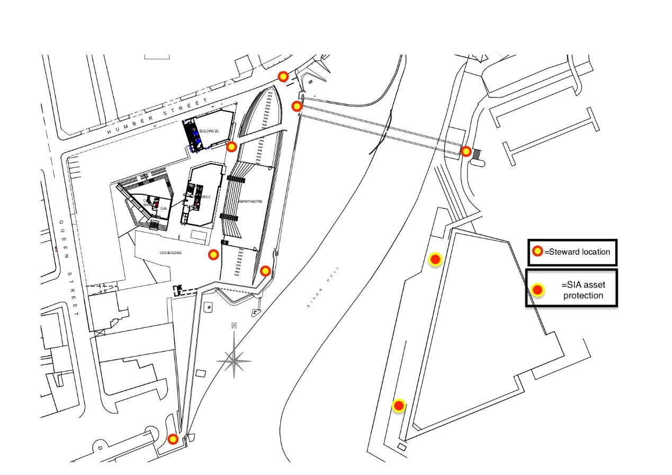

**KEY TIMES**

**Installation Live** 18:00 to 22:00

**Shift Times** 17:00 to 22:30 (Friday 8th)

17:30 to 22:30 (Saturday 9th & Sunday 10th)

**KEY Hull 2017 STAFF**

James Clark, Event Manager

Hannah Williams Walton, Producer

Andrew Knight, Look Up Curator

Hazel Colquhoun, Look Up Curator

**KEY CONTACT NUMBER**

James is your Event Manager and will be on site from Friday-Sunday. If you need to get in contact with him within this time his number is: 07722 119318

**WELFARE FACILITIES AND SIGN IN**

Please report to the Old Argos building on Lowgate at the start of your shift.

**Please arrive promptly as you must be in position at the event site at 17:45**

Welfare facilities are available at the old Argos building.