**PERIPLUM, LOGG SECRET PROJECT – DESCRIPTION REVISED**

**‘Messages from the 7th Alley’**

**Outline**

We will deliver message-in-bottle artworks to people’s doorsteps in the Preston Road and Greatfield areas of East Hull. We will deliver up to 150 bottles total over 2 days – 23rd-24th September. Recipients are nominated in advance by community leaders and participants of workshops taking place at Child Dynamix Youth Centre on Preston Road on 17th September.

The bottle messages contain a poem relating to the East Hull myth of the 7 Alleys. The local legend says that at the end of the 6 alleys (around Hedon Road Cemetery) the 7th Alley is a portal between a hidden world and the local neighbourhoods. When it opens up, magic is released and spreads throughout the area.

The bottles will also contain an invitation to join the ‘Search for the 7th Alley’ on a horse-and-carriage ride for up to 4 people per journey. The bottle contents contain instructions on how to do this. Recipients of the bottles simply need to text or call a number we will provide in the bottles to confirm a time on a specific date. These spaces will be limited so it will be operated on a first come first serve basis and this will be made clear on the invite.

The horse-and-carriage rides are being offered on the 25th September, 1st & 2nd October TBC(See schedule below for areas of these journeys, based around St. Stephen’s in Greatfield and another location around Preston Road - TBC.) They will be accompanied by an actor inside the carriage, and a fiddle player who will take the audience on a short journey looking for the seventh alley.

**Delivery Transport**

We are currently discussing delivery options with horse-and-carriage services. KRM Carriages (http://www.krmcarriages.co.uk/) are local and have availability of a six-seater carriage on the 23rd, 25th, 1st & 2nd. They have all necessary licenses/insurance. In the case of using KSM, we would deliver ‘invisibly’ from our car in the early morning on the day they’re not available (24th September). Cost of hire is normally £600 per day but we are in the process of negotiating a reduction to £500-£550 per day.

We will deliver up to 100 bottles per day (150 total limit over 2 days). Routes and extent of the deliveries each day will need to work within the horse’s mileage limit of 7 miles and 2-4 hours per day. We will plan each day’s delivery route in advance with the horse’s mileage limit in mind. We will collect addresses for recipients and plan routes in advance.

Upon each individual delivery a hand bell will be rung to alert the household occupants.

**Collecting Nominations**

We are aiming to collect up to 100 nominations of bottle recipients from workshop participants and community leaders in advance of the delivery weekends to give a strong base. We have formed initial positive relationships with Christina Reading from Purple House Women’s Centre, Paul Clark from Child Dynamix and Dave Edeson from the Inspire Communities charity. We are holding workshops at Child Dynamix centre in Preston Road on 17th September (see below).

**Bottle contents**

The bottles will contain:

* Poem and folklore relating to the legend of the 7 alleys
* A short message (wish) from the person making the nomination
* Instructions on how to book a time on the horse-and-carriage ride to join the ‘search for the 7th Alley’, including the phone number they need to contact

**Schedule – key dates**

17th September Workshops with invited participants at Child Dynamix

23rd September Bottle deliveries by horse in Greatfield

24th September Bottle deliveries by car (early morning) in Preston Road area

25th September Horse and carriage rides for bottle recipients around Preston Road or deliveries TBC

30th September Bottle deliveries by horse in Greatfield or Preston

1st October Horse and carriage rides for bottle recipients in Greatfield

2nd October Horse and carriage rides for bottle recipients around Preston Road

**Horse-and-carriage rides**

Based around the embarkation points of the horse-and-carriage rides (St Stephen’s in Greatfield and another location TBC around Preston Road) there will be a simple installation – potentially including bunting along gates and fences. The horse ride will begin and end in these ‘static’ locations. Those taking the journey will have a confirmed time booked in advance through phone communication. Bottle recipients will need to bring their bottle along to gain access to the journey. We will look to hold a number of journey times aside for walk-up members of public who haven’t received bottles.

Inside the carriage will be a fiddle player and an actor with a map, telling the story of the search for the 7th Alley – how they are inhabitants of the 7th Alley and need to return their before midnight when the portal will open up again.

**Workshops**

We are offering a workshop session for local participants from the Preston Road and Greatfield areas to take part in the following activities to help shape the project:

* Sharing stories and legends of East Hull
* Nominating people/households to receive the message-in-bottle artworks (we are looking to collect a total of 50-100 nominations before deliveries begin on 23rd September)
* Nominating something that they treasure in their neighbourhood, whether a place, a club, something they like doing or anything they choose
* Turning these nominations for East Hull’s Treasure into a short message which accompanies the bottle artworks – either a written message or a recorded audio message. Each participant’s message contains their name (first name or nickname only) and a description of the thing that they treasure in the neighbourhood.

Through discussions with Paul Clark of Child Dynamix we have identified a target of inviting 5 families, 5 young people and 5 older people to take part in the workshop session. We have confirmed the workshop date as 17th September, with sessions from 11am-1pm and 1.30-3.30. The second of these sessions will be offered to other community groups.

**Staffing & Security arrangements**

* KRM carriages will bring 3 personnel - 1 driving, and 1 for each horse.
* Periplum will have 3 people present at all aspects of delivery
* Adam Long will be present on *Thurs 22nd, Fri 23rd & Thurs 29th, Fri 30th September, Sat 1st & Sun 2nd October 2016*

**Infrastructure & Equipment**

* KRM Carriages will bring a horse carrier with 2 horses and 1 carriage plus all equipment needed for adequate care of horses.
* Other deliveries will be in the Periplum vehicle (exact details TBC)
* Bottles and contents may need a storage area TBC

**Images**

Basic prototype of bottle: Recommended KRM Carriage:

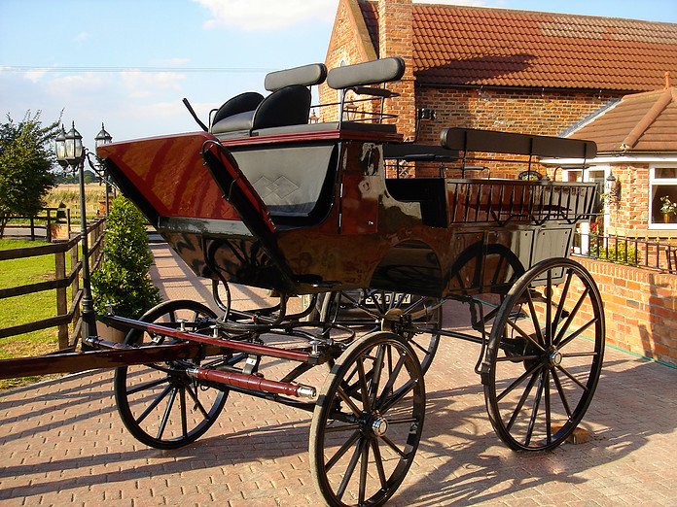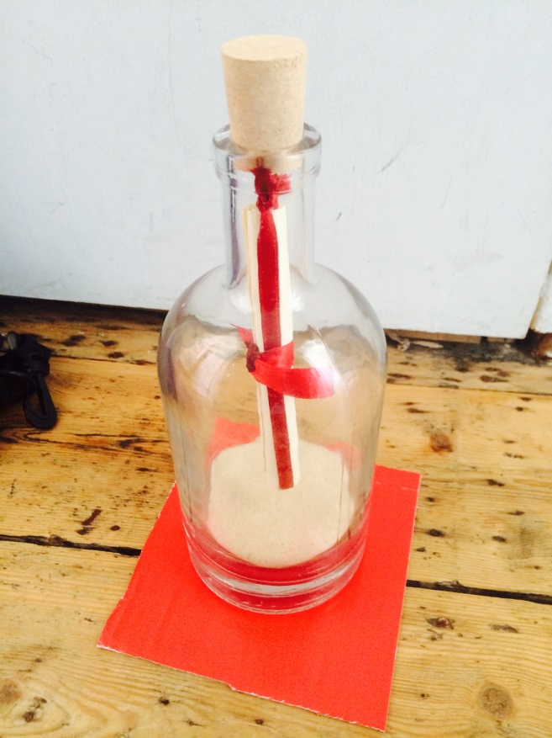

**Ensuring Accessibility**

KRM Carriages – we don’t think carriages are wheelchair accessible so will need to make this clear when inviting people to sign up to live event. Developing an alternative for wheelchair audience- meet the horses etc – would be good to get some advice on this,

We are developing the narrative experience and bearing this in mind with the live performance – having a transcript of spoken word available for deaf audience. The live performance should be accessible for visually impaired audience.

**Safeguarding approach**

* Copies of CRBs submitted to all parties.

**Environmental Awareness**

* Bottles designed with this in mind- all items are recyclable.
* Horse and carriage is environmentally friendly as opposed to car emissions?

**Audience Management**

Being developed in relationship to ideas and discussed with Louise & Adam.

**Emergency arrangements**

To be discussed with KRM carriages

•         **Insurance**

PLI has been sent over. We will be gathering copies of insurance from KLM carriages.

•         **Marketing Narrative**

The carriage is lost and looking for the 7th Alley. The coach drivers are dressed in Victorian Livery and the 2 passengers are in Victorian outfits. There will be hats and some coats for audiences to wear when inside the carriage so that the carriage will look authentic when travelling through streets.

People will be encouraged to look out for the 7th alley carriage and post photos on facebook and twitter.

Periplum happy to add any details on suggestion from marketing and in relationship to other groups/press ideas.

**Monitoring & Evaluation**

To be discussed

**Risk Assessments**

Will work on this next week.

**Production Questions**

* **We need access to parking area for horse transportation and an indoor space to prepare bottles etc**
* **Proposed spaces are Freedom centre for Preston Road and St Stephens for Greatfield but we need to confirm availability so we can start to confirm dates/times (see below)**
* **We will see how address nominations for initial delivery progress and then may need to think through a different approach?**
* **Advice on accessibility would be good – how can we ensure that there is a good alternative experience for wheelchair audience? What can be made only possible for this audience?**

**Delivery Schedule & Key Contacts**

|  |  |  |  |
| --- | --- | --- | --- |
| **Sat 17th September 2016** | |  |  |
| Location | Child Dynamix, Youth Centre 187e Preston Road |  |  |
| 11.00 -13.00 | Child Dynamix Workshop | Paul inviting 5 families, 5 youths, 5 older paticipants | Paul.Clark@childdynamix.co.uk |
|  |  | Up to 30 participants | jane.stafford@childdynamix.co.uk |
| 13.30 - 15.30 | TBC workshop | Periplum contacting other community groups | [Christina.Reading@purplehouse.co.uk](mailto:Christina.Reading@purplehouse.co.uk) |
|  |  | Periplum asking groups to nominate addresses | [jennie_mason@hotmail.com](mailto:jennie_mason@hotmail.com) |
|  |  | Possibility of a 2nd workshop at Greatfield?? | [claire@greatfield.org.uk](mailto:claire@greatfield.org.uk) |
| *Thurs 24th September 2016* | |  |  |
|  | *Periplum arrive - preparation of bottles and routes* |  |  |
| **Fri 23rd September 2016** | |  |  |
| 9.30 | Periplum meet KRM Carriages to prepare carriage & horses | Location needed where we can park cars & horse truck | | |
| 11.00-14.00 | Door to door bottle deliveries by Horse & Carriage | Exact route confirmed 7 miles maximum. | Routes confirmed by Monday 19th September- |  |
|  |  | **Confirm meeting place & confirm delivery addresses** | |
| 14.00-19.00 | Text messages monitored by Periplum | Space - prepare bottles for next day delivery |  |
| **Sat 24th September 2016** | |  |  |  |
| 09.30 -13.00 | Periplum additional bottle deliveries | Exact route confirmed once addresses received | Routes confirmed by Monday 19th September- |  |
|  |  |  |  |  |
| 14.00-19.00 | Text messages monitored by Periplum | Space - prepare bottles for next day delivery |  |  |
| **Sun 25th September 2016** | |  |  |  |
| 9.30 | Periplum meet KRM Carriages to prepare carriage & horses | Location needed where we can park cars & horse truck, preferably with storage for bottles | | |
| 11.00-14.00 | Door to door bottle deliveries by Horse & Carriage | Exact route confirmed 7 miles maximum. | Routes confirmed by Monday 19th September- |  |
|  |  | **Confirm meeting place & confirm delivery addresses** | |  |
| 14.00-19.00 | Text messages monitored by Periplum | Accommodation - prepare bottles for next day delivery | | |
|  |  |  |  |  |
| *Thurs 29th September 2016* | |  |  |  |
|  | *Periplum arrive - preparation of bottles and routes* |  |  |  |
| **Fri 30th September 2016** | |  |  |  |
| 09.30 -13.00 | **Periplum additional bottle deliveries** | Exact route confirmed once addresses received | Routes confirmed by Monday 19th September- |  |
|  | or carriage??? Waiting on KRM availability?? |  |  |  |
| 14.00-19.00 | Text messages monitored by Periplum | Space - prepare bottles for next day delivery |  |  |
| **Sat 1st October 2016** | |  |  |  |
|  |  | **Event in either Preston or Greatfield** |  |  |
| Times flexible to venues | | Location needed in Preston or Greatfield - quiet space with 1.5min circular horse & carriage route | | |
|  |  | Route confirmed once location and times confirmed | | |
| Performance Journeys can take place over 3 hours | | St Stephens Gardens in Greatfield? Can we use on a Sunday or Saturday? | | |
|  |  |  |  |  |
| **Sun 2nd October 2016** | |  |  |  |
|  |  | **Event in either Preston or Greatfield** |  |  |
| Times flexible to venues | | Location needed in Preston or Greatfield - quiet space with 1.5min circular horse & carriage route | | |
|  |  | Route confirmed once location and times confirmed | | |
| Performance Journeys can take place over 3 hours | | St Stephens Gardens in Greatfield? Can we use on a Sunday or Saturday? | | |
|  |  |  |  |  |