HMAP Dataset 17

North Sea Demersal Fish

Supporting Documentation



Summary

Dataset Title: North Sea Demersal Fish

Large Marine Ecosystem: 22: North Sea

Subject: catch, effort and biological data relating to UK North Sea demersal fishery, 1920-1997

Data Provider: John K Pinnegar
CEFAS
Lowestoft Laboratory
Pakefield Road
Lowestoft, Suffolk
NR33 0HT, UK
email: j.k.pinnegar@cefas.co.uk

Data Editor: David J Starkey, MHSC, University of Hull
d.j.starkey@hull.ac.uk

Extent: 284 records

Keywords: North Sea demersal fishery; UK catch and effort data; HMAP Data Pages

Citation:

(a) The dataset: please cite as follows: J. Pinnegar, ‘North Sea Demersal Fish’, in D.J. Starkey & J.H. Nicholls (comp.) HMAP Data Pages (www.hull.ac.uk/hmap)
(b) Supporting documentation: please cite as follows: J. Pinnegar, ‘North Sea Demersal Fish, Supporting Documentation’, in D.J. Starkey & J.H. Nicholls (comp.) HMAP Data Pages (www.hull.ac.uk/hmap)

Acknowledgements:
The contributions of Steve Mackinson and Georg Engelhard to this research work are gratefully acknowledged.

2. Research Context & Objectives

Fishery scientists tend to take a rather short-term view of history (Pauly 1995), referring only as far back in time as their biological sampling programmes will allow. Most fishery-independent survey time series do not extend back beyond the 1970s, yet we are increasingly being asked to comment on the longer-term impacts of climate change or increased fishing pressure. A recent study (Myers & Worm 2003) demonstrated that populations of predatory fishes can decline by as much as 80 percent within the first 10-15 years of exploitation, and that the majority of fish stocks in the ocean today are at 10 percent or less of virgin levels. This implies that the most dramatic changes in exploited fish populations can occur long before scientifically rigorous monitoring systems are in place. Clearly, fisheries scientists must begin to take a longer-term view if they are ever to untangle natural and anthropogenic influences on marine systems.

Deploying the extensive documentary and printed materials relating to the UK’s North Sea fishing interests since the mid-nineteenth century, this research will shed light on the process of long-term change in one of the world’s most heavily exploited ecosystems. It has three specific objectives:

- in the UK there is a wealth of archival evidence concerning levels of fishing and the trade in fish products. Such records include those kept by HM Customs & Exercise (going back as far as the sixteenth century), shipping or railway inventories, tithe accounts etc. Analysis of these documentary records will allow fishery biologists to extend existing stock estimates many centuries back in time. Ravier & Fromentin (2001), for example, were able to reconstruct a 300-year (1650-1950) time series of Mediterranean tuna catches based on the records of bankers, financiers and tax collectors. Collation of information contained in the ‘railway inventories’, which comprise quantitative data concerning the amount of fish transported inland by the major British railway companies in the period before the government recorded catch statistics systematically, will be the first product of this strand of the research effort (see HMAP Data Pages [www.hull.ac.uk/hmap], Dataset 17);

- more than a century of scientific endeavour has resulted in a wealth of published information. Hundreds of biological time series have been described for the North Sea in peer-reviewed publications and reports, the majority of which are held by CEFAS, which was established in 1903 and has one of the most comprehensive libraries on fishery and marine science in Europe These published time-series will be catalogued in an online research resource that will complement printed archival guides such as Goodwin’s appraisal of documentary Research Vessel (RV) data (CEFAS Technical Report 112, 2001), and Georg Engelhard’s Catalogue of DEFRA Historical Catch and Effort Charts: Six Decades of Detailed Spatial Charts for British Fisheries (CEFAS Technical Report 128, 2006). Data underpinning some of these time series will also be rendered accessible via the HMAP Data Pages. Dataset 17, derived from the work of J.G. Pope and T.C. Macer, is the first product of this work;

- increasingly sophisticated modelling techniques have been developed to ‘reconstruct’ marine ecosystems from historical data. Steve Mackinson, for instance, has produced an ‘Ecopath’ model of the North Sea ecosystem in 1880 (Representing Trophic Interactions in the North Sea in the 1880s using the Ecopath Mass-Balance Approach [CEFAS Technical Report, 2001]), deploying information derived from contemporary works on the fisheries of the region. Similar techniques will be used to construct an ‘Ecopath’ model of the North Sea in the late twentieth century to assess in what ways, and to what extent, the ecosystem has changed since steam trawling was introduced in the 1880s.

3. Primary Source Materials

Objective (1): Although annual statistics relating to the dimensions, ownership and build of fishing vessels registered in the UK are available in the Annual Statements of Navigation from the early 1850s (see D.J. Starkey et al, Shipping Movements in the Ports of the UK [Exeter, 1998]), detailed quantitative data regarding catches before 1890 are only available for Scotland (in the AF series, National Archives, Edinburgh). Nevertheless, indications of the scale of fish landings in England and Wales can be gleaned from a number of sources, notably the reports of the various Royal Commissions and Parliamentary enquiries convened to examine the fisheries in the late nineteenth century. A further source of information is the traffic information assembled and published by British railway companies from 1879 onwards. These returns include data on the quantity of fish transported by rail from the ports where it was landed. As railways carried the bulk of British fish landings, these data provide a reasonably accurate measure of the growth of fish production, although they take no account of fish taken to market by other modes of transport – notably by vessel – and fish consumed in the port of landing (see HMAP Data Pages [www.hull.ac.uk/hmap], Dataset 17). Figure 1 indicates the utility of such information for the establishment of baselines through which change over time can be measured:

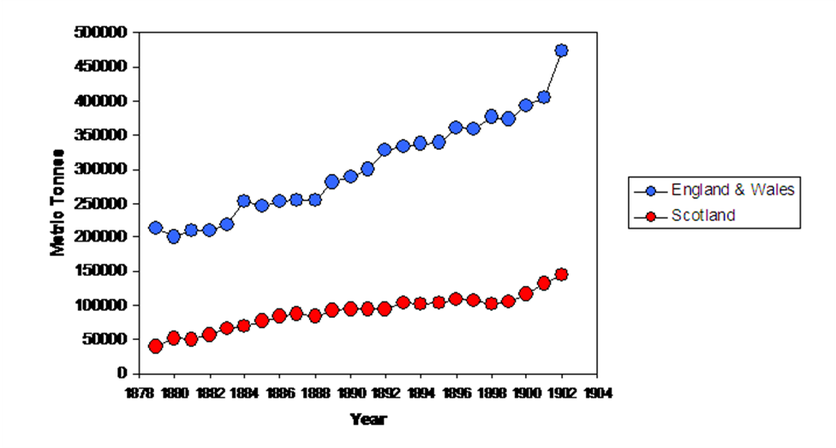

Figure 1: The quantity of fish (in metric tonnes) transported inland by railway in England, Wales and Scotland (1879-1902). Note that the tonnage of fin-fish transported in England and Wales in 1902 (473274 metric tonnes) was 3½ times that landed at English and Welsh ports in 2002 (128300 metric tonnes).

Primary Source Materials, continued

Objective (2): Dataset 56 provides an example of the type of material held in the CEFAS Library that will be deployed to meet this objective. It comprises unpublished data assembled by J.G. Pope and C.T. Macer to underpin their seminal article: ‘An evaluation of the stock structure of North Sea cod, haddock and whiting since 1920, together with a consideration of the impacts of fisheries and predation effects on their biomass and recruitment’, ICES Journal of Marine Science, 53 (1996),1157-1169.

Objective (3): To facilitate the construction of an ecosystem-wide ‘Ecopath’ model for 1880, Mackinson relied upon the international fisheries data for 1892-1902 published by Kyle (1905). However, as these only covered certain key species (plaice, sole, turbot, brill, herring, haddock, cod), data relating to mackerel, sprat, saithe, whiting, ling, tusk, halibut and skate were derived from Hoek and Kyle’s 1905 compilation of data from England, Scotland, Netherlands and Germany, supplemented by additional Scottish & English data. For the 1903-1972 period, broadly compatible data was published in ICES’s Bulletin Statistique, and for 1973 onwards fisheries catch data for all nations fishing in the North Sea (Denmark, UK, Norway, Netherlands, Germany, France, Belgium, Sweden), for all commercial species, is available in electronic form through ‘Fishstat’. Although comparative analysis of these data, using the Ecopath model and its derivatives ‘Ecosim’ and ‘Ecospace’ (see V. Christensen, C. Walters & D. Pauly, Ecopath with Ecosim: A User’s Guide (2000) is at an experimental stage, some tentative findings have been produced and are presented in outline form in the graphs below.

4. Metadata: Explanation of Data Fields

The entries below are outlined as per the field headings of HMAP Dataset 17. An explanation is offered for each field in general terms, and also in dataset specific terms.

ID
ID is the unique, consecutive serial numbers for the complete HMAP database.

InstitutionCode
InstitutionCode is the name given to the overall project of which this Dataset forms a part (HMAP).

CollectionCode
CollectionCode is the specific HMAP project Dataset reference code (used for OBIS referencing purposes).

DateLastModified
This is the date when the data were last modified.

CASE_STUDY
CASE_STUDY is the location identifying description of the Dataset. In this instance: North Sea Demersal Fish.

DATASET
DATASET is the HMAP project unique Dataset reference.

PERIOD
The Historical Period covered.

ID_NUMBERS
This field contains the range of record numbers shown in the ID field.

REFERENCE
REFERENCE refers to the source of records employed in the research.

publication_date
This is the date when the Dataset was published.

GENERAL_DESCRIPTION
This is a brief description of the Dataset

Citation
Citation is the field where the formal attribution is shown for users of the HMAP Datasets to cite; it credits the researchers and editors of a Dataset together with its database compilers. This citation must be quoted whenever records are referenced or employed for any purpose.

Please quote the relevant citation when using extracts or details from this Dataset:

- J. Pinnegar, ‘North Sea Demersal Fish’, in D.J. Starkey & J.H. Nicholls (comp.) HMAP Data Pages (www.hull.ac.uk/hmap)

BasisOfRecord
BasisOfRecord is the abbreviation applied that indicates whether the record is based on observations (O), living organisms (L), specimens (S), germplasm/seeds (G), photos (P), or from literature with original basis unknown (D); the HMAP value is generally 'O'.

OCEAN_REGION
This field indicates the specific Ocean Region where the Dataset research has been carried out. If this field shows 'None', then the research reflects activities carried out in non-seaward locations (e.g. in rivers, weir fishing, etc.). In this Dataset, the North Atlantic Ocean region was researched.

LME
This field indicates the name of the Ecosystem where the record event occurred. To find out more about LMEs (which are confined to continental shelf regions) browse the Large Marine Ecosystem site (http://www.edc.uri.edu/lme/) where LME GIS data may be downloaded. In this Dataset, the North Sea region was researched.

LME_NUMBER
This field indicates the number of the LME that is shown in the previous field. In this Dataset, the LME number is 22.

LATITUDE
The LATITUDE refers to a mean value of the species distribution from surveys and should be cross referenced with the LONGITUDE field for specific location determination.

LAT_PRECISION
This gives the actual precision of the calculated LATITUDE field. The available options are:
- Approx Approximate position
- Estimated Estimated position
- Exact Exact position
- Ground Centre Notional centre of the relevant fishing ground
- Unknown Position not known

LONGITUDE
The LONGITUDE refers to a mean value of the species distribution from surveys and should be cross referenced with the LATITUDE field for specific location determination.

LON_PRECISION
This gives the actual precision of the calculated LONGITUDE field. The available options are:
- Approx Approximate position
- Estimated Estimated position
- Exact Exact position
- Ground Centre Notional centre of the relevant fishing ground
- Unknown Position not known

ST_YEAR
This field refers to the start year of the beginning of the sampling.

EN_YEAR
This field refers to the end year of the end of the sampling. Unless the sampling spanned an extensive period, this value is usually the same as the ST_YEAR field entry.

ScientificName
This field indicates the scientific name of the species under investigation which is linked to the HMAP related FISH BASE database containing detailed information about the species that were sampled.

ObservedWeight
This field indicates the observed mass of the sample in Kilograms. Where this data is not available, a value of "unknown" is entered.

Catch_N
CATCH_N indicates the actual number of specimens sampled for a particular record. Where this data is not available, a value of "unknown" is entered.

NOTES

The NOTES field gives detailed information specific to a particular record. The details are provided to clarify specific entries and where further explanation is required than is generally provided in this METADATA file. For complete and academically verifiable explanations, refer to the published research materials that are indicated in the REFERENCE field.

CPUE
The CPUE field (Catch Per Unit Effort) is expressed as: CATCH_MT / EFFORT (number of fishing units employed).

RECRUITS
Actual number of fish recruited (recorded in millions of fish).

RECRUIT_AGE
Where known, the actual age (in years) of the recruited fish.

SSB
Spawning-Stock Biomass (recorded in thousand tonne units).

F_effort

Calibrated fishing effort based upon fishing mortality rates (F).

F1_AGES
Fishing mortality rates (F) fish age ranges, first group of comparison.

F1_VPA
Fishing mortality rates (F) based upon Virtual Population Analysis (VPA).

F2_AGES

Fishing mortality rates (F) fish age ranges, second group of comparison.

TOTAL_BIOMASS
Calculated total of biomass (recorded in thousand tonne units).

STOCK NUMBERS
Stock numbers calculated based upon VPA (recorded in millions of fish).

5. Outputs
John K Pinnegar, Trevor Hutton & Vicenzo Placenti, ‘What relative seafood prices can tell us about the status of stocks’, Fish and Fisheries, 2006, 7, 219-26.
John K Pinnegar & Georg H Engelhard, ‘The “shifting baseline” phenomenon: a global perspective’, Reviews in Fish Biology & Fisheries, (online 2007, doi: 10.1007/s11160-007-9058-6)

Enquiries regarding the information contained in this document and the accompanying dataset should be directed to David J Starkey (d.j.starkey@hull.ac.uk) or John H Nicholls (j.nicholls@hull.ac.uk).

