**“RETURN TO VEGAS”**

[A Treatment For A True Story That Never Happened]

What follows is a treatment for a site specific play with music entitled to “Return to Vegas”. The play is written to be performed in The Wellington Club in Kingston upon Hull.

**STAGING**

At any one time the action will take place in the body of the club as a whole [THE CLUB]; in, or around the bar [THE BAR]; inside and outside the main door [ENTRANCE]; on a stage at the bar end of the club [END STAGE]; on a small stage in the middle of the dance floor [CENTRE STAGE] and on the larger stage at the opposite end of the club to the bar, where the bands normally perform and where our band will set up [BAND STAGE].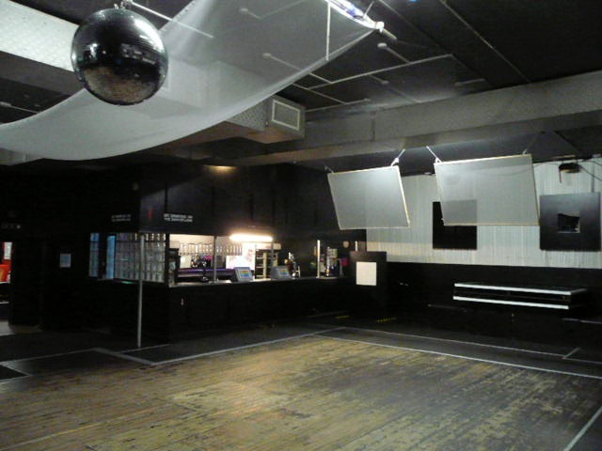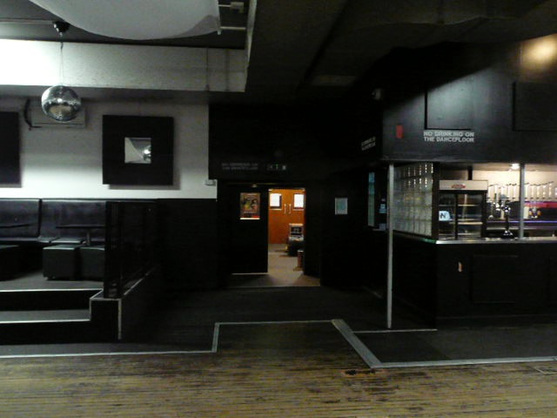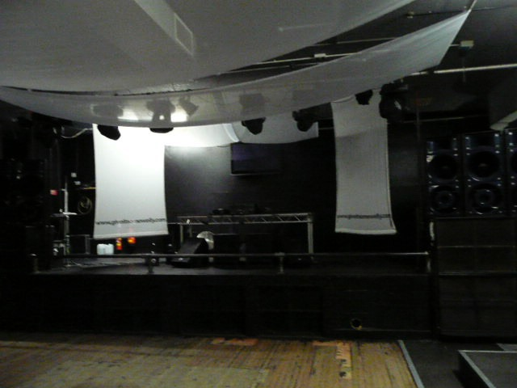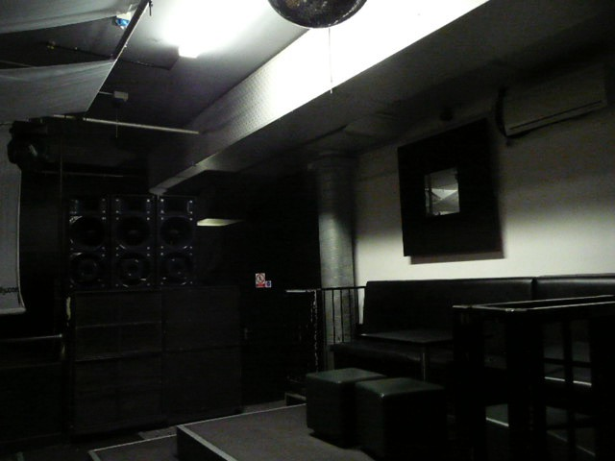

These specific stage areas will be delineated by lighting. It is envisaged that video cameras and screens strategically placed in the club should cover any sightline problems, as well as being used for Frank Wheeler’s videoed will. Frank appears on screen only, which creates the opportunity to cast a celebrity actor, Hull persona, or both (Terence Stamp? Tom Courtney?). In addition there should be a karaoke machine on the band stage to display the words to all the songs, especially those which will require the audience to join in.

Some of the audience is seated on the raised areas at the sides of the room and at tables at the bar end of the club next to the end stage. In front of the band stage is a dance floor where other audience members dance.

As this is a semi promenade production, two actors playing bouncers police the dancing audience, like “gatherers” at a medieval mystery play. They also play small parts when necessary. They are able to create passageways through the audience for the principals to move during the action and will be available to hand props and microphones to the cast as required.

The bar should remain open throughout the show and the audience allowed to move around as much as they want to, regulated by the bouncers, just as if it were a regular night at the club.

**THE STORY**

Johnny Holloway, a faded pop star, has been serving time for a drugs related crime, the exact nature of which we will find out during the action of the play. The story concerns his problems caused by an unexpected inheritance; his troubled relationship with an ex lover, Carol; and his eventual redemption and exoneration for a crime he did not commit.

**DRAMATIS PERSONAE**

JOHNNY HOLLOWAY

Faded pop star and one time amateur boxing prospect. He still carries a torch for his ex girlfriend, Carol. The play starts with his release from prison. It will be revealed during the action that Johnny has not been serving time simply for a drugs conviction, but for manslaughter. A young man, Michael McAllister, has died due to a reaction with whatever the drugs were cut with.

RICKY WHEELER

Son of the late gangster/business man Frank Wheeler. Frank’s only heir, he has been in charge of The Wellington Club and other enterprises since Frank's illness. He is not the man Frank was and, despite his bravado, appears out of his depth.

CAROL [A.K.A. ANGEL]

Johnny’s ex-girlfriend, now, [unknown to Johnny and the audience], in a relationship with Ricky Wheeler. She virtually runs The Wellington Club for Ricky. The relationship with Ricky has gone sour and she secretly moonlights as a stripper [Angel] in order to earn enough money to leave him and start a new life away from Hull.

EZRA

An ex army officer, dishonourably discharged due to his nefarious dealings while serving in Northern Ireland. He went on to be a soldier of fortune, and since his return to Hull he has been gradually filling the criminal void left by Frank's illness and eventual demise.

KAISHA

Ezra’s girlfriend and Ricky’s mistress. We will learn that she was also the girlfriend of the late Michael McAllister. She is a damaged soul, with a deep dislike for Johnny.

SEAN

Johnny's best friend. He has known Johnny since school and has shared his petty criminal past. He is a self-taught electronics wiz.

BOUNCER 1 (Crowd Control)

Doubles as BARRY, a shady solicitor, and a PRISON WARDER

BOUNCER 2 (Crowd Control)

Doubles as EZRA’S HENCHMAN and BARMAN AT THE RENO CLUB,

**UNIT BREAKDOWN**

**ACT 1**

**PROLOGUE**

The band set up on the BAND STAGE. Perhaps they play a couple of instrumental numbers. One of the band then introduces, as if it were a gig, tonight’s “main attraction” Johnny Holloway. Johnny enters, joins them and sings…

*NUMBER 1 ‘THE PRISONER’*

As he sings, Johnny changes from the prison overalls he is wearing into slightly old-fashioned civvies, held for him by a prison warder.

During an instrumental break in the song, Ricky and Kaisha are discovered on the CENTRE STAGE. Ricky is getting dressed and Kaisha is wrapped in a sheet. They have obviously just had sex. Sean arrives and informs Ricky that his father is dying in hospital.

The focus returns to Johnny on the BAND STAGE who continues to sing *‘The Prisoner”*

There is another instrumental break and Ricky joins Carol at Frank’s bedside on the END STAGE.

[N.B. we never see Frank, whose bed is judiciously placed behind a hospital screen].

We are given to understand that Frank has asked for his bible and wants to see Johnny to apologise for something (at this moment unspecific).

Once again the focus returns to Johnny singing on the BAND STAGE. He gradually moves to the CENTRE STAGE, where Sean is waiting for him and as the song finishes, they embrace. Sean has come to meet Johnny outside the prison gates.

———————————————————————————————————————————

**UNIT 1** [Frank’s Wake]

Johnny and Sean turn towards the BAND STAGE, where Ezra welcomes them to Frank’s wake at THE CLUB.

Ezra leads the tributes to Frank by telling an anecdote about Frank intervening when some Manchester gangsters tried to bus in some “mysteries” from Manchester. (See original film script)

We learn that the club was originally called “The Las Vegas”, but Ricky changed it to “The Wellington”, or ‘The Welly” as it is known, because of some unspecified scandal that occurred there some time ago.

Carol and Kaisha hand round finger food to the mourners [the audience] and in doing so Carol comes face to face with Johnny. He tries to make conversation with her, but she is very cool with her ex boyfriend.

Sean sings…

*NUMBER 2 “SHE’S NOT YOUR GIRLFRIEND ANYMORE”*

———————————————————————————————————————————

**UNIT 2**  [The Will]

The song finishes abruptly and lights snap on to the CENTRE STAGE. Barry, Ricky and Johnny step into the light.

Barry hands out copies of Franks will from his briefcase. Unconventionally he also plays the will on videotape. Frank was a good businessmen, but totally uneducated. In fact he was illiterate and recorded all his business dealings on cassette or video tape.

From the tape of Frank we learn that, to his surprise, Johnny has been the left half of the club.

Lights come up on THE CLUB and Ricky storms out the main doors, shouting abuse at the mourners [audience].

———————————————————————————————————————————

**UNIT 3** [The Security Camera]

Barry takes Johnny to join Sean at THE BAR in order to buy him a celebratory drink.

At the bar Kaisha refuses to serve Johnny and Carol is distinctly cool with him still.

Johnny decides to leave and is followed by Barry offering him a lift home, which Johnny refuses.

As Sean makes to follow Johnny, Carol pulls him to one side and asks him to set up an extra security camera in the cellar. She needs it to catch the person who is stealing stock.

Sean agrees to set it up and Carol thanks him by giving him a drink. She wishes him a Merry Christmas.

*SONG 3 “EVERYBODY KNOWS IT’S CHRISTMAS”*

———————————————————————————————————————————

**UNIT 4** [Memorabilia]

Sean joins Johnny on the CENTRE STAGE.

Sean has a box belonging to Johnny which he has stored for him while Johnny was doing time.

The box contains memorabilia of his singing career and a stash of £20 notes, saved in case of emergencies.

Amongst the memorabilia is an unopened bottle of champagne, bought to celebrate some important moment in Johnny's past.

Sean and Johnny go through the memorabilia and we realise just how big a star Johnny was before “that incident”.

Johnny sings…

*SONG 4 “I’M NOT THE MAN I USED TO BE”*

During the song Johnny moves to THE BAR of what has now become “The Reno Club”. He orders drinks from the barman, but is refused as his £20 notes are out of date and no longer valid currency.

He finishes the song, as Sean pays for the drinks.

———————————————————————————————————————————

**UNIT 5**  [The Reno Club]

There is a drum roll and from the BAND STAGE a member of the band introduces the stripper for the evening, Angel.

Angel is in fact Carol and she performs a striptease to an instrumental of…

*SONG 5 “OH CAROL”*

At the end of Carol’s act Sean spots the girl he is supposed to be meeting that night. Her name is Mel and he is excited about meeting her because she has the reputation of being a bit of a sexual athlete. He shows Johnny the knickers she left with him the last time they met. He leaves Johnny to return her knickers. [Mel is in fact a member of the audience picked at random by the actor playing Sean]

A now fully clothed Carol approaches the bar and bumps into Johnny.

They chat tentatively and we learn something of their previous relationship. However before the conversation can develop further, Johnny is inveigled by the band to join them on the stage and sing one of his old numbers.

Johnny sings…

*SONG 6 “AROUND THE WORLD”*

By the time the song finishes Johnny realises that Carol has vanished.

———————————————————————————————————————————

**UNIT 6** [A dodgy phone call]

The song finishes and lights isolate the END STAGE where Ezra, with his back to the audience, is discovered taking a phone call.

We hear him making arrangements for an illegal “drop” of some kind.

During the phone call, Ezra seems strangely agitated and it is only at the end of the call that we realise that Kaisha has been fellating him.

She has obviously overheard the arrangements for the “drop”.

———————————————————————————————————————————

**UNIT 7**  [The Offer]

At the ENTRANCE to The Wellington Club Johnny is refused admittance by Ricky.

Ricky offers Johnny £50,000 for his share of the club.

Johnny is insulted and refuses.

An irate Ricky storms off allowing Johnny access to the club.

———————————————————————————————————————————

**UNIT 8**  [The missing phone]

Johnny goes to the bar to order drinks.

Kaisha, who is working behind the bar, throws a drink in Johnny’s face.

“KAISHA: You should be doing life!

JOHNNY: We’re all doing life.”

Carol intervenes and Johnny takes the opportunity to ask Carol out.

Carol is reluctant to accept

Johnny sings...

SONG 7 "OH CAROL"

———————————————————————————————————————————

**UNIT 9**  [£10K]

CENTRE STAGE. Underscored by *“Oh Carol”,* Barry is on his mobile placing a bet with his bookie.

Johnny joins him.

Barry tells Johnny that he will need at least £10,000 to fight Ricky in court, in order to get his half of the club.

Barry explains to Johnny that, considering the situation he is in at present, he can't afford not to.

———————————————————————————————————————————

**UNIT 10** [Champagne]

Johnny has moved to the END STAGE, where he joins Carol.

He switches off a cassette machine and the underscore of *“Oh Carol”* stops abruptly.

Carol comments on the song as if they have been listening to it for some time and we have joined them half way through their evening together

Johnny is trying to get back with Carol. She however is trying to find the right time to tell him something important.

They look through the box of memorabilia and find the bottle of champagne. Johnny goes to chill it.

While he is away Carol sings...

SONG 8 "DO YOU REALLY WANT TO KNOW"

As the song finishes Carol's phone rings and she lies to the person on the other end about where she is. She leaves hurriedly.

Johnny returns with a mug and a glass to drink the champagne, but finds her gone. He is upset and picks up a guitar and starts to compose the song *“Crushed”.*

The electricity goes off. Johnny lights a Zippo lighter and, by it’s light, curses his luck.

———————————————————————————————————————————-

**UNIT 11**  [Crime Pays]

At THE BAR of The Wellington Club, Kaisha tells Carol that Johnny has inherited half the club.

Carol is hurt and annoyed that Johnny has not told her.

Kaisha reflects that in Johnny's case crime does pay. However Carol defends Johnny as he has done his time.

Kaisha loses her temper and we learn that Michael McAllister, the young man that died, was her boyfriend. She is angry with Carol for defending Johnny, because Michael was also Carol's brother.

It was partly as a reaction to her brothers death that Carol turned to the sympathetic Ricky for comfort. They married while Carol was still grieving.

Kaisha and Carol sing…

SONG 9 “WISH YOU WERE HERE”

With these revelations we close the act…

———————————————————————————————————————————-

**INTERVAL**

———————————————————————————————————————————-

**ACT 2**

**ENTREACTE**

To regain the audiences attention and to quieten them down for Act 2, the band play an instrumental reprise of "THE PRISONER"

——————————————————————————————————————————-

**UNIT 12**  [The Plot]

At the end of the number, Sean joins Johnny on the END STAGE. He has brought them takeaways.

Sean and Johnny discuss stealing Ricky’s 4x4 to raise the £10,000 needed to pay for Barry's services.

Sean is reluctant and has to be persuaded.

N. B. It is in this unit that Johnny finds out that Carol is now Ricky’s girl.

*SONG 10 “THIS BROKEN HEART” [Verse 1]*

*The music continues as an underscore under…*

———————————————————————————————————————————-

**UNIT 13** [CCTV]

At THE BAR, Carol checks the new security camera that Sean has set up in the cellar.

She inadvertently sees a recording of Ricky having sex with Kaisha in the cellar.

She also hears Kaisha telling Ricky about Ezra’s “drop” and their plan to intercept it.

Ricky enters needing ready cash from the till for an impromptu trip to London. [To sell the “gear” he has stolen from Ezra.]

Ricky checks the CCTV and notices that his 4x4 has been stolen. He exits to make sure that what he has seen on the CCTV is accurate.

N.B. Carol has seen who has stolen it.

Carol sings…

*“this broken heart” [verse 2]*

———————————————————————————————————————————

**UNIT 14**  [At the Docks]

CENTRE STAGE, Sean is emptying the (offstage) 4x4 of Rick’s personal effects.

Johnny stops him disposing of an attache case he has found in the vehicle. In the case they find the “gear” that Ezra had been expecting.

Johnny holds onto the case, while Sean goes off to deliver the 4x4 to the person who is to buy it from them for £10,000.

Johnny sings the opening bars and middle eight of of *“Oh Carol”*, which then segues into Carol on the BAND STAGE singing…

*SONG 11 “JOHNNY COME HOME”*

The musical sequence is concluded with Johnny singing the last few bars *“Oh Carol”*

———————————————————————————————————————————-

**UNIT 15** [Conned]

Sean returns to Johnny on the CENTRE STAGE with the money he has got from the sale of the 4x4.

They have been conned. When they examine the money they find it is coloured paper wrapped up in a few real bank notes.

Sean and Johnny go their separate ways to work out what to do next.

———————————————————————————————————————————-

**UNIT 16**  [Slapping the Slapper]

On the END STAGE, Ezra is slapping Kaisha around in an attempt to find out where his “gear” is. He knows that she could be the only one with the knowledge to betray him.

N.B. This is a violent mirror image of Unit 6.

One of the bouncers acts as Ezra’s henchmen and drags Kaisha offstage. Ezra follows lighting a blowtorch.

———————————————————————————————————————————-

**UNIT 17** [Carol’s Escape]

Carol enters THE BAR area. She carries two suitcases with her. She is leaving town and searches the tills for any loose cash to help her on her way.

Ricky enters and begs her not to leave to. He tells her that he loves her.

Carol sings...

*SONG12 "LOVE'S NOT ENOUGH"*

Ezra crashes in looking for his “gear”. He threatens Ricky, who Kaisha has admitted to being in league with.

Carol, having seen Johnny steal the 4x4 on the CCTV, promises to get the gear back for Ezra.

After some persuasion, Ezra leaves promising to return “team handed” if Carol doesn't get the gear back for him.

Using the threat of Ezra, Carol exhorts a deal from Ricky whereby she will get the gear back for him, in exchange for him giving Johnny his half of the club.

Ricky sings…

*SONG 13 “WHAT DO YOU MEAN?”*

———————————————————————————————————————————

**UNIT 18**  [The Snooker Hall]

On the CENTRE STAGE, Johnny and Sean are joined by Carol and Barry.

Carol offers Johnny Ricky’s half of the club in exchange for Ezra’s “gear”.

Johnny accepts the deal and hands over the attaché case in exchange for the deeds to the club.

Johnny wants Carol to stay and run the club with him.

Carol knows that this is more than a business arrangement and turns Johnny down. She believes that their relationship would never work.

A dejected Johnny gives Carol a cassette of the song that he has written for her *[“Crushed”]* as a farewell gift.

Carol leaves and Johnny tells Sean that, now she has gone, he will sell the club. First however he will have a “blowout” bash to celebrate the new year before he himself moves on.

COUNTDOWN TO THE NEW YEAR….. 5,4,3,2,1 (The Audience)

A net opens filling THE CLUB with Balloons. It is midnight.

———————————————————————————————————————————-

UNIT 19 [The New Years Party]

*SONG 14 “EVERYBODY KNOWS IT’S CHRISTMAS” Reprise*

Johnny is throwing his party in THE CLUB.

The bouncers and anyone else available give out party hats and blowers to the dancing audience.

Johnny shows Sean the old “Las Vegas” sign that he has found in the cellar.

Ricky arrives drunk and, like the saloon in an old western, the room goes quiet and the music stops.

Ricky confronts Johnny and over the club’s sound system plays him a tape.

On the tape we hear Frank and Ezra admit their guilt over the drugs and the death of Michael McAllister and discuss getting Johnny to take the blame.

Johnny has been betrayed but exonerated.

Kaisha enters singing a slow acoustic version of…

*SONG 15 “JOHNNY COME HOME” Reprise*

As the tempo quickens, Kaisha encourages the audience to join in.

Johnny is encouraged onto the BAND STAGE to finish the number.

——————————————————————————————————————————-

UNIT 20 [The Finale]

Underscored by *“Crushed”*, Carol enters THE CLUB and approaches the BAND STAGE.

Carol requests a song from Johnny and the band; the song that Johnny wrote for her.

Johnny and the band sing…

*SONG 16 “CRUSHED”*

N.B. At the end of the show, after any curtain call, the band should play a couple of instrumental dance tunes and then the evening should continue with a DJ, as if it were a normal club night.