**Northern Souls**

17:00 – 17:45 at Fruit

**Ra Page –** 0779 256 4747

 Founder of Manchester-based independent publisher Comma Press.

**Saba Ahmed -** 0777 825 0434

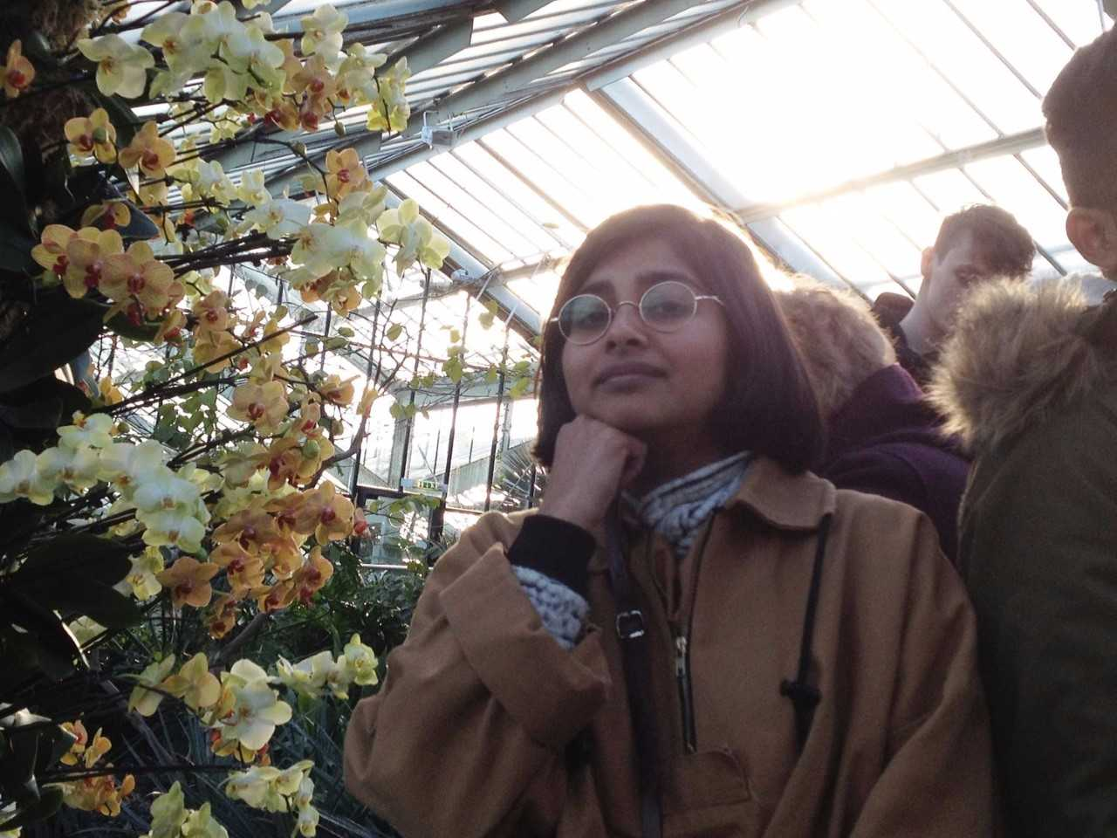 Associate Publisher at Tilted Axis & Editorial Production Manager at And Other Stories

**Jacob Ross -** 07730582777

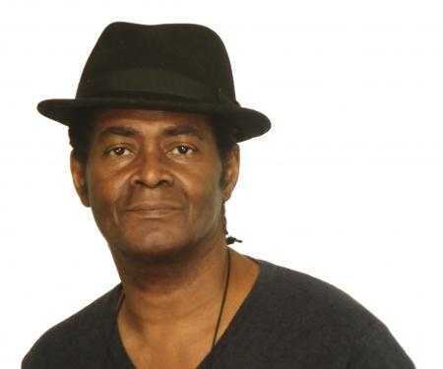Associate Fiction Editor at Peepal Tree Press.

**Jamie McGarry -** 01723332077

 Founder of Valley Press in 2008 as an English Literature undergraduate.