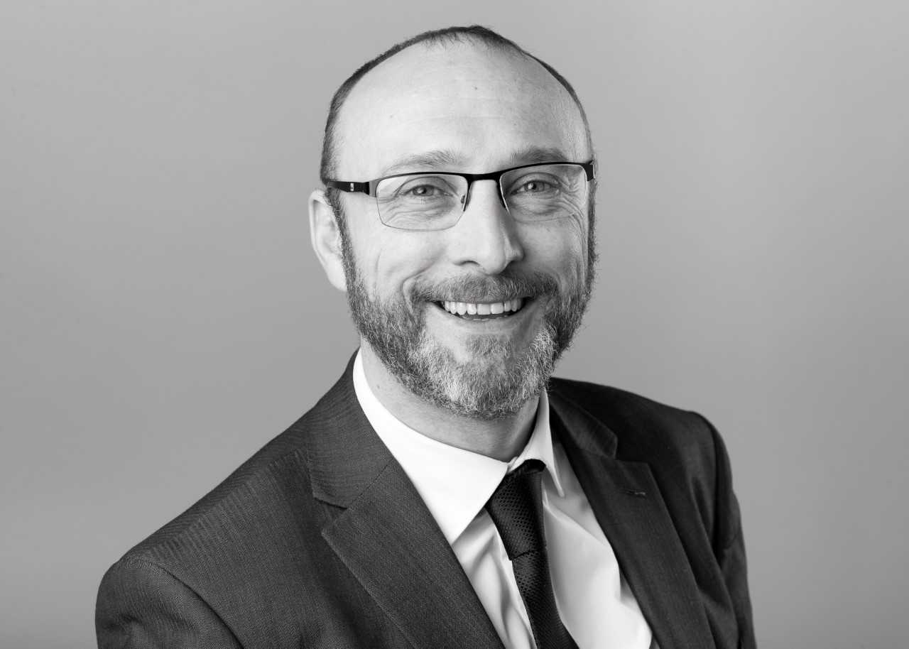

Anthony Yates joined Visit Hull and East Yorkshire (VHEY) in 2007 as the Visitor Economy Manger.

Prior to this he spent seven years at Marketing Birmingham developing and marketing the city’s leisure tourism offer and five years at the North West Tourist Board leading several region-wide marketing and development programmes.

Leading Hull’s Conference Bureau and Leisure Tourism teams, Anthony has overseen the continued growth of the city’s tourism economy in both the leisure and business tourism sectors.

Anthony was part of the Bid Team securing the UK City of Culture for Hull and now sits on the Hull 2017 Senior Leadership Team, City Council’s Place Management Group and National Tourism Funding Project Boards.