Appendix 10: Peer Assessment

  - Introduction
A number of professionals working in the culture sector were asked to contribute to the evaluation of Look Up as Peer Assessors. This was to ensure a third-party objective opinion from the sector, as well as to ensure that the three-tier evaluation of the event, using Arts Council England’s Quality Metrics, was realised.
    - The Peers
In total, eight Peer Assessors were identified to take part in two semi-structured depth interviews pre-visit and post-visit to a number of Look Up artworks. Due to resources and availability not all artworks were subject to Peer Assessment. Eight of the ten were assessed:
- City Speaks, Michael Pinsky (Fruit Market)
- The Train Track and The Basket, Claire Barber (Hull Paragon Interchange)
- Paper City by various artists (Humber Street)
- Bleached, Tania Kovats (C4DI and The Deep)
- This is a Freedom of Expression Centre, Bob & Roberta Smith (HSAD)
- Elephant in the Room, Claire Morgan (Princes Quay)
- A Hall for Hull, Pezo von Ellrichshausen and Felice Varini (Trinity Square)
- Floe, Heinrich and Palmer (The Deep).
Blade by Nayan Kulkarni (Queen Victoria Square) and Washed Up Car-Go by Chris Dobrowolski (The Deep) were not included.
The Peer Assessors were:
- Donna Loveday: a design curator, writer and educator. Donna has contributed to the developing discipline of design curating practice through her critically acclaimed exhibitions and teaching on the Masters programme, Curating Contemporary Design at Kingston University in partnership with the Design Museum, London. Formerly Head of Curatorial at the Design Museum, Donna has over twenty years’ experience curating exhibitions and creative programmes for museums and cultural organisations.
- David Gilbert: a curator, producer, project manger and educator. David has developed and delivered exhibitions, programmes and projects in the visual arts, working for organisations and freelance in galleries, in public spaces, in a site-responsive manner and within heritage sites and festivals.
- Samantha Lackey: Acting Head of Collections and Exhibitions and Senior Curator at the Whitworth in Manchester and former curator at The Hepworth Wakefield. Samantha was a Senior Research Fellow in the Centre for Studies in Surrealism and its Legacies before moving into curating. She has published on surrealist film, theories of attention in film and the role of the body in moving image work.
- Helen Pheby: Helen is a highly experienced curator, project manager, fundraiser and team leader who has dedicated over two decades of research and practice to the study and mediation of art in relation to life. She has built an extensive portfolio of international projects within and beyond the institution; served on the Arts Council Collection Acquisition Committee (2016-17); and is a Curatorial Advisor to Art Role, Kurdistan-Iraq.
- Catherine Ince: Catherine is a Senior Curator at the Victoria and Albert Museum where she is developing the curatorial programme of V&A East. Until 2015 Catherine was a Curator at the Barbican Centre specialising in twentieth century and contemporary design and architecture. Prior to joining the Barbican, Catherine was Curator, and subsequently Co-Director, of the British Council’s Architecture, Design and Fashion department where she organised international touring exhibitions and collaborative projects about contemporary design and architecture, and commissioned the British Pavilion at the Venice Biennale of Architecture. Catherine is currently an international juror for the Swiss Design Prize and is a member of the advisory board for the Stanley Picker Gallery and Dorich House Museum at Kingston University.
- Nicola Stephenson: Nicola is a creative producer and curator for projects with a range of artists of national and international profile. She has selected and produced both large scale and intimate projects that work to animate public places that include opera houses, museum spaces, railways, hospitals, public transport, waterways, historic houses and parks.
- Chelsey Everatt: Chelsey is Arts Development Officer at North Lincolnshire Council. Previously, she was an Artistic & Quality Assessor at the Arts Council. In addition, she was a Community Development Worker at the Linkage Community Trust and a Project Worker on the Lincolnshire One Venues Young People’s Programme. Chelsey has a range of experience in delivering and managing arts and cultural projects, with particular focus on engagement and participation.
- Davy McGuire: Davy is half of Davy and Kristin McGuire, an award winning creative studio that design unique visual experiences through art installations and theatrical projects. As well as creating bespoke projects for cultural institutions and brands, they produce and sell their own works through international galleries. Their hybrid art works are delicate, filigree fantasies built with fragile materials that are momentarily brought to life through digital projections and silent storytelling.
All Peer Assessors were sent links to the publicity material and press coverage about Look Up and the individual artworks they were visiting to assess, to give them a sense of what Look Up and the artwork was about, and a basis on which to set their expectations.
The templates for the interviews are provided in Appendices 11 and 12:
- Peer Assessors Discussion Template (Pre-Event): carried out as telephone interview before they visited the artwork(s); and
- Peer Assessors Discussion Template (Post-Event): carried out as telephone interview after they visited the artwork(s).
The focus of the Peer Assessments was as follows:
- Awareness and / or knowledge of the commissioned artists: to determine whether expectations were based on any first hand experiences of the artists.
- Arts Council Quality Metrics: rating of all Arts Council England Quality Metrics and reasons for these answers, both in terms of expectation pre-event and reactions post-event.
- Creative Case for Diversity: perceptions of how diversity would be represented or explored within the commissions from the publicity materials and information shared; and how, in reality, they felt diversity was represented or explored within the commissions.
- Perceptions of Hull: shifts in the perceptions of Hull amongst peer assessors, as a result of attending Look Up.
  - Arts Council Quality Metrics
    - Overall Rating
As shown in Table 1, on average, peer assessors rated Look Up highly across most of the quality metrics. However, prior to visiting any Look Up artworks their scores were significantly more diverse than after visiting:
- Prior to the event the average score for metrics ranged from 5.8 out of 10 to 8.6 out of 10 (a difference of 2.8).
- After the event the average score for metrics ranged from 7.2 out of 10 to 8.4 out of 10 (a difference of 1.2).
Prior to visiting Look Up the five top scoring metrics were:
- Presentation: It will be produced and presented
- Relevance: It has something to say about the world in which we live
- Concept: It is an interesting idea
- Rigour: It will be well thought through and put together
- Local impact: It is important that it's happening here (in Hull).
Originality: It is ground-breaking; Distinctiveness: It is different from things I’ve experienced before; and Challenge: It is thought provoking were the lowest average scoring metrics prior to visiting Look Up.
After visiting Look Up the five top scoring metrics were:
- Concept: It is an interesting idea
- Local impact: It is important that it's happening here (in Hull)
- Relevance: It has something to say about the world in which we live
- Captivation: It will be absorbing and will hold my attention
- Risk: The artists are really challenging themselves with this work.

Originality: It is ground-breaking; and Distinctiveness: It is different from things I’ve experienced before were the lowest average scoring metrics after visiting Look Up.
Three quarters of the quality metrics received a greater average score from peer assessors after visiting Look Up:
- Originality: It will be ground-breaking
- Challenge: It is thought-provoking
- Distinctiveness: It is different from things I’ve experienced before
- Risk: The artists are really challenging themselves with this work
- Enthusiasm: I will come to something like this again
- Concept: It is an interesting idea
- Local impact: It is important that it's happening here (in Hull)
- Excellence: It is one of the best examples of its type
- Captivation: It will be absorbing and will hold my attention.
Two of the twelve metrics received a marginally lower average score from peer assessors after visiting Look Up:
- Presentation: It is well produced and presented
- Rigour: It is well thought through and put together.
The remaining metric - Relevance: It has something to say about the world in which we live - received the same average score from peer assessors before and after visiting Look Up.
Overall, the average rating across all twelve quality metrics increased from an average of 7.3 to 7.7 (a difference of 0.4).
Peer assessors were also asked to provide a summary of their reasoning for each score, both prior to visiting and after visiting Look Up. Reasons are presented alongside each individual artwork in Sections 1.2.2 to 1.2.9.
Table 1: Arts Council England Quality Metrics – All Look Up Artworks Combined
ACE Quality Metrics: All Look Up Artworks Combined | Pre-Event  (n=20) | Post-Event  (n=19) | Change in score from Pre to Post Event
Concept: It will be / is an interesting idea | 7.9 | 8.4 | +0.5
Presentation: It will be / is well produced and presented | 8.6 | 7.4 | -1.2
Distinctiveness: It will be / is different from things I’ve experienced before | 6.4 | 7.3 | +0.9
Challenge: It will be / is thought-provoking | 6.6 | 7.5 | +0.9
Captivation: It will be / is absorbing and will hold my attention | 7.6 | 7.7 | +0.1
Enthusiasm: I will / would come to something like this again | 6.9 | 7.5 | +0.6
Local impact: It is / is important that it's happening here (in Hull) | 7.8 | 8.3 | +0.5
Relevance: It will have/has something to say about the world in which we live | 8.1 | 8.1 | 0.0
Originality: It will be / is ground-breaking | 5.8 | 7.2 | +1.4
Risk: The artists are really challenging/challenged themselves with this work | 6.9 | 7.7 | +0.8
Excellence: It will be / is one of the best examples of its type | 7.4 | 7.6 | +0.2
Rigour: It will be / is well thought through and put together | 7.8 | 7.4 | -0.4
TOTAL AVERAGE | 7.3 | 7.7 | +0.4

Figure 1: Arts Council England Quality Metrics – All Look Up Artworks Combined
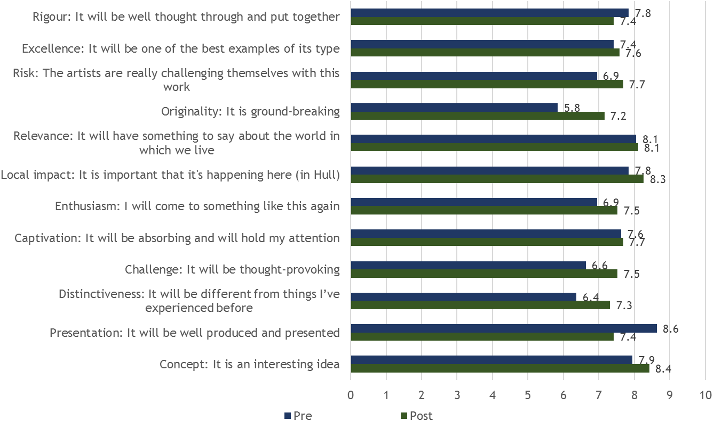
    - City Speaks
Prior to visiting City Speaks, peer assessors were asked if they had seen previous work by the artist; had previous knowledge of the artist but had not seen any of their work; or if they had neither seen work by nor had previous knowledge of the artist. One peer assessor had previously seen work by Michael Pinsky, whilst the remaining two had not seen his work before and had no knowledge of him. The peer assessor who had seen previous work by Michael Pinsky was asked to share their thoughts on his work, to see what preconception might be held towards the artist and his work prior to the visit.
‘I have commissioned Michael Pinksy many years ago … He produces strong work and always works in a site-specific way and responds to site and situation more broadly, which is always more interesting I think and generates interesting narratives too. It is the kind of work that people feel confident to talk about in their own language.’
(Peer Assessor)
As shown in Table 2, on average, peer assessors rated City Speaks highly across most of the quality metrics. Both prior and after visiting City Speaks their scores were mixed, especially in terms of certain quality metrics:
- Prior to visiting City Speaks the average score for metrics ranged from 5.7 out of 10 to 8.7 out of 10 (a difference of 3.0).
- After visiting City Speaks the average score for metrics ranged from 5.0 out of 10 to 9.0 out of 10 (a difference of 4.0).
Prior to visiting City Speaks the five top scoring metrics were:
- Presentation: It will be produced and presented
- Local impact: It is important that it's happening here (in Hull)
- Relevance: It has something to say about the world in which we live
- Concept: It is an interesting idea
- Rigour: It will be well thought through and put together.
Originality: It is ground-breaking Distinctiveness: It is different from things I’ve experienced before; and Risk: The artists are really challenging themselves with this work were the lowest average scoring metrics before visiting City Speaks.
After visiting City Speaks the five top scoring metrics were:
- Concept: It is an interesting idea
- Local impact: It is important that it's happening here (in Hull)
- Relevance: It has something to say about the world in which we live
- Risk: The artists are really challenging themselves with this work
- Enthusiasm: I would come to something like this again.
Presentation: It is well produced and presented and Challenge: It is thought-provoking were the lowest average scoring metrics after visiting City Speaks.
Half of the quality metrics received a greater average score from peer assessors after visiting City Speaks:
- Risk: The artists are really challenging themselves with this work
- Originality: It will be ground-breaking
- Concept: It is an interesting idea
- Distinctiveness: It is different from things I’ve experienced before
- Enthusiasm: I will come to something like this again
- Excellence: It is one of the best examples of its type.
Three of the twelve metrics received a lower average score from peer assessors after visiting City Speaks:
- Presentation: It is well produced and presented
- Challenge: It is thought-provoking
- Rigour: It is well thought through and put together.
The remaining metrics – Captivation: It is absorbing and held my attention; Local impact: It is important that it’s happening here (in Hull); and Relevance: It has something to say about the world in which we live - received the same average score from peer assessors before and after visiting City Speaks.
Overall, the average rating across all twelve quality metrics increased from an average of 7.1 to 7.3 (a difference of 0.2).
In providing reasons for their scores, both prior to and after visiting City Speaks, peer assessors gave the following responses.
Concept
Both prior to and after visiting the artwork, peer assessors commented on the concept’s strengths in terms of the very public nature of the work; its scale and visibility; and its context within the City of Culture year.
‘Not having visited Hull previously I am expecting that to be interesting in terms of from the information about Hull and its location.’
(Peer Assessor)
‘It offers a very public space for people to interact with and the context of the work is really important.’
(Peer Assessor)
‘There was an element of risk to it which was strong aspect of the work and it had an unmediated voice and it was an enormous scale. So I found that impressive and appealing. A strong concept all round.’
(Peer Assessor)

Prior to visiting one peer assessor also spoke of the participatory nature of it being a strength, whilst after visiting another peer assessor celebrated the fact that it enabled people to send a message directly to the city.
‘It is participatory … it is cumulative so it is going to grow over time.’
(Peer Assessor)
‘It was an opportunity for people to send a message to the city which I thought was a really lovely idea, and it was so incredibly visible in terms of where it was.’
(Peer Assessor)
Presentation
Prior visiting the artwork, peer assessors had high hopes for the presentation of the work, based on what they had heard about the quality of presentation across the Hull 2017 programme, and from images seen of the work online.
‘I have high expectations of that.’
(Peer Assessor)
‘Presenting in Hull it will be pretty brilliant because now is the moment … That is what I have heard from colleagues that the work is good.’
(Peer Assessor)
‘It looks great what I can see from the images on the web.’
(Peer Assessor)
After visiting City Speaks all peer assessors commented on the fact that finding the lectern had been a challenge. They had all begun at the tidal barrier, read the interpretation board, but found it extremely difficult to locate the lectern. For one peer assessor the message they spoke into the lecterns was also not relayed.
‘You could read the text very easily. The only thing I would say is, the point at which you send your message, which was close to the Humber Street Gallery, I didn’t realise that's where it was, I had to ask someone. I didn't quite understand how you sent your message, so I thought it perhaps would have benefited from a little more interpretation.’
(Peer Assessor)
‘I’m going to have to judge it from the documentation as it wasn't actually working … I walked to the barrier and saw the information board around the barrier and there was no indication where the lectern was other than by the dock. So I guess if I was looking at the interpretation I would have suggested that there should have been some directional indication … When I reached the lectern there was no interpretation and to me it wasn't necessarily apparent that the public was invited to take part in it … It was produced to a very high quality but the interpretation made it slightly inaccessible.’
(Peer Assessor)
Distinctiveness
Both prior visiting the artwork, peer assessors had mixed opinions about how distinctive the artwork would be. One peer assessor was very expectant that it would be different to things they had seen before, whilst another felt they had seen similar types of work before, though not to quite the same scale.
‘Haven't encountered anything like it before, innovative.’
(Peer Assessor)
‘I’ve seen a lot of similar text based display, so it is not a new idea, although it is on a greater scale than things I have seen previously.’
(Peer Assessor)
‘It wasn't utterly different to work that I had seen before but never the less it was very distinctive.’
(Peer Assessor)
Challenge
Prior to visiting the artwork, peer assessors found it hard to judge whether it would be thought provoking from the information they had seen. One peer assessor did state that being participatory in nature meant that it had to be thought provoking to some level.
‘I suppose unless there is editing in terms of content then you can say anything you like and it is entirely shaped by what people want to say and that in itself is very challenging.’
(Peer Assessor)
After visiting the City Speaks, two peer assessors felt unable to comment on the as the artwork was not working at the time. The other peer assessor found it thought provoking because of the concept.
‘It was designed to be thought provoking. I'm very familiar with the concept of speakers corner, which I know influenced the concept, and I thought it was a really lovely contemporary interpretation of that.’
(Peer Assessor)
‘Very hard to judge on the basis that it wasn't working when I was there. I am not sure if I can comment on it, but it has the potential to be thought provoking.’
(Peer Assessor)
Captivation
Prior to visiting the artwork, peer assessors found it hard to judge how captivating the artwork would, as they felt it depended on whether and how people chose to interact with it.
‘I suspect it will although I suspect it is a piece of work that requires interaction … This work raises questions about what happens when people aren't interacting with it and also unexpected interaction and people doing things that you didn't expect them to do.’
(Peer Assessor)
After visiting the City Speaks, two peers found it difficult to rate captivation – one because it was not working and the other because it could not be seen on a bright day. The other peer found it captivating because of the anticipation of what would come up, as well as queuing to have their turn.
‘I was reading and waiting for the messages to come up and actively wanting to engage with it.’
(Peer Assessor)
‘I think it would be very captivating but with the proviso that it would have to be functioning.’
(Peer Assessor)
Enthusiasm
Prior to visiting the artwork, peer assessors found it hard to judge whether they would visit again as there was not felt to be sufficient information to know one way or the other. One peer assessor was positive in regard to this metric because of being a follower of the artists work.
‘I have been to see his work in other places so he is an artist whose work I would travel to see.’
(Peer Assessor)
After visiting again the failure for it to work or be seen negatively impacted on scores by two assessors.
Local impact
Both prior to and after visiting City Speaks, peer assessors all felt that the local impact was intrinsically linked to the site specific nature of the work, and the fact that it was in the public realm, displaying messages from the people of Hull.
‘It is important that this work is happening in Hull and it is important that it is in the public realm and is accessible and front facing and is part of the visual arts offer.’
(Peer Assessor)
‘It the kind of work that could happen in other places and people might respond to it differently, but because it is participatory and the content is generated locally it is intrinsically reflecting Hull back out to Hull.’
(Peer Assessor)
After visiting one peer assessor also made reference to how the tidal barrier structure itself had been transformed into an artwork.
‘It is exclusively specific to its space. It was a specific piece and the tidal barrier was an interesting 'sculpture'.
(Peer Assessor)
Relevance
Prior to visiting City Speaks, peer assessors all felt that the way the artwork immediately displayed what was being said by members of the public, meant that it was of relevance to the world today as it effectively became a conduit for sharing people’s thoughts and reflections.
‘Because it is expressing immediately people's response and however it manifests itself it will express what is happening in the world at the moment.’
(Peer Assessor)
‘Speaking back it is an 'echo-chamber' I suppose. People's voices are going to be visually represented and speak back to their peers.’
(Peer Assessor)
After visiting two peer assessors reflected on the fact that it had relevance may depend on what time you happened to see it, i.e. had someone recently said something thoughtful into the lectern, or just something trivial.
‘Definitely, people having the opportunity to say what they thought about Hull and what was going on, and other more important political, global issues.’
(Peer Assessor)
‘I don't know without knowing what sort of statements were being displayed … It seemed like what was being displayed was trivial and every thing in between, so it is difficult to say. Certainly it has the potential to be powerful in that respect.’
(Peer Assessor)
Originality
Both prior to and after visiting City Speaks, two peer assessors did not see the artwork as particularly ground breaking, as they had both seen similar works recently. However, one did state the size of the piece and the fact it was outdoors lent it some originality over similar work experienced.
‘Because of the familiarity of the work and work I have experienced previously.’
(Peer Assessor)
‘Scrolling text in itself is not original in itself. I have seen other artists using this form, so there isn't a huge degree of originality to it.’
(Peer Assessor)

Risk
Both prior to and after visiting City Speaks, one peer assessor referenced risk in regard to the fact that the content (messages) were to be created by the public inherently had a degree of risk – both in terms of whether they would engage and how they might engage. The scale of the display was also commented on prior to visiting.
‘I think in terms of scale and allowing the public to create the content ot the work there is a high degree of risk there.’
(Peer Assessor)
‘It was quite challenging but I am not sure what the response was of the public.’
(Peer Assessor)
‘It does leave it open to the possibility of kind of unintended consequences which is a brave thing to do in terms of practice.’
(Peer Assessor)
Excellence
Prior to visiting the artwork, peer assessors found it hard to judge whether it would be one of the best examples of its type, though one felt it would be interesting at nigh time.
‘It will animate public space as an interesting feature after-dark.’
(Peer Assessor)
After visiting City Speaks, its lack of functionality was an issue.
‘Again because I couldn't see it working.’
(Peer Assessor)
Rigour
Prior to visiting the artwork, one peer assessor’s positivity in regard to this metric was based on their previous experience of the artist’s work.
‘From my knowledge of the artist certainly - it will be well executed and technically it will be strong.’
(Peer Assessor)
After visiting City Speaks, peer assessors spoke of the strength of the location and use of the tower. However, the interpretation was felt to have let it down in regard to this metric.
‘The connection of the lectern to the barriers was a fantastic line of sight -straight down past the Humber Street Gallery and all the action in terms of visual arts. So absolutely it was rigorously thought through in that respect, but as I said the information of how it should be interacted with was lacking.’
Table 2: Arts Council England Quality Metrics – City Speaks
ACE Quality Metrics: City Speaks | Pre-Event  (n=3) | Post-Event  (n=3) | Change in score from Pre to Post Event
Concept: It will be / is an interesting idea | 7.7 | 9.0 | +1.3
Presentation: It will be / is well produced and presented | 8.7 | 5.0 | -3.7
Distinctiveness: It will be / is different from things I’ve experienced before | 5.7 | 7.0 | +1.3
Challenge: It will be / is thought-provoking | 6.7 | 6.0 | -0.7
Captivation: It will be / is absorbing and will hold my attention | 6.7 | 6.7 | 0.0
Enthusiasm: I will / would come to something like this again | 7.0 | 7.7 | +0.7
Local impact: It is / is important that it's happening here (in Hull) | 8.7 | 8.7 | 0.0
Relevance: It will have/has something to say about the world in which we live | 8.0 | 8.0 | 0.0
Originality: It will be / is ground-breaking | 5.7 | 7.3 | +1.6
Risk: The artists are really challenging/challenged themselves with this work | 6.0 | 7.7 | +1.7
Excellence: It will be / is one of the best examples of its type | 7.0 | 7.3 | +0.3
Rigour: It will be / is well thought through and put together | 7.3 | 6.7 | -0.6
TOTAL AVERAGE | 7.1 | 7.3 | +0.2

    - The Train Track and The Basket
Prior to visiting The Train Track and The Basket, peer assessors were asked if they had seen previous work by the artist; had previous knowledge of the artist but had not seen any of their work; or if they had neither seen work by nor had previous knowledge of the artist. One had previous knowledge of Claire Barber, whilst the remaining two had not seen her work before and had no knowledge of her.
As shown in Table 3, on average, peer assessors gave The Train Track and The Basket a medium rating across most of the quality metrics. Both prior and after visiting The Train Track and The Basket their scores were mixed, especially in terms of certain quality metrics:
- Prior to visiting The Train Track and The Basket the average score for metrics ranged from 5.0 out of 10 to 8.7 out of 10 (a difference of 3.7).
- After visiting The Train Track and The Basket the average score for metrics ranged from 5.3 out of 10 to 9.0 out of 10 (a difference of 3.7).
Prior to visiting The Train Track and The Basket the five top scoring metrics were:
- Relevance: It has something to say about the world in which we live
- Presentation: It will be produced and presented
- Concept: It is an interesting idea
- Captivation: It is absorbing and held my attention
- Rigour: It will be well thought through and put together.
Enthusiasm: I will come to something like this again; Originality: It is ground-breaking; Distinctiveness: It is different from things I’ve experienced before; and Risk: The artists are really challenging themselves with this work were the lowest average scoring metrics before visiting The Train Track and The Basket.
After visiting The Train Track and The Basket the four top scoring metrics were:
- Local impact: It is important that it's happening here (in Hull)
- Relevance: It has something to say about the world in which we live
- Concept: It is an interesting idea
- Rigour: It will be well thought through and put together.
Distinctiveness: It is different from things I’ve experienced before and Captivation: It is absorbing and held my attention were the lowest average scoring metrics after to visiting The Train Track and The Basket.
Seven of the twelve quality metrics received a greater average score from peer assessors after visiting The Train Track and The Basket:
- Challenge: It is thought-provoking
- Local impact: It is important that it's happening here (in Hull)
- Risk: The artists are really challenging themselves with this work
- Enthusiasm: I will come to something like this again
- Originality: It will be ground-breaking
- Excellence: It is one of the best examples of its type
- Rigour: It is well thought through and put together.
Four of the twelve metrics received a lower average score from peer assessors after visiting The Train Track and The Basket:
- Presentation: It is well produced and presented
- Captivation: It is absorbing and held my attention
- Relevance: It has something to say about the world in which we live
- Distinctiveness: It is different from things I’ve experienced before.
The remaining metric - Concept: It is an interesting idea - received the same average score from peer assessors before and after visiting The Train Track and The Basket.
Overall, the average rating across all twelve quality metrics increased from an average of 6.5 to 6.9 (a difference of 0.4).
In providing reasons for their scores, both prior to and after visiting The Train Track and The Basket, peer assessors gave the following responses.
Concept
Prior to visiting the artwork, peer assessors commented on the concept’s strengths in terms of the choice of location and its relevance to the movement of people.
‘It is an interesting idea and has an interesting point of transition of space and powerful aspect of the movement of people and is very timely and is conceptually strong.’
(Peer Assessor)
‘I am always interested in people's travel experiences … I am particularly interested in that area and nomadism.’
(Peer Assessor)
After visiting, the location was again commented upon. One peer assessor found the incorporation of textiles interesting. However, it was commented on that it was not immediately obvious where it was.
‘It was an interesting idea in terms of the use of textiles in the images and in the use of the space.’
(Peer Assessor)
‘When I got to the station I missed it the first time around, it was only when I was leaving I encountered it, I had to ask someone where it was.’
(Peer Assessor)

Presentation
Prior visiting the artwork, one peer assessor focused on how the location of the artwork may have an influence on how bold the work could be; whilst another reflected on the detail within the promotional imagery.
‘I suspect it might have to be tempered to the … and it may have to compromise or it might work brilliantly.’
(Peer Assessor)
‘It look s that way from the image and looks technically well executed.’
(Peer Assessor)
After visiting peer assessors questioned the location and one commented that they felt it lacked coherence.
‘It was well presented and particularly as there are limitations to this type of project in that there are people passing through this public space.’
(Peer Assessor)
‘It was well produced but I kind of felt that it was a bit of a disparate piece of work and lacked a bit of coherence …There were some large sections to it which were quite coherent, I actually liked some of the detail of it … but the diagrams were a relatively small element or area so it is real very hard to say, as they were a little bit incoherent and disparate.’
(Peer Assessor)
Distinctiveness
Both prior to and after visiting the artwork, peer assessors did not feel that the artwork was particularly different from work they had seen before, in that sort of space. Again comments were also made about how easily lost or missed it was within the setting.
‘I am not sure it will be … It is quite hard to tell from the image but it doesn't look untypical of the intervention you might make in this type of space.’
(Peer Assessor)
‘I know it was closely connected to this idea of travel, obviously the location at the station was right, but where it was on the windows, I thought it got a bit lost.’
(Peer Assessor)
‘I wouldn't say it was an utterly different experience from what I have experienced before, and from certain perspectives it is similar to work I have seen before. Part of that was the environment that it is in and how you distinguish from, for example, from work in glass to other artwork. Liked the work but struggled to be seen in the environment it was in.’
(Peer Assessor)

Challenge
Both prior to and after visiting the artwork, peer assessors felt that it would be a though provoking piece, because of the theme being explored – transmigration. However, questions were raised about how strongly this theme came through within the artwork itself.
‘It will be thought provoking and definitely with the areas that are being looked at. I am quite interested to know why the areas of Mongolia and Iceland have been selected).’
(Peer Assessor)
‘I think in terms of the narrative related to the work. It is to what extent the narrative is apparent to the viewer. It has the potential to be challenging but it might be ambient in the way that people experience it and pass through without noticing it.’
(Peer Assessor)
‘I think it was thought-provoking but the combination of the train track and the basket was not entirely apparent in the content of the work.’
(Peer Assessor)
Captivation
Prior to visiting The Train Track and The Basket, peer assessors spoke of how they expected it to be an aesthetically pleasing artwork in itself, as well as how it would respond to the light.
‘I suspect that it will be very seductive visually.’
(Peer Assessor)
‘It is fairly high up and has an interesting effect with the light passing through it depending on the time of the day and castes shadows onto the interior of the station.’
(Peer Assessor)
After visiting two peer assessors had engaged for quite long periods of time with the piece. However, on peer assessor felt that it’s location did not lend itself well to attracting or holding the attention.
‘I spent some time looking at it and looked at it again when I went back to the station, and did spend some time looking at certain elements of it. For example, large panels when you come out of the station, which I looked at quite closely and I looked at outside of the building as well. So it was quite captivating because I chose to spend some time looking at it … I am not sure it had high impact in terms of other people looking at the work.’
(Peer Assessor)
Enthusiasm
Both prior to and after visiting the artwork, all peer assessors felt this was the type of work they would see again. Only one provided further detail and qualification of the reason why.
‘I think I would. It has exceeded my expectations. I thought from the images I have seen that it was higher up than it was and it benefitted from being at the level it was. From eye-level it worked well.’
(Peer Assessor)
Local impact
Both prior to and after visiting the artwork, only one peer assessor spoke of the Hull specific content of the piece, whilst recognising it had wider relevance. Other peer assessors reflected on the suitability of the station as a location, but were less clear on how it specifically related to Hull
‘In terms of content it is working with the material that is specific to Hull but has a universal significance as well. So yes it is clearly a Hull based piece of work.’
(Peer Assessor)
‘I’m not familiar with the station and how it might have impacted.’
(Peer Assessor)
Relevance
Prior to visiting The Train Track and The Basket, all peer assessors saw the artwork as having great relevance, both to the past and present in terms of travel and immigration.
‘Oh definitely and the way we live, the way we travel and why we travel.’
(Peer Assessor)
‘Yes it does, dramatically. It is picking up on current issues around migration and transmigration.’
(Peer Assessor)
‘It did have something to say about the past but also it is connected to the present.’
(Peer Assessor)
After visiting these thoughts were confirmed, though one peer assessor only spoke of its relevance in an historical context.
‘Perhaps in terms of the world in which we lived (past tense) in an historic sense.’
(Peer Assessor)
Originality
Both prior to and after visiting the artwork, peer assessors did not feel the work was groundbreaking, as it was not significantly different from other work of a similar nature. However, some mentioned the interesting idea behind it and some of the approaches used as having some degree of originality.
‘It is relatively representative of that type of work.’
(Peer Assessor)
‘Relatively traditional, with an historic narrative, but the execution of it was little incoherent. In one sense I liked the fact that there was a variance in scale with some things scaled up, but the actual stitches scaled down.’
(Peer Assessor)
Risk
Both prior to and after visiting the artwork, peer assessors did feel the artist challenged herself because of the nature of the space they chose to work in.
‘I have the impression that they did - because in terms of the space there was a lot of visual interference going on.’
(Peer Assessor)
Excellence
Prior to visiting the artwork, peer assessors found it hard to judge whether it would be one of the best examples of its type. After visiting it was felt to have been a good example of its type, but not one of the best.
‘I felt it had an incoherence to it. It was good but not the best window based installation I have seen.’
(Peer Assessor)
Rigour
Prior to visiting the artwork, peer assessors found it hard to judge whether it would be well thought through and put together, though there was a degree of expectation that it would be.
‘Compositionally it looks quite interesting.’
(Peer Assessor)
After visiting, one peer assessor felt that it had been well thought through, whilst two had question marks and felt there was room for improvement.
‘Because I saw it in the day there was so much light coming through the windows which made it difficult to see.’
(Peer Assessor’
‘I found it quite incoherent as a total artwork.’
(Peer Assessor)
Table 3: Arts Council England Quality Metrics – The Train Track and The Basket
ACE Quality Metrics: The Train Track and The Basket | Pre-Event  (n=3) | Post-Event  (n=3) | Change in score from Pre to Post Event
Concept: It will be / is an interesting idea | 7.7 | 7.7 | 0.0
Presentation: It will be / is well produced and presented | 8.0 | 6.7 | -1.3
Distinctiveness: It will be / is different from things I’ve experienced before | 5.7 | 5.3 | -0.4
Challenge: It will be / is thought-provoking | 4.7 | 7.0 | +2.3
Captivation: It will be / is absorbing and will hold my attention | 7.0 | 6.0 | -1.0
Enthusiasm: I will / would come to something like this again | 5.0 | 6.3 | +1.3
Local impact: It is / is important that it's happening here (in Hull) | 6.7 | 9.0 | +2.3
Relevance: It will have/has something to say about the world in which we live | 8.7 | 8.0 | -0.7
Originality: It will be / is ground-breaking | 5.7 | 6.3 | +0.6
Risk: The artists are really challenging/challenged themselves with this work | 5.7 | 7.0 | +1.3
Excellence: It will be / is one of the best examples of its type | 6.3 | 6.7 | +0.4
Rigour: It will be / is well thought through and put together | 7.0 | 7.3 | +0.3
TOTAL AVERAGE | 6.5 | 6.9 | +0.4

    - Paper City
Prior to visiting Paper City, the peer assessor was asked if they had seen previous work by any of the artist; had previous knowledge of any of the artists but had not seen any of their work; or if they had neither seen work by nor had previous knowledge of the artists. The peer assessor had no prior experience or knowledge of the commissioned artists for Paper City.
The peer assessor was also asked about their experience and knowledge of G.F Smith. As with the artists, the peer assessor also had no experience or prior knowledge of the co-commissioner of Paper City.
As shown in Table 4 the peer assessor rated Paper City highly across most of the quality metrics. However, prior to visiting Paper City the assessor’s scores were slightly more diverse than after visiting:
- Prior to visiting Paper City the average score for metrics ranged from 6.0 out of 10 to 9.0 out of 10 (a difference of 3.0).
- After visiting Paper City the average score for metrics ranged from 6.0 out of 10 to 8.0 out of 10 (a difference of 2.0).
Prior to visiting Paper City the three top scoring metrics were:
- Presentation: It will be produced and presented
- Risk: The artists are really challenging themselves with this work
- Rigour: It will be well thought through and put together
- Concept: It is an interesting idea
- Captivation: It is absorbing and held my attention
- Enthusiasm: I will come to something like this again
- Local impact: It is important that it's happening here (in Hull)
- Excellence: It is one of the best examples of its type.
Originality: It is ground-breaking was the lowest average scoring metric before visiting Paper City.
After visiting Paper City the two top scoring metrics were:
- Concept: It is an interesting idea
- Local impact: It is important that it's happening here (in Hull).
Rigour: It is well thought through and put together; Excellence: It is one of the best examples of its type; and Relevance: It has something to say about the world in which we live were the lowest average scoring metrics after visiting Paper City.
Only one of the twelve quality metrics received a greater average score from the peer assessor after visiting Paper City - Originality: It will be ground-breaking.
Seven of the twelve metrics received a lower average score from the peer assessor after visiting Paper City:
- Rigour: It will be well thought through and put together
- Excellence: It is one of the best examples of its type
- Risk: The artists are really challenging themselves with this work
- Presentation: It is well produced and presented
- Captivation: It is absorbing and held my attention
- Enthusiasm: I will come to something like this again
- Relevance: It has something to say about the world in which we live.
The remaining metrics - Concept: It is an interesting idea; Distinctiveness: It is different from things I’ve experienced before; Challenge: It is thought-provoking; and Local impact: It is important that it's happening here (in Hull) - received the same average score from the peer assessor before and after visiting Paper City.
Overall, the average rating across all twelve quality metrics decreased from an average of 7.8 to 6.9 (a difference of -0.9).
In providing reasons for their scores, both prior to and after visiting Paper City, peer assessors gave the following responses.
Concept
Both prior to and after visiting Paper City, the peer assessor was basing this on their interest in paper being used as a media; and seeing what other artists do with it, especially those used to working with other media.
‘I find paper is an interesting subject. I like to see what other artists do with it particularly artists whose work isn't particularly focused on paper … Max Lamb does work with crockery, so I'd be particularly interested to see what they do with the material.’
(Peer Assessor)
Presentation
Prior visiting the artwork, the peer assessor had high expectations for Paper City. After visiting they felt that the artworks had made great use of the chosen site, that it was a strong location and that artworks linked to the historic industries of the area. However, the quality of the artwork was not as high as hoped.
‘I think it is well presented in the sense that is was chosen in a nice place … It took up the whole area, it is nice part of Hull and a nice environment to be around. Some of the work itself wasn't as well done as I thought it would be. It is just a mixed bag of work really … In terms of the work itself the themes were presented well in terms of the area … like the connections with fishing and ways of 'Hullness'.’
(Peer Assessor)

Distinctiveness
Prior to visiting Paper City the peer assessor was not sure how distinctive it would be, especially given that they work so intensively with paper. After visiting the assessor reflected that the project was distinctive in terms of its use of the area, and how different individuals had taken different approaches.
‘Interesting to open up a whole sort of area within the city to walk around it … interesting material to look at and artists have used it in different ways.’
(Peer Assessor)
Challenge
Both prior to and after visiting the artwork, the peer assessor felt that the thought provoking aspect of the project linked predominantly to how the paper had been used to create different things.
‘If you mean it will be an intervention in a space, it will be interesting as it is made from interesting material and yes that is thought provoking. In a political way and a way that questions culture I am not sure.’
(Peer Assessor)
‘I think it was interesting to see for how the material was used structurally and what the potential of the material could be.’
(Peer Assessor)
Captivation
Prior to visiting the artwork, the peer assessor felt that it would be captivating, simply because of their own interest, working in paper and seeing what others chose to do with it.
‘Again the way things were placed around the area, it was nice to explore … As a whole it was quite captivating, as I spent a lot of time going round the pieces, but looking at individual pieces they didn't keep my attention for very long.’
(Peer Assessor)
Enthusiasm
Prior to visiting the artwork, the peer assessor found it hard to judge whether they would visit again. After visiting they were disposed to attend something similar on future, but reflected on this in terms of having had a nice overall experience.
‘It was just a nice day and people were, and sort of Hull City of Culture volunteers were really nice. Generally it was a nice area and nice places to go and it was pleasant to experience. It gives you a chance to look at that area and the different architecture around there and it was nice and it was an adventure.’
(Peer Assessor)
Local impact
Both prior to and after visiting Paper City, the peer assessor felt that it was important it was happening in Hull, as it was highlighting a specific industry in Hull that many people might not be aware existed. Equally, the works themselves explored other industries.
‘It had a sense of location, the 'Hullensian' themes through the exhibition, the company [G.F Smith] was from Hull, and it kind of presents what is happening in Hull, the kind of industry that is going on in Hull.’
(Peer Assessor)
Relevance
Prior to visiting the artworks, the peer assessor questioned relevance in terms of how likely the work was to inspire audience to stop and really explore the context of each piece.
‘I wonder if people who look at the pieces will have an awareness as they are passing by of the context of the work … in the sense that it is from a Hull based company … It might just be that people walk by and say that it is really nice … But will it ask any other questions, it is hard to judge.’
(Peer Assessor)
After visiting they did not feel that any of the artworks had particularly chosen to say anything specific about the world today.
‘I don't think it said anything in particular about the world in which we live or that was the agenda about it.’
(Peer Assessor)
Originality
Both prior to and after visiting Paper City, the peer assessor did not feel that they had seen anything to indicate that they way the artworks were made, or the subjects they chose to explore as being particularly groundbreaking.
‘Subject wise it was very safe, it wasn't to make statements that were going to make people think too much about the way they live.’
(Peer Assessor)
Risk
Both prior to and after visiting the artworks, the peer assessor spoke of risk in terms of the technical challenges of working with paper as a media. After visiting they felt that some artists had challenged themselves, whilst others had been safer in their approach.
‘Paper has very specific qualities … that has challenges that other materials don't … That has technical challenges for anyone … not having massive experience in that particular field.’
(Peer Assessor)
‘I think some of the artists did definitely take risks in really changing their form and challenging ideas, working in interesting places … Other people didn't really take risks, doing something straight-forward and easy.’
(Peer Assessor)
Excellence
Prior to visiting the artwork, the peer assessor had high expectation as a result of looking at the websites of artists involved. After visiting, however, the overall project had not quite measured up to previous experiences they had had.
‘What it lacked it in some of the pieces, and I’m not saying this across the board, was … cleanness and real attention to detail … Some pieces were bigger pieces and the structure was breaking a little bit. If it starts to warp it doesn't have the cleanliness, which was the intention of the artist.’
(Peer Assessor)
Rigour
Prior to visiting the artwork, the peer assessor had high expectations, again because of research done into the artists and also into G.F Smith. After visiting they felt that the event itself had been well produced, but that perhaps the selection of artists and / or how they were instructed had perhaps led Paper City to fall short of their expectations.
‘I think whoever chose the artists could have been more rigorous … could have pushed the artists more … Some of it felt like wasn't put together well artistically. On the other had where it was placed, where it was laid out, the maps, the volunteers were great.’
(Peer Assessor)
Table 4: Arts Council England Quality Metrics – Paper City
ACE Quality Metrics: Paper City | Pre-Event  (n=1) | Post-Event  (n=1) | Change in score from Pre to Post Event
Concept: It will be / is an interesting idea | 8.0 | 8.0 | 0.0
Presentation: It will be / is well produced and presented | 9.0 | 7.0 | -2.0
Distinctiveness: It will be / is different from things I’ve experienced before | 7.0 | 7.0 | 0.0
Challenge: It will be / is thought-provoking | 7.0 | 7.0 | 0.0
Captivation: It will be / is absorbing and will hold my attention | 8.0 | 7.0 | -1.0
Enthusiasm: I will / would come to something like this again | 8.0 | 7.0 | -1.0
Local impact: It is / is important that it's happening here (in Hull) | 8.0 | 8.0 | 0.0
Relevance: It will have/has something to say about the world in which we live | 7.0 | 6.0 | -1.0
Originality: It will be / is ground-breaking | 6.0 | 7.0 | +1.0
Risk: The artists are really challenging/challenged themselves with this work | 9.0 | 7.0 | -2.0
Excellence: It will be / is one of the best examples of its type | 8.0 | 6.0 | -2.0
Rigour: It will be / is well thought through and put together | 9.0 | 6.0 | -3.0
TOTAL AVERAGE | 7.8 | 6.9 | -0.9

    - Bleached
Prior to visiting Bleached, peer assessors were asked if they had seen previous work by the artist; had previous knowledge of the artist but had not seen any of their work; or if they had neither seen work by nor had previous knowledge of the artist. Two had seen previous work by Tania Kovats, whilst the remaining peer assessor had not seen her work before and had no knowledge of her. The peer assessors who had seen previous work by Tania Kovats were asked to share their thoughts on her work, to see what preconceptions might be held towards her work prior to the visit.
‘I have seen the work of Tania Kovats at the Fruit Market in Edinburgh and I think she is a great artist and her work is very very beautiful.’
(Peer Assessor)
‘I have seen plenty of Tania's work in previous places. I have not been universally impressed with the work that I have seen previously, but occasionally that has been part of larger events and group exhibitions where there has been work which has appealed to me more.
(Peer Assessor)
As shown in Table 5, on average, peer assessors rated Bleached highly across most of the quality metrics. However, prior to visiting Bleached their scores were significantly more diverse than after visiting:
- Prior to visiting Bleached the average score for metrics ranged from 5.7 out of 10 to 8.3 out of 10 (a difference of 2.6).
- After visiting Paper City the average score for metrics ranged from 7.7 out of 10 to 9.3 out of 10 (a difference of 1.6).
Prior to visiting Bleached the four top scoring metrics were:
- Presentation: It will be produced and presented
- Relevance: It has something to say about the world in which we live
- Concept: It is an interesting idea
- Excellence: It is one of the best examples of its type.
Rigour: It will be well thought through and put together; Enthusiasm: I will come to something like this again; and Local impact: It is important that it's happening here (in Hull) were the lowest average scoring metrics before visiting Bleached.
After visiting Bleached the four top scoring metrics were:
- Relevance: It has something to say about the world in which we live
- Concept: It is an interesting idea
- Enthusiasm: I will come to something like this again
- Challenge: It is thought-provoking.
Local impact: It is important that it's happening here (in Hull) was the lowest average scoring metric after visiting Bleached.
Eleven of the twelve quality metrics received a greater average score from peer assessors after visiting Bleached. The only metric to receive a lower average score after visiting was Presentation: It is well produced and presented.
Overall, the average rating across all twelve quality metrics increased from an average of 7.0 to 8.4 (a difference of 1.4).
In providing reasons for their scores, both prior to and after visiting Bleached, peer assessors gave the following responses.
Concept
Prior to visiting the artwork, peer assessors had mixed expectations. Two peer assessors were excited by the idea – one because of its topical nature, and the other because of the location. The other peer assessor was to be convinced.
‘It is interesting and also very topical and pertinent and not just in terms of the craft but in the design as well.’
(Peer Assessor)
‘I love the idea of going to the Deep. It is a kind of hallowed kids place and a serious space … It is a lovely place to start thinking about its place in the world.’
(Peer Assessor)
‘Slightly mechanistic - it looks as though someone from the Deep has said "What would you like to do?”’
(Peer Assessor)
After visiting Bleached, all peer assessors were unanimously positive, reflecting on the strength of the idea and quality of the execution.
‘It was a very interesting idea - particularly taking the Deep as the starting point by the river.’
(Peer Assessor)
‘This work exceeded my expectations and it was an interesting idea and powerful and beautiful in its execution.’
(Peer Assessor)
Presentation
Prior to visiting the artwork, peer assessors had high hopes for the presentation of the work, based on what they knew of the artist, what they had seen within the images, and their overall impressions of Hull 2017.
‘I can see from the image … that the technical quality is extremely high.’
(Peer Assessor)
‘She is a very well known artist and hugely experienced … and it is in Hull. I’m expecting everything to be a high standard.’
(Peer Assessor)
After visiting all felt it had delivered in terms of presentation, though one peer assessor felt that the C4Di space had worked much more successfully as a location than The Deep, as other aspects of The Deep interfered with finding and enjoying the artworks.
‘Really beautiful presentation in the gallery space and the location on the waterfront I think was very pertinent.’
(Peer Assessor)
‘Part of the work which was at the Deep I found problematic … There was logic to them being in the location, but the empty space across the dock was far more ideally suited to the presentation of the work.’
(Peer Assessor)
Distinctiveness
Both prior to and after visiting the artwork, peer assessors had mixed opinions about how distinctive the artwork would be. The two peer assessors who had experienced Tania’s work before felt they knew what to expect, whilst the other peer assessor felt that exploring marine pollution through art was a distinctive approach.
‘We have done work with our students around the idea of marine pollution and how designers are responding to that whole issue, and it is fascinating the debates that it generates.’
(Peer Assessor)
‘I mean I know Tanya Kovat's work so I had some idea as to what to expect -but I thought it was pretty distinctive.’
(Peer Assessor)
Challenge
Both before and after visiting Bleached, all peers assessors focused on the topical nature of the artwork. This, combined with the interpretation supporting the artwork was felt to have been the case after visiting also.
‘It is incredibly topical and is something we all need to engage with.’
(Peer Assessor)
‘The interpretation was quite specific in terms of talking about the work. Particularly one of the rusted piece's I saw … so yes it was thought-provoking and the interpretation supported that very well.’
(Peer Assessor)
‘It was thought-provoking particularly looking at ecological issues but without focusing on them in a heavy-handed way.’
(Peer Assessor)
Captivation
Prior to visiting the artwork, peer assessors had mixed expectations in terms of captivation. On peer assessor expected to be captivated because of previous experience, whilst another felt it was a conventional gallery piece.
‘Sculptural work tends to be captivating … This work has also been highly 'instagrammed' in my world.’
(Peer Assessor)
‘It is a relatively predictable mode of presentation … This looks more like a gallery setting.’
(Peer Assessor)
After visiting Bleached, all spoke of it being a fascinating experience, particularly within the C4Di space.
‘It was absolutely demanding of sustained interest.’
(Peer Assessor)
Enthusiasm
Both prior to and after visiting the artwork, peer assessors universally felt this is the sort of work they would come to see again.
‘I certainly thought it was beautiful work -very well executed.’
(Peer Assessor)
Local impact
Both prior to and after visiting Bleached, peer assessors all felt that the local impact was there, in terms of the subject matter’s relevance to the location. However, all felt that it was not necessarily a topic specific to Hull
‘It is difficult for me to tell if there is a particular critical relevance of this work for Hull.’
(Peer Assessor)
‘So that relationship with a significant building and the contents of that building was weak to me … It had a relevance to Hull but it was tangential.’
(Peer Assessor)
Relevance
Both prior to and after visiting the artwork, peer assessors all felt that the artwork had relevance to the world today, specifically because of the environmental themes presented within it.
‘Because at the moment we are facing many pressing issues … Underscoring that is the relationship with the world and our environment. This is what Tanya Kovat's work responds to.’
(Peer Assessor)
Originality
Prior to visiting Bleached, peer assessors either felt unable to judge whether it was original or expected it to be mechanistic. However, after visiting all were of the opinion that it had groundbreaking elements.
‘Interesting in the way the artist presents the issue and the work itself.’
(Peer Assessor)
‘It was fairly ground-breaking I think that it was original.’
(Peer Assessor)
Risk
Prior to visiting, peer assessors felt unable to judge the risk taken, or felt that it was not much of a detour from existing work by the artist.
‘It continues to be an extension of some aspects of existing practice rather than an entirely new body of work from what I can see.’
(Peer Assessor)
After visiting, however, all peer assessors felt that the artist had challenged herself, both in terms of the subject matter and the location.
‘I'm sure they did in terms of how they presented this issue to audiences.’
(Peer Assessor)
‘They have been thoughtful in that it sits in well with its location.’
(Peer Assessor)
Excellence
Both prior to and after visiting the artwork, peer assessors praised the technical quality of the work. After they also spoke of how well the piece had responded to the location.
‘It looks good work-it looks well made and technically strong.’
(Peer Assessor)
‘The main body of the work was really well executed. It was high quality … made for the locations and the core pieces were superb.’
(Peer Assessor)
Rigour
Prior to visiting, peer assessors either felt unable to judge whether it would be well produced and put together. After visiting all were of the opinion that it had been, especially within the C4Di space.
‘In terms of the gallery space and its position on the waterfront, I think a lot of thought went into that.’
(Peer Assessor)
Table 5: Arts Council England Quality Metrics – Bleached
ACE Quality Metrics: Bleached | Pre-Event  (n=3) | Post-Event  (n=3) | Change in score from Pre to Post Event
Concept: It will be / is an interesting idea | 7.7 | 9.0 | +1.3
Presentation: It will be / is well produced and presented | 8.3 | 8.0 | -0.3
Distinctiveness: It will be / is different from things I’ve experienced before | 7.0 | 8.0 | +1.0
Challenge: It will be / is thought-provoking | 7.0 | 8.7 | +1.7
Captivation: It will be / is absorbing and will hold my attention | 7.0 | 8.3 | +1.3
Enthusiasm: I will / would come to something like this again | 6.3 | 8.7 | +2.4
Local impact: It is / is important that it's happening here (in Hull) | 6.7 | 7.7 | +1.0
Relevance: It will have/has something to say about the world in which we live | 8.0 | 9.3 | +1.3
Originality: It will be / is ground-breaking | 5.7 | 8.0 | +2.3
Risk: The artists are really challenging/challenged themselves with this work | 6.7 | 8.0 | +1.3
Excellence: It will be / is one of the best examples of its type | 7.7 | 8.3 | +0.6
Rigour: It will be / is well thought through and put together | 6.0 | 8.3 | +2.3
TOTAL AVERAGE | 7.0 | 8.4 | +1.4

    - This is a Freedom of Expression Centre
Prior to visiting This is a Freedom of Expression Centre peer assessors were asked if they had seen previous work by the artist; had previous knowledge of the artist but had not seen any of their work; or if they had neither seen work by nor had previous knowledge of the artist. All had previously seen work by Bob and Robert Smith. When asked to share their thoughts on the work, to see what preconception might be held towards the artist they said:
‘Bob and Roberta Smith work is interesting and their profile is raised the more and more engaged with political issues the work has become.’
(Peer Assessor)
‘Bob and Roberta Smith, you know what to expect if you know what I mean … I am very interested to see the political aspect of Roberta's work particularly around the arts school and education.’
(Peer Assessor)
As shown in Table 6 the peer assessor rated This is a Freedom of Expression Centre highly across most of the quality metrics. However, prior to visiting This is a Freedom of Expression Centre assessors scores were significantly more diverse than after visiting:
- Prior to visiting This is a Freedom of Expression Centre the average score for metrics ranged from 5.3 out of 10 to 8.3 out of 10 (a difference of 3.0).
- After visiting This is a Freedom of Expression Centre the average score for metrics ranged from 7.5 out of 10 to 10 out of 10 (a difference of 2.5).
Prior to visiting This is a Freedom of Expression Centre the five top scoring metrics were:
- Rigour: It will be well thought through and put together
- Presentation: It will be produced and presented
- Challenge: It is thought-provoking
- Captivation: It is absorbing and held my attention
- Relevance: It has something to say about the world in which we live.
Originality: It is ground-breaking and Local impact: It is important that it's happening here (in Hull) were the lowest average scoring metrics before visiting This is a Freedom of Expression Centre.
After visiting This is a Freedom of Expression Centre the four top scoring metrics were:
- Relevance: It has something to say about the world in which we live
- Captivation: It is absorbing and held my attention
- Concept: It is an interesting idea
- Excellence: It is one of the best examples of its type.
Originality: It is ground-breaking; Distinctiveness: It is different from things I’ve experienced before; and Local impact: It is important that it's happening here (in Hull) were the lowest average scoring metrics after visiting This is a Freedom of Expression Centre.
All twelve quality metrics received a greater average score from the peer assessors after visiting This is a Freedom of Expression Centre/
Overall, the average rating across all twelve quality metrics decreased from an average of 7.1 to 8.5 (a difference of 1.4).
In providing reasons for their scores, both prior to and after visiting This is a Freedom of Expression Centre, peer assessors gave the following responses.
Concept
Both prior to and after visiting the artwork, peer assessors commented on how interesting the idea behind the project was.
‘Critically and politically relevant and I find it absolutely fascinating actually.’
(Peer Assessor)
‘Yes juxtaposing of two text pieces which will interesting.’
(Peer Assessor)
‘It is a great idea and worked really well and is part of an on-going project.’
(Peer Assessor)
Prior to visiting one peer assessor was struggling with the different elements of the project and how these fit together as a concept, whilst afterwards one peer assessor spoke how the project had elevated previous work done by the artist.
‘It is an interesting idea but I am not clear from what I have seen what the concept is … if it is talks, workshops or an exhibition.’
(Peer Assessor)
‘Yes the concept was an original idea that runs through Bob and Roberta's work that is not unfamiliar to me, but because there was a significant new piece of work shown I would say it has elevated it.’
(Peer Assessor)
Presentation
Prior to visiting the project, peer assessors had high hopes for the presentation based on their previous experience of the artist’s work.
‘From having seen his work previously and from the image on the website it looks to be a well presented, interesting installation and freestanding in a space will make it quite interesting … rather than a wall-based installation.’
(Peer Assessor)
After visiting it was felt by one peer assessor to have been good, whilst the other felt the chosen site for the project had inherent difficulties.
‘I found it was a problematic site … because of the distribution of the work around the site - on the stairs, upstairs, and then the main space where the new piece of work was. … There was student work in the first space and the corridor which kind of confused the presentation for me.’
(Peer Assessor)
Distinctiveness
Both prior to and after visiting the artwork, peer assessors questioned its distinctiveness, based on the fact that they had previous experience of seeing the artist’s work. This was not seen to be a giant departure from what he had previously done.
‘I don’t think it will be that different from Bob and Roberta Smith I have seen previously, in terms of form.’
(Peer Assessor)
‘I have seen quite a lot of the work before, for example, the letter to Michael Gove. Although I was pleased to see the piece of work, which I hoped would be powerful, was.’
(Peer Assessor)
Challenge
Both prior to and after visiting the artwork, peer assessors felt that the artwork was thought provoking. Expectations were that it would be, as this is a central aspect of the artistic practice of Bob and Roberta Smith, and the experience lived up to that expectation.
‘This work is always thought-provoking.’
(Peer Assessor)
‘It was thought-provoking and explicitly political, including statements about the fire at Grenfell and also an account of Black Woman being questioned by the police.’
(Peer Assessor)
‘Its whole modus operandi is to be thought provoking.’
(Peer Assessor)
Captivation
Prior to visiting the artwork, peer assessors found it hard to judge how captivating the artwork would. One spoke of how it might depend when you went, due to the different activities programmed. Another expected they would take time to read all the texts spoken of in the promotional material.
‘I think how captivating it is will depend on when you visit … I can tell sometimes it will be a very activated experience and sometimes less so.’
(Peer Assessor)
‘It is large work and I am interested to read the texts and I am anticipating that I am wanting to spend some time reading the texts.’
(Peer Assessor)
After visiting the This is a Freedom of Expression Centre, peer assessors had found it absorbing.
‘It did absolutely and held my attention in the space used.’
(Peer Assessor)
Enthusiasm
Both prior to and after visiting the artwork, peer assessors felt that it was the type of work they would go and see again, though after one peer assessor clarified that this would only be if it were new artwork by the artist.
‘A bit disappointed that there was a lot of work that I had seen previously.’
(Peer Assessor)
Local impact
Both prior to and after visiting This is a Freedom of Expression Centre, peer assessors all felt that the discourse being encouraged by the work was important to have anywhere and was therefore important it happened in Hull. However, this also meant that the content was not Hull-specific.
‘In terms of the space that was chosen it made sense, but it could have been any art college … it was universal and could have worked anywhere in the world. It was less specific to Hull than I imagined.’
(Peer Assessor)
‘It is important that this kind of discourse happens everywhere.’
(Peer Assessor)
Relevance
Both prior to and after visiting the artwork, all peer assessors felt that it was work of relevance to the world today – reflecting on its political content.
‘I am sure it will. They talk about the nature of modern protest … it is very topical.’
(Peer Assessor)
‘Bob and Roberta Smith's work is directly and physically engaged in the world in which we live.’
(Peer Assessor)
‘It directly keyed into addressing political perspectives.’
(Peer Assessor)
Originality
As with distinctiveness, both prior to and after visiting the artwork, peer assessors spoke of their familiarity with the work of the artist. As such, they did not expect to see anything specifically groundbreaking in terms of new approaches. However, when comparing it to other artists’ work, or viewing it form the perspective of a new audience member to the artist’s work they could see that it would be viewed as original.
‘It maybe work that an audience in Hull is less familiar with so it depends on your perspective.’
(Peer Assessor)
‘I guess in terms of originality I had to look for it … but it is very distinctive work and there are very few people you could confuse his work with.’
(Peer Assessor)

Risk
Both prior to and after visiting City Speaks, peer assessors referenced risk in regard to the controversial nature of the artist’s work. However, there were also comments made in regard to how much of a departure from their usual work it was, or was allowed to be.
‘One of the difficult things about their work is that you want something very specific … It is very difficult for artists to take a risk when they are not being asked to take one.’
(Peer Assessor)
‘It has the potential to be controversial so the artist is opening themselves up to attack or criticism potentially.’
(Peer Assessor)
‘Particularly with the new piece of work, because it was part of a focus on art education and the wider holistic development of human beings … So it had quite a challenging element to it.’
(Peer Assessor)
Excellence
Both prior to and after visiting the artwork, peer assessors felt that This is a Freedom of Expression Centre was a strong piece of work.
‘I thought it was a good example of its type … I kind of liked the idea the 'interview' contained spelling mistakes and idiomatic aspects of speech.’
(Peer Assessor)
‘I imagine it will be one of the best of its type because the work is fairly strong.’
(Peer Assessor)
Rigour
Prior to visiting the artwork, peer assessors previous experience of the artist’s work meant that they had certain expectations for how well thought through and put together it would be.
‘My experience of previous works and my general feeling about the delivery of Hull 2017 would suggest that it will be well put together.’
(Peer Assessor)
‘It is potentially strong work and execution looks interesting and it is a large piece of work.’
(Peer Assessor)
‘In terms of the space where the new piece of work was, I thought that was effective. How it was presented and how powerful it was as an installation itself, was well conceived and executed.’
(Peer Assessor)
After visiting, the artwork seemed not to have disappointed, however, one peer assessor spoke of the challenges of the space itself.
‘In terms of the nature of the site, the journey through the building to get to the main space was problematic and may not be part of the conception and execution of the work, but it was a limiting factor.’
(Peer Assessor)
Table 6: Arts Council England Quality Metrics – This is a Freedom of Expression Centre
ACE Quality Metrics: This is a Freedom of Expression Centre | Pre-Event  (n=3) | Post-Event  (n=2) | Change in score from Pre to Post Event
Concept: It will be / is an interesting idea | 7.7 | 9.0 | +1.3
Presentation: It will be / is well produced and presented | 8.0 | 8.5 | +0.5
Distinctiveness: It will be / is different from things I’ve experienced before | 6.0 | 7.5 | +1.5
Challenge: It will be / is thought-provoking | 8.0 | 10.0 | +2.0
Captivation: It will be / is absorbing and will hold my attention | 8.0 | 9.5 | +1.5
Enthusiasm: I will / would come to something like this again | 6.0 | 8.0 | +2.0
Local impact: It is / is important that it's happening here (in Hull) | 5.7 | 7.5 | +1.8
Relevance: It will have/has something to say about the world in which we live | 8.0 | 10.0 | +2.0
Originality: It will be / is ground-breaking | 5.3 | 7.5 | +2.2
Risk: The artists are really challenging/challenged themselves with this work | 6.7 | 8.0 | +1.3
Excellence: It will be / is one of the best examples of its type | 7.0 | 9.0 | +2.0
Rigour: It will be / is well thought through and put together | 8.3 | 8.5 | +0.2
TOTAL AVERAGE | 7.1 | 8.5 | +1.4

    - Elephant in the Room
Prior to visiting Elephant in the Room, peer assessors were asked if they had seen previous work by the artist; had previous knowledge of the artist but had not seen any of their work; or if they had neither seen work by nor had previous knowledge of the artist. One peer assessor had previous experience of Claire Morgan’s work, whilst the remaining two had not seen her work before and had no knowledge of her. The peer assessor who had seen previous work by Claire Morgan was asked to share their thoughts on her work, to see what preconception might be held towards the artist and her work prior to the visit.
‘Claire Morgan - I think I have seen her work in Yorkshire somewhere and it is very lovely and beautiful work.’
(Peer Assessor)
As shown in Table 7, on average, peer assessors rated Elephant in the Room highly across most of the quality metrics. However, prior to visiting This is a Elephant in the Room assessors scores were significantly more diverse than after visiting:
- Prior to visiting Elephant in the Room the average score for metrics ranged from 4.0 out of 10 to 8.3 out of 10 (a difference of 4.3).
- After visiting Elephant in the Room the average score for metrics ranged from 7.3 out of 10 to 9.0 out of 10 (a difference of 2.3).
Prior to visiting Elephant in the Room the five top scoring metrics were:
- Presentation: It will be produced and presented
- Local impact: It is important that it's happening here (in Hull)
- Risk: The artists are really challenging themselves with this work
- Captivation: It is absorbing and held my attention
- Excellence: It is one of the best examples of its type.
Challenge: It is thought-provoking; Enthusiasm: I will come to something like this again; Concept: It is an interesting idea; Relevance: It has something to say about the world in which we live; and Rigour: It will be well thought through and put together were the lowest average scoring metrics before visiting Elephant in the Room.
After visiting Elephant in the Room the six top scoring metrics were:
- Risk: The artists are really challenging themselves with this work
- Concept: It is an interesting idea
- Presentation: It will be produced and presented
- Distinctiveness: It is different from things I’ve experienced before
- Local impact: It is important that it's happening here (in Hull)
- Rigour: It will be well thought through and put together.
Challenge: It is thought-provoking and Enthusiasm: I will come to something like this again were the lowest average scoring metrics after to visiting Elephant in the Room.
Eleven of the twelve quality metrics received a greater average score from peer assessors after visiting Bleached.
The only remaining metric - Presentation: It is well produced and presented - received the same average score form assessors both prior to and after visiting Elephant in the Room.
Overall, the average rating across all twelve quality metrics increased from an average of 6.5 to 8.1 (a difference of 1.6).
In providing reasons for their scores, both prior to and after visiting Elephant in the Room, peer assessors gave the following responses.
Concept
Both prior to and after visiting the artwork, peer assessors commented on the concept’s strengths in terms of it being an interesting idea; though prior to visiting a couple of peer assessors were not completely sure of what the installation would be.
‘It is an interesting idea. I haven't seen any images related to the work so I am really not sure what the installation is.’
(Peer Assessor)
‘It looks interesting because it is not too literal. I’m not particularly interested in work that it is not site-specific and is didactic in its approach … It has a lightness to it which I like.’
(Peer Assessor)
‘It was an interesting idea. It is a life-size whale in a shopping centre! A very large public work in potentially a difficult space, so conceptually that is a hard thing to do, apart from anything else.’
(Peer Assessor)
Presentation
Prior visiting the artwork, peer assessors had high hopes for the presentation of the work, based on the artist’s portfolio, their perception of the Hull 2017 programme, and from images seen online. One peer assessor did reference the challenge presented by the space.
‘As with work in Hull 2017, I am sure it will be beautifully produced.’
(Peer Assessor)
‘It does look like a risky piece of work to install in a public space.’
(Peer Assessor)

After visiting Elephant in the Room, two peer assessors felt positive about the delivery of the piece, whilst the other commented that it had got somewhat lost.
‘I t worked really well in a difficult space and it was very complex work.’
(Peer Assessor)
‘I liked the four big lights and posts - it almost set a stage. And I thought the positioning of it worked well too. It was really well executed.’
(Peer Asssessor)
‘I thought it was a little bit underwhelming in the space. I think some people missed it or they didn’t actually realise what it was. I think it was a bit lost in the space … I wonder whether it would have benefited from being in more of a darkened environment, so you could appreciate the detail.’
(Peer Assessor)
Distinctiveness
Prior to visiting the artwork, peer assessors did not feel that the artwork would be different to other installation pieces that they had seen before.
‘At the moment, from what I can see of it, it will be similar to work that I have seen before in terms of its physical manifestation.’
(Peer Assessor)
After visiting the artwork, however, all felt that Elephant in the Room was something unique.
‘Never seen anything quite like it.’
(Peer Assessor)
‘I think it was different from things I have experienced before … It was slightly crowd-pleasing work … It had a degree of spectacle to it, which I thought was great.’
(Peer Assessor)
Challenge
Both before and after visiting Elephant in the Room, peer assessors felt the work had the potential to be thought provoking. In essence this depended on whether it managed to grab the attention of passersby sufficiently to engage them with the interpretation. When this occurred it was clearly thought provoking, but the location was deemed to counteract this.
‘It is a really difficult space that it is located in and I suspect that it is really difficult when you are working with that kind of space to engage and provoke thought within that context - I think to work it needs to be antagonistic and I don't think this is antagonistic work.’
(Peer Assessor)
‘I think it will be thought provoking, although the downside of it is that the thought provoking side might pass some people by because of its location … Where people are aware of it and take time to look at the interpretation around it they will find it challenging, but where they are unaware or decide they are not interested to spend time with it.’
(Peer Assessor)
‘It did have the potential to be thought provoking, but as I said the nature of the work worked against it. It did have interpretation there to give a context to the work, but I’m not sure how many people would have been aware of the interpretation, and the work could be enjoyed away from the interpretation … I’m not sure it allowed a great degree of contemplation.’
(Peer Assessor)
Captivation
Prior to visiting the artwork, two of the peer assessors felt that it had the ingredients to be captivating due to its beauty. However, one assessor spoke of how it may have to complete with a lot of other visual distractions.
‘I suspect it will be captivating. I suspect it might be very beautiful … but I imagine it is competing with a lot of other visual material.’
(Peer Assessor)
‘It will hold my attention on the basis that it looks like a beautiful installation.’
(Peer Assessor)
After visiting Elephant in the Room, peer assessors spoke of how they did find it captivating, looking to explore it from different angles.
‘It did [capture my attention] and also the people around me.’
(Peer Assessor)
‘I went up and down the escalators from different angles, as it were, and I could see several people photographing and doing similar things finding good view points. Although it was static it invites interaction.’
(Peer Assessor)
Enthusiasm
Prior to visiting the artwork, peer assessors found it hard to judge whether they would visit again as they did not have sufficient knowledge of the artist, though there was an expectation it was the type of artwork they normally choose to visit.
‘It is hard to say as I don't have knowledge of the artist’s work … It is certainly the kind of installation that I’m interested in going to see again.’
(Peer Assessor)
After visiting there was a sense that they would not necessarily go and see that exact piece of work again, but would be interested to see something similar.
‘I would come to see similar work but not necessarily this piece of work.’
(Peer Assessor)
Local impact
Both prior to and after visiting Elephant in the Room, peer assessors all felt that the artwork was relevant to the location. However, they were questioning of whether people would pick up on this relevance without engaging with the artwork’s interpretation.
‘Clearly it has a relevance to Hull, but I did kind of wonder because of lack of awareness of the interpretation … Although it is relevant I’m not sure that is apparent to the causal viewer.’
(Peer Assessor)
Despite this, there was universal agreement that having visual artwork of this nature within a commercial space such as this was important.
‘It is has a relevance to Hull but I suppose it might be a problem that it is in a large public space like a shopping centre, but that is also a good thing.’
(Peer Assessor)
Relevance
Both prior to and after visiting the artwork, peer assessors generally felt that the artwork had something to say about the world today. However, again there were doubts about whether audiences would pick up on this.
‘It did certainly, but again because visitors might not have seen the interpretation, because they were not aware of it.’
(Peer Assessor)
Originality
Prior to visiting the artwork, peer assessors did not feel that the artwork would be groundbreaking, as it was considered similar to things they had seen before. However, after visiting the artwork, their opinions were slightly altered by the scale and technical approach of the work.
‘I have seen slightly similar things, but the scale was very impressive. It was a challenging technical task to create and install a piece of work like that.’
(Peer Assessor)
‘It was really interesting and I have not seen something like this before.’
(Peer Assessor)

Risk
Both prior to and after visiting Elephant in the Room, all peer assessors referenced risk in regard to the location of the installation. Its scale and the intricacy of the piece were specifically referenced post-visit.
‘I think there is a high element of risk because of the location and making a fragile piece of work in a thorough-fare.’
(Peer Assessor)
‘Definitely with the scale and intricacy of the piece, and I'm sure that installing it within the shopping centre would have been very challenging.’
(Peer Assessor)
‘The location was not the most inviting. Yes, it has the advantage of having been a site with a large number of visitors, but with the complication that people are coming for other reasons … The scale was a challenge and the installation was very slick, so it looks like a very challenging prospect.’
(Peer Assessor)
Excellence
Prior to visiting the artwork, peer assessors found it hard to judge whether it would be one of the best examples of its type, though they did say the images online made it look very beautiful and delicate. Having visited the artwork, there was agreement that is was a high quality piece of work.
‘It was well executed, I thought, and well presented.’
(Peer Assessor)
Rigour
Prior to visiting the artwork, peer assessors were wither not sure if it would be well thought through and put together, or that what they had seen online made them feel it would be.
After visiting, peer assessors spoke of the strength of the artwork in terms of its technical delivery, and the construction of the actual artwork. However, one peer assessor commented on how the location did not lend itself to audience engagement.
‘The connection of the lectern to the barriers was a fantastic line of sight -straight down past the Humber Street Gallery and all the action in terms of visual arts. So absolutely it was rigorously thought through in that respect, but as I said the information of how it should be interacted with was lacking.’
Table 7: Arts Council England Quality Metrics – Elephant in the Room
ACE Quality Metrics: Elephant in the Room | Pre-Event  (n=3) | Post-Event  (n=3) | Change in score from Pre to Post Event
Concept: It will be / is an interesting idea | 6.3 | 8.3 | +2.0
Presentation: It will be / is well produced and presented | 8.3 | 8.3 | 0.0
Distinctiveness: It will be / is different from things I’ve experienced before | 4.0 | 8.3 | +4.3
Challenge: It will be / is thought-provoking | 5.7 | 7.3 | +1.6
Captivation: It will be / is absorbing and will hold my attention | 7.3 | 8.0 | +0.7
Enthusiasm: I will / would come to something like this again | 6.0 | 7.3 | +1.3
Local impact: It is / is important that it's happening here (in Hull) | 8.0 | 8.3 | +0.3
Relevance: It will have/has something to say about the world in which we live | 6.3 | 7.7 | +1.4
Originality: It will be / is ground-breaking | 4.7 | 8.0 | +3.3
Risk: The artists are really challenging/challenged themselves with this work | 8.0 | 9.0 | +1.0
Excellence: It will be / is one of the best examples of its type | 7.3 | 8.0 | +0.7
Rigour: It will be / is well thought through and put together | 6.3 | 8.3 | +2.0
TOTAL AVERAGE | 6.5 | 8.1 | +1.6

    - A Hall for Hull
Prior to visiting A Hall for Hull, peer assessors were asked if they had seen previous work by the artist and/or architect; had previous knowledge of the artist and/or architect; but had not seen any of their work; or if they had neither seen work by nor had previous knowledge of the artist and/or architect. One peer assessor had seen previous work by the artist or architect, whilst the other had not seen their work before and had no knowledge of them.
As shown in Table 8 the peer assessors rated A Hall for Hull highly across most of the quality metrics. However, after to visiting A Hall for Hull the assessor’s scores were slightly more diverse than before visiting:
- Prior to visiting A Hall for Hull the average score for metrics ranged from 6.5 out of 10 to 9.0 out of 10 (a difference of 2.5).
- After visiting A Hall for Hull the average score for metrics ranged from 4.5 out of 10 to 8.5 out of 10 (a difference of 4.0).
Prior to visiting A Hall for Hull the five top scoring metrics were:
- Rigour: It will be well thought through and put together
- Enthusiasm: I will come to something like this again
- Concept: It is an interesting idea
- Distinctiveness: It is different from things I’ve experienced before
- Local impact: It is important that it's happening here (in Hull).
Captivation: It is absorbing and held my attention and Challenge: It is thought-provoking were the lowest average scoring metric before visiting A Hall for Hull.
After visiting A Hall for Hull the two top scoring metrics were:
- Distinctiveness: It is different from things I’ve experienced before
- Enthusiasm: I will come to something like this again.
Rigour: It is well thought through and put together; Risk: The artists are really challenging themselves with this work; and Originality: It will be ground-breaking were the lowest average scoring metrics after visiting A Hall for Hull.
Three of the twelve quality metrics received a greater average score from assessors after visiting A Hall for Hull:
- Challenge: It is thought-provoking
- Captivation: It is absorbing and held my attention
- Excellence: It is one of the best examples of its type.
Six of the twelve metrics received a lower average score from the peer assessor after visiting A Hall for Hull:
- Rigour: It will be well thought through and put together
- Originality: It is ground-breaking
- Concept: It is an interesting idea
- Presentation: It is well produced and presented
- Enthusiasm: I will come to something like this again
- Local impact: It is important that it's happening here (in Hull).
The remaining metrics - Distinctiveness: It is different from things I’ve experienced before; Relevance: It has something to say about the world in which we live; and Risk: The artists are really challenging themselves with this work - received the same average score from the peer assessor before and after visiting A Hall for Hull.
Overall, the average rating across all twelve quality metrics decreased from an average of 7.8 to 7.4 (a difference of -0.4).
In providing reasons for their scores, both prior to and after visiting A Hall for Hull, peer assessors gave the following responses.
Concept
Prior to visiting A Hall for Hull, peer assessors were excited by the concept of an installation that sought to create a civic space within an already public space, which in essence would give the population ownership of the art; whilst also celebrating the surrounding built heritage.
‘The way that it has been deliberately conceived to create a public space within a public space and to respond to the architecture around it and the immediate environment.’
(Peer Assessor)
‘From what I have read it expresses a connection and dialogue with the architecture of the city and opening and exploring that particular space and particularly civic space is always a brilliant starting point in the context of the city of culture and not only how you present visions of the visual arts and culture but how you embed that within a place to get locals and visitors to explore sites within the project you are doing.’
(Peer Assessor)
After visiting, the peer assessors both felt that it activated the particular space and had got public engagement, however, there was an impression that it had fallen slightly short of expectations.
‘I think the concept was … The general public were engaging with it … some elements didn't follow through as I’d hoped in terms of going in the columns, but in terms of activating the public space it presented interesting ideas and the Felice Varini overlay was an interesting idea.’
(Peer Assessor)
‘It really activated the square itself … It had its own presence and made you look around … Really worked in that sense.’
(Peer Assessor)
Presentation
Prior visiting the artwork, peer assessors had high hopes for the presentation of the work, based on their knowledge of the artist, images seen and wider awareness of the Hull 2017 programme.
‘From what I can see from the images it has been very well produced.’
(Peer Assessor)
‘My expectation of the presentation will be high because of the commissioning body the artist Felice … and the context of the commission by Hull as City of Culture.’
(Peer Assessor)
After visiting A Hall for Hull, in general expectations had been met, however, one peer assessor felt that the finish was not quite up to the standard they had hoped for.
‘The materiality of it was much stronger than I thought and the cut steel caught the light quite beautifully and it was accessible in terms of the visitors … I thought it was well done-looked good and had a good finish.’
(Peer Assessor)
‘It was although it wasn't quite the finish I expected … From the photographs I expected the production of the piece to be much more fine than it actually was.’
(Peer Assessor)
Distinctiveness
Both prior to and after visiting the artwork, peer assessors felt that the artwork was different to things that they had seen before, reflecting on the site-specific nature of the installation and how it reacted to its surroundings. There was a sense from the peer assessor who knew Felice Varini’s work that perhaps his input had not come across as strongly as expected, but it was still felt to have responded well to the environment.
‘It is my anticipation of it and my expectation is to do with the experience I have with the work, the overlaying of Felice's art work. I know some of his work and I’m intrigued how those two things fit together, and I’m intrigued in relation to the square and the other buildings round about that they are addressing … I have high expectations of the materiality of what it does in terms of its distinctiveness of an historic setting.’
(Peer Assessor)
‘It was very original and the collaboration between the architect and the artist was very strong … The painting on the installation was very strong.’
(Peer Assessor)
‘Felice Varini works quite consistently … It was not as distinctive from other work … It felt very site-specific and considered in terms of column grid extension and gesture in the public realm … The relationship to the surrounding buildings and it is a unique work because of its site specific nature and uniqueness in that respect.’
(Peer Assessor)
Challenge
Prior to visiting the artwork, peer assessors found it hard to judge whether it would be thought provoking from the information they had seen, though they hoped it would be.
‘I’m hoping it will be thought-provoking and will reframe the concepts … Being able to inhabit the columns by going in and out of them, and how far that is going to be successful in being provocative, I’m less convinced of.’
(Peer Assessor)
After visiting A Hall for Hull, the peer assessors did feel it had made them think and consider the space, however, one was less convinced it had achieved this to the degree that the description of the project had communicated it wanted to.
‘It had ambitions to create a dialogue with historic buildings and don't think it did that as successfully as it wanted … I think the provocation of wanting to be aware of ones environment weren’t as successful as I’d have hoped, but I think people were engaging with it as an addition to public space.’
(Peer Assessor)
‘I think it really did make me reconsider that space because I have probably walked through that … square and probably not lingered that long and thought about the architecture.’
(Peer Assessor)
Captivation
Prior to visiting the artwork, peer assessors found it hard to judge how captivating the artwork would, but had high hopes that at least elements of it would be absorbing. This seemed to play out when experiencing the artwork.
‘I think it … the materiality of it and it had a beautiful collection of colours on the surface of the structure … Because of the scale it was intriguing and I observed people whilst they were taking photographs and the volunteers were understanding the points where people should stand, with spots where you could see the geometries overlaid on the columns. That clearly absorbed people and younger visitors going in and out with families and that proved absorbing.’
(Peer Assessor)
‘From what I have understood it has different responses depending on which column you are actually in … I have to say I’m intrigued and if I wasn't going to see it I would want to go and see it.’
(Peer Assessor)
‘I spent quite a lot of time there and I noticed that there were a lot of people there going in and out of the individual chambers … clearly people are drawn to that square.’
(Peer Assessor)
Enthusiasm
Both prior to and after visiting the artwork, peer assessors universally felt it was something they would choose to go and visit or revisit.
‘If I wasn't going to see it I would definitely go and see it. I have been aware of it on social media and I spoke to someone who was at an exhibition on Saturday and they said if I hadn't been I must go.’
(Peer Assessor)
‘I think site-specific work is always interesting even if not successful. You need to experience the work for yourself and see how it works and see if it does what it intended to do.’
(Peer Assessor)
Local impact
Both prior to and after visiting A Hall for Hull, peer assessors all felt that the local impact was intrinsic because it was responding directly to the site. They also reflected on how it was important that City of Culture was bringing international practitioners and national partners to work in a UK city that was not London.
‘It has been commissioned by leading partners specifically for that place in Hull, outside a landmark place in the city, and also it has national and international attention.’
(Peer Assessor)
‘Really good that City of Culture … with its own culture is sending out to practitioners from around the world to make new work and have dialogue with a local context … a City of Culture which is looking in and looking out. It was a good collaboration between the different partners.’
(Peer Assessor)
‘Very site-specific to that square and it was obviously enjoyed by local people and the what appeared to be tourists that had made a journey to that space to see that work.’
(Peer Assessor)

‘It is made in relation to the place … If you look at it that it is an international practice and non-UK practitioners and it is RIBA … you can argue that it is important it’s happening in Hull and not in London.’
(Peer Assessor)
Relevance
Prior to visiting the artwork, peer assessors were a bit unsure as to whether it had something to say about the world in which we live.
‘It has created a social space out of a non-place.’
(Peer Assessor)
‘Probably in quite an esoteric manner I imagine. Primarily it’s inviting you to enjoy selective public space and it is inviting you to look at your city in a new way … It is saying is that public spaces are important and don't lose public spaces.’
(Peer Assessor)
After visiting it was felt that it was more about celebrating the area and less about challenging people’s desire to retain public spaces.
‘It asks you to engage with your surroundings; engage with the built environment; and historic fabric generally, but it is a gentle position … It didn't speak of the urgency and something that was more topical.’
(Peer Assessor)
‘It was very particular. It was about the architecture of that place. There wasn't a wider narrative than that.’
(Peer Assessor)
Originality
Both prior to and after visiting A Hall for Hull, peer assessors spoke of it being original as opposed to groundbreaking. It was unique from things they had experienced elsewhere.
‘I haven't seen anything like this before and haven't seen this level of collaboration between artist and architect in the public realm.’
(Peer Assessor)
‘I sit on the fence with this way of looking at things. I think it is original and I would question the usefulness of that word [groundbreaking] … It is taking a strong typology and form and inviting a different kind of encounter. It is highly original.’
(Peer Assessor)
‘It was very thought provoking. It did respond very well and I haven't seen anything else like that in the world.’
(Peer Assessor)

Risk
Both prior to and after visiting the artwork, peer assessors did not see it as a particularly risky piece, but it was not felt that it intended to be so.
‘It feels strongly rooted in their body of work and it is a continuum of what they have made before.’
(Peer Assessor)
‘The scale of it was huge and I can imagine in terms of production it was a very ambitious project, but … it is a very resolved … I don't know how much risk taking there was to get there.’
(Peer Assessor)
Excellence
Both prior to and after visiting the artwork, peer assessors felt it was a high quality piece of art, which was well designed for the space in which it sat. However, after visiting one peer assessor was not sure it had done what it stated it set out to achieve.
‘It is fairly monumental … beautifully designed and constructed from the images.’
(Peer Assessor)
‘Knowing their work and the type of specific architectural public art, I think it will be strong and good and have that quality about it.’
(Peer Assessor)
‘Very well executed and very strong aesthetic intervention … Maybe a little bit mute in terms of what it said and what it hoped to say.’
(Peer Assessors)
Rigour
Prior to visiting the artwork, both peers expected the piece to be well thought through and put together, based on the partners involved and the creative professionals who designed it.
‘The people who have commissioned it have sought out professionals in the field … It hasn't just been shipped in … It has been thought through.’
(Peer Assessor)
‘It is coming from the practitioners who have made it and their way of working and their desire to execute rigorous production from concept to final finish and an experience.’
(Peer Assessor)
Table 8: Arts Council England Quality Metrics – A Hall for Hull
ACE Quality Metrics: A Hall for Hull | Pre-Event  (n=2) | Post-Event  (n=2) | Change in score from Pre to Post Event
Concept: It will be / is an interesting idea | 8.5 | 8.0 | -0.5
Presentation: It will be / is well produced and presented | 8.0 | 7.5 | -0.5
Distinctiveness: It will be / is different from things I’ve experienced before | 8.5 | 8.5 | 0.0
Challenge: It will be / is thought-provoking | 7.0 | 8.0 | +1.0
Captivation: It will be / is absorbing and will hold my attention | 6.5 | 8.0 | +1.5
Enthusiasm: I will / would come to something like this again | 9.0 | 8.5 | -0.5
Local impact: It is / is important that it's happening here (in Hull) | 8.5 | 8.0 | -0.5
Relevance: It will have/has something to say about the world in which we live | 7.5 | 7.5 | 0.0
Originality: It will be / is ground-breaking | 7.5 | 6.0 | -1.5
Risk: The artists are really challenging/challenged themselves with this work | 6.5 | 6.5 | 0.0
Excellence: It will be / is one of the best examples of its type | 7.5 | 8.0 | +0.5
Rigour: It will be / is well thought through and put together | 9.0 | 4.5 | -4.5
TOTAL AVERAGE | 7.8 | 7.4 | -0.4

After visiting, peer assessors questioned how much time the practitioners had spent onsite, as it was not as well thought through as they initially expected.
‘Yes I would be interested to know how often they have visited the site … The point at which you can see Varini's abstract elements going together … was in the middle of the road and you had to move out of the way of cars … You might say that that was just the limitations of space … but it raises issues of how distant they were from the site itself.’
(Peer Assessor)
    - Floe
Prior to visiting Floe, peer assessors were asked if they had seen previous work by the artists; had previous knowledge of the artists but had not seen any of their work; or if they had neither seen work by nor had previous knowledge of the artists. One peer assessor had previous knowledge of Heinrich and Palmer, whilst the other had not seen their work before and had no knowledge of them.
As shown in Table 9 the peer assessors rated Floe across most of the quality metrics. However, prior to visiting Floe the assessors scores were slightly more diverse than after visiting:
- Prior to visiting Floe the average score for metrics ranged from 4.5 out of 10 to 8.5 out of 10 (a difference of 4.0).
- After visiting Floe the average score for metrics ranged from 6.5 out of 10 to 9.0 out of 10 (a difference of 2.5).
Prior to visiting Floe the five top scoring metrics were:
- Rigour: It will be well thought through and put together
- Local impact: It is important that it's happening here (in Hull).
- Captivation: It is absorbing and held my attention
- Concept: It is an interesting idea
- Presentation: It is well produced and presented.
Challenge: It is thought-provoking; Originality: It will be ground-breaking; and Risk: The artists are really challenging themselves with this work were the lowest average scoring metric before visiting Floe
After visiting A Hall for Hull the five top scoring metrics were:
- Presentation: It is well produced and presented
- Captivation: It is absorbing and held my attention
- Local impact: It is important that it's happening here (in Hull).
- Rigour: It is well thought through and put together
- Concept: It is an interesting idea.

Challenge: It is thought-provoking; Enthusiasm: I will come to something like this again; Originality: It will be ground-breaking; and Excellence: It is one of the best examples of its type were the lowest average scoring metrics after visiting Floe.
Eight of the twelve quality metrics received a greater average score from assessors after visiting Floe:
- Challenge: It is thought-provoking
- Originality: It is ground-breaking
- Risk: The artists are really challenging themselves with this work
- Presentation: It is well produced and presented
- Distinctiveness: It is different from things I’ve experienced before
- Concept: It is an interesting idea
- Captivation: It is absorbing and held my attention
- Excellence: It is one of the best examples of its type.
One of the twelve metrics received a lower average score from the peer assessor after visiting Floe - Enthusiasm: I will come to something like this again.
The remaining metrics - Local impact: It is important that it's happening here (in Hull); Relevance: It has something to say about the world in which we live; and Rigour: It is well thought through and put together- received the same average score from peer assessors before and after visiting Floe.
Overall, the average rating across all twelve quality metrics increased from an average of 6.8 to 7.5 (a difference of 0.8).
In providing reasons for their scores, both prior to and after visiting Floe, peer assessors gave the following responses.
Concept
Both prior to and after visiting Floe, peer assessors commented on strength of the concept. This came from the fact that the projection was about exploring ideas, as much as celebrating the aesthetics of the building on to which the projection was taking place.
‘Working with some of the ideas of The Deep and using the architecture of the building sounds interesting.’
(Peer Assessor)
‘A lot of projection work can tend to be quite decorative, rather in spectacle than having content. I’m interested that they are trying to deal with concepts rather than just the visual.’
(Peer Assessor)
‘Concept was in the zeitgeist of current concerns about the environment and tried to relate to the specifics of that building well.’
(Peer Assessor)
‘Really loved the use of the building and obviously place specific.’
(Peer Assessor)
Presentation
Prior to visiting the artwork, peer assessors had high hopes for the presentation based on what they saw of the artists work online and previous experience of the City of Culture programme.
After visiting it appeared that in the main these expectations had been met.
‘Really high production values.’
(Peer Assessor)
‘Slightly nit picking, but the projection spilled over onto the dock slightly. If it was to the edge of the building it would have been a sharper aesthetic, but it was excellent in many ways.’
(Peer Assessor)
Distinctiveness
Both prior visiting the artwork, peer assessors had mixed opinions about how distinctive the artwork would be. Both had seen multiple projection pieces on to architecturally interesting buildings, including during the Made in Hull event. However, it was commented upon by one of the assessors that the uniqueness of the building would lend the work a degree of uniqueness.
‘This sort of work has been around for many years now … You have had many things like this already with the original event, so whether audiences will find it very original I am not sure.’
(Peer Assessor)
‘I have seen quite a lot of light shows on buildings, but the architecture of this building is quite unusual anyway and it is a site specific.’
(Peer Assessor)
‘There were some interesting parts with the types of 3D projection on the building, but I wouldn't say it was amazingly distinctive.’
(Peer Assessor)
Challenge
Both prior to and after Floe, peer assessors found it hard to determine if the piece was thought provoking. It had definitely caused a level of reflection, and some parts were deemed harder to understand than others, but that was as far as it went.
‘I think it did give you a long view of the world's history and I thought it was very good … I don't think it provoked my thoughts beyond that, which is fine … If its purpose was about climate change I’m not sure if it quite hit that nail. But in terms of giving a long view of where we are now I thought that it did that very well.’
(Peer Assessor)
‘The first part … was quite intriguing … it was more abstract. You weren't quite sure what the images were. That was quite challenging really. The second part wasn't challenging, it was just images of fish. But then images were taken out and removed … For the audience I guess some bits were challenging and other bits a bit simplistic for me.’
(Peer Assessor)
Captivation
Prior to visiting the artwork, peer assessors found it hard to judge how captivating the artwork would, as they were not one hundred percent sure of what it would be made up of.
‘I haven't got a sense yet of how much movement will be involved and if there is sound and those kind of things really, so I’m not really sure … and I don't know if there is a narrative and it unfolds.’
(Peer Assessor)
After visiting, both found that it had been captivating – one staying to view it several times and the other being engaged despite the intensely cold weather.
‘I watched it two or three times.’
(Peer Assessor)
‘It was freezing … But it did hold my attention generally.’
(Peer Assessor)
Enthusiasm
Both prior to and after visiting Floe, peer assessors felt it likely that they would attend something like it again.
‘I really like this sort of thing and I think it had some really good things about it, like the production side and very strong imagery in places.’
(Peer Assessor)
Local impact
Both prior to and after visiting the artwork, peer assessors all felt that the local impact was intrinsically linked to the site-specific nature of the work. It was felt that 2017 had really raised the bar in what people have come to expect and more work like this can only be a good thing for the city.
‘It is an iconic building in Hull anyway, and I think it is quite interesting to use it in a canvas in this way. It is not just a canvas, it is dealing with content issues to do with the building and also environmental issues as well … To put Hull and local historic areas in context.’
(Peer Assessor)
‘The more things … in Hull of that standard and ambition is only good for the city, which has achieved so much this year and set a really good high standard … Doing public work like that is really laudable.’
(Peer Assessor)
‘It was definitely site specific … There are not many sub-aquariums like it that have such architecture … But the actual work wasn't so place specific.’
(Peer Assessor)

Relevance
Prior to visiting Floe, peer assessors were not clear on whether they felt the artwork would have something to say about the world we live in.
‘That is my expectation with subject matter.’
(Peer Assessor)
After visiting, however, one peer assessor felt that it did have relevance in asking to reflect on how we have arrived at our current state of being. The other questioned whether the piece had delivered on what it set out to do.
‘It not often that we stand and look at what has gone before, geology wise … to get to the place in which we live now. So I thought that was the most interesting thing for me.’
(Peer Assessor)
‘From all the blurb I read, it was supposed to be about our relationship with the sea and I didn't particularly get that from it.’
(Peer Assessor)
Originality
Both prior to and after visiting Floe, peer assessors debated how groundbreaking it was as a work. In terms of projections on to buildings, this is not a new field of work, so in that sense it was not groundbreaking. However, there was mention that perhaps the approach to content and the scale on which it was done were somewhat pushing boundaries.
‘It is very hard to say … The person I went with does projection work and he had just seen something in Bilbao, on the museum. So, I suppose there are things going on in that vein, but it is the first example that I had seen on that scale … I had not seen something like this before.’
(Peer Assessor)
‘The projection was done really well, but the content for me wasn't that original … it was really more the projection and the scale.’
(Peer Assessor)

Risk
Both prior to and after visiting Floe, peer assessors spoke of how the scale of the piece was the most challenging aspect for the artists to deal with. There was recognition that technically it was a great achievement and would likely have used a large number of projectors.
‘I’m sure it’s a real extension of their practice and I’m sure it would have been technically hugely challenging … You have to have a huge amount of projectors to do something like that.’
(Peer Assessor)
Excellence
Prior to visiting the artwork, peer assessors found it hard to judge whether it would be one of the best examples of its type. After visiting Floe, one peer assessor felt that, aside form a couple of niggles, it was an excellent piece of work. The other peer assessor reiterated a previous point that certain parts of the artwork were much stronger than other.
‘The only area I think that could have been improved on, was the sound score and that issue of spillage on the bottom part of the projection.’
(Peer Assessor)
‘I don't think people went “wow, that is amazing”. There was a little clap afterwards. But again, I think it is because the audiences of Hull have been educated so much this year with all the cultural activities that they have probably seen a lot like this.’
(Peer Assessor)
Rigour
Both before and after visiting Floe peer assessors were confident that it had been well thought through and put together. Prior to the visit this was based on viewing examples of the artists previous work online, and the reputation of City of Culture. Post-visit it linked to the choreography of the piece.
‘I have confidence in that they have been commissioned as part of the programme, and I’m expecting the artists to have done a lot of preparation.’
(Peer Assessor)
‘It was a mixture of animation and film and I think they choreographed it really well.’
(Peer Assessor)
‘There were some really clever sections of it and there were some more challenging aspects of it … You could tell that the artist had spent a lot of time working on the building and layering up in the most appropriate places to get the best effects possible. They had thought about that in a lot of detail.’
(Peer Assessor)
Table 9: Arts Council England Quality Metrics – Floe
ACE Quality Metrics: Floe | Pre-Event  (n=2) | Post-Event  (n=2) | Change in score from Pre to Post Event
Concept: It will be / is an interesting idea | 7.5 | 8.0 | +0.5
Presentation: It will be / is well produced and presented | 7.5 | 9.0 | +1.5
Distinctiveness: It will be / is different from things I’ve experienced before | 6.0 | 7.0 | +1.0
Challenge: It will be / is thought-provoking | 4.5 | 6.5 | +2.0
Captivation: It will be / is absorbing and will hold my attention | 8.0 | 8.5 | +0.5
Enthusiasm: I will / would come to something like this again | 7.5 | 6.5 | -1.0
Local impact: It is / is important that it's happening here (in Hull) | 8.5 | 8.5 | 0.0
Relevance: It will have/has something to say about the world in which we live | 7.0 | 7.0 | 0.0
Originality: It will be / is ground-breaking | 4.5 | 6.5 | +2.0
Risk: The artists are really challenging/challenged themselves with this work | 5.5 | 7.5 | +2.0
Excellence: It will be / is one of the best examples of its type | 6.0 | 6.5 | +0.5
Rigour: It will be / is well thought through and put together | 8.5 | 8.5 | 0.0
TOTAL AVERAGE | 6.8 | 7.5 | +0.7

    - Artworks Ranked by Quality Metrics
Prior to visiting the artworks, Paper City and A Hall for Hull had the highest average score, and level of expectation of all the artworks subject to peer assessment. Elephant in the Room and The Train Track and The Basket had the lowest average score.
Table 10: Ranked Artworks Pre-visit
Artwork Name | Average Score
Paper City | 7.8
A Hall for Hull | 7.8
City Speaks | 7.1
This is a Freedom of Expression Centre | 7.1
Bleached | 7.0
Floe | 6.8
The Train Track and the Basket | 6.5
Elephant in the Room | 6.5
After visiting the artworks, Paper City and A Hall for Hull had drop down the rankings – Paper City significantly. This is a Freedom of Expression Centre and Bleached had moved from midway up the rankings from the pre-visit scores to the highest scoring artworks.
Table 11: Ranked Artworks Post-visit
Artwork Name | Average Score
This is a Freedom of Expression Centre | 8.5
Bleached | 8.4
Elephant in the Room | 8.1
Floe | 7.5
A Hall for Hull | 7.4
City Speaks | 7.3
The Train Track and the Basket | 6.9
Paper City | 6.9

    - Artworks: Quality Metrics Compared
Figures 2 to 13 show each quality metric and the score per artwork post-visit. These show that:
- City Speaks, Bleached and This is a Freedom of Expression Centre were the top scorers for Concept.
- Floe, This is a Freedom of Expression Centre and Elephant in the Room were the top scorers for Presentation.
- A Hall for Hull, Elephant in the Room and Bleached were the top scorers for Distinctiveness.
- This is a Freedom of Expression Centre, Bleached and A Hall for Hull were the top scorers for Challenge.
- This is a Freedom of Expression Centre, Floe and Bleached were the top scorers for Captivation.
- Bleached, A Hall for Hull and This is a Freedom of Expression Centre were the top scorers for Enthusiasm.
- The Train Track and The Basket, City Speaks and Floe were the top scorers for Local impact.
- This is a Freedom of Expression Centre, Bleached, The Train Track and The Basket and City Speaks were the top scorers for Relevance.
- Bleached, Elephant in the Room and This is a Freedom of Expression Centre were the top scorers for Originality.
- Elephant in the Room, This is a Freedom of Expression Centre and Bleached were the top scorers for Risk.
- This is a Freedom of Expression Centre, Bleached, A Hall for Hull and Elephant in the Room were the top scorers for Excellence.
- This is a Freedom of Expression Centre, Floe, Elephant in the Room and Bleached were the top scorers for Rigour.

Figure 2: Arts Council England Quality Metrics – Concept
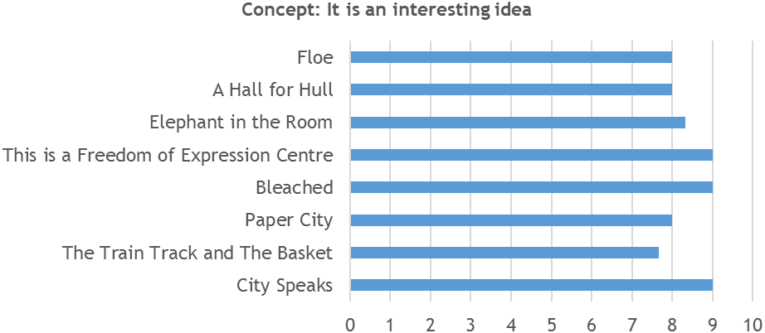
Figure 3: Arts Council England Quality Metrics – Presentation
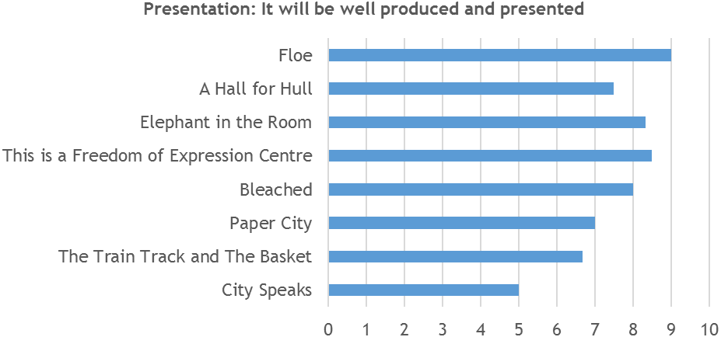
Figure 4: Arts Council England Quality Metrics – Distinctiveness
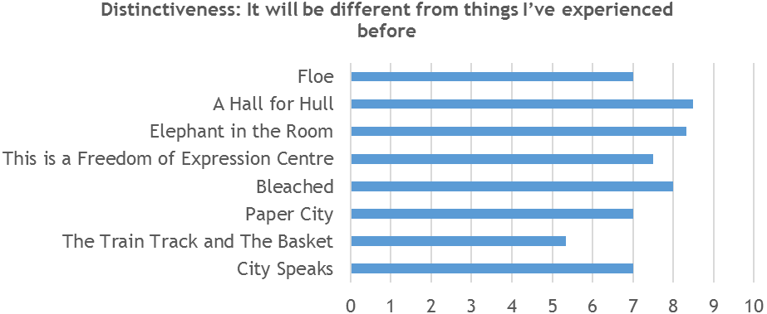
Figure 5: Arts Council England Quality Metrics – Challenge
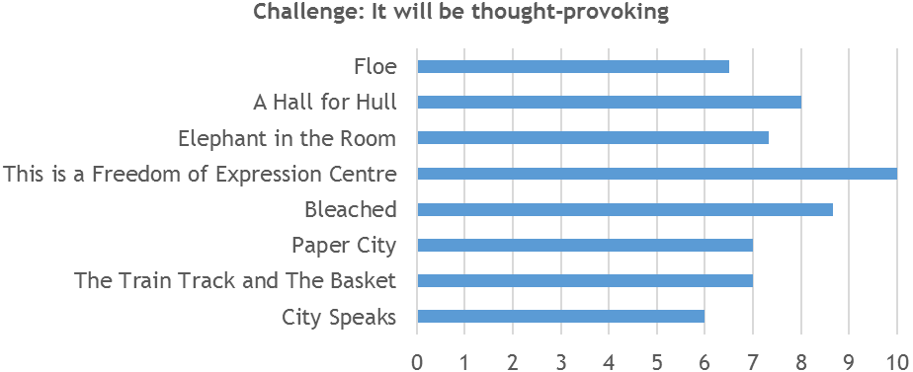
Figure 6: Arts Council England Quality Metrics – Captivation
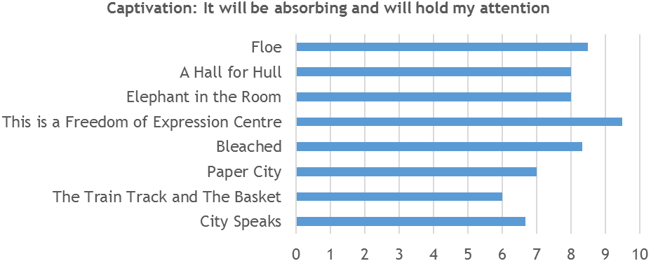
Figure 7: Arts Council England Quality Metrics – Enthusiasm
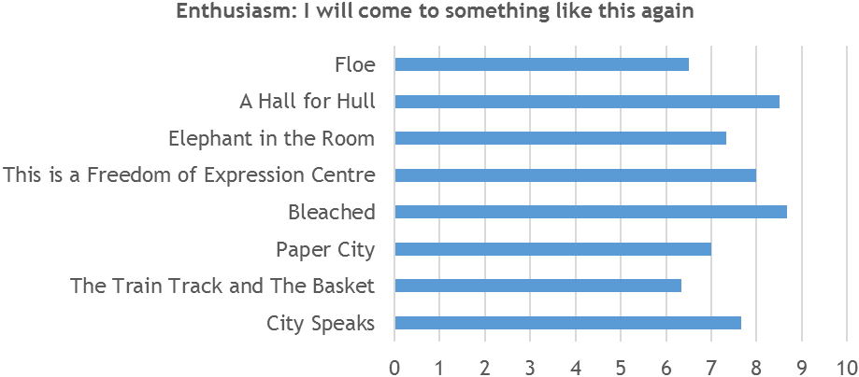
Figure 8: Arts Council England Quality Metrics – Local Impact
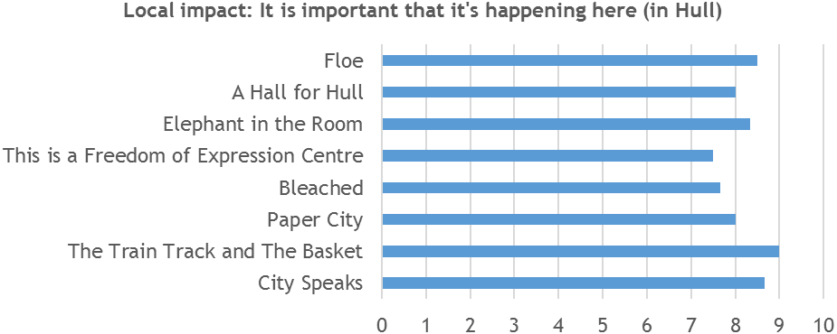
Figure 9: Arts Council England Quality Metrics – Relevance
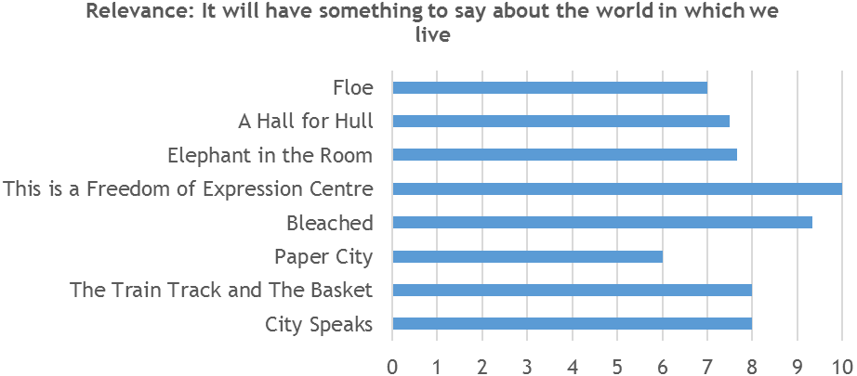
Figure 10: Arts Council England Quality Metrics – Originality
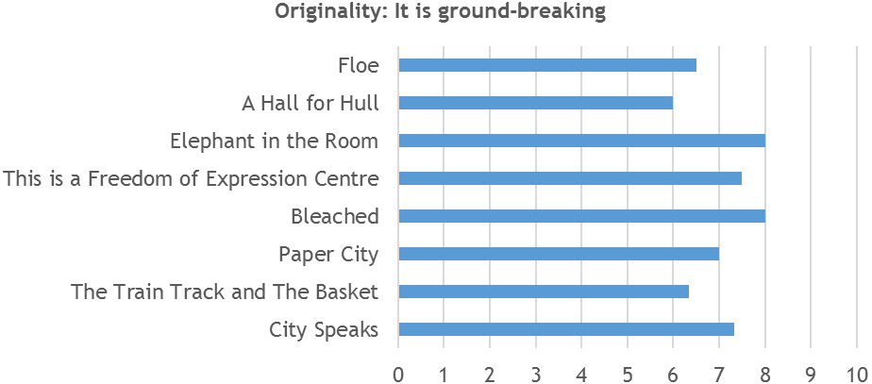
Figure 11: Arts Council England Quality Metrics – Risk
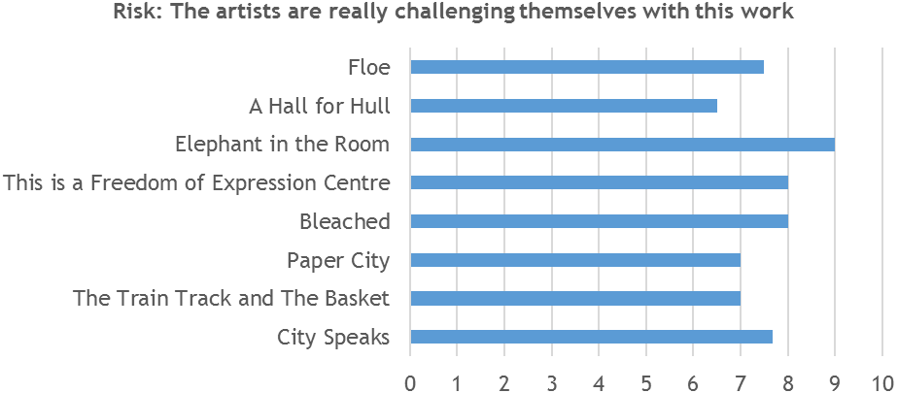
Figure 12: Arts Council England Quality Metrics – Excellence
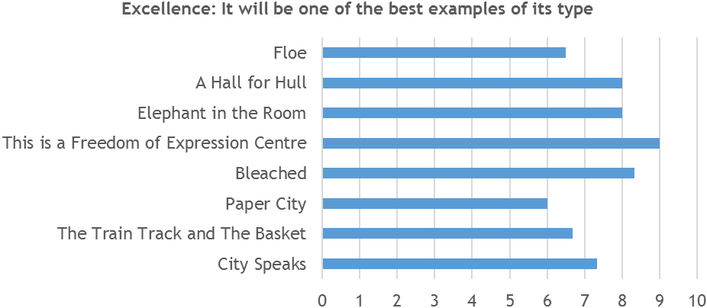
Figure 13: Arts Council England Quality Metrics – Rigour
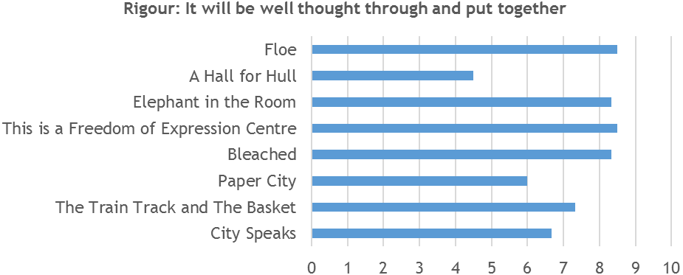
  - Creative Case for Diversity
Pre-event, peer assessors were unable to make a judgement on how they felt that diversity might be explored or represented by the different artworks within the Look Up programme. The main exceptions to this were:
- City Speaks
- The Train Track and The Basket
- This is a Freedom of Expression Centre; and
- A Hall for Hull.
In regards to City Speaks, it was considered that there were no limitations to who would or could engage with the piece, As such, it was inherently open to welcoming as broad and diverse a range of people as wanted to interact.
‘Because of its openness to everybody and it has accessibility for everybody to participate. I imagine irrespective of language as well, it is exceptionally well placed to do that and overcome barriers that might be created in other ways and other art forms.’
(Peer Assessor)
‘It has the most potential to literally represent diversity, in that everyone can participate and everyone who can speak into a microphone can be involved in the creation of the work.’
(Peer Assessor)
The subject matter being explored by The Train Track and The Basket was referenced in terms of the geographical diversity that it would explore.
‘The subject sounds as though explicitly it thinks about the movement of people and different personalities and identities … but again it is really hard to tell how that works in relation to the station.
(Peer Assessor)
‘Certainly diversity is implicit in the content and the characteristics of the work. It embodies diversity, but that is implicit rather than explicit.’
(Peer Assessor)
For one of the peer assessors who had previous experience of the work of Bob and Roberta Smith, they spoke of how diversity is something explored within that artist’s practice.
‘Diversity is implicit and explicit in the work, so to a very high degree.’
(Peer Assessor)
As with City Speaks, A Hall for Hull was seen to represent diversity in the way that is was a highly accessible artwork. This was in terms of both physical and intellectual accessibility.
‘It looks accessible, because it is on a level and it is physically accessible and it doesn't appear to have intellectual barriers.’
(Peer Assessor)
‘It has clearly been designed in a way that it is accessible … for example, people who have hearing impairments - it is a very experiential piece of work; it can be accessed by wheelchairs and push chairs … People will naturally walk into the space when out doing their shopping.’
(Peer Assessor)
Following attendance at the Look Up artworks these preconceptions were played out, though Bleached and Elephant in the Room were also included due to their accessibility to all audiences.
- City Speaks
‘Yes it was absolutely open to anyone.’
(Peer Assessor)
- The Train Track and The Basket
‘It spoke of migration and cultural identity and gender identity also. So implicitly it was strong in that respect.’
(Peer Assessor)
- Bleached
‘Not explicitly at all, but implicitly as it had a global theme as it were and has relevance to anyone and everyone.’
(Peer Assessor)
- This is a Freedom of Expression Centre
‘It explicitly attempted to suggest that it was open to diverse audiences. It talked explicitly of the experience of black people and the state and security and used and mediated their voices to think about diversity.’
(Peer Assessor)
‘The new piece of work that was included in the show, although it wasn't try to cover all bases in terms of diversity, it was specifically about inclusiveness.’
(Peer Assesor)
- Elephant in the Room
‘It spoke to broad issues and was inclusive of anyone [due to location] and as such attracted diverse audiences.’
(Peer Assessors)
- A Hall for Hull
‘In the sense that it is open to everyone and there is a whole cross-section were visiting it.’
(Peer Assessor)

  - Perceptions of Hull
Three peer assessors stated that they had no previous or existing personal connection to Hull. The others all had connections:
- One had family from Hull;
- Two were working / had previously worked in Hull; and
- Two had friends who live in Hull.
Before attending Look Up, the peer assessors’ descriptions of Hull varied in depth and tone. Mention was made of it reputation externally, however, they spoke of how it was undergoing great change and that there was a real hive of activity within the city. Others spoke of its geographical location, its sense of identity, and friendly people. In the main messages were positive.
‘Hull has a bad reputation … but essentially it is a very nice place to live with lots of attractions to go and see and people are bloody lovely.’
(Peer Assessor)
‘In recent years it has been ambitious … It has been one of those places that has had a bad reputation and has managed to turn it around - everything from shopping and arts and culture … There are exciting things going on … City of Culture has become a real focal point for the area.’
(Peer Assessor)
‘It is a really interesting city … It surprises people when they go there, how much more there is than their external perceptions … It is like a town version of a city and it is friendly and quite an accessible place … I lived there 1991-1994 and it has changed a lot. Time Based Arts were based in Hull … I don't think arts infrastructure has been that strong across the board, but you would get groups like … So it is a city of surprises.’
(Peer Assessor)
‘I would describe it as not a seaside town, but a dock town, with a beautiful harbour and a lot of interesting heritage, and there has been significant investment recently in regeneration … I have become much more aware of Hull's presence in the media since Hull City of Culture started and it has been on Radio 3 quite often … My perception of Hull has shifted in the last year since … It would now be a place I would visit and even stay overnight.’
(Peer Assessor)
‘I know it has some good band; it has some good galleries and museums; and it has a strong industrial heritage; and it is by water … A staunch Northern city with a strong industrial background and civic heritage.’
(Peer Assessor)
‘I know it has a very rich history and I know it has been an important port and trading route … I know that it has an industrial past and there is a lot going on obviously with City of Culture, but there has been a lot going on in terms of art, design and culture.’
(Peer Assessor)
‘One of the great Northern cities that has had difficult times, but is an extraordinary city and has a great sense of itself.’
(Peer Assessor)
‘Hull has had high indices of multiple deprivation for a long time and is a socially-economically deprived area, but to me it’s a very interesting place. I’m quite fond of Spurn Point. The other aspect of Hull is it’s pretty distant from many other places and one of the reasons I don't go to Hull often is the distance from where I am … I regard it as remote.’
(Peer Assessor)
Seven of the eight peer assessors said their experience of visiting Look Up artwork(s) would encourage them to speak more positively about Hull to someone else. This linked to their wider experience of the city, not just the Look Up artworks they experienced. Many had visited museums, galleries and other spaces across the city centre; and may remarked on the change in atmosphere and buzz, which was palpable.
‘It was my first visit to Hull … I was very impressed. I went to the Wilberforce Museum, Ferens Art Gallery, I went to see other things … I would definitely recommend the city to others … I really loved Humber Street Gallery and that whole area.’
(Peer Assessor)
‘Since I first went to Hull, before the project [UK City of Culture] started … the atmosphere of Hull from an outsiders point seems to have changed. You come out of the station and there are volunteers around. There is a sort of buzz about the city … That part of the city where Paper City was [Humber Street] looked like a relaxing extremely cool part of the city … What you see is a lot of culture regardless of City of Culture.’
(Peer Assessor)
‘I popped in to see the Turner Prize and saw the Jason Bruges robotics … There were great ambitious things going on, which isn't just about Floe and there is the transformative effect that City of Culture has had. I have said that to a few people since I went. Floe is the reason why I went, but I was very struck by the feeling of great work and creativity. The volunteer people were really enthusiastic so it felt really new and there was a different kind of energy in the city.’
(Peer Assessor)
‘Definitely more positively now that I have had first hand experience of visiting Hull … The space and the buildings around are some of the most historic in the city, it is a really beautiful space … Absolutely I can speak knowledgeably and enthusiastically about Hull.’
(Peer Assessor)
‘There is a real vibrancy and energy. It felt like you would be missing out by not going. Also, the Turner Prize was packed.’
(Peer Assessor)
‘I had a great time. It was my first time in Hull, it was a beautiful day and I enjoyed working around the city. It is very walkable. I even bobbed into a couple of museums. I had a great reception from the volunteers, who were very informative and helpful. I had high hopes and they were exceeded. I have recommended Hull to different friends since I got back.’
(Peer Assessor)
‘I really hadn't been to Hull for a while and it really did seem to have a lot going on in terms of development. I would speak very positively, the Humber Street area in particular.’
(Peer Assessor)
The remaining peer assessor stated that they would not change the they would describe Hull to someone else, though they had noticed the positive impact that Hull 2017 Volunteers were having on the city.
‘It didn't particularly sway me either way. What I would say is that when I first got there in terms of branding was it City of Culture then I saw lots of volunteers about and that was good … Work like this has really created a community of volunteers.’
(Peer Assessor)
  - Other Observations
    - Strengths of Look Up
The Hull 2017 Volunteers were mentioned as a particular strength by a number of peer assessors, both in terms of their roles at Look Up installations and more broadly.
‘I thought the volunteers were wonderful. They gave me so much information, wherever I went they were so helpful and informative. I thought that was a real success.’
(Peer Assessor)
‘The volunteers deserve a mention. They are everywhere and enthusiastic,’
(Peer Assessor)
In addition to this, the way that Look Up fed into the broader Hull 2017 programme was praised, as it felt integrated into the whole, rather than something disconnected.
‘It also feels these things aren't happening in isolation and not just a one off, because as I mentioned I saw a couple of things that are part of a public realm, which was very accessible and a good standard … There were people doing virtual reality demonstrations and a lot of other things going on as well … I thought it great there is all this stuff going on which is really cutting edge - the robotics that whole technology thing which I am sure a lot of young people would be really interested in.’
(Peer Assessor)
    - Areas for Improvement
Some aspects that were identified as detracting from the experience, or in need of improvement were:
- Signage and interpretation
‘I thought some things were easy to miss, so there's a need for better signage or interpretation.’
(Peer Assessor)
- Cross selling of the other events going on to audiences
‘Potentially there were some lost opportunities in connection with audiences … We weren't there a significant amount of time … At no point were the volunteers signposting us to other things engage with. There wasn't even an information point, and in terms of evaluation with audiences I don't think there were places where people could give feedback and things like that.’
(Peer Assessor)
- Lack of artist led events linked to the artwork
‘ I think with works like that … to have the option of having conversation amongst themselves or to meet the artists.’
(Peer Assessor)
- The title of the programme being misleading in some regards
I suppose one thing that puzzled me slightly was the title Look Up, as it wasn't always the case of looking up … In some you would be looking up, and they gave an opportunity to look up to architecture … but some of the work was kind of gallery shows.’
(Peer Assessor)

