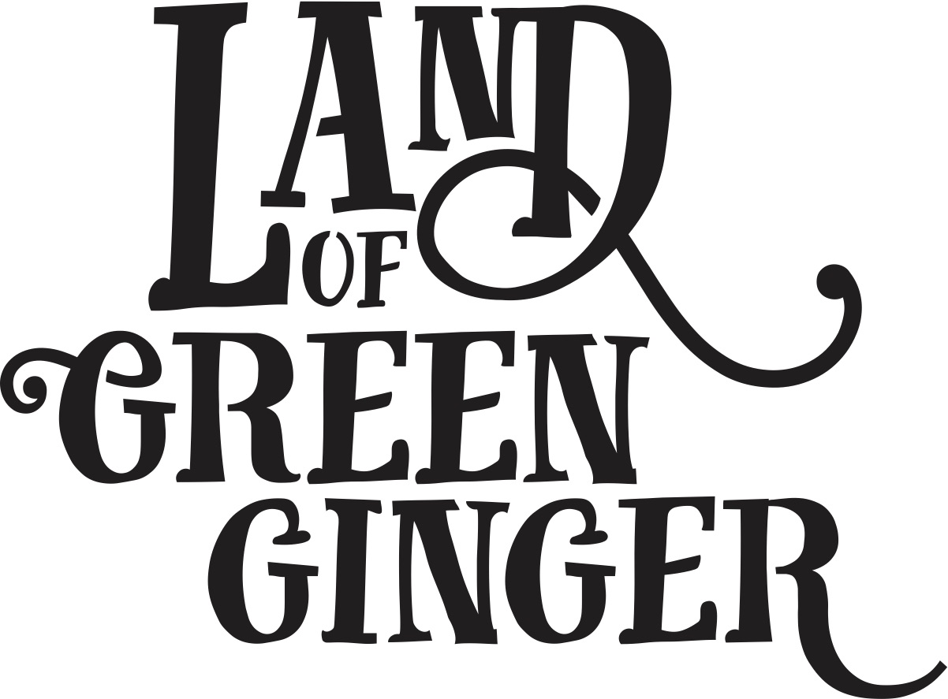

The Longhill Burn

Thank you for being part of The Longhill Burn. Please provide us with the following information.

|  |  |
| --- | --- |
| First Name |  |
| Surname |  |
| Address |  |
| Email Address |  |
| Telephone |  |
| Date of Birth |  |

Emergency Contact Details

|  |  |
| --- | --- |
| Name |  |
| Relationship |  |
| Phone number |  |

Would you be happy to be contacted to take part in research about your experience with The Longhill Burn?

Yes  No

Do you agree to let us photograph/film you as part of the Guild of Commoners for documentation purposes?

Yes  No

The following questions will enable us to see how well we are reaching a broad range of people with our opportunities, as well as how this compares to the general population locally and beyond. All data provided will remain anonymous and will be processed and stored in line with the Data Protection Act 1998.

Postcode: ___________________

Age

0-2 years  25-29 years  60-64 year

3-5 years  30-34 years  65-69 years

6-10 years  35-39 years  70-74 years

11-15 years  40-44 years  75+ years

16-17 years  45-49 years  Prefer not to say

18-19 years  50-54 years

20-24 years  55-59 years

Gender

Male  Female  Transgender

Gender non-conforming  Prefer not to say

Disability

Are your day-to-day activities limited because of a health problem or disability which has lasted, or is expected to last, at least 12 months?

Yes – limited a lot  Yes – limited a little

No  Prefer not to say

Ethnic Origin

What is your ethnic origin?

A. White

Welsh / English / Scottish / Northern Irish / British

Irish

Gypsy or Irish Traveller

Any other White background (Please specify):

B. Mixed / multiple ethnic groups

White and Black Caribbean

White and Black African

White and Asian

Any other Mixed / multiple ethnic background (Please specify):

C. Asian / Asian British

Indian

Pakistani

Bangladeshi

Chinese

Any other Asian background (Please specify):

D. Black / African / Caribbean / Black British

African

Caribbean

Any other Black / African / Caribbean background (Please specify):

E. Other ethnic group

Arab

Any other ethnic group (Please specify):