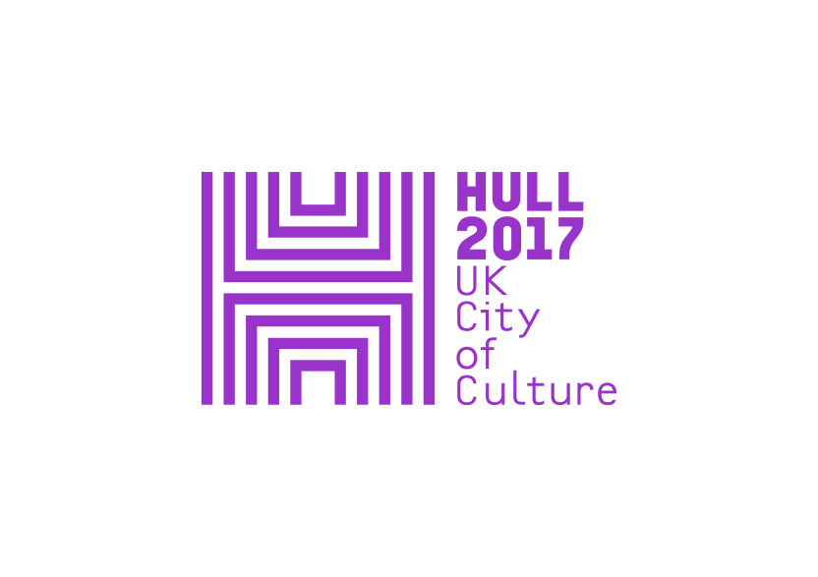

HULL UK City of Culture 2017 and PRS Foundation present

**ROOTS OF THE CITY: A CONCERT OF MUSIC**

Over 300 Hull residents young and old will come together in a showcase of musical creativity.

UK’s top composers spent months in Hull working with local musicians and residents to create new sounds and songs of the city.

On Saturday 24 June over 300 local Hull residents from age 7 to 96? will gather together to perform a showcase of music they have written and developed with some of the UK’s top composers and musicians.

Eliza Carthy, Brian Irvine, Errollyn Wallen, Sam Lee and Jason Singh have collaborated with a wide range of local musicians to bring music to the heart of the community in Hull as part of the PRS Foundation’s New Music Biennial, a festival of new music which will premiere many new works from 20 composers between 30 June and 2 July.

These music residencies in the city have offered those involved creative workshops exploring storytelling, songwriting, beatboxing, instrumental and experimental music across many genres. Now 15 minutes of the music created by each composer and their residents will be woven together into a large-scale finale by **James Redwood** and presented at Hull’s City Hall on 24 June at 3.00pm, with Sam, Eliza, Brian and Errollyn and then as part of the New Music Biennial weekend in a ‘super group’ moment.

* The Big Elastic Band will make its debut starring 10 residents from Pickering and Ferens Homes alongside children of Mersey Primary School to share music created with Brian Irvine.
* Talented young musicians from Wyke College will join a band to support the Freedom Chorus, performing a new song for Hull, by Eliza Carthy – ***Hull Is Freetown*** incorporating a catchy cup percussion rhythm .
* Children from Buckingham Primary School, Trinity Academy and Hull 2017 volunteers will perform new songs for Hull collaboratively written as part of Sam Lee’s residency.
* Members of the Freedom Chorus and local children??? will perform extracts of Ebb and Flow live, creating a vocal soundscape inspired by the sounds of Hull through vocal sculpting techniques created with Jason Singh.
* ***A Modern Spiritual*** created by Errollyn Wallen with refugees and asylum seekers and children from Thoresby Primary School will be performed (sorry I don’t know what this group of 50 refers to).

The residency project continues until March 2018. It is hoped that this project will leave a legacy of workshop structures and practical tools as well as an exchange of practice which PRS Foundation hopes will continue to benefit the local musicians and communities engaged in this project.

ROOTS OF THE CITY: A CONCERT OF MUSIC

City Hall, Hull

Saturday 24 June, 3pmpm

Sunday 2 July, 1.30pm

Tickets – Free

Box Office: <https://www.hull2017.co.uk/whatson/events/roots-of-the-city-concert-of-music/> Tel. City Hall box office 01482 300300

NOTES

**ABOUT THE RESIDENCIES**

**SAM LEE**

Sam Lee is a Mercury Prize nominated folk singer, song collector, promoter (of BBC award-winning folk club The Nest Collective) and radio host. His two critically acclaimed albums (‘Ground of Its Own’ and ‘The Fade in Time’) showcase songs he has collected first hand from the Gypsy Traveller Community.

Sam is taking the artistic lead in a collaborative project with regular sessions led by musicians Jack Durtnall, Sam Pirt and Hazel Ritchings, and input from storytellers. They have introduced students at Trinity Academy and Buckingham Primary School to former sea farers from Hull’s marine heyday, and folk from the Traveller community, capturing their stories to use as a starting point for creating songs with the young people.

The project has worked with Trinity Academy, with former sea farers from Hull, the Traveller community, Year 5 pupils of Buckingham School and Year 8 and 9 pupils in Trinity Academy and guest artists including Jack Durtnall, Richard O’Neil, Hazel Richings and Sam Pirt.

**ELIZA CARTHY**

If there is one musician who embodies the dynamism and vitality of the current English folk revival, it’s Eliza Carthy. Beloved of staunch traditionalists and iconoclasts alike, Eliza’s music effortlessly crosses boundaries of genre and style. Whether performing a centuries-old ballad or a self-written song, her powerful, nuanced voice, fiercely beautiful fiddle playing and mesmerizing live performances have influenced a whole generation of young musicians.

Eliza has created a new song for the city called, ‘Hull Is Freetown’ based on a reworking of *Three Day Millionaire* by (her uncle) Mike Waterson. She has met with a wide cross section of the community, including students at Wyke College, Kingston Boxing Club, Dancers from the Hindu Cultural Association, Hessle Road residents at Boulevard Village HallCoffee Morning, volunteers at Giroscope Housing Co-operative, Year 1 and 5 pupils at Spring Cottage Primary School, employees at Associated British Ports, local Market Traders and a cross section of Hull2017 volunteers. Eliza has worked with Hull based folk duo Gary Hammond and Sam Pirt (aka The Hut People) to create a ‘Hull Is Freetown’ song, with a cup percussion pattern available to watch online and which can be learned by everyone.

**ERROLLYN WALLEN**

Errollyn Wallen is at ease both as a singer-songwriter of pop-influenced songs and a composer of contemporary new music. She describes her own Ensemble X with the motto, ‘We don’t break down barriers in music…we don’t see any.’

Her residency in Hull has focused on the modern spiritual, linking in with her piece Mighty River which will be performed as part of the PRS New Music Biennial Festival. Inspired by people’s stories and reflections on hardship and how music can sustain us through hard times, her work has reached out to the local refugee and migrant communities involved in Hull’s Open Doors project (a community organization working with refugees, migrants and asylum seekers) as well as working with year 4 pupils at Thoresby Primary School. Errollyn has worked in these communities with the support of choral leader Em Whitfield Brooks, and local musicians Gary Hammond, Pete Jack and Frankie Banham of Mambo Jambo (world music). Professional orchestral players have also been brought in to inspire participants.

**JASON SINGH**

Jason Singh is a beatboxer, vocal sculptor and sound artist whose work is rooted in inspiring people to engage in creative experiences through voice, technology, performance and participation.

Jason’s Residency has created a sound installation, ***Ebb and Flow* which explores people’s memories of Hull** through a unique 3D fully immersive sound experience. It connects to Hull’s links with water, transformation, regrowth and change. The installation will include stories, songs, fond memories, vague and vivid accounts of the past, seasons and descriptions of spaces that once existed. It runs for **2017 seconds on a loop.**

The content of the installation has been derived from various workshops working with people of different ages, cultures and communities in Hull, including The Warren youth project, and a group of members from Hull Freedom Chorus, and people with dementia attending Buckingham Day Centre. *Ebb and Flow* also includes contributions from local artists: **Jez Riley French**, musician, composer, lecturer and artist from Hull, musician **Wai Wan** and **the Hull Freedom Chorus**.

It is a **23-speaker, fully immersive Ambisonic sound installation** and will be constructed using a Higher Order Ambisonics sound-field, almost like a dome-shaped structure, which will be programmed and **installed in the Hull History Centre by Liverpool based 3D/Ambisonic’s company, Kinicho**.

**BRIAN IRVINE**

Composer/conductor Brian Irvine’s huge body of work includes operas, orchestral works, large-scale participatory work, films, multi-media installations, dance works as well as ensemble, solo, and chamber pieces. His sound world is a personal concoction of contemporary classical, cartoon, punk, jazz, thrash and trash. It often takes the form of giant super structures - as in the head on collision of two symphony orchestras, or the 7 day performance installation of 3000 collected objects, symphony orchestra, choir, intervention performers and soloists in NEST (the Northern Ireland Artists Taking The lead commission for the London 2012 Olympics).

Brian has been working in a specific geographical area just outside the city centre to the East. It is economically deprived and neglected, culturally underserved or even unserved, . Brian has been forming music groups within the community with older people in Pickering and Ferens Homes who have formed the Big Elastic Band, and residents at The Crossings and Emmaus Hull (place of change schemes for former homeless people). He has also worked with children of all ages in Mersey Primary School, bringing them together with older people to give an intergenerational flavour to his project. Brian has also spent time with older people at Buckingham Day Centre whose voices he has captured in recording. . Brian has also held a composition masterclass as part of Albemarle Saturdays – a Creative Communities project for Hull 2017 .

**Acknowledgements:**

PRS for Music Foundation’s New Music Biennial and residency programme is generously supported by Hull UK City of Culture, Paul Hamlyn Foundation, BBC Radio 3, Southbank Centre, Arts Council England, Arts Council of Wales, Creative Scotland, Arts Council of Northern Ireland, Cockayne, The John S Cohen Foundation, the Jerwood Charitable Foundation, The Finzi Trust, RVW Trust, The Bliss Trust and NMC Recordings.

The New Music Biennial Minute of Listening programme is delivered in partnership with Sound and Music and is generously supported by PRS Foundation and Paul Hamlyn Foundation.

