**Volunteer Briefing**

**Part 1**

**Humber Street Gallery**

**Jan 2017**

**INTRODUCTION**

Humber Street Gallery is a contemporary arts space positioned in Hull's cultural quarter, the Fruit Market. It comprises a contemporary visual arts led gallery and a vibrant café.

This document is designed to give a thorough context to the building, its spaces and its objectives in order to inform volunteers who will be on-shift with the gallery spaces during 2017.

**AIM**

Our aim is to be forward-thinking in our choice of exhibitions, and to present the best of all aspects of art and design to our audience by including a range of contemporary visual art.

Without losing our artistic integrity we will often include a focus on popular culture and social history to broaden the appeal and accessibility of our exhibitions. We aim to ensure Humber Street is a venue where people can learn, engage and become inspired.

We want to create an environment that instils a sense of confidence, enjoyment, understanding and a desire to return again and again by providing an exhibitions programme that appeals to a wide cross-section of people regardless of age, background or ability.

We hope to generate debate, expand boundaries and encourage change and development, both for those familiar with the arts and those new to this arena.

Humber Street Gallery will primarily serve as a showcase for major commissioned exhibitions and loans from established lenders, creating strong working relationships with such institutions as the Tate, Magnum, Film and Video Umbrella and the Crafts Council.

**AUDIENCE**

Humber Street aims to enhance the quality of the visitor experience whilst also raising its profile as a credible venue for exhibitions of importance. Over the next five years we will look to strengthen existing relationships and develop new collaborative commissioning partnerships.

Although we will strive to raise the cultural aspirations of our audience, we also want to attract new audiences into the gallery environment and encourage lifelong learning amongst local people, visitors, educational groups and those already interested in the arts. For this reason we aim to present a programme of exhibitions that is relevant and accessible to all.

**VENUE CONTEXT**

The gallery has been created for its community - as an asset and resource for it to enjoy, embrace and benefit from. All aspects of the venue are underpinned by the following charitable objectives:

1. To advance the education of the public through the promotion of artistic and cultural events and exhibitions.
2. To provide or assist in the provision of facilities in the interests of social welfare for recreation or other leisure time occupation for the purposes of improving the conditions of life.
3. The relief of unemployment for the public benefit in such ways as may be thought fit.
4. The retention, conservation and preservation of Humber Street for the purpose of furthering the objects and the conservation and preservation of other such buildings of historic and architectural importance.
5. Such other charitable purposes consistent with the objects above for the benefit of the inhabitants of Hull, and the public at large.

**VISION**

Our vision is to become *‘An extraordinary destination for the arts’.*

This journey will see us achieving the following objectives, to:

1. Become a leading visual arts centre in the North of England
2. Be cemented firmly at the heart of Hull’s  cultural offer
3. Be alive with creativity and full of energy
4. Have a thriving local audience base
5. Be key to supporting and developing creative practice in the region
6. Become a nationally renowned  exhibition commissioning venue.

**DEVELOPMENT OF THE ARTISTIC PROGRAMME**

Humber Street Gallery is opening during Hull's UK City of Culture year with a year long exciting arts and cultural programme, celebrating the unique character of the city, its people, history and geography.

In 2017, the programme runs from early February to 31 December. We have a responsibility therefore to ensure we both offer audiences a range of high quality experiences and also that we play our part in supporting the local arts and creative sector to thrive and grow.

Humber Street Gallery intends to explore best practice around capturing, curating and disseminating knowledge about the crucial importance of cultural heritage and the visual arts. We hope to bring together museums, galleries, artists, funding bodies and donors to examine and provoke discussion around the importance and long-term impact through collaborative partnership.

**BRAND & IMAGE**

**Concept**

Hull’s brand new contemporary art space - presenting the best of all aspects of art and design through a forward-thinking and diverse programme of exhibitions, catering to a wide audience base.

**Look & Feel**

Both the gallery and the logo are designed to be a number of things:

1. Timeless rather than trend-led.
2. Distinctive without shouting – the brand is designed to sit in the background – the art is intended to do the shouting.
3. Accessible to all (easily drawn in a text book, easily transferred to large print).
4. It forms the 64 from the Gallery’s street address.

**Tone of Voice**

Ambitious and proud, sometimes challenging and provocative but never at the expense of being welcoming.

**EXHIBITIONS & ARTISTS**

**COUM – Wreckers of Civilisation**

**3 February – 22 March 2017**

First retrospective of COUM transmissions and a series of live shows, talks and one-off events and new live art commissions, creating in effect a two month long festival celebrating and exploring the spirit and continuing global legacy of COUM.

Curated in association with Cosey Fanni Tutti and Andrew Wheatley from Cabinet, with archived loans from TATE and personal collections.  
***[This exhibition contains explicit content – not advised for children]***

**Sarah Lucas -POWER IN WOMAN**

**3 February – 22 March 2017**

Three sculptures will be displayed each depicting a female figure in cast plaster. These works were first shown last year as part of Lucas’s acclaimed commission by the British Council for the British Pavilion at the Venice Biennale

On loan from Sadie Coles HQ.

***[This exhibition contains explicit content – visitor discretion is advised]***

**Re-Rooted (Hull Time Based Arts Mini Festival)**

**24 -26 March 2017**

Two day creative event / closing party with a new program of performances, film events and site specific interventions by artists originally part of ROOT Festival /Hull Time Based Arts and contemporary artists both influenced and now emulating values of experimentation and risk.

A network of activities in cultural institutions, civic space and living environments will include: art and media installations, performances, film program, social events and creative information exchange.

New Commissions, informal symposia and publication investigating how current practice has been informed through radical and practical interventions of embodied and performative improvisation pioneered in Hull.

The event will be revelatory, radical and entertaining, ROOT set in a contemporary setting and within a new agenda of talent development and retention.

Curated in association with Mike Stubbs.

**BRIEFING – Look Up**

Second Installation

*‘The City Speaks’ by Michael Pinsky 03.02 -31.12.17*

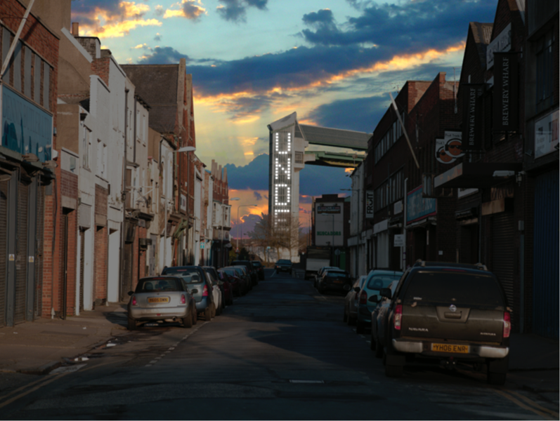

**The Work**

The City Speaks is a major new commission for HULL 2017 by the artist Michael Pinsky. It functions as a 21st century Speakers’ Corner in which open-air public speaking takes on epic proportions as spoken words are translated to text and relayed on the west tower supporting Hull’s tidal surge barrier.

A steel lectern located on the quayside of Humber Dock provides a platform for members of the public to broadcast their thoughts and feelings. A microphone captures their words and sends them to a data processing cloud which transcribes these words into a scrolling dot-matrix text ascending the tidal barrier. The plinth and the tidal barrier perfectly align at each end of Humber Street, allowing the speaker to see their own speech being displayed across Hull, embodied into one of the city’s architectural icons.

The work, which forms part of the ‘Look Up’ programme of artists’ commission for the city, was developed with The Light Lab and realised with the co-operation of the Environment Agency.

**Details**

The screen measures 16m high x 2m wide and uses a customised arrangement of ultra-light-weight LED video modules with a 60mm pixel pitch.

The installation uses voice recognition software known as Cloud Speech API which has been developed by Google to convert audio speech to text. Speech API can stream text results, with the recognized text appearing almost immediately while speaking and can filter inappropriate content.

**The Artist**

Michael Pinsky is a British artist whose international projects have created innovative and challenging works in galleries and public spaces. He has undertaken many residencies that explore issues which shape and influence the use of our public realm. Taking the combined roles of artist, urban planner, activist, researcher, and resident, he starts residencies and commissions without a specified agenda, working with local people and resources, allowing the physical, social and political environment to define his working methodology.

His work has been shown at: TATE Britain; Museum of Contemporary Art, Chengdu; Saatchi Gallery; Victoria and Albert Museum; Institute for Contemporary Art, London; La Villette, Paris; BALTIC, Gateshead; Centre for Contemporary Art, Glasgow; Modern Art Oxford, Milton Keynes Gallery, Cornerhouse, Manchester; Liverpool Biennial, Centre de Création Contemporaine, Tours; Armory Center of the Arts, Los Angeles and the Rotterdam International Architectural Biennial.

Michael Pinsky graduated from the Royal College of Art. He has received awards from the RSA, Arts Council England, British Council, Arts and Business, the Wellcome Trust and his exhibition Pontis was shortlisted for the prestigious Gulbenkian Museums Award.

**Quotes**

Michael Pinsky has described how,

*'Hull’s tidal surge barrier, the site for this work, plays a significant role in protecting the city from flooding. It has become a gateway guarding the future of Hull, not unlike Beverley Gate where, in 1642, Sir John Hotham refused Charles I entry to the city. This act of defiance in the defence of freedom is widely acknowledged as the spark that ignited the English Civil War.*

*These principles of resistance and protection lie at the core of The City Speaks. This installation gives a new voice to the people of Hull and in doing so celebrates resilience and freedom.'*