Appendix 20:
Delivery Partner Consultation

  - Introduction
Delivery Partners for Look Up are those who co-commissioned the artwork to which they were connected. The nature of the co-commission varied:
- G.F Smith and The Deep (Floe) were involved in the creation of the brief and selection of the commissioned artists.
- RIBA ran an open competition, asking for responses to a brief put together by the Look Up Core Project Team. A panel then selected the winning commission, which was managed by RIBA.
- Siemens and Hull School of Art and Design provided funding and other resources to enable the projects to be realised.
To gain feedback from Delivery Partners, consultation was undertaken once their Look Up project had completed. Seven responses were received from key individuals at:
- Siemens (Blade)
- The Deep (Floe)
- G.F Smith (Paper City)
- Hull School of Art & Design (This is a Freedom of Expression Centre)
- RIBA (A Hall for Hull).
The Environment Agency (City Speaks); Hull Paragon Interchange (The Train Track and The Basket); Princes Quay (Elephant in the Room); and Hull Minster (A Hall for Hull) have been consulted via a Partner Venue survey (see Appendix 22). The Deep is included within this consultation also, due to lesser involvement in Washed Up Car-go and Bleached.
The data collection methodology employed was a quantitative and qualitative questionnaire (Appendix 20), for which delivery Partners were emailed a link to an online survey (Appendix 20). Two then took part in a depth interview. The discussion guide for this is provided as Appendix 21.
The focus of this research was to undertake two types of evaluation:
- Process Evaluation: motivations; approaches to project development and delivery; highlights, challenges and key learnings from the project; and the partnership performance of Hull 2017 and the broader team.
- Outcomes Evaluation: skills and knowledge development; confidence; collaboration and partnership; audience and other outcomes.
  - Process Evaluation
To inform the planning, development and delivery of future projects, a series of questions were asked linked to the process of Look Up. These concentrated primarily on:
- Motivations: What attracts delivery partners to get involved in projects such as Look Up?
- Project Development and Delivery: What approach was used; and what were the highlights, challenges and key learnings of being involved in Look Up?
- Partner Performance: How did they feel the Hull 2017 Core Project Team performed as a partner throughout the course of their involvement and how could this have been improved?
    - What Was It About Look Up?
Hull’s ‘UK City of Culture’ status appears to have been a significant factor for many partners, in their decision to work on Look Up:
- Five out of seven partners said it ‘completely’ influenced their decision
- Two out of seven partners said it had been a significant influence:
  - One gave a score of 9 out of 10
  - One gave a score of 7 out of 10.
This led to an average score of 9.4 out of 10 regarding the influence of UK City of Culture status as a motivation to be involved.
‘We were keen to do something in whole, as part of 2017.’
(Delivery Partner)
Partners were also asked to share their other key motivations for working on the project, with the opportunity to provide up to three. Key motivations that were common across delivery partners were:
- To celebrate and/or motivate staff or students (four of seven);
- To increase the profile of their organisation (three of seven);
- To demonstrate commitment to Hull and its community (three of seven);
- To contribute to City of Culture year (two of seven); and
- To showcase their product (two of seven).
The depth interviews that took place provided further explanation of motivations, especially in terms of raising profile and contributing to City of Culture year as a key player within the city.

‘We were very keen … to have some fairly high profile stuff going on last year because we saw it as a really big chance to get more people into the building, because people tend not to know that we're here and certainly don't come inside the building.’
(Delivery Partner)
‘I think we see ourselves as very much part of the city … To be part of City of Culture, which was celebrating how far Hull had come and everything Hull had to offer seemed the right thing to do.’
(Delivery Partner)
The prospect of working in collaboration with the team at Hull 2017, the curators and the artists also seemed to be a big attraction. One partner, who had previously worked with the curators - Hazel Colquhoun and Andrew Knight – had confidence that whatever the project, it would be a good one.
‘I have previously worked with Andrew and Hazel. I've known Andrew for many years in various contexts to do with arts projects and so on and when they were pitching actually, for the Look Up contract, Andrew said, "We'd love to do something with you” … which was absolutely fantastic.’
(Delivery Partner)
There was also the fact that in working with Hull 2017, the types of projects that could be done together would be of a greater scale and ambition than each organisation could do alone.
‘We started talking to [Hull] 2017 and rather than us commission projects of our own with that money [the money we had in mind], which they would have marketed it as part of the whole thing [year], they wanted us very much to work with them … They would then match our contribution and we would do bigger projects.’
(Delivery Partner)
Equally, Hull 2017 had the networks and kudos to be able to secure artists unknown to the organisations involved, or who the organisations may struggle to secure independently.
‘And they had more knowledge of national artists than we would have.’
(Delivery Partner)
‘To have the most fantastic exhibition by a leading artist, that we would never have been able to attract [was a main success].’
(Delivery Partner)
Both partners also spoke of how the selected projects for their venues were relevant to, and shared what they were about as an organisation. This appeared to impact on their assessment of getting involved in Look Up.
‘[Part of the artwork] made a very bold statement which we hoped would stamp what we do here and what we feel, the sort of ethos here.’
(Delivery Partner)
‘It was also complementary I think to what we do onsite - actually having specific art projects that we're going to relate to [our organisation] … We felt that because of the nature of [what we do], the siting, that we're already a cultural location. We wanted to actually put things on.’
(Delivery Partner)
For one partner, it also seemed a continuation of work they were already doing, in terms of investing in the arts. They had a history of hosting art exhibitions, and supporting local festivals.
    - Project Development and Delivery
In the depth interviews with delivery partners involved with Look Up, the extent to which partners had been able to influence the artwork commissioned and/or hosted by them was discussed. For one, it was not about influencing the work of the artist, but rather having their own project going on in parallel that became part of the overall installation.
‘[Our team] were developing work in response to particular issues that they felt strongly about, and so the exhibition of that work happened [concurrently with the artist’s project].’
(Delivery Partner)
For the other it was somewhat mixed. There were times when they felt that they played an integral role in the commission of artists and the development of the idea, but others where they felt the team from Hull 2017 were in full control.
It appeared from the depth interviews with partners, that team work and compromise had made their projects run smoothly. When asked if anything about the project had not met expectations one partner could not think of any way that it had fallen short.
‘We were able to compromise, if there were issues with the space we were using or where [the artist] wanted the work putting up, we seemed to be able to get over those really easily… people were really flexible.’
(Delivery Partner)
Equally, staff at one of the delivery partner venues were mentioned as having stepped up as part of the team.
‘Our own technicians were brilliant, they worked really hard to sort everything out over the summer.’
(Delivery Partner)
Delivery partners were asked about the most exciting and challenging aspects of working on Look Up, and their key learning’s for future projects.
Excitement
The excitement of being involved in Look Up was primarily the positive reaction of the public to the artworks; the quality of the artworks delivered; and the way the artwork changed the aesthetic of the venue.
‘The high calibre of the output…Execution hit expectations and we delivered some front page national press for the company.’
(Delivery Partner)
‘Seeing [artwork] designed by [the artist] light up [our venue].’
(Delivery Partner)
‘Seeing the public reaction.’
(Delivery Partner)
‘I could have waxed lyrically in the run up to [the project] … encouraging people to come. I understood what they were going to really experience. And I could also explain it from a layman's point of view. I could explain the synergy between the subject and [our organisation].’
(Delivery Partner)
Also mentioned was the opportunity the project provided to work with artist and creative professionals.
‘Working with the artists provided the best and most valuable experience.’
(Delivery Partner)
Challenges
Frequent challenges were those linked to health and safety, and the logistics of installing the artwork - ensuring that people enjoying the artworks were safe.
‘Health and safety logistics for art installation.’
(Delivery Partner)
‘Getting the job done safely.’
(Delivery Partner)
‘The artist wanted people just to stumble across it and for it to be a surprise to people … When you stick volunteers next to [the artwork], and signage and barriers so that people don't get run over … it kills the spontaneity of it.’
(Delivery Partner)
From a safety perspective as well, one partner mentioned that the wires connected to the installation, being visible within a public place, had been a cause for concern due to recent terrorist events that had taken place in Manchester. Some members of the public had been put on edge by this.

Other challenges included securing internal budget for the project; the challenges of fitting within Hull 2017’s marketing and communications protocols, relative to how they would normally approach this area; and communications on the project being complicated by multiple partners.
‘It was challenging to partner with the marketing and PR functions in Hull 2017. They had so many projects on so [our project] wasn't always their biggest priority, whereas for us the project was our biggest focus for the year…The differing level of priorities made some timings a struggle and caused some frustration. We felt we could have delivered more for both parties in terms of media and reach.’
(Delivery Partner)
‘The communication/marketing of the project was a lost opportunity with too many stakeholders involved and it seemed that Hull 2017 were not putting the same amount of resources behind the projects as us, and their audiences were not necessarily aligned with ours. There was a greater emphasis on local news stories rather than national coverage.’
(Delivery Partner)
‘[Hull 2017] have been trying to control the time scale [for marketing and communications], whereas perhaps we would have gone a little bit more gung ho to start pushing things. Put things on our event program … Because we've been part of a bigger programme, we've almost had to wait our turn. Whereas if we know now that we're going to do something for Easter next year, we'll already be mentioning it, drip feeding it through.’
(Delivery Partner)
‘The curators seemed overworked and stressed and the one assigned to our project got a job during the project, which meant that she was not very much engaged through the second half. It was also an issue that she [knew] the contractor … this often meant that communications was always channelled through the curator... There was a sense that only 'problems' were being identified by the Look Up Curator, leading to a number of reasons why the project should discontinue, rather than looking for positive and creative solutions.’
(Delivery Partner)
‘There was a production company and there was the artist. There was that whole chain. … That was a lot of the problem.’
(Delivery Partner)
Timing was also raised as a challenge by one partner in terms of both attracting some of the audiences they wished to, and the impact of a combined decision to upscale the project late in the day.
‘It was a bit of a rush towards the end because we'd only decided to make it much more than it was intended to be fairly late in the process, so it was a bit of a scramble getting it up in time.’
(Delivery Partner)
‘It would've been good to have more school audiences, but that was difficult because it was during the holidays.’
(Delivery Partner)
The capacity within one organisation, to support the project, was referenced as a challenge to delivery; whilst another partner spoke of their personal struggle to engage with and fully understand the intentions of the artwork, in relation to their organisation.
‘In terms of managing time, we have excellent but fairly minimal technician support, so that was quite challenging, trying from our side to fit in with when [the artist] wanted the work to arrive and all of that stuff, but we managed that in the end, thanks to their flexibility and their huge efforts.’
(Delivery Partner)
‘I didn't really get the links. I felt it was a little bit, I felt it was tenuous. I struggled to really think of ways to engage with the public about [it].’
(Delivery Partner)
In the case of the latter, the organisation had not been involved in the commissioning process for the project discussed. It was not clear if, in addition to this, they had a lack of interaction with the commissioned artist and/or if the team at Hull 2017 had not enabled them to sufficiently understand the project. Whatever the cause, the partner felt they had little influence over the direction of the artist or the art, which led to the project not meeting their expectations.
‘[The project] felt more like a, to me this is, but more like a pet project for the artist, rather than having really taken our vision and turned it into an art creation.’
(Delivery Partner)
There also seemed to be an expectation from this partner that all projects would be “loud” and high impact. They struggled with the concept of quieter pieces of artwork in relation to their venue.
‘I guess it just, visually, didn't have as much impact as [other projects]. But that was probably the nature of the beast rather than necessarily that it was a poorer quality installation.’
(Delivery Partner)
In reflecting on the spaces used to install the artwork there were instances where it was felt to have been a strong choice, and other instances less so. For the latter this led to artwork being located within a different space, which meant that the connection to the venue was weakened and there was a challenge in securing desired audience numbers.
‘We found it was difficult once our customers left the building to then say, "Oh, and if you walk over the bridge and over there and turn left, there's a little bit more for you to see”.’
(Delivery Partner)
In reflecting on the name, Look Up, one partner struggled with how this fit against some of the projects within the programme. Their approach to the name was to interpret it literally, so where you were not physically looking up at something this jarred.
‘If it's at shop level, it can be a little disappointing.’
(Delivery Partner)
Key Learnings
Learnings from each venue partner differed, except for planning, which in various guises was mentioned as a critical success factor. Other learning’s linked to finding ways to ensure buy-in from management; the types of artwork that are most successful for their organisation; and the way the project enabled them to deliver on key organisational aims.
‘Fantastic cultural opportunities … are not always valued by [management] so thinking laterally is pretty important.’
(Delivery Partner)
‘It underpinned some of our key values of empowering staff that we continue to strive for.’
(Delivery Partner)
‘Partnering with others can share the burden, but clear defined roles need setting out at the outset.’
(Delivery Partner)
‘Planning, planning and more planning!’
(Delivery Partner)
‘Clear expectations of decision-making and roles and responsibilities.’
(Delivery Partner)
‘The sum of the parts is greater than the whole.’
(Delivery Partner)
Within the depth interviews one partner spoke of the importance of partnership development in helping you achieve bigger and better things, whilst the other spoke of how being involved in the project throughout the commissioning process had positive impacts on the organisation’s understanding of the project
‘If you take care to make the right contacts and foster the right relationships, you achieve fantastic results … A lot of the activity that is not necessarily the basic activity of the [organisation] is incredibly valuable, and needs to be done in partnership with other organisations … It’s really really important to have that outward facing awareness of what's going on and to cooperate with people; so you know, people offering you things, you say yes, and you try and make it happen.’
(Delivery Partner)
‘We were … very much part of the process with [the project]. So maybe that helped with our understanding.’
(Delivery Partner)
Another partner spoke of how it had reaffirmed for them, their role in the city and made them value the architecture of where they were based, stating how easy it is to become complacent about such things.
‘It's confirmed the importance of [the organisation] in the city. The fact that we have been part of this … we are firmly established as an iconic building and part of Hull.’
(Delivery Partner)
‘It's been a really great reminder as to the value of the actual building … If you're not careful it becomes just normal to us.’
(Delivery Partner)
    - Partner Performance
The partnership with Hull 2017 and the external arts consultants working on Look Up as curators was highly praised (see Figure 1). In response to the question ‘Thinking about your partnership with Hull 2017, and the curators of the Look Up programme (Andrew and Hazel) how well did they:
- Manage their relationship with you’ – five stated very well and one don’t know or N/A.
- Communicate with you during event delivery’ – five stated very well and one well.
- Explain the Look Up project (concept, aims and objectives) - six stated very well and one neither badly nor well.
- Communicate with you post-event - four stated very well and two well.
- Communicate with you pre-event - four stated very well, one well and one neither well nor badly.
- Outline your role and responsibilities as part of the Look Up team - four stated very well, two well and one neither well nor badly.
In expanding on this, partners spoke of the support and understanding provided by the curators.
‘It worked very well - Hull 2017 were extremely supportive as they understood the difficult situation facing [us] and were generous in their offer. Our relationship with Andrew and Hazel was excellent… [We] really appreciated the offer of involvement in the project.’
(Delivery Partner)
‘I'm not sure it could have been [improved] - it had some areas that were imperfect, however that added to its perfectness.’
(Delivery Partner)
Figure 1: Partnership Performance
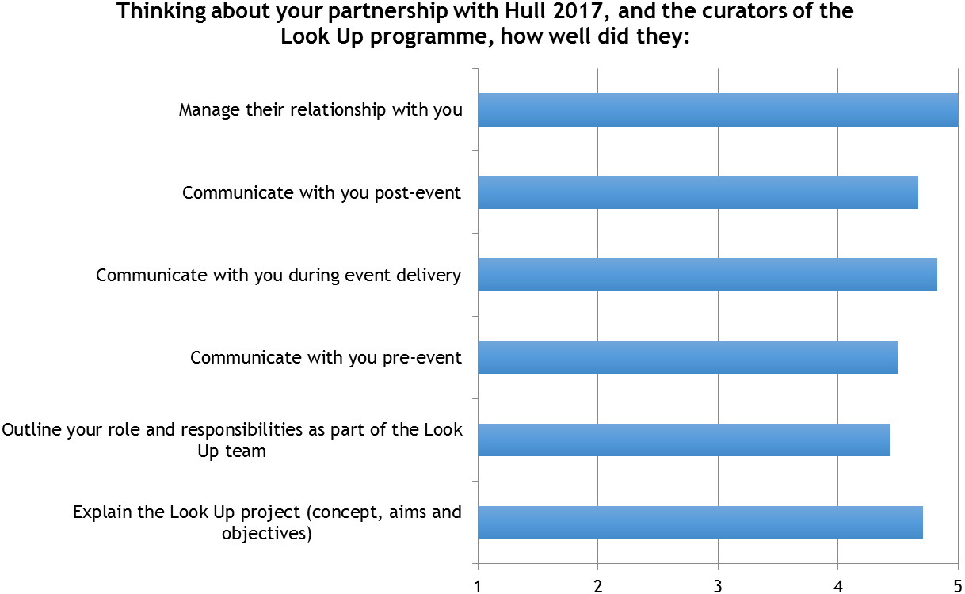
‘They took on all the stuff that I wouldn't have been able to deal with and I knew I could get hold of them.’
(Delivery Partner)
During the depth interviews, one partner also reinforced this by saying how the project they were involved in had exceeded their expectations, especially in terms of the approach taken by the curators.
‘It was well organized, so I knew that I'd be able to work efficiently with Andrew and Hazel … Hazel was a partner in admin organisation of this, so that went really smoothly. I could easily contact her if there were any issues that arose then they were quickly sorted out.’
(Delivery Partner)
Whilst delivery partners were generally satisfied with the project’s management, two partners mentioned that time pressures got in the way of having more regular communications with the Hull 2017 team and curators. However, both saw this lack of time as a knock-on effect of the Look Up Core Project Team (CPT) having to manage multiple projects.
‘I think the partnership with the curators was excellent…The partnership with Hull 2017 was more challenging but I don't think this could have been improved - it was the nature of the amount of deliverables the Hull 2017 team had. The only possible suggestion could have been with some kind of video linking for meetings … A lot of meetings were conducted over the phone with multiple partners it was a challenge … The few times we were together face to face felt we managed to move things forward.’
(Delivery Partner)
‘Andrew and Hazel were professional, competent and a pleasure to work with. We needed to accept though that they and the rest of the team had many projects to curate which they tended to work on more in series rather than in parallel.’
(Delivery Partner)
Delivery partners, on the whole, were favourable towards the nature of the partnership between themselves, Hull 2017 and the external curators (see Figure 2).
- Four strongly agreed, two agreed and one neither agreed nor disagreed their ‘partnership with Hull 2017 was positive’.
- Four strongly agreed, two agreed and one neither agreed nor disagreed their ‘partnership with Hull 2017 was effective’.
- Four strongly agreed and two agreed their ‘partnership with the curators of the programme was positive’.
- Four strongly agreed and two agreed their ‘partnership with the curators of the programme was effective’.
Figure 2: Nature of Partnership
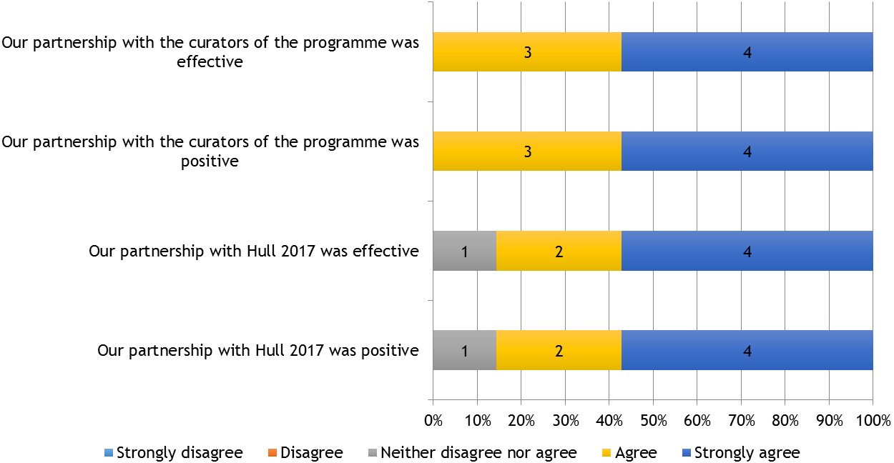
Referencing Hull 2017, one partner spoke of how the organisation had been very supportive in finding a way to involve them in some way within the Artistic Programme for the year, despite the fact they were not able to be a funding partner. This was clearly appreciated.
‘Because of the financial situation … we weren't a major partner anyway … The 2017 team were very good in trying to either promote what we were doing or put things our way if it seemed that there was a good partnership there, but the Look Up one was the major one, so it was really good.’
(Delivery Partner)
The other partner praised the Hull 2017 from the viewpoint of how they had supported on the technical and logistic side of things.
‘The [Look Up] team have all been great. They're very can-do. They want to deliver. They're very pleasant to work with. I think sometimes they are torn between the artists, who just continue to give them this vision and it'll all be mazing, and actually then me and my team at the other end who are saying like we need to know [the specifics and Health & Safety plans.’
(Delivery Partner)
There was also a strong sense from one partner that the project had really benefited from the additional wraparound support that Hull 2017 could offer in terms of marketing and communications.
‘It was a real bonus having it marketed through 2017, which was one of the big attractions of actually being involved in that Look Up project.’
(Delivery Partner)
The support provided by Hull 2017 Volunteers, both in delivering and promoting the projects was celebrated.
‘Having the volunteers standing outside, because this building doesn't invite people in really, but when they were standing outside they were definitely engaging with people, so we were getting people coming in who probably wouldn't have done.’
(Delivery Partner)
The curators were praised again in terms of how they had performed in their role as curators and in communicating on some projects.
‘The [project] was curated in a very coherent way.’
(Delivery Partner)
‘The emails were coming thick and fast as to what we needed and when. It was very clear.’
(Delivery Partner)
‘I've always been convinced, I guess, of their drive and their commitment. And their willingness to try to get a product that everybody's happy with. There's never been any question mark over that.’
(Delivery Partner)
  - Outcomes
The key areas of focus in terms of the outcomes that Look Up had on delivery partners, included:
- Skills and knowledge development: new and existing skills, knowledge and learning gained and developed, as a result of working on Look Up.
- Collaboration and partnerships: new and existing collaborations and partnerships built or developed as a result of working on Look Up.
    - Skills and Knowledge
Professional Skills and Knowledge
Four of the seven partners said they and/or their staff had gained and/or developed skills or knowledge from working on the Look Up project relevant to their organisation (see Figure 3):
- Two partners stated that they and/or their staff have increased existing skills and knowledge and that they gained new skills and knowledge;
- One partner stated they and/or their staff have increased existing skills and knowledge;
- One partner stated they and/or their staff gained new skills and knowledge; and
- One partner was not sure if they and/or their staff increased existing skills and knowledge or gained new skills and knowledge, however, upon seeing the list of skills and knowledge they selected on area where there had been a positive impact.
The most commonly stated skills and knowledge gained or developed were project management (3 partners); marketing and/or social media (2 partners); community engagement (2 partners); and health and safety (2 partners). Others, selected once, included:
- Project development
- Audience development
- Production and / or technical
- Council planning procedures for public heritage sites.
(See Figure 4)
Figure 3: Skills and Knowledge Resulting from Look Up
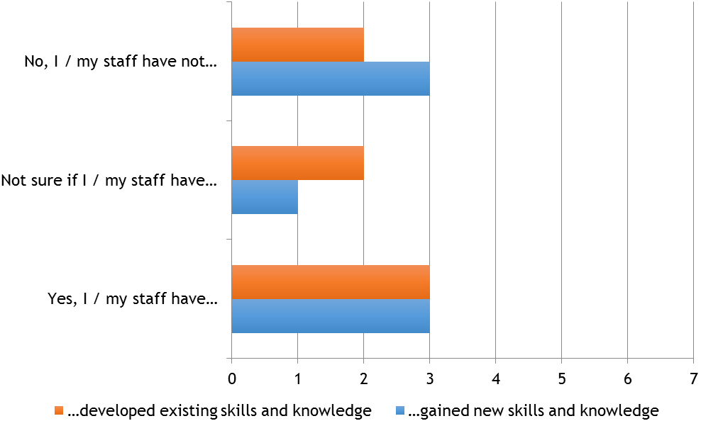
Figure 4: Skills and Knowledge Gained or Developed
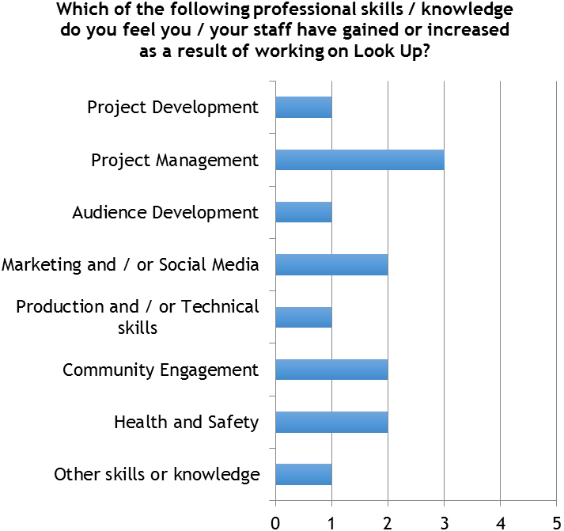
In looking at each partner response individually:
- One partner gained or developed project management; marketing and / or social media; community engagement; and health and safety skills or knowledge.
- One partner gained or developed project management; marketing and / or social media; and health and safety skills or knowledge.
- One partner gained or developed project development; project management; and audience development skills or knowledge.
- One partner gained or developed production and / technical skills; and knowledge of council planning procedures for public heritage sites.
- One partner gained or developed community engagement skills or knowledge.
In providing reasons for these answers, partners said:
‘These are areas that our people are already competent in, however, the scale of [the project] meant that the expectations were heightened. It was also done under a spotlight and as a result our people had to move up another gear. They did.’
(Delivery Partner)
‘[The project] allowed [us] to develop and shape a multi-layered project, which keyed into a number of other events. These included working with students from other institutions, planning and working with the artist and Look Up programme curators and involved us in the process of arranging for the erection and permissions for a specially-commissioned sign. It also enabled us to collaborate with the Freedom Festival in hosting an event.’
(Delivery Partner)
‘These were all skills integral to the project and therefore as is the nature of working on anything like this you develop your skills further as there is always something additional you haven't come across before.’
(Delivery Partner)
‘We have run events in other cities on many occasions over the years although none have been open to the general public.’
(Delivery Partner)
One partner also talked how staff in their organisation got very much involved in the project, and were willing to do whatever it took to make the project happen.
‘I think it upped everybody's game because it was something to aim for, we really wanted it to happen.’
(Delivery Partner)
Confidence
Four of six partners stated that they would be much more confident in working on a similar project in future (8 out of 10 or higher, whilst one was somewhere in the middle (5 out of 10), and the other only slightly more confident (3 out of 10).
Figure 5: Confidence to Work on a Similar Project
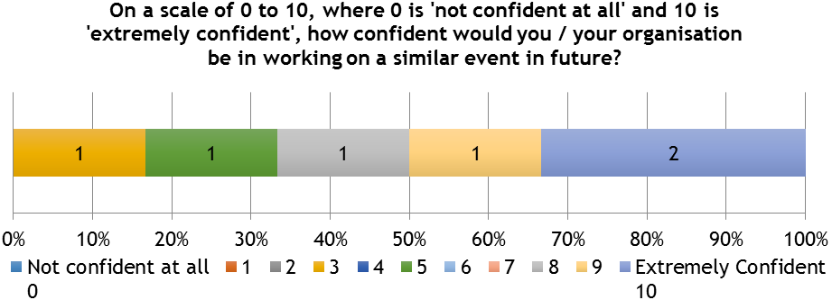
For those whose confidence increased significantly, reasons linked to the success of planning and delivering the project, which was of a greater scale and ambition for some, than previous experiences; the project proving what the partner already knew in terms of their own staff capabilities; and just knowing that they could deliver:
‘The project allowed our staff to work on a larger scale than previously. What was achieved was not wholly new to us but the project's scale and number or project partners made it more complex than previous work.’
(Delivery Partner)
‘Although every event is different, other than working with a third party interest on this occasion (the Hull 2017/Look Up team) and having the event open to the general public, we are used to holding events of this sort.’
(Delivery Partner)
‘The process of planning and carrying out the project was very successful because of good communication with the curators, who ensured that both the artist and ourselves had all the information we needed. Between us we were able to ensure planning produced a project which met all expectations.’
(Delivery Partner)
‘It sort of reinforced my ability, I guess, to work with a wide range of people … and it's made me feel more confident that my instincts are correct, in terms of where to site things, how to use the building, how to organise what is and isn't possible. So, the logistics of it.’
(Delivery Partner)
Where the scores were lower, this was linked to a belief that Look Up presented a unique opportunity for that partner, as opposed to a lack of confidence to deliver. It was felt unlikely that they would ever be involved in something similar again.
‘City of Culture was unique. [The project] was an enormous effort, not just for our business and employees, but for many stakeholders. I just don't believe that such an occasion will arise in the near future that will allow all the parts of the jigsaw to fall in place.’
(Delivery Partner)
Other Organisational Impacts
During the depth interviews, one partner felt that their involvement in Look Up had brought them a great deal of pride.
‘I think personally with … having been part of [Look Up] and just our building being used is a sense of pride there … That [project’s] gone nationally. So that's something that we're proud that we were part of, something that dramatic. I think it was a one off opportunity to be involved with that.’
(Delivery Partner)
As a team it had also made them consider art in a different way – that it could be used to communicate their message, which in turn may help get this message to audiences who learn in a different way.
‘I think certainly it's opened our eyes to the ways in which people learn. And as an educational organisation, if you're trying to get across charitable messages, in the future, maybe, a sculpture or an artwork of some description is the best way to get across what is potentially a difficult message … Engaging with the artistic world might be a useful tool for us in the future.’
(Delivery Partner)
    - Collaboration & Partnerships
Six of seven partners stated that working on Look Up had enabled them to build new relationships with other individuals and/or organisations that they had not come across before.
Five of seven partners stated that working on Look Up had enabled them to develop existing relationships with other individuals and/or organisations (i.e. a deepening of partnerships that pre-date Look Up).
Figure 6: Partnership Development on Look Up
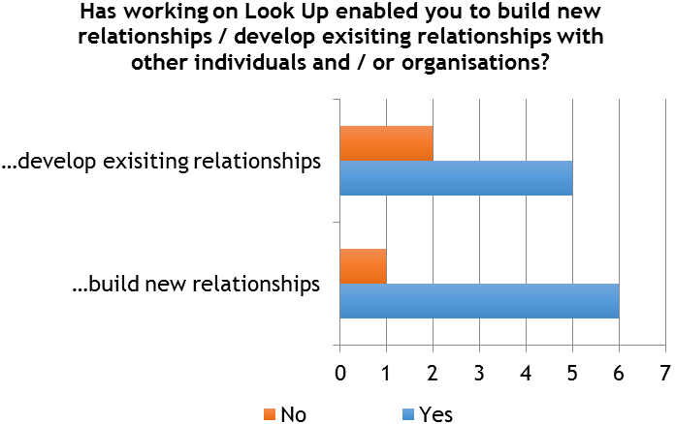
Partners had:
- Created new relationships with artists, creative professionals, the public sector and suppliers via their project, growing their networks within the cultural sector, gaining experience of working with commissioning agencies and expanding other professional connections.
- Built additional trust and professional respect with those who they had previously worked.
‘We developed new partnerships with various artists/creatives in specialisms that we hadn't previously been connected with.’
(Delivery Partner)
‘New partnership with the artist … which is valuable as we share values about arts education. Developed existing partnership with Hazel Colquhoun and Andrew Knight, establishing mutual trust and confidence in each other's efficiency and reliability.’
(Delivery Partner)
‘And similarly the artist … I think we blew her away in terms of who we are as an organisation … she occasionally emails me about [events and work] she’s involved with.’
(Delivery Partner)
‘We worked closely with the City of Culture Company, which was a new relationship. We also worked with areas of the council and police that were new to us. Also there was a far broader media interest in the story and as such we forged new and stronger relationships with existing and new media groups.’
(Delivery Partner)
‘We worked with the Hull 2017 and Look Up team, whereas our events in the past have been entirely under our own control.’
(Delivery Partner)
In terms of the collaboration with Hull 2017, one delivery partner spoke of their disappointment that it was not as collaborative as they had hoped at the start. There had been a sense that with their financial investment in the project it would have been more of a joint venture - being much more involved in the development of the brief and artist selection.
    - Audience Outcomes
In terms of reflecting back on some of the initial reason for getting involved in the project, delivery partners spoke about where they felt their Look Up projects performed well. There was certainly a feeling that it had increased footfall and driven new audiences into the building. One of the partners questioned if this was specifically due to Look Up, or the impact of the wider Hull 2017 programme, though they had seen social media activity linked to Look Up at their venue.
‘As a whole [we have] benefited with increased visitor numbers this year. But I'm not entirely sure whether that's necessarily due to the artworks that we've been involved with or just the general City of Culture effect.’
(Delivery Partner)
‘On social media, I was seeing people talking about [the project] before it happened, actively deciding to come into Hull to see that particular installation.’
(Delivery Partner)
The other partner could be more certain of how audiences were attributable to their Look Up project, as visitors were coming at a time of year that would usually have been a quiet time for them.
‘We had about 1,200 people visited and then because we used the volunteers … we had about 200 of them … We would never have had that many people coming into a show here and certainly not over the summer, when normally, it's very quiet … We had a whole range of ages, interests and all sorts of people.’
(Delivery Partner)
Through getting these new people through the door, the partner also felt that they had been able to demonstrate what the organisation had to offer and what it was about, which could only be a good thing.
‘I think it certainly brought a lot of people in who had no idea of what we had here, of the resources we had, the space we had or what we did … People came in, saw the building, saw the facilities, saw the branding, which is very distinctive and really explains who we are and what we're about and I think at that point, it was extremely valuable.’
(Delivery Partner)
When asked what they felt the audiences who visited got out of the project, one partner had found the project had been thought provoking for those who visited.
‘It was interesting listening to the volunteers, who obviously had a lot of time standing round … looking at the work and were obviously thinking about it … It's not your average art exhibition … it was a very different sort of work … the content of it, which you need to actually think about quite a lot … So people were very thoughtful and most of the feedback we had was that, yeah it had made them think about things they hadn't thought about, or they really enjoyed being challenged.’
(Delivery Partner)
Another partner spoke of how one installation may have added value to a visit people were already taking to their venue.
    - Other Outcomes
In a sense, partners felt that Look Up and Hull 2017 more broadly had helped put them on the map. For one partner, involvement on Look Up had also provided a very clear and simple answer to the question about how they were involving themselves in the year.
‘I've been grateful I suppose that we have had a formal involvement with 2017. It's been a nice, easy method of communicating our support of 2017 to customers and staff. It's been an easy answer in place when somebody says to us, whether it's staff or the media or whoever, what are you doing to support 2017.’
(Delivery Partner)
One delivery partner also reflected on how the use of Hull 2017 Volunteers on their project had caused them to look at ways they could retain their relationship with the volunteers into the future.
‘The volunteers, I mean that's been ... because that was such a significant block of time and we had the volunteers in the building, that's been a really good relationship because we've explored that in other ways now, in that we've been running master classes … a whole lot of them know that this place is here and we will continue that relationship.’
(Delivery Partner)
The likelihood that partners would commission similar work in future was varied. One partner interviewed stated that their organisation was not in a financial position to be able to do this, and doubted they would get the organisational buy-in needed. This was despite their individual desire to be able to do work like this in future. As such, they would continue to focus on aspects they knew they could deliver against.
‘We will also continue to work on the legacy with the volunteers … but as an [organisation], I think it's very doubtful that much will happen … that's a great sadness because it was a wonderful opportunity to actually move forward in that respect.’
(Delivery Partner)
For another partner, the project had impressed so much that conversations were already taking place about what else they might be able to do. However, cost was a determining factor in this.
‘Cultural activities are probably higher up our agenda, higher in our mind in sense of helping us deliver the messages we want to get across. But they still would need to pay for themselves … in terms of delivery of the message.’
(Delivery Partner)

The Deep were consulted as a Venue Partner, however, in the case of Floe they would also be considered a Delivery Partner. Where questions were the same within each survey, The Deep’s responses have also been included.

