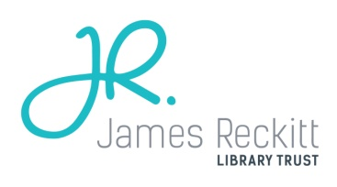 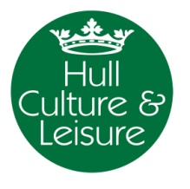

1. **Background:**

2017 will see the 10th Anniversary of the James Reckitt Hull Children’s Book Award (JRHCBA). The 10th Book Award will run between January and June 2017, as it has in previous years with thanks to the funding commitment of the James Reckitt library Trust and match funding from Hull Culture and Leisure’s Library Service.

As the JRHCBA has proven over the years to be a huge success with children, teachers, library staff and volunteers, the Library Service aims to celebrate its success by holding a Children’s Literature Festival in June or July 2017.

2017 is also the 10th Anniversary of the Children’s Laureate, a role that is held for two years and which means 2017 will also see the appointment of a new Children’s Laureate.

1. **Outline for 2017 Hull Children’s Literature Festival**
   1. Governance
2. Hull Children’s Literature Festival will be managed by Hull Culture and Leisure Library Service
3. A steering group will be established to provide strategic direction and developmental support. This will be made up of the following representatives:

* Hull Culture and Leisure Library Service
* Hull 2017
* University of Hull
* The Reading Agency

* 1. Staffing

1. Producer

The Library Service will appoint a Children’s Literature Festival Director in April/May 2016 to develop and organise the Festival. The post will be funded by the Library Service for 21 hours per week and will be a fixed-term contract for 18 months.

1. Administration

Will be provided by the Library Service’s administration team

1. Intern(s)

One or two interns will be employed to support the producer

1. Apprentices

Two apprentices will be employed to work on the festival – probably level 3

1. Volunteers

Volunteer roles will include: front of house; guides; hospitality; stewards

* 1. Timescales

1. The Festival will be held from 30 June 2017 to 9 July 2017
2. Events will run each day during the week and over the two weekends to enable both families and schools to participate in the huge range of events that will be on offer
3. We aim to publish the programme in January 2017
   1. Location
4. East Park will be the primary venue. It is possible to use West Park also however, this would reduce the ‘Festival’ atmosphere.
5. A range of marquees will be used to house the events.
6. The Programme
   1. General principles
7. The Festival will feature an exciting, inspiring and diverse programme
8. The programme will be aimed at children and young people from birth to 18, their families and educationalists
9. Events will be held each day
10. The programme will be created to allow people to attend as many events as they wish i.e. with minimal crossover of performances
11. Many different art forms will be included e.g. writing, illustration, drama performance, storytelling, music performance
12. Opportunities for writer development will be offered along with opportunities of professional development for teachers, librarians and artists
13. There will be a combination of free and paid for events (an allocation of tickets for paid for events will be distributed to children from deprived backgrounds)
14. The JRHCBA presents two awards each year, one for Key Stage 2 and one for Key Stage 3. Each of the ten winners for each Key Stage will be invited to take part in the Festival. In addition some of the past shortlisted authors will also be invited to participate. A list of previous shortlists and the winners is included at Appendix 1.
15. Writers invited to attend will not be limited to JRHCBA winners or shortlisted, other both notable and new writers will be invited
16. Sessions with writers will be a mixture of author readings, interviews with, workshops etc
17. There will be a number of commissions offered e.g. for new writing, illustration, drama performance etc
18. Partners

* Hull Culture and Leisure Parks and Cultural Services
* Hull 2017
* University of Hull
* British Library
* Waterstones
* Publishers
* The Reading Agency
* Book Trust
* Secondary Schools
* Primary Schools
* Nurseries and Children’s Centres