**CREATIVE COMMUNITIES PROGRAMME**  
**PROJECT UPDATE REPORT**

**GENERAL INFORMATION**

|  |  |
| --- | --- |
| **PROJECT NAME:** | Song For Hull |
| **PROJECT LEAD:** | Lucy Vere |
| **REPORT DATE:** | 14/08/17 |

**INTRODUCTION**

Everyone who receives a grant from the Creative Communities Programme must complete this Project Update Report by the dates on the accompanying reporting schedule. Please read it straight away – you will need to collect the information throughout the lifetime of your project.

Please refer to your Agreement, and any changes you agreed with us, when you complete this Project Update Report form.

This Project Update Report tells us:

* What has happened during your project to date;
* Your current income and expenditure figures;
* What you have learned so far, and how you have adapted to these learnings.

We will send you a separate online survey about your experience of the Creative Communities Programme. We will process the information you to understand:

* The effect of our grant and support to date;
* The current effectiveness of our services and grants administration; and
* Where and how we need to make changes. We also use this information to report to our funders.

Please email this activity report to: creativecommunities@hull2017.co.uk

1. **PROJECT REPORT**

Please provide a brief update (3 or 4) sentences on each of the following areas to let us know how your project is going and how we can support you.

**EVENT PLANNING AND PROJECT MANAGEMENT**

* The event plan is in place and we have a full show running order and all artists in place ready for Hull City Hall Concert on 20th October.
* We now have 7 not 8 schools taking part but they are all learning their material, have rehearsed with Helen Garnett (Our MD)
* The schools have submitted some brilliant poems for Nineties Boy to use to write the “Song for Hull. This is now written and will be recorded in September and release on the day of the concert after it’s first performance
* Each schools poem winner will also be coming into the hospital to meet the member of staff who most inspires them and videos to be made to be shown on the night W/C 25/09/17
* We do need further support to spread the word about the project as ticket sales are slow – we need the sales to ensure the legacy of song for hull for 2018 onwards or we will not have the money to carry forward…

**MARKETING AND COMMUNCIATIONS, PARTICIPATION AND LEARNING**

Facebook and Twitter accounts are fully active and have 117 and 75 followers respectively. We also actively use the Hospital Choir Facebook (364) and twitter (265) pages to retweet and promote Song for Hull. We also have active engagement with all of our 7 schools via twitter alongside social media support from our three acts, Jonathan Ansell, The Garnett Family and Nineties Boy. Facebook Competitions also held. Hospital press team have been internally promoting the project and will do more external promotion via Hospital Facebook pages.

Posters and flyers are available at Hull City Hall. They will also be sent out to schools and used by the Hospital Choir when busking in the Town centre in the next 4 weeks.

Press release on poems support by CoC team. No real uptake by media. We do need more support to get higher awareness of the project out there. We really need this advertised via the Hull City of Culture facebook page to increase box office traffic.

**Participation and Learning**:

7 schools are now taking part in the project as one has dropped out. We have have increased the number of spaces available to Priory School as their school choir was oversubscribed for this project. The other 6 primary schools are Chiltern, Thoresby Stepney, St George’s, Ings, Woodland. Newington Primary School dropped out due to their music link going on maternity leave.

Each School has had access to an online rehearsal area with school specific songs to learn alongside songs they sing with the acts on the night. They have also each had singing workshop with Helen Garnett (our MD) to ensure they understand and are singing the material well. They will join with all the acts on Wednesday 18th October for a mass reheasals.

Participation and learning continued:

The Hospital Choir has increased the number of reheasals/workshops and are learning 15 songs! Their sessions continue with Helen Garnet (Project MD) to ensure they can support all 7 schools with their material and also perform their own set. Over 45 hospital staff will be involved alongside over 200 primary school children.

All schools have also participated in poem writing about Hull and the Song for Hull Project. Nineties Boy is writing the “Song for Hull” using these as inspiration for the lyrics. These are a great output and will be displayed on the night as well as through Facebook and Twitter

**RISK REGISTER**

We have sent you a template of a Risk Register with example risks that projects may face. Please complete this return with the Project Update Report.

**Please use the space below for any comments and supporting information.**

Our major risk for the project is lack of ticket sales. We have mitigated this risk to some extent due to sponsorship but this income plus the Creative Communities funding does not cover the full costs of putting on the event. We really need further support to increase box offices sales.

We really need some focus on the event from the CoC media team and create a further social media presence alongside some of the bigger hitters! We know we are at the cheesier end of the culture scale but we are also worried that the big venue/packed house experience the kids are expecting just won’t happen without a deccent audience.

**BUDGET UPDATE**

In this section we ask for a summary of the income and expenditure of your activity to date.

Pleasecomplete the Budget Template provided. The template includes instructions on how to complete it.

**Please use the space below for any comments and supporting information.**

We have checked and cannot reclaim the VAT on this project as it is seen as a separate activity to the NHS Trust.

**Specific Requirements - VAT**

If you are registered for VAT, your expenditure figures should not include VAT that you can claim back. If you are not registered for VAT, your figures should include VAT. You may need to get advice from your own accountant or the relevant tax office. For information about VAT and other taxes, contact HM Revenue and Customs (HMRC) through their website at [www.hmrc.gov.uk](http://www.hmrc.gov.uk)

**TIMELINE UPDATE**

We have sent you a copy of your original Project Timeline. Please complete the columns called Status and Notes to let us know if your project is on track.

**Please use the space below for any comments and supporting information.**

We are behind track with tickets sales and getting the song for hull recorded in time for release on 20th October. Mitigating actions in place mean that this is now likely to happen on time. Recording of song 23/09/17 with schools, 02/12/15 Jonathan Ansell and Nineties Boy and 05/10/17 The Garnett Family and Hey Choir.

1. **MONITORING & EVALUATION REPORT**
2. **Event delivery**

**To date, how are you currently doing on reaching the targets laid out for project activity?**

|  |  |  |  |
| --- | --- | --- | --- |
|  | **ORIGINAL TARGET\*** | **REVISED TARGET\*** | **ACTUAL TO DATE\*** |
| **PROJECT VENUE/LOCATION** | | |  |
| HU1 – HU9 | 8 schools | 7 schools | 7 schools |
| Not HU1 – HU9 |  |  |  |
| **ACTIVITY** | | |  |
| Number of performances | 1 | 1 | 0 |
| Number of exhibition days | 2 | 2 | 0 |
| Number of commissions* |  |  |  |
| Number of sessions for education, training or taking part* | 18 | 17 | 13 |
| Number of accessible activities | 18 | 17 | 13 |

**\*Original target: target(s) listed within your contract**

**\*Revised target: new suggested targets now that your project planning and delivery is underway**

**\*Actual to date: only complete this column if you have delivered some activity with the public**

**\*Commissions: a commission is defined as the hiring or payment to an artist / artistic company to create an art work or performance. A commission can be wholly or partly funded by you / your organisation.**

**\*Sessions for education, training or taking part: includes guided sessions, learning sessions, skills development workshops, formal training of volunteers, practical workshops, all other community/public facing workshops.**

If your project will incorporate heritage, please briefly say how you are developing, presenting and/or telling people about heritage or historical content, e.g. using heritage buildings or sites, collecting oral history (stories and memories), displaying historical artworks or collections, working with museums or archives, sharing or presenting historical stories or events.

N/A

1. **Project Delivery Team**

**This can include formal and informal feedback given to you by staff, freelancers and / or your own observations. You can use notes or minutes from project team meetings; informal conversations; emails; etc. to inform this.**

**Thinking about your project to date, what would you say have been the main successes for the project delivery team:**

Ensuring decisions are made on what material the children, hospital choir and the supporting artists will be doing. Ensuring that this includes the kids and makes them feel they are part of the project.

School visits and subsequent workshops have been a great success. The approach has allowed teachers to have access to first class teaching resources and musical arrangements. Schools are excited and engaged.

Regular project meetings

**Thinking about your project to date, what would you say have been the main challenges for the project delivery team:**

Working as a team and ensuring that we can all agree on the way forward. There are lots of us and we need to have better role clarity.

We need more time and marketing experience as getting the word out about the event is challenging.

Doing a project this large alongside the day job

Ensuring you marry up the needs of the artists involved vs. The needs of the project.

Keeping to the timeline!

The money!

1. **Audiences & Participants**

**To date (up to and including now), how many people have engaged with the project? If you are yet to do any public facing work, please leave this section blank.**

|  |  |  |
| --- | --- | --- |
| **TYPE OF ENGAGEMENT** | **ACTUAL TO DATE** | **% FROM HU1-HU9\*** |
| Number of audience members* | 0 | TBC |
| Number of participants* | 260 (7 schools 1 hospital choir) | TBC |
| **TOTAL BENEFICIARIES** |  |  |

**\*The % can be taken from the results of your audience and participant surveys or box office reports**  
**\*‘Audience members’ includes people going to an exhibition or performance, and people getting access to work that is printed, recorded, broadcast or on the internet.**  
**\*‘Participants’ means doing the activity.**

**Please complete the Total column within the tables below. You should collect this information using the Audience and Participant Surveys (which will be designed with support from the Hull 2017 team) and / or via the Participant Equal Opportunities Form provided in the Toolkit.**

*We will collect this at the event and via the schools prior to the concert.*

|  |  |  |  |  |
| --- | --- | --- | --- | --- |
|  | **ACTUAL TO DATE** |  |  | **ACTUAL TO DATE** |
| **AGE GROUPS** | |  | **CONDITIONS** |  |
| 0-2 years |  |  | Learning disability |  |
| 3-5 years |  |  | Long-term illness/condition |  |
| 6-10 years |  |  | Sensory impairment |  |
| 11-15 years |  |  | Mental Health condition |  |
| 16-17 years |  |  | Physical impairment |  |
| 18-19 years |  |  | Cognitive impairment |  |
| 20-24 years |  |  | Other |  |
| 25-29 years |  |  | **ETHNICITY** |  |
| 30-34 years |  |  | Welsh / English / Scottish / Northern Irish / British |  |
| 35-39 years |  |  |
| 40-44 years |  |  | Irish |  |
| 45-49 years |  |  | Gypsy or Irish Traveller |  |
| 50-54 years |  |  | Any other White background |  |
| 55-59 years |  |  | White and Black Caribbean |  |
| 60-64 years |  |  | White and Black African |  |
| 65-69 years |  |  | White and Asian |  |
| 70-74 years |  |  | Any other Mixed/multiple ethnic background |  |
| 75+ years |  |  | Indian |  |
| Prefer not to say |  |  | Pakistani |  |
| **GENDER** |  |  | Bangladeshi |  |
| Male |  |  | Chinese |  |
| Female |  |  | Any other Asian background |  |
| Transgender |  |  | African |  |
| Other |  |  | Caribbean |  |
| Prefer not to say |  |  | Any other Black/African/Caribbean background |  |
| **DISABILITY/LONG TERM ILLNESS** | |  | Arab |  |
| Yes |  |  | Any other ethnic group |  |
| No |  |  | Prefer not to say |  |

**This can include formal and informal feedback given to you by staff and / or your own observations. You can use comments books; informal conversations; emails; etc. to inform this.**

**Thinking about your project to date, what would you say have been the main successes for your audience members / participants:**

The chance to learn and sing together with a professional artist. The ability to then take that learning and learn and sing in your own time using the resources from the Song for Hull Online rehearsal areas.

Clear high profile goals to work towards. Feeling part of the City of Culture at a personal level

**Thinking about your project to date, what would you say have been the main challenges for you / your audience members / participants:**

Getting in touch with schools and getting timely responses! They are busy and can be hard to keep in touch and get them to do the things we need to keep the project going.

Scheduling to match hospital schedules, school children and the artists! It’s like herding cats!

1. **Online Engagement**

**To date, how has your project impacted upon your online presence?**

|  |  |  |
| --- | --- | --- |
|  | **TOTAL PAGE VIEWS TO DATE SINCE PROJECT BEGAN** | **UNIQUE PAGE VEIWS TO DATE SINCE PROJECT BEGAN** |
| Website views relating to project | **Don’t have web page** |  |

|  |  |  |  |  |
| --- | --- | --- | --- | --- |
|  | **LIKES/FOLLOWERS AT START OF THE PROJECT** | **LIKES/FOLLOWERS SINCE PROJECT BEGAN** | **IMPRESSIONS ON POSTS RELATING TO THE PROJECT TO DATE** | **ENGAGEMENTS WITH POSTS RELATING TO THE PROJECT TO DATE** |
| Facebook | **0** | **117** | **I don’t know how to work this out!** | **I don’t know how to work this out!** |
| Twitter | **0** | **75** |  |  |
| Instagram | **0** | **0** |  |  |
| Other |  |  |  |  |

**DEFINITIONS**

* **Followers include:** Facebook Page Likes / Profile Friends; Twitter Followers; YouTube Subscribers; etc.
* **Impressions:** impressions (“views”) of Facebook posts linked to CCP project; impressions (“views”) of Twitter tweets linked to CCP project; views of YouTube videos linked to CCP project; etc.
* **Engagements:** Facebook posts, likes, shares, comments; Twitter tweets, retweets, likes; YouTube shares, comments; etc.

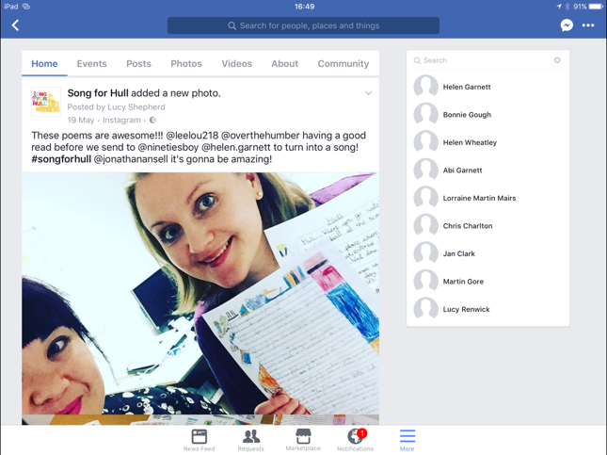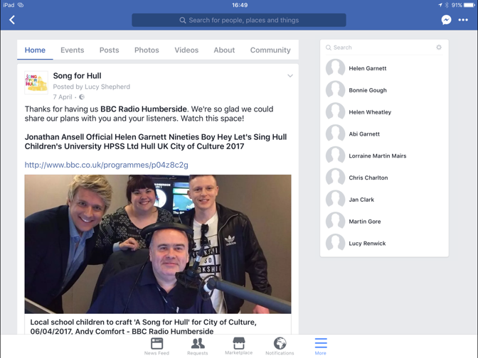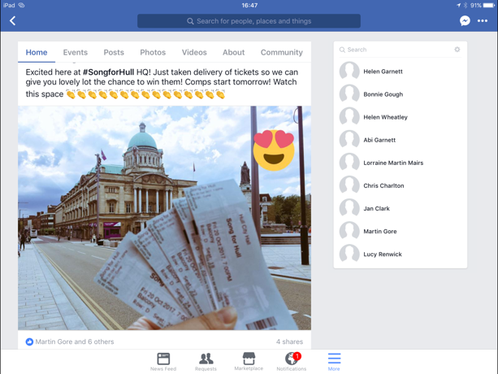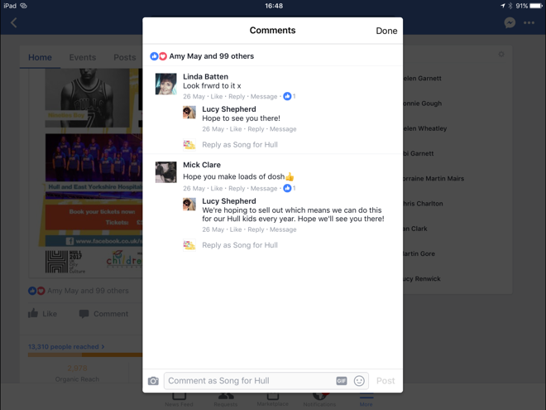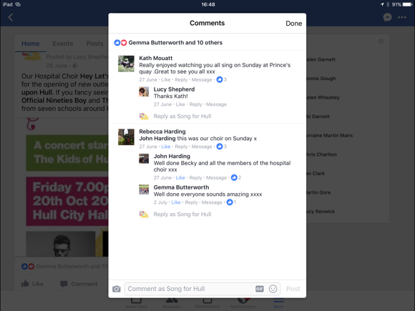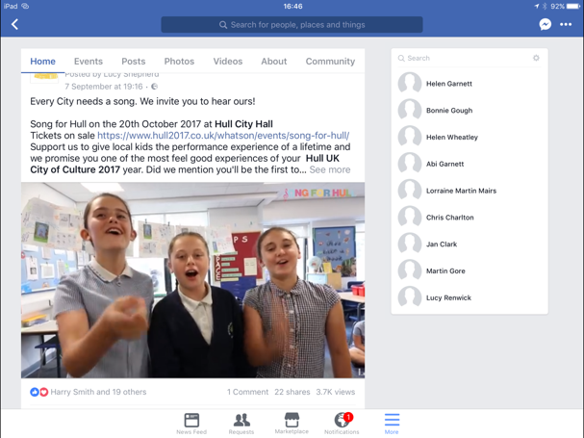**In the boxes below, please share a selection of audience comments or quotes from social media made about your project:**

1. **Partners**

**To date, how many partners are involved with the project?**

|  |  |  |
| --- | --- | --- |
|  | **ACTUAL TO DATE BASED IN**  **HU1 – HU9** | **ACTUAL TO DATE BASED OUTSIDE**  **HU1 – HU9** |
| **PARTNER TYPE** | | |
| Artistic partner (e.g. theatre, art gallery, music venue) | 1 | 0 |
| Heritage partner (e.g. museum, archive) | 0 | 0 |
| Funder (e.g. Arts Council England, business, private trust) | 4 | 1 |
| Public Sector partner (e.g. libraries, GPs) | 1 | 0 |
| Voluntary sector partner (e.g. community group, charity) | 1 | 0 |
| Education (e.g. school, college, university) | 7 | 0 |
| Other | 2 | 2 |
| **PARTNERSHIP STAGE** | | |
| Number of new partnerships established via this project | 9 | 3 |
| Number of existing partners involved in this this project | 1 | 1 |

**This can include formal and informal feedback given to you by staff and/ or your own observations. You can use comments books; informal conversations; emails; etc. to inform this.**

**Thinking about your project to date, what would you say have been the main successes for your partners:**

Hull Children’s university have been able to give 7 schools the opportunity to involved in a project that will give the kids and teachers (free of charge) an amazing collective experience.

Great exposure for HPSS and All For One Choirs to new projects and opportunities.

Swift – Great partnership and community support reputation. Chance to support schools their employees kids go to.

Hospital improving connections with the community and showing it’s a great place to work and been treated in. Workforce of the future!

**Thinking about your project to date, what would you say have been the main challenges for your partners:**

Getting them to work alongside the public sector and their needs for process and structure. Artistic vs bureaucracy!!

Understanding the different priorities and timelines. Some partners have not got used to the pace of work and the notice needed to get everyone in the right place at the right time!