TURNER // RETURN 16 November 6-10pm
Local artists will be taking over the Ferens Art Gallery, the home of Turner Prize 2017, for an evening of creativity and celebration in Hull.

1 | RETURN // PRINT  Lead : Hack & Host | Outside to the right of the Ferens entrance  Seating for 10 | Meet Me at the Blue Box  Hull based arts collective, Hack & Host have recreated Hull Daily Mail’s famous Blue Box. A place to meet, exchange and share, the Blue Box has been making its way around Hull capturing voices across the city and their thoughts on Turner Prize 2017.  Located at the main entrance of the Ferens Art Gallery, you’re invited to visit the Blue Box and find out what the story is so far through the specially created newspaper. Feel free to have a sit down, read the paper and add your own thoughts.. Remember: Whatever you think about art, you’re right.  6-9pm  <<INSERT>>
2 | RETURN // ART  Lead: Curators George & Sacha | Studio  150 capacity | Between Competition and Care  Artes Mundi, BALTIC Artists’ Award, Turner Prize, John Moores Painting Prize, Paul Hamlyn Foundation Awards for Artists and the Max Mara Prize for Women… the current list of contemporary art prizes goes on.  This explosion of such prizes in recent years raises the question:  Is competition the best environment for artists to make work and for the public to encounter new work?  And as a result, how do we care for art, audiences, and artwork in the context of competition?  As part of Turner//Return, the Ferens Art Gallery and Hull 2017 are pleased to present ‘Between Competition and Care’, a panel discussion on the nature of art prizes with Sarah Munro, Director of BALTIC Centre for Contemporary Art, and Ben Borthwick, Artistic Director of Plymouth Art Centre. Hosted by Turner Prize 2017 curators Sacha Craddock and George Vasey.  6.30-7.30pm  The Studio  Free, booking tickets advisable as spaces are limited  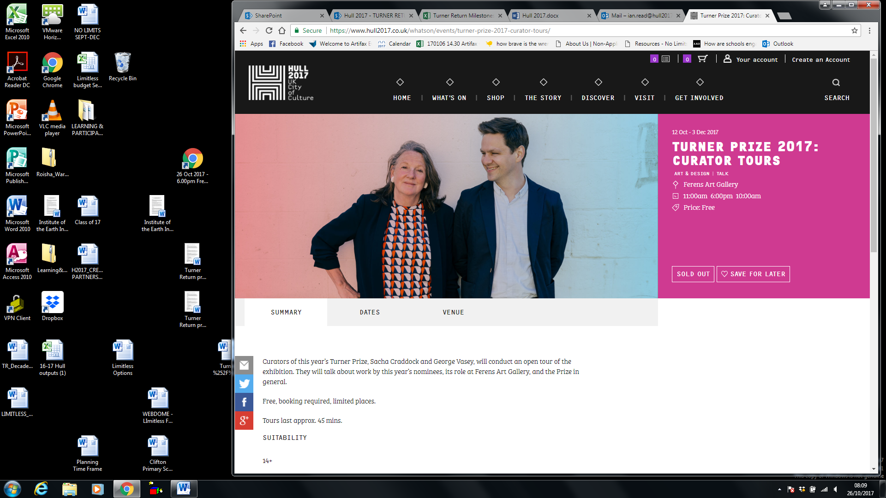  Art Film Screenings  Drop in to a programme of emerging artists’ films specially selected by the Turner Prize 2017 curators.  8-10pm  The Studio  Free, unticketed, full details of films and timings available on the night
3 | RETURN // FEESTING  Lead: Future Ferens & Anna Bean | Gallery 2  Dutch 17th  Seating for 20 | FEEST  The table has been set, the food has been made… all we need now are the guests. In the sumptuous surroundings of the Dutch 17th Century Gallery we are inviting you to join our ‘feest’.  Artist Anna Bean and Future Ferens ask you to join them to talk about art, life, your day at work - whatever it is, they are there to listen and respond, and there’s plenty to eat. Tuck in. Bon Appetit! Smakelijk!  6-10pm Drop In  Dutch 17th Gallery  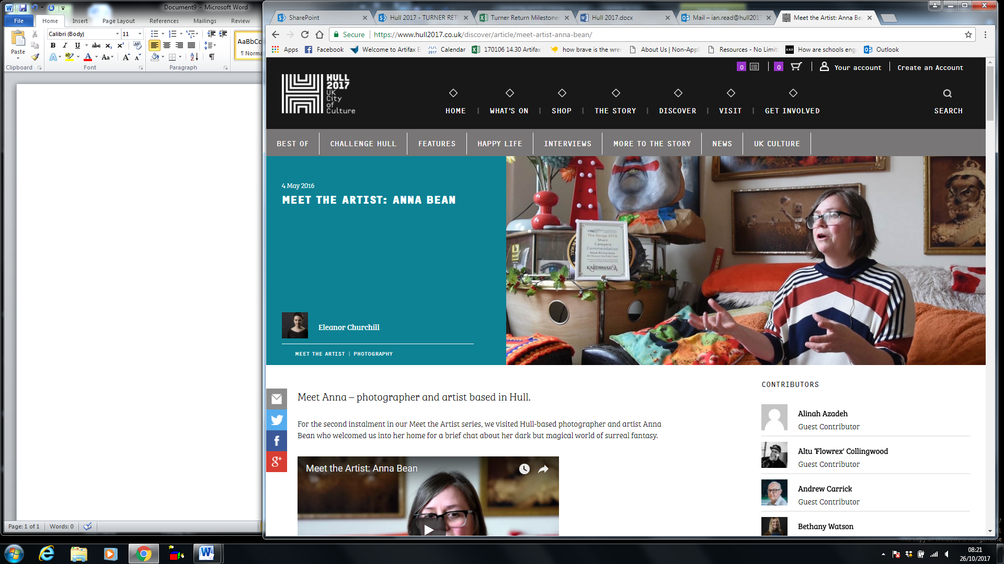  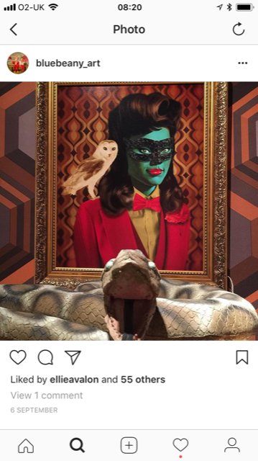
4 | RETURN // FINE CUT  Lead: Greasy Fingers | Gallery 3  European 18th  Seating for 1  20 capacity | GREASY FINGERS BARBERSHOP  Let your hair down in RETURN // FINE CUT with local lads Greasy Fingers, who are bringing their barber chair and scissor skills to the gallery for one night only. Sit down, relax and get a quick trim in style.  6-9.30pm  European 18th  Free with limited availability, first come first served
5 | RETURN // DEBATE  Lead: FandangoeKid | Café / shop  30 capacity | TABOO EMOTIONS  Fandangoekid is a graphic artist who documents love and loss and encourages a more open approach to typically taboo subjects.  Join Annie, the Fandangoekid, at the Ferens café, where she’ll be showcasing a specially made mural. At this drop-in workshop where you can to contribute to piece of art to make your voice heard.  Be brave, join the discussion and let your words be seen.  6-10pm  Café & Shop (the Café will be serving refreshments)  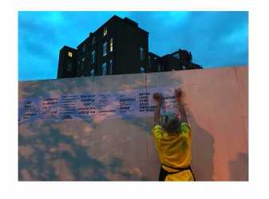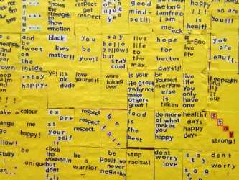
7 | RETURN // PERFORMANCE  Lead: LO:CUS | 50 capacity | Bits of Things  Taking inspiration from the Turner Prize 2017 exhibition and audience reactions, local dancers Jo Ashbridge and Tamar Draper take over the gallery with a new piece of dance. They will explore themes of place and identity, memory, communication, vulnerability and contrast. – First performance 6.15pm
8 | RETURN // EXCHANGE  Lead: Kate Genever | Galleries 5, 6, 7, 8 &9  30 per tour | LIVE TOURS  You’ve seen it, now return for an alternative view. Join your host for an unconventional tour to experience Turner Prize 2017 in a new way.  From The Central Courtyard, first tour leaves at 6.10pm
9 | RETURN // DECADENCE  Lead: Eli Chambers | Thomas Ferens gallery  50 capacity | THE GIFT  Sink into the decadent surroundings of art purchased by Thomas Ferens and gifted to the city. Grab a drink at the pop-up prosecco bar and indulge in the electronic sounds of Polo, Kev La Kat and other special guests, curated by Ellie Churchill from Chambers.  The Pop-Up Prosecco Bar will be open from 7pm-10pm  Thomas Ferens Gallery (upstairs)  POLO // 9.30-10pm  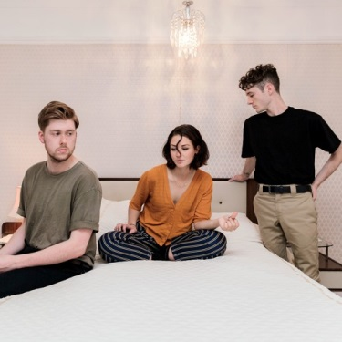  Kev La Kat  8.30-9pm  Special guests (BAND TBC)  7.30-8pm

