**Art can change the world**

16:15 – 17:00 at 1@the Dock

**Nikki Bedi -** 07888723429

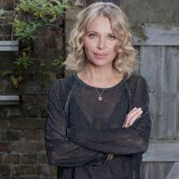 BBC televison and radio broadcaster with a passion for making arts and culture accessible.  
  
**Kate West, Hack and Host –** 07708510727

Hack & Host is a collective of artists who have a mutual interest in raising the quality of contemporary art in Hull.

**Gillian Nicol -** 07936 599323

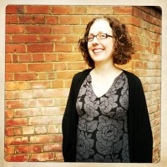 Director of Digital and Online Content, a-n The Artists Information Company

**Aisha Zia -** 07877316600

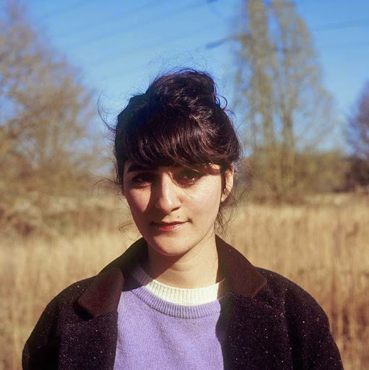 Aisha is a British writer for both theatre and film.

**Léonie Higgins -** 079791 246053

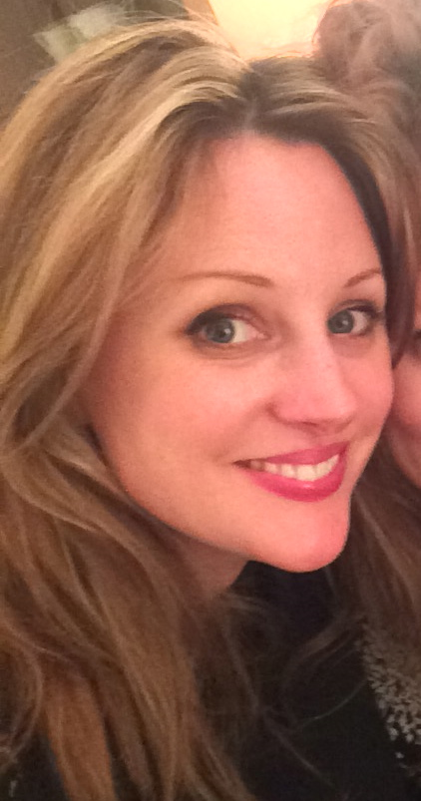 Léonie Higgins is one third of Eggs Collective.